



MODEL TASK FOR ASSIGNMENT 2.1 – ZEUS LANGUAGE

Language: Zeus
Team - Ahnaf Kamal - Id: 041034479 / Skylar Phanenhour- Id: 041024402

- Note: This task is part of the Assignment 2 from Compilers Course. Any problem, contact your lab professor.

PART 1: RE – Regular Expression (1.5 mark)

Lexeme Classes: Define the classes to be used in your regular expression:

L = [A-Z|a-z]
D = [0-9]
U = [ _ ]
DQ = “
SQ = ‘
O = [^L|D|U|DQ|SQ|TAG|EQ|PERIOD]
TAG = #
EQ = =
PERIOD = .

Define the RE to be used for: variables, literals and keywords:

* CMMNT: TAG(^O)* // single line comment
* MLCMMNT: TAGEQ(^TAGEQ)*EQTAG // multi line comment
* Variables:
- VARID : L(L|D|U)0-29 // variable name, methods fall under here.
* Literals:
- INTD = D[D]* // integers
- REID = D+.D+ // real
- SL = DQ[^DQ]*DQ // string literal
- CHARID=SQ[^SQ]{1}SQ // chars

* Keywords: {If, else, elseif, for, while, println, printf, function, return, square, cube, PI, end, readLine, int, real, string, void, const}

PART 2: TD – Transition Diagram (1.5 marks)
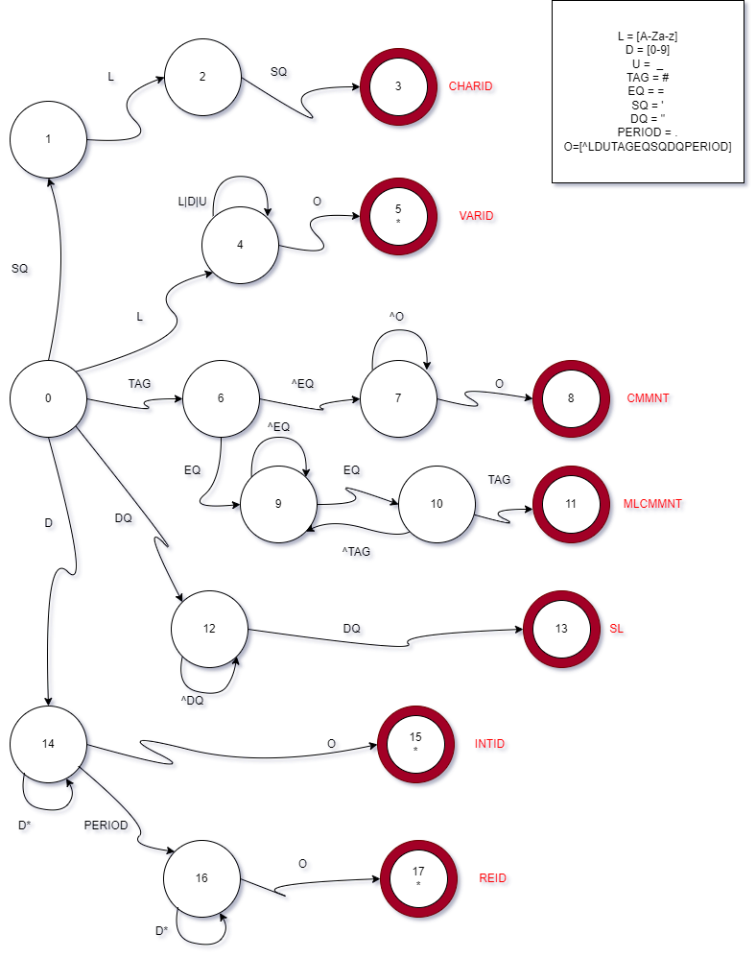

PART 3: TT – Transition Table (2 marks)

Activity: Now, it is possible to define the TT for these lexemes:

Answer (Transition Table):

Input | Output
State | 0 | 1 | 2 |  | 3 | 4 | 5 | 6 | 7 | 8 | Type
 | L[A-Z | a-z] | D[0-9] | U[_] |  | TAG(#) | EQ(=) | SQ(‘) | DQ(“) | PERIOD(.) | O[^LDUTAGEQSQDQPERIOD] | -
0 | 4 | 14 | ESNR |  | 6 | ESNR | 1 | 12 | ESNR | ESNR | NOAS [0]
1 | 2 | ESNR | ESNR |  | ESNR | ESNR | ESNR | ESNR | ESNR | ESNR | NOAS [1]
2 | ESNR | ESNR | ESNR |  | ESNR | ESNR | 3 | ESNR | ESNR | ESNR | NOAS [2]
3 | FS | FS | FS |  | FS | FS | FS | FS | FS | FS | ASNR[CHARID] [3]
4 | 4 | 4 | 4 |  | ESNR | ESNR | ESNR | ESNR | ESNR | 5 | NOAS[4]
5 | FS | FS | FS |  | FS | FS | FS | FS | FS | FS | ASNR[VARID][5]
6 | 7 | 7 | 7 |  | 7 | 9 | 7 | 7 | 7 | 7 | NOAS[6]
7 | 7 | 7 | 7 |  | 7 | 7 | 7 | 7 | 7 | 8 | NOAS[7]
8 | FS | FS | FS |  | FS | FS | FS | FS | FS | FS | ASNR[CMMNT][8]
9 | 9 | 9 | 9 |  | 9 | 10 | 9 | 9 | 9 | 9 | NOAS[9]
10 | 9 | 9 | 9 |  | FS | 9 | 9 | 9 | 9 | 9 | NOAS[10]
11 | FS | FS | FS |  | FS | FS | FS | FS | FS | FS | ASNR[MLCMMNT][11]
12 | 12 | 12 | 12 |  | 12 | 12 | 12 | 13 | 12 | 12 | NOAS[12]
13 | FS | FS | FS |  | FS | FS | FS | FS | FS | FS | ASNR[SL][13]
14 | ESNR | 14 | ESNR |  | ESNR | ESNR | ESNR | ESNR | ESNR | 15 | NOAS[14]
15 | FS | FS | FS |  | FS | FS | FS | FS | FS | FS | ASWR[INTID][15]
16 | ESNR | 16 | ESNR |  | ESNR | ESNR | ESNR | ESNR | ESNR | 17 | NOAS[16]
17 | FS | FS | FS |  | FS | FS | FS | FS | FS | FS | ASWR[REID][17]

Update: Feb 3rd 2023.

Adapted from resources developed by Prof. Svillen Ranev (Algonquin College, 2019)

