Algonquin College Logo

# SCHOOL OF ADVANCED TECHNOLOGY

### ICT - Applications & Programming

### Computer Engineering Technology – Computing Science



A11

Game Interface

Team:

Ahnaf Kamal- Id: 041034479/ Skylar Phanenhour- Id: 041024402

Game Proposal - Picross

***This template is suggested (not mandatory) to answer A11 Specification.***

|  |  |
| --- | --- |
| **Part**  **1** | **GUI Definition** |

**EXPLANATION**

*The purpose of this assignment is to define the elements of the GUI application to be used in your game implementation.*

* ***Example (Prof. suggestion)****:*

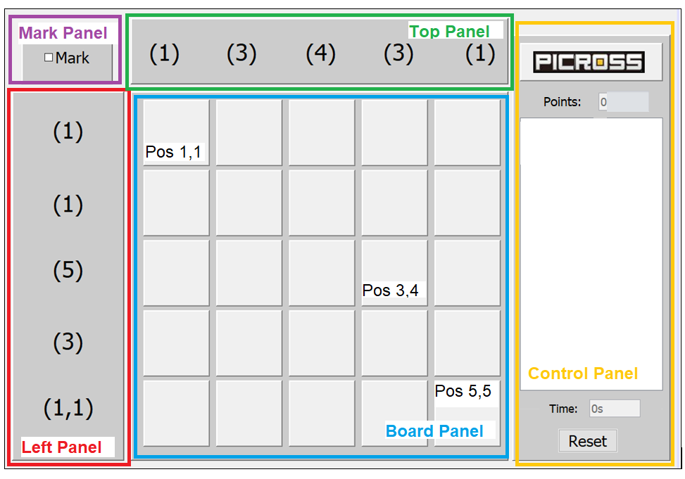

* ***Note****: The professor interface is also a proposal. It means that your own implementation can be different. What does matter is that the game functionality will be respected.*
  1. **Defining the Components**

**List of components**

JFrame, JPanel, JLabel, JRadioButton, JButtons, JTextField. All of these components will be implemented from the Java Swing library.

**Functionalities and Behaviors**

* Ability to change grid size (5x5) (6x6).
* Ability to solve/reveal the entire picross.
* How to play section. We will have an instructions button that will create a new window/frame that will display the instructions on how to play the game. There will be a button in this window that will return the user back to the original picross game window.
* Reset button, when this button is clicked, the board resets all of the tiles to the original/default pattern.
* Change language. We will have radio buttons that will indicate the language. Once the radio button is clicked, the page will refresh with the same contents, but in a different language.
* Change color scheme. We will have a list of color schemes that the user can choose from that will change the foreground of the text and the background color of the components.
* Validation system that shows if the tile placement is right or wrong. A red highlight or an X mark can be shown if the tile chosen is wrong. A green highlight can be used to indicate if the tile is correct.

**Languages**

English: Because it’s mandatory.

French: Because we are bad at French and we’d like to get better.

**Details**

Components

* Frame (JFrame)
  + 1000x1000
* Panels (JPanel)
  + Top Panel
    - 550x100
  + Side Panel
    - 100x550
  + Bottom Panel
    - 650x150
  + Board Panel
    - 550x550
    - Will use GridLayout for the tiles.
  + Mark Panel
    - 100x100
  + Control Panel
    - 800x235
* Buttons (JButton)
  + Solve
  + Reset
  + New Board
  + Instructions
* Radio Button
  + Change the language, change the colour scheme.
* Labels (JLabel)
  + Score, Timer, # of tile specifications, display the chat messages.
* Text Field
  + Text field to type messages in the chat.

Color Scheme: Dark Grey, White, Orange

* 1. **User Manual**

**Basic cycle**

* User is shown a default picross pattern to solve.
  + Timer starts
  + Score initialized at 0
* The user places tiles or marks tiles as empty.
* If the user does not want to solve the problem, they can reveal the answer by clicking the “Solve” button.
* The user can reset the panel to undo all tile/mark placements (this does not regenerate the picross pattern)
* When all the correct tiles are placed, the score goes up and the timer resets.
* The user can quit the game whenever they want, in addition, they are given the option to quit after solving the picross as well.
  + At this point, they can press the “New board” button to make a new board with a randomly generated pattern when they play again. This will keep the score while resetting the timer. (loop starts again)

*Create a brief description about how your game can be used.*

***Example****: If you have to design the solution to be saved and played later, how are the stems. Most importantly, how someone can play the* ***Picross****.*

* *Note: your process does not need to be followed exactly when you are going to the implementation. For while, it is only a script about how to play.;*

**FINAL SUGGESTIONS**

* Validation system that shows if the tile placement is right or wrong. A red highlight or an X mark can be shown if the tile chosen is wrong. A green highlight can be used to indicate if the tile is correct.
* Changing color schemes, this will change the text color, foreground as well as the background color of the components.
* Solve button, which when clicked, will auto complete the puzzle for the user. Clicking this button will not increase the score.
* New board option. After clicking this button, a new board will be generated with a random pattern of tiles.

*Here some ideas to think about your language....*

* *Try to create a game whose execution can be very intuitive (easy to be played).*
* *Remember that this game will be in fact implemented only in the next assignment.*

**References**

*[Include eventual references used here]*

* ***NOTE****: Even if you use one specific tool (ex: ChatGPT), report it here.*

Algonquin College

Winter, 2023