**Title:** Four Way Traffic light Control with Basic Circuit

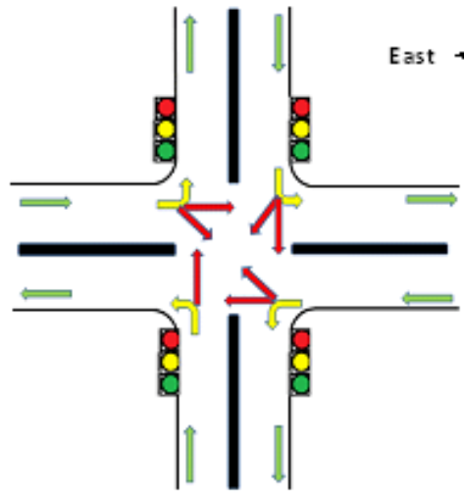

Methodology:

For this project, we'll need a power production circuit that can generate 6v DC. We shall use this electricity as a source. Then we'll need a frequency generator that runs at 1 Hz. We also built a positive counter to keep track of the time. side is controlled by a control circuit. Then I created a circuit based on the logic of the green, yellow, and red lights.

Circuit Diagram:

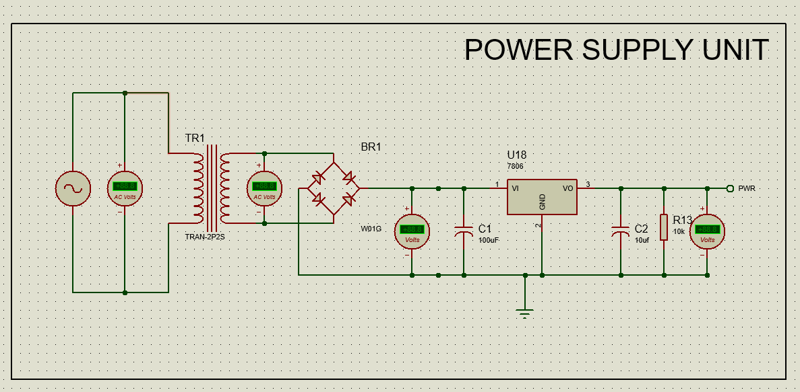

This is a power supply unit that accepts 220v 50hz ac as an input and outputs 6v dc. The power will be used as the circuit's source throughout.

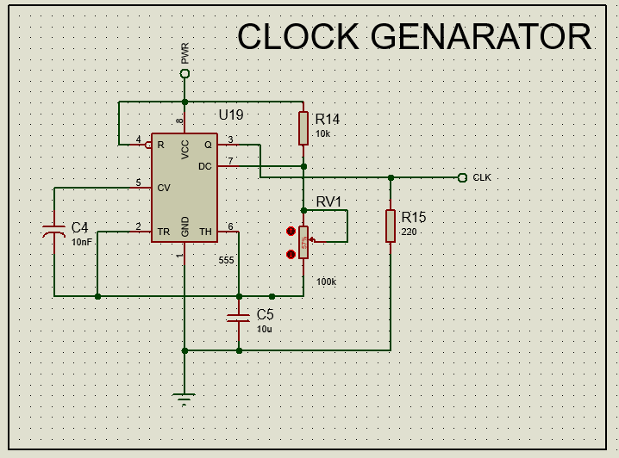

This is a circuit for a 1Hz clock generator. As an Astable (free-running) mode, I utilized a 555 timer.

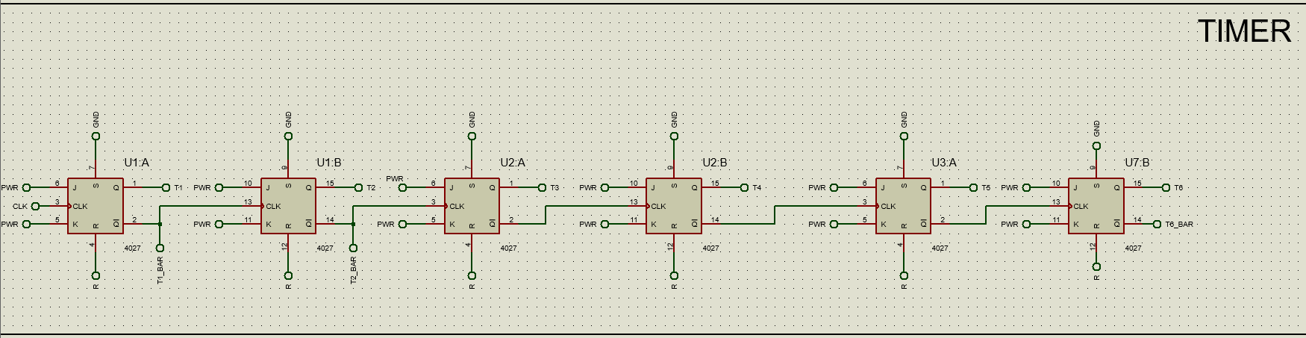

This is an up-counter circuit diagram. As a counter, the T-flip Flop is utilized. The quantity of flipflops depends on how much time you have to wait.

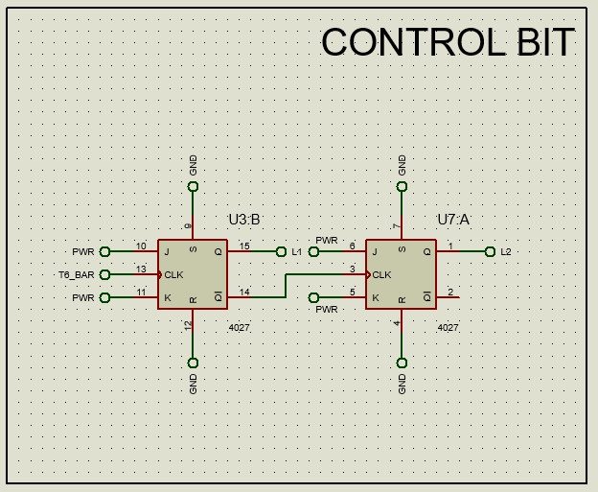

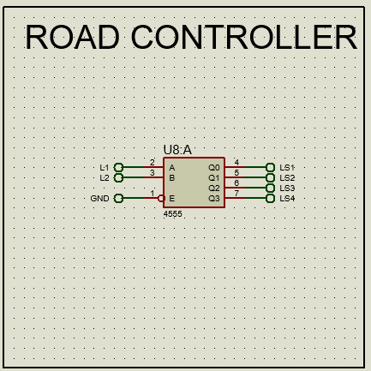

control This bit is used to select which side of the road you want to control.

And final for Green , Yellow , Red light will look like this ,

