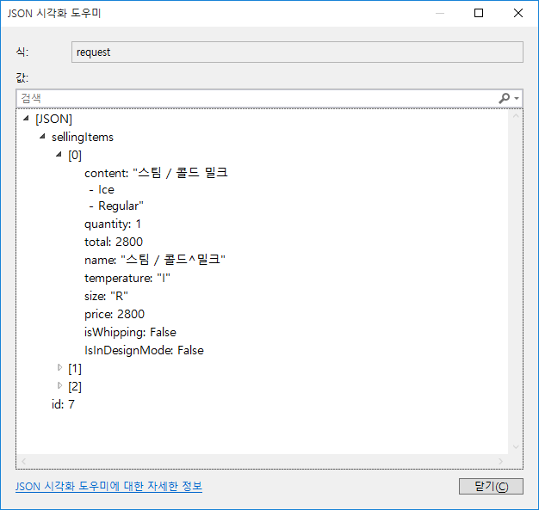

{"sellingItems":[{"content":"스팀 / 콜드 밀크\n - Ice\n - Regular","quantity":1,"total":2800,"name":"스팀 / 콜드^밀크","temperature":"I","size":"R","price":2800,"isWhipping":false,"IsInDesignMode":false},{"content":"바닐라 밀크\n - Ice\n - Regular","quantity":1,"total":3500,"name":"바닐라 밀크","temperature":"I","size":"R","price":3500,"isWhipping":false,"IsInDesignMode":false},{"content":"허니 밀크\n - Ice\n - Regular","quantity":2,"total":7000,"name":"허니 밀크","temperature":"I","size":"R","price":3500,"isWhipping":false,"IsInDesignMode":false}],"id":7}

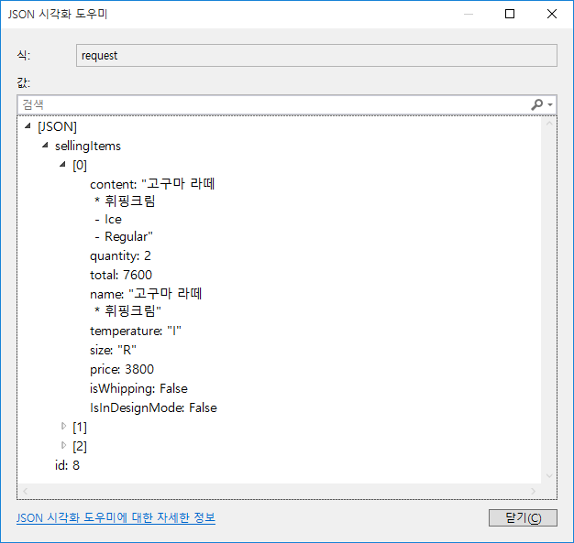

{"sellingItems":[{"content":"고구마 라떼\n \* 휘핑크림\n - Ice\n - Regular","quantity":2,"total":7600,"name":"고구마 라떼\n \* 휘핑크림","temperature":"I","size":"R","price":3800,"isWhipping":false,"IsInDesignMode":false},{"content":"고구마 라떼\n - Ice\n - Regular","quantity":2,"total":7600,"name":"고구마 라떼","temperature":"I","size":"R","price":3800,"isWhipping":false,"IsInDesignMode":false},{"content":"에스프레소\n - None\n - None","quantity":1,"total":2000,"name":"에스프레소","temperature":null,"size":null,"price":2000,"isWhipping":false,"IsInDesignMode":false}],"id":8}

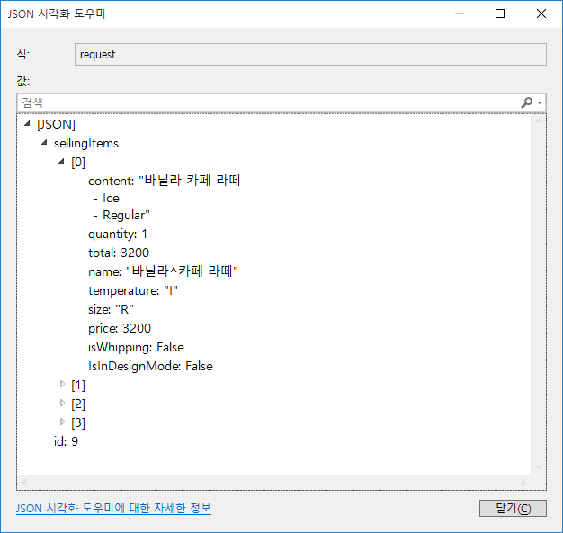

{"sellingItems":[{"content":"바닐라 카페 라떼\n - Ice\n - Regular","quantity":1,"total":3200,"name":"바닐라^카페 라떼","temperature":"I","size":"R","price":3200,"isWhipping":false,"IsInDesignMode":false},{"content":"아메리카노\n - Ice\n - Regular","quantity":3,"total":6000,"name":"아메리카노","temperature":"I","size":"R","price":2000,"isWhipping":false,"IsInDesignMode":false},{"content":"에스프레소 콘 파냐\n \* 휘핑크림\n - None\n - None","quantity":1,"total":2500,"name":"에스프레소^콘 파냐\n \* 휘핑크림","temperature":null,"size":null,"price":2500,"isWhipping":false,"IsInDesignMode":false},{"content":"에스프레소 콘 파냐\n - None\n - None","quantity":1,"total":2500,"name":"에스프레소^콘 파냐","temperature":null,"size":null,"price":2500,"isWhipping":false,"IsInDesignMode":false}],"id":9}