ComputeNet Whitepaper

Research Preview v1.0

An Open Protocol for Verified Useful Compute
https://www.compute-net.org/

Abstract
ComputeNet is an experimental open protocol designed to transform compute into a verifiable, decentralized, utility-backed network resource.
Where Bitcoin introduced decentralized monetary consensus and Ethereum introduced decentralized execution, ComputeNet explores a third primitive:
Decentralized verification of useful compute.
The protocol proposes a Proof of Useful Compute (PoUC) model in which computational work is only considered valid when:
- the task is deterministic,
- the output is reproducible,
- the execution can be independently verified,
- receipts can be cryptographically attested,
- validators can reach consensus on execution validity.
ComputeNet is being developed under a research-first framework with:
- no ICO,
- no premine,
- no founder allocation,
- no custodial promises,
- no investment guarantees.
The protocol is intended to follow a Bitcoin-style fair-launch philosophy where network participation emerges organically through open-source infrastructure and validator participation.
This document describes the early research architecture, consensus concepts, compute receipt system, validator topology, testnet structure, and long-term protocol direction.

1. Introduction

1.1 The Compute Problem
Artificial intelligence, simulation systems, cryptographic verification, scientific modeling, rendering, and inference workloads are rapidly increasing global demand for compute.
Modern compute markets suffer from several structural problems:
- centralized cloud dependency,
- opaque compute pricing,
- unverifiable execution,
- fragmented idle compute,
- weak trust guarantees,
- poor interoperability,
- inefficient resource coordination.
At the same time, existing proof-of-work systems consume energy while producing computational outputs with little reusable utility.
ComputeNet explores an alternative model:
Computational work should produce reusable value.

1.2 Core Thesis
The core thesis behind ComputeNet is simple:
Useful computation can become a native protocol primitive.
Instead of hashing purely for difficulty competition, nodes may eventually compete by:
- executing deterministic workloads,
- generating verifiable outputs,
- producing cryptographic execution receipts,
- participating in decentralized validation.
The long-term objective is a decentralized network where compute itself becomes measurable, attestable, and exchangeable.

2. Protocol Philosophy

2.1 Research-First Development
ComputeNet is currently operating in:
Research Preview / Private Testnet mode.
The current network is:
- non-economic,
- non-custodial,
- non-commercial,
- experimental.
There is currently:
- no public token,
- no mining,
- no public rewards,
- no economic issuance,
- no investment mechanism.
The purpose of the current network phase is:
- protocol experimentation,
- validator architecture testing,
- compute receipt verification,
- consensus validation,
- distributed systems research.

2.2 Fair Launch Principles
ComputeNet intends to follow several foundational principles:

No Premine
No founder allocation or hidden supply.

No ICO
No public fundraising through token sales.

No Central Custody
The protocol is intended to operate without custodial control.

Open Participation
Validator participation should eventually emerge through open protocol rules.

Utility-First Orientation
The network should prioritize useful computation over speculative activity.

3. System Architecture

3.1 High-Level Architecture
ComputeNet currently consists of:
- validator nodes,
- deterministic compute runners,
- proof engines,
- receipt engines,
- consensus coordinators,
- telemetry systems,
- peer registries,
- public observer infrastructure.
The architecture is intentionally modular.
Each component can evolve independently while preserving protocol interoperability.

3.2 Core Components

Validator Nodes
Validators:
- receive compute receipts,
- verify deterministic outputs,
- attest validity,
- participate in consensus.
Validators currently operate through FastAPI-based services.

Deterministic Runner
The deterministic execution layer ensures workloads produce reproducible outputs.
Properties:
- stable execution,
- predictable outputs,
- reproducible hashing,
- deterministic receipt generation.
This is critical because useful compute only becomes verifiable when independent validators can reproduce identical outputs.

Compute Receipt Engine
Execution results are transformed into structured receipts.
Receipts contain:
- job identifiers,
- manifest hashes,
- execution hashes,
- validator metadata,
- timestamps,
- proof metadata.
These receipts form the protocol’s primary evidence structure.

Proof Engine
The Proof Engine verifies compute validity.
Current research implementations include:
- local deterministic proofs,
- placeholder ZK proof integration layers,
- aggregate proof structures.
Long-term research directions may include:
- real zkVM integrations,
- recursive proof systems,
- hardware attestation,
- trusted execution environments.

Consensus Layer
Consensus currently operates through validator attestations.
Validators:
- independently verify receipts,
- cast weighted attestations,
- determine consensus ratios,
- finalize accepted compute.
Future versions may explore:
- Byzantine fault tolerance,
- stake-independent validator weighting,
- adaptive trust systems,
- probabilistic verification.

4. Proof of Useful Compute (PoUC)

4.1 Definition
Proof of Useful Compute (PoUC) is the conceptual foundation of ComputeNet.
In PoUC:
- computational work must produce reusable outputs,
- outputs must be independently verifiable,
- validators must be able to reproduce execution,
- receipts must be consensus-verifiable.
The protocol does not currently claim to have solved decentralized useful compute fully.
Instead, ComputeNet should be viewed as:
An evolving research framework attempting to solve it incrementally.

4.2 Desired Properties
An ideal PoUC system should provide:

Determinism
Inputs should produce reproducible outputs.

Verifiability
Independent validators should verify execution validity.

Replay Resistance
Receipts should resist duplication or manipulation.

Fraud Detection
Dishonest validators should be identifiable.

Cost Efficiency
Verification should remain computationally cheaper than generation.

Utility Production
The network should generate reusable computational value.

4A. Verification Pipeline

4A.1 Overview
The central challenge ComputeNet attempts to address is not simply distributed computation.
The deeper challenge is:
How can a decentralized network verify that useful computation was genuinely executed correctly?
ComputeNet approaches this problem through a layered verification pipeline combining:
- deterministic execution,
- reproducible workloads,
- execution hashing,
- portable compute receipts,
- validator re-execution,
- consensus attestations,
- aggregate proof formation.
The protocol is intentionally designed so that:
verification should eventually become cheaper than execution.

4A.2 Job Manifest Creation
Every compute task begins as a deterministic job manifest.
A manifest contains:
- job identifiers,
- execution targets,
- workload definitions,
- expected inputs,
- execution parameters,
- verification modes.
The manifest acts as the canonical execution blueprint.
All validators should receive identical manifest definitions.

4A.3 Deterministic Execution
The deterministic runner executes workloads under reproducible constraints.
The objective is:
- identical inputs,
- identical runtime assumptions,
- identical outputs.
Determinism is essential because decentralized verification becomes impossible if validators cannot reproduce execution results consistently.
Examples of deterministic workloads may include:
- hashing tasks,
- matrix operations,
- benchmark simulations,
- compression routines,
- deterministic inference tasks,
- reproducible scientific workloads.

4A.4 Execution Hashing
After execution completes, outputs are hashed.
The execution hash acts as:
- an immutable execution fingerprint,
- a compact representation of compute output,
- a reproducibility anchor.
If multiple validators independently produce identical hashes from identical manifests, the probability of consistent execution validity increases significantly.

4A.5 Compute Receipt Construction
Execution metadata is transformed into a structured compute receipt.
Receipts may contain:
- manifest hashes,
- execution hashes,
- validator IDs,
- timestamps,
- proof payload references,
- execution summaries,
- consensus metadata.
The receipt becomes the network’s portable evidence artifact.

4A.6 Independent Validator Re-Execution
Validators independently:
- retrieve manifests,
- rerun workloads,
- regenerate outputs,
- compare execution hashes.
This creates distributed verification.
No single validator is treated as authoritative.
Instead, trust emerges from independent reproducibility.

4A.7 Consensus Attestation
After validation:
- validators cast attestations,
- acceptance ratios are aggregated,
- consensus thresholds determine finalization.
Current research implementations use validator-weighted attestation aggregation.
Future research may explore:
- probabilistic verification,
- Byzantine fault tolerance,
- adaptive trust scoring,
- challenge windows.

4A.8 Fraud Detection
The network attempts to detect fraudulent execution through:
- mismatched execution hashes,
- inconsistent receipts,
- validator disagreement,
- replay anomalies,
- malformed manifests.
Future versions may incorporate:
- slashing systems,
- validator reputation models,
- anomaly scoring,
- dispute arbitration.

4A.9 Replay Protection
Replay resistance is essential.
Receipts should eventually resist:
- duplication,
- output recycling,
- fake execution reuse,
- stale receipt injection.
Potential future mechanisms include:
- nonce structures,
- execution windows,
- challenge epochs,
- state-linked receipt hashes.

4A.10 Aggregate Proof Formation
Multiple validator attestations can be aggregated into unified proof bundles.
Aggregate proofs aim to provide:
- compact verification evidence,
- portable auditability,
- consensus reproducibility,
- efficient downstream validation.
The protocol currently experiments with proof aggregation layers combining:
- local deterministic proofs,
- placeholder zk verification structures,
- consensus attestations.

4A.11 Future Zero-Knowledge Verification
Long-term research may explore:
- zkVM integration,
- recursive proof systems,
- SNARK/STARK compression,
- hardware attestation,
- trusted execution environments.
The long-term objective would be:
compact cryptographic verification of useful compute.
However, ComputeNet does not currently claim production-grade zero-knowledge compute verification.
This remains an active area of protocol research.

4A.12 Verification Philosophy
The ComputeNet verification model is based on a simple principle:
useful compute only becomes trustworthy when independent systems can reproduce and verify it.
The protocol therefore prioritizes:
- reproducibility,
- deterministic execution,
- independent validation,
- portable evidence,
- consensus-based truth formation.

4B. Measuring and Verifying Useful Compute

4B.1 Core Principle

ComputeNet is designed around a simple protocol objective:
The network should reward verified useful compute rather than merely claimed compute.
The central challenge is therefore not only distributed computation, but reliable measurement and decentralized verification of execution validity.

4B.2 What Qualifies as Useful Compute
Potential workload categories may include:
- AI inference workloads
- deterministic model execution
- scientific simulations
- rendering workloads
- compression and optimization routines
- benchmarking tasks
- matrix and tensor operations
- cryptographic computation
- reproducible analytical workloads
The protocol intentionally prioritizes deterministic and reproducible computation.

4B.3 Compute Measurement

Useful compute may eventually be measured through a combination of:
- execution duration
- workload complexity
- reproducibility cost
- hardware utilization
- validator verification cost
- execution integrity
- consensus confidence
The protocol does not currently claim a finalized universal compute valuation model.
Instead, ComputeNet treats compute measurement as an evolving research problem.

4B.4 Compute Receipts

Each completed workload produces a structured compute receipt.
Example receipt fields may include:
- job_id
- manifest_hash
- input_hash
- output_hash
- runtime
- validator_signature
- execution_timestamp
- consensus_metadata
Receipts act as portable cryptographic evidence that useful computation was executed and independently verified.

4B.5 Independent Verification

Validators independently:
- retrieve workload manifests,
- reproduce execution,
- regenerate execution hashes,
- compare outputs,
- attest validity.
No individual validator is treated as authoritative.
Instead, truth emerges through decentralized reproducibility and validator consensus.

4B.6 Replay Sampling

The network may use probabilistic replay verification in which only a percentage of workloads are re-executed by validators.
This is intended to make verification economically scalable while preserving fraud resistance.
The long-term objective is: verification should remain cheaper than execution.

4B.7 Challenge Windows

Future protocol versions may introduce challenge windows allowing validators to dispute suspicious receipts prior to finalization.
Potential challenge triggers may include:
- inconsistent hashes,
- abnormal runtime behavior,
- duplicated outputs,
- malformed manifests,
- statistical anomalies.

4B.8 Reputation and Trust Weighting

Future research directions may include validator reputation systems based on:
- historical verification accuracy,
- uptime reliability,
- fraud detection history,
- consensus alignment,
- reproducibility consistency.
Validator weighting should remain subordinate to decentralization and anti-capture principles.

4B.9 Long-Term Verification Research

Long-term verification research may include:
  - zero-knowledge compute proofs
  - zkVM integration
  - trusted execution environments
  - hardware attestation
  - recursive proof systems
  - proof compression
  - distributed anomaly detection

4B.10 Verification Philosophy

ComputeNet is built around the principle that:
Useful compute only becomes economically trustworthy when independent systems can reproduce and verify it.
The protocol therefore prioritizes:
  - deterministic execution
  - reproducibility
  - independent validation
  - portable evidence
  - decentralized consensus
  - measurable utility

5. Validator Network

5.1 Validator Roles
Validators serve as the trust infrastructure of ComputeNet.
Their responsibilities include:
- receipt validation,
- consensus participation,
- peer propagation,
- uptime reporting,
- fraud detection.

5.2 Validator Topology
The current architecture is evolving from:
- single-machine simulated validators,
to: multi-VPS distributed validators.
Future topology goals include:
- geographically distributed validators,
- independent operators,
- peer discovery,
- resilient gossip propagation,
- autonomous recovery.

5.3 Peer Discovery
Validators maintain peer registries.
Future peer discovery may include:
- bootstrap peer lists,
- gossip synchronization,
- liveness scoring,
- adaptive trust weighting.

6. Consensus Model

6.1 Current Consensus
Current consensus is validator-attestation based.
Validators:
- verify receipts,
- cast attestations,
- aggregate acceptance ratios,
- finalize valid execution bundles.

6.2 Future Consensus Research
Future consensus research areas may include:
- asynchronous BFT,
- validator reputation systems,
- adaptive verification thresholds,
- probabilistic sampling,
- challenge-response dispute windows.
The long-term objective is:
decentralized compute validity without centralized trust.

7. Compute Receipts

7.1 Purpose
Compute receipts are the foundational truth artifact within ComputeNet.
A receipt acts as:
- proof of execution,
- execution identity,
- validator evidence,
- consensus reference.

7.2 Receipt Structure
Receipts may contain:
- job IDs,
- execution metadata,
- input references,
- manifest hashes,
- output hashes,
- validator attestations,
- timestamps,
- proof payloads.
Receipts are intended to become portable, reproducible, and independently auditable.

8. Security Model

8.1 Current Security Position
ComputeNet is currently experimental.
The network has not undergone:
- formal audits,
- adversarial stress testing,
- production-grade security certification.
The current private testnet exists specifically to:
- discover weaknesses,
- test assumptions,
- validate architecture,
- identify attack vectors.

8.2 Threat Areas
Potential threat areas include:
- validator collusion,
- replay attacks,
- receipt forgery,
- fake compute outputs,
- Sybil attacks,
- peer poisoning,
- denial-of-service attacks,
- consensus manipulation.

8.3 Future Security Research
Future areas of investigation may include:
- cryptographic proof compression,
- zero-knowledge verification,
- secure enclaves,
- hardware attestation,
- post-quantum upgradeability,
- distributed fraud scoring.

9. Telemetry and Observability

9.1 Protocol Telemetry
ComputeNet includes telemetry systems for:
- validator uptime,
- peer liveness,
- receipt activity,
- consensus reports,
- runtime compute jobs.

9.2 Public Observer Mode
The current public-facing infrastructure operates in:
Public Observer Mode.
This mode allows:
- public-readable telemetry,
- bootstrap peer visibility,
- genesis candidate visibility,
- explorer access.
Without:
- public mining,
- public validator onboarding,
- economic participation.

10. Genesis Candidate

10.1 Genesis Philosophy
ComputeNet intends to treat genesis as:
a protocol freeze event.
Genesis should only occur after:
- multi-node validation,
- adversarial testing,
- consensus stability,
- deterministic compute verification,
- public documentation,
- reproducible snapshots.

10.2 Genesis Principles
Planned genesis principles include:
- open-source launch,
- no premine,
- no ICO,
- no founder allocation,
- transparent issuance rules,
- public reproducibility.

11. Current Development Status

11.1 Current Capabilities
The current research-preview network includes:
- live validator services,
- system demonization,
- compute receipt generation,
- deterministic execution,
- validator telemetry,
- public observer infrastructure,
- bootstrap peer manifests,
- genesis candidate manifests,
- private testnet explorer.

11.2 Current Limitations
Current limitations include:
- limited validator count,
- early-stage peer discovery,
- placeholder proof systems,
- no production-grade security review,
- limited compute workload diversity,
- no external validator mesh yet.

12. Long-Term Vision

12.1 Network Objective
The long-term objective of ComputeNet is:
a decentralized protocol for verifiable useful compute.
Potential future use cases may include:
- AI inference verification,
- distributed scientific workloads,
- rendering networks,
- simulation markets,
- decentralized benchmarking,
- verifiable agent execution,
- cryptographic proof marketplaces.

12.2 Open Research Questions
Several major research questions remain unresolved:
- How should useful compute be measured?
- How should fraud be penalized?
- How can deterministic execution scale?
- What workloads qualify as useful?
- How should validator incentives function?
- Can useful compute remain decentralized?
- Can verification remain cheaper than execution?
ComputeNet does not claim to have fully solved these questions.
Instead, the protocol exists to explore them experimentally.

13. Protocol Ethos
ComputeNet is being developed around several foundational ideas:
- openness over exclusivity,
- utility over speculation,
- experimentation over marketing,
- infrastructure over hype,
- decentralization over control.
The project should be understood primarily as:
a protocol research initiative exploring verifiable useful compute.

14. Disclaimer
ComputeNet is experimental software.
The protocol is currently in research-preview/private-testnet mode.
Nothing in this document constitutes:
- investment advice,
- an offer of securities,
- financial guarantees,
- economic promises,
- mining guarantees,
- token issuance commitments.
Participation in future testnets may involve technical, operational, and security risks.
The protocol may change substantially prior to any potential public launch.

Conclusion
ComputeNet explores a simple but ambitious idea:
computation itself may eventually become a verifiable decentralized protocol primitive.
The current network remains early-stage, experimental, and intentionally limited.
However, the long-term research direction is clear:
- useful compute,
- deterministic verification,
- decentralized consensus,
- reproducible execution,
- open participation.
Whether such a system can scale globally remains an open question.
ComputeNet exists to explore that question openly.

Appendix A — Current Research Components
Current research modules include:
- validator APIs,
- proof engines,
- compute receipt engines,
- deterministic runners,
- consensus coordinators,
- peer registries,
- telemetry systems,
- bootstrap manifests,
- public observer infrastructure.

Appendix B — Current Public Research Endpoints
Public Observer Endpoint:
https://www.compute-net.org/explorer
Validator Endpoints:
- validator alpha
- validator beta
- validator gamma
Explorer Components:
- telemetry reports
- runtime jobs
- bootstrap peers
- genesis candidate

End of Document

Whitepaper Enhancements — Research Preview v2.1
Purpose of this Revision
This revision expands the verification architecture, protocol identity, and long-term research direction of ComputeNet.

Protocol Primitives
- Truth Stack: Layered verification architecture responsible for deterministic execution validation and consensus formation.
- Deterministic Execution Layer: Execution environment attempting to ensure reproducible workloads.
- Compute Receipts: Portable cryptographic evidence artifacts generated from verified execution.
- Cross-Validator Replay: Independent validator re-execution designed to verify compute reproducibility.
- Consensus Proof Bundles: Aggregated validator attestations representing finalized execution truth.
- Witness Mesh: Observer and witness infrastructure monitoring validator behavior.
- =

Why ComputeNet Matters
The deeper challenge ComputeNet attempts to explore is decentralized trust in machine-generated computation. As AI systems increasingly generate analysis, simulations, decisions, and autonomous actions, the ability to independently verify those outputs may become foundational infrastructure.
ComputeNet explores a model where verification eventually becomes cheaper than execution.

Architecture Diagrams
Verification Pipeline
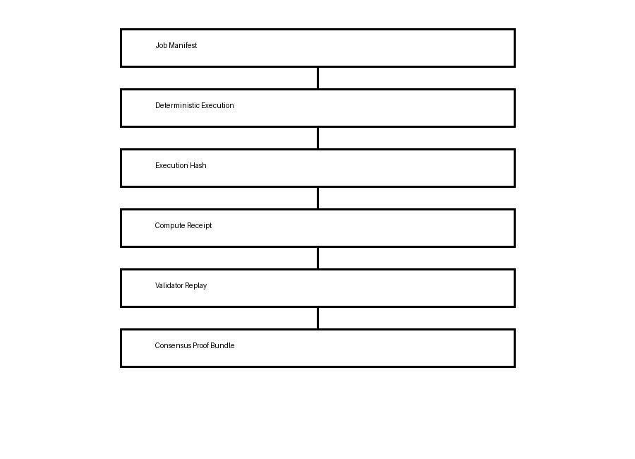
Validator Mesh
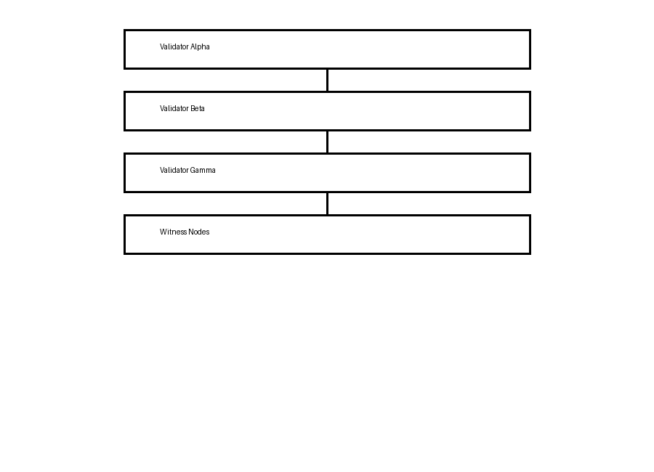
Protocol Layers
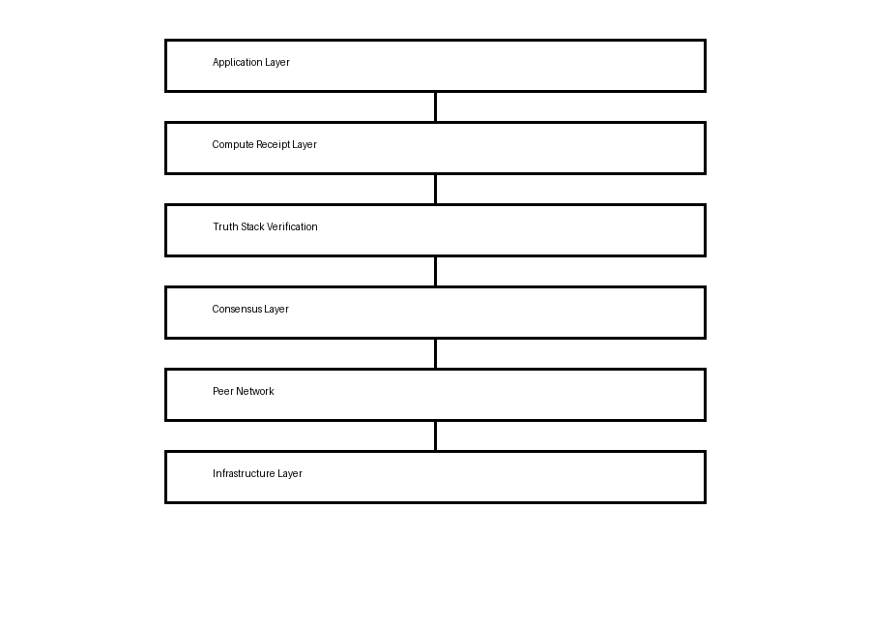

Indicative Roadmap
- v0.11 — Open Public Testnet
- v0.12 — External Validator Expansion
- v0.13 — Reproducible Public Releases
- v0.14 — Extended Stress Testing
- v0.15 — Security Review and Audit Preparation
- v1.0 — Mainnet Genesis Candidate

