INTRODUCTION

Cineplex is all about movies. In a Cineplex there are many different movies for a particular time. For watching the particular movie customer has to purchase ticket for those movies. So, we created a management system where user can purchase ticket for their own wills.

OBJECTIVE

The main objective of our database system was to provide an alternate and convenient way for a customer to buy cinema tickets anytime and anywhere. And we think we accomplished our objective.

ERD EXPLAINATION

ENTITY 1: USER

All User can enter to look at the site but in logged in.  
 ATTRIBUTES:

1. Username – varchar (Unique)

2. Full name–varchar

3. Password-Varchar

4. Email Id- varchar

5. Contact-INT

ENTITY2: TICKETS

For all Users who can know all info of a movie an also can see movies by buying tickets.

ATTRIBUTES:

1. User Name – varchar

2. Date- Date

3. Show Time – Time

4. Movie name- varchar

5. Theater Name- varchar

6. Hall name- varchar

7. Category-varchar

8. Price-INT

9. Order Id-Primary key

ENTITY 3: Admin

Only Admin can access this.

ATTRIBUTES:

1. Admin ID–varchar
2. Password – varchar

ENTITY4: MOVIE

Different types of movie which are currently running on several theater.

ATTRIBUTES:

1. MOVIE ID- Primary key

2. Movie Name- Varchar

3. Rating- INT

4. Details-Varchar

5. Director-Varchar

ENTITY5: SHOW

User can know what is presently showing on Cineplex.

ATTRIBUTES:  
 1. Movie Name-Varchar

2. Theater ID-foreign key

3. Category

4. Time-time

5. Theater Name- Varchar

6. Date of show- Date

ENTITY6: Theater

Can know about the theater in detail.

ATTRIBUTES:

1. Theater ID- Primary key

2. Address- varchar

3. Category- varchar

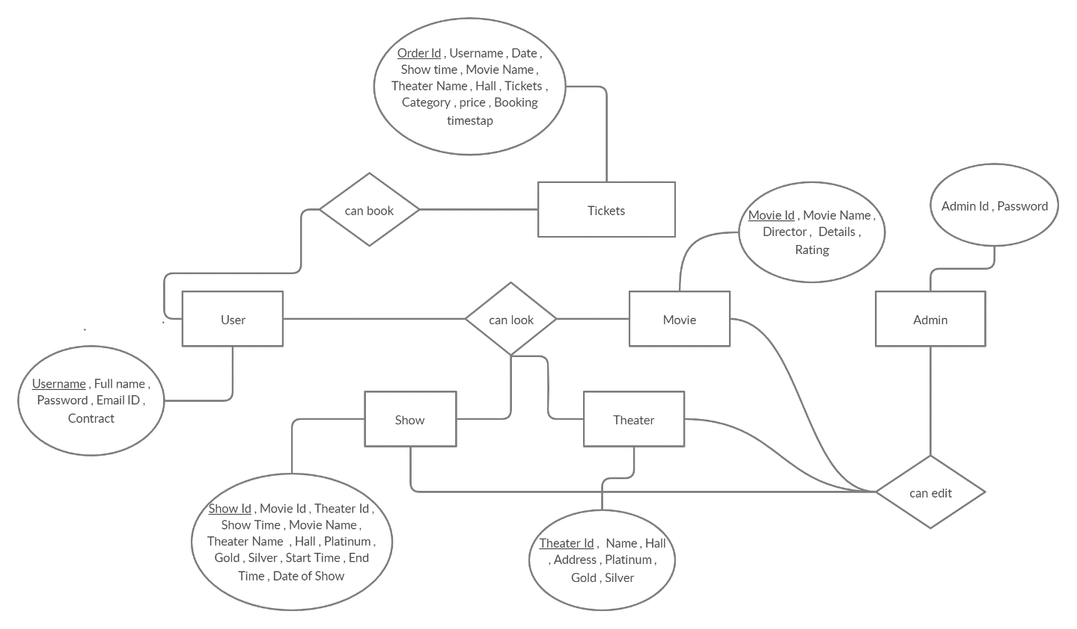

Figure-1 : ERD diagram of Cineplex Management System.

CONCLUSION

In this project we developed a Cineplex management system. We think we full filled our project requirement. From this project we learned how a management system works. So we think we can use this knowledge in other sectors.