Answers to questions in

Lab 1: Filtering operations

Name: Ahou Lucas Program: Applied and Computational Mathematics

Instructions: Complete the lab according to the instructions in the notes and respond to the questions stated below. Keep the answers short and focus on what is essential. Illustrate with figures only when explicitly requested.

Good luck!

___________________________________________________________________________

Question 1: Repeat this exercise with the coordinates p and q set to (5, 9), (9, 5), (17, 9),
(17, 121), (5, 1) and (125, 1) respectively. What do you observe?

Answers:

Taking the inverse Fourier transform of a single point image gives back a basis function with

$w=\left(p,q\right)⇒F\left(x\right)=\frac{1}{N}e^{i2π{\left(px_{1}+qx_{2}\right)}/N}$

Thus, for each pair $\left(p,q\right)$ we get a $cos$ and $sin$ wave for the real and imaginary part of the image respectively. The direction of those waves are given by the vector $\left(p,q\right)$ and frequency of the waves are given by:

$$f=\frac{\sqrt{p_{c}^{2}+q_{c}^{2}}}{N}$$

where $\left(p_{c},q_{c}\right)$ are the centered values (i.e. taken $modN$)
__________________ _________________________________________________________

Question 2: Explain how a position (p, q) in the Fourier domain will be projected as a sine wave in the spatial domain. Illustrate with a Matlab figure.

Answers:

For $\hat{F}$ for which its values are 0 everywhere except 1 at $\left(p,q\right)$, the definition of the discrete inverse fourier transform gives:

$$F\left(x\right)=\frac{1}{N}e^{i2π{\left(px_{1}+qx_{2}\right)}/N}$$

Expanding using the euler’s formula for the complex exponential and taking the real/imaginary parts respectively gives us a cosine and sine waves.
The frequency of the waves were discussed in the first question. To further illustrate that, let’s compute the wavelength which is given by:
$λ=\frac{1}{f}=\frac{N}{\sqrt{p_{c}^{2}+q_{c}^{2}}}$

On the figure below, I plotted the real part of the waves for $\left(p,q\right)=\left(5,9\right)$ and plotted the direction of the waves and the wavelength:

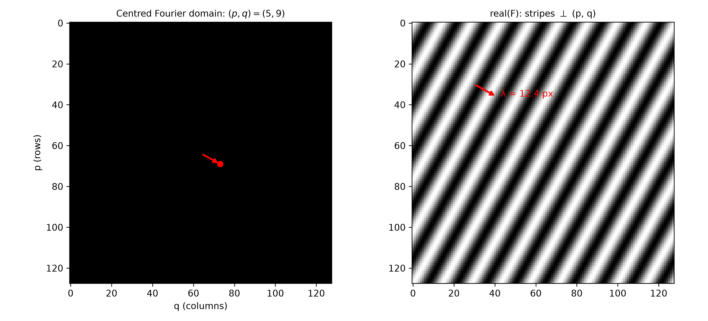
___________________________________________________________________________

Question 3: How large is the amplitude? Write down the expression derived from Equation (4) in the notes. Complement the code (variable amplitude) accordingly.

Answers:

Again, starting from the derived expression above we can easily compute the magnitude. As the amplitude of a complex exponential is always 1, we get that:
$\left|F\left(x\right)\right|=\frac{1}{N},∀x$

So the amplitude is constant with respect to x which is why the amplitude plot is flat.
However, numpy’s ifft2 function uses a different normalization convention. It uses a factor of $\frac{1}{N^{2}}$ when taking the inverse discrete Fourier transform. Thus, by a similar reasoning, we should compute the amplitude accordingly in our code:

$$\left|F\left(x\right)\right|=\frac{1}{N^{2}},∀x$$

___________________________________________________________________________

Question 4: How does the direction and length of the sine wave depend on p and q? Write down the explicit expression that can be found in the lecture notes. Complement the code (variable wavelength) accordingly.

Answers:

___________________________________________________________________________

Question 5: What happens when we pass the point in the center and either p or q exceeds half the image size? Explain and illustrate graphically with Matlab!

Answers:

___________________________________________________________________________

Question 6: What is the purpose of the instructions following the question What is done by these instructions? in the code?

Answers:

___________________________________________________________________________

Question 7: Why are these Fourier spectra concentrated to the borders of the images? Can you give a mathematical interpretation? Hint: think of the frequencies in the source image and consider the resulting image as a Fourier transform applied to a 2D function. It might be easier to analyze each dimension separately!

Answers:

___________________________________________________________________________

Question 8: Why is the logarithm function applied?

Answers:

___________________________________________________________________________

Question 9: What conclusions can be drawn regarding linearity? From your observations can you derive a mathematical expression in the general case?

Answers:

___________________________________________________________________________

Question 10: Are there any other ways to compute the last image? Remember what multiplication in Fourier domain equals to in the spatial domain! Perform these alternative computations in practice.

Answers:

___________________________________________________________________________

Question 11: What conclusions can be drawn from comparing the results with those in the previous exercise? See how the source images have changed and analyze the effects of scaling.

Answers:

___________________________________________________________________________

Question 12: What can be said about possible similarities and differences? Hint: think of the frequencies and how they are affected by the rotation.

Answers:

___________________________________________________________________________

Question 13: What information is contained in the phase and in the magnitude of the Fourier transform?

Answers:

___________________________________________________________________________

Question 14: Show the impulse response and variance for the above-mentioned t-values. What are the variances of your discretized Gaussian kernel for t = 0.1, 0.3, 1.0, 10.0 and
100.0?

Answers:

___________________________________________________________________________

Question 15: Are the results different from or similar to the estimated variance? How does the result correspond to the ideal continuous case? Lead: think of the relation between spatial and Fourier domains for different values of t.

Answers:

___________________________________________________________________________

Question 16: Convolve a couple of images with Gaussian functions of different variances (like t = 1.0, 4.0, 16.0, 64.0 and 256.0) and present your results. What effects can you observe?

Answers:

___________________________________________________________________________

Question 17: What are the positive and negative effects for each type of filter? Describe what you observe and name the effects that you recognize. How do the results depend on the filter parameters? Illustrate with Matlab figure(s).

Answers:

___________________________________________________________________________

Question 18: What conclusions can you draw from comparing the results of the respective methods?

Answers:

___________________________________________________________________________

Question 19: What effects do you observe when subsampling the original image and the smoothed variants? Illustrate both filters with the best results found for iteration i = 4.

Answers:

___________________________________________________________________________

Question 20: What conclusions can you draw regarding the effects of smoothing when combined with subsampling? Hint: think in terms of frequencies and side effects.

Answers:

___________________________________________________________________________

