Overview of the analysis: The nonprofit foundation Alphabet Soup wants a tool that can help it select the applicants for funding with the best chance of success in their ventures. With your knowledge of machine learning and neural networks, you’ll use the features in the provided dataset to create a binary classifier that can predict whether applicants will be successful if funded by Alphabet Soup.

Results:

To begin the data processing any irrelevant information was removed. After dropping EIN and

NAME the remaining columns were considered features for the model. NAME was added

back into the second test for binning purposes. The data was then split for training and testing

sets. The target variable for the model was labeled “IS_SUCCESSFUL” and has the value of 1

for yes and 0 for no. APPLICATION data was analyzed and “CLASSIFICATION value was used

for binning. We used several data points as a cutoff to bin “outlier” variables together with the new

value of “Other” for each unique value. Categorical variables were encoded by pd.getdummies()

after checking to see if the binning was successful.

Compiling, Training, and Evaluating the Model

Preprocessing:

There were three layers total for each model after applying Neural Networks. The number of input features dictated the number of hidden nods. 6,301 parameters were created by a three-layer training model. The first attempt had an accuracy of 72%.

Optimization Results:

The NAME column was added back into the dataset and any outliers of <5 were removed from the dataset. There were three layers total for each model after applying Neural Networks. The number of input features dictated the number of hidden nods. 38,301 parameters were created by a three-layer training model. The optimization model achieved an accuracy of 79%.

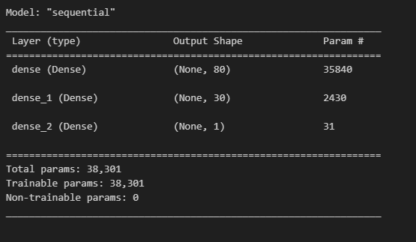

Summary: The results of the deep learning model show that models should have multiple layers. Since, the computer learns how to predict and classify information based on the filtering inputs through each layer.