Temasek Polytechnic

School of Informatics and IT

**Diploma in Information Technology (IT)**

Project Plan

**Project Particulars**

|  |  |
| --- | --- |
| **Tutor** | Mel Goh |
| **Class** | P03 |
| **Project Title** | Delonix Regia Hotel Management System |

**Project Team’s Particulars**

|  |  |
| --- | --- |
| **Matric Number** | **Student Name** |
| 1403530G | **Shannon Sim Jun Hao** |
| 14011811C | **Vivian Neo Wen Ting** |
| 1405591G | **Joycelyn Nge** |
|  |  |

Table of Contents

1. Introduction
   1. Objectives and scope of the project
   2. Assumptions and constraints
   3. Definitions and acronyms
2. Roles and responsibilities
3. Estimates and project schedule
   1. Work breakdown structure
   2. Project schedule
   3. Budget summary
4. Risk management plan

Project Plan

1 Introduction

1.1 Objectives and scope of the project

The objectives of the project is to develop an efficient and effective hotel management system to solve the problems that the management system is currently facing.

The list of features that will be developed are:

1. Security feature
2. Online booking system
3. Data entry system
4. Automated database system

The security features that we are going to implement is that users of the software system willl be given a account with a unique password and encryption will be added to strengthen the security.

The hotel will have a new online booking system which will be running on I-cloud so that the system will be real-time which means that there will not be an occurence of double booking.

The hotel will have a new data entry system where by we will integrate various department databases together so that it will systems will communicate together.

The hotel will have a new database entry system which will update itselfs and other databases linked to it whenever a new or existing data is added or edited.

1.2 Assumptions and constraints

During the planning process, our team assumed that the hotel management system that we are developing will be catered to both internal and external users like the housekeeping, receptionist and customers.

We also assumed that we do not need to show a working and usable prototype to Mr. & Mrs. Wang before the Testing phase.

The constraints that our team faced are:

1. Timeframes

The project time span is within 6 weeks hence, the number of features that our team can develop are limited due to time constraint.

1. Budget

The company is managed by a middle-aged couple therefore the costs should not be too expensive.

1. Resources

The amount of resources that is needed to create or run the system is very limited due to budget constraint. As a result, the number of features created might be limited as well.

1.3 Definitions and acronyms

Acronyms

SDLC - System Development Life Cycle

TOR - Terms of reference

PP - Project Plan

SRS - System Requirement Specification

SDS - System Design Specification

2 Roles and responsibilities

|  |  |
| --- | --- |
| **Objectives/Deliverables** | **Members** |
| Project Management | Joycelyn and Vivian |
| Project Planning | Joycelyn, Vivian and Shannon |
| Document Specifications | Vivian and Shannon |
| Develop Front-end Features/Functionalities | Vivian and Shannon |
| Develop Back-end Features/Functionalities | Joycelyn and Shannon |
| Creation of Database (Design and Schema) | Joycelyn and Vivian |
| Establish Database Connection (Linking of Database) | Joycelyn and Shannon |
| System testing Plans | Joycelyn and Vivian |
| UAT Plans | Vivian and Shannon |
| Error testing logs and Modification | Joycelyn and Shannon |
| Terms of Reference: Introduction & Resources | Vivian |
| Terms of Reference: Objectives & Constraints | Vivian |
| Terms of Reference: Scope & Product Positioning | Shannon |
| Terms of Reference: Distribution of Workload & Approach and Methodology | Shannon |
| Project Plan: Budget Summary | Joycelyn |
| Project Plan: Assumptions | Shannon |
| Project Plan: Definitions and Acronyms | Vivian |
| Project Plan: Project Schedule | Joycelyn |
| Project Plan: Work Breakdown Structure | Joycelyn |
| Project Plan: Risk Management Plan | Vivian |

3 Estimates and project schedule

3.1 Work breakdown structure

|  |  |  |  |  |  |
| --- | --- | --- | --- | --- | --- |
| Phase | Task | Days | Start Date | End Date | Responsibility |
| Report | SDLC Report | 3 | 25/4 | 28/4 | Shannon Sim, Vivian Neo, Joycelyn Nge |
| TOR Report | 4 | 2/5 | 5/5 | Shannon Sim, Vivian Neo, Joycelyn Nge |
| PP Report | 4 | 3/5 | 6/5 | Shannon Sim, Vivian Neo, Joycelyn Nge |
| Revise of Report | 1 | 7/5 | 7/5 | Joycelyn Nge |
| Specification | Meeting Minutes | 1 | 8/5 | 8/5 | Shannon Sim, Vivian Neo, Joycelyn Nge |
|  | SRS | 3 | 9/5 | 11/5 | Shannon Sim, Vivian Neo, Joycelyn Nge |
|  | SDS | 5 | 13/5 | 18/5 | Shannon Sim, Vivian Neo, Joycelyn Nge |
|  | Revise of Specification | 1 | 19/5 | 19/5 | Joycelyn Nge |
| Implementation | Data Management  Testing  Help Desk  Testing  Booking  Testing  User Management  Testing | 3  1  3  1  3  1  3  1 | 20/5  23/5  20/5  23/5  20/5  23/5  20/5  23/5 | 22/5  24/5  22/5  24/5  22/5  24/5  22/5  24/5 | Joycelyn Nge  Everyone  Shannon Sim  Everyone  Vivian Neo  Everyone  Shannon Sim  Everyone |

3.2 Project Schedule

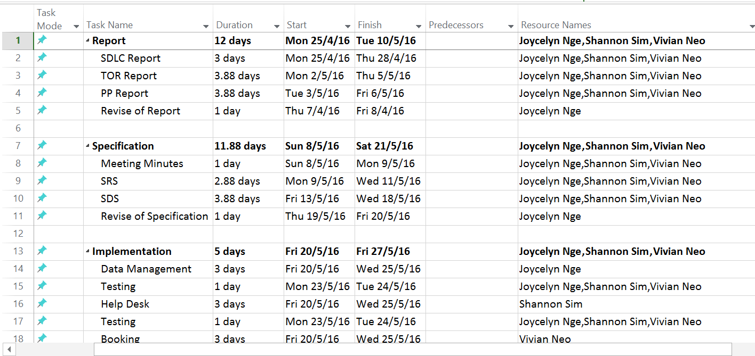



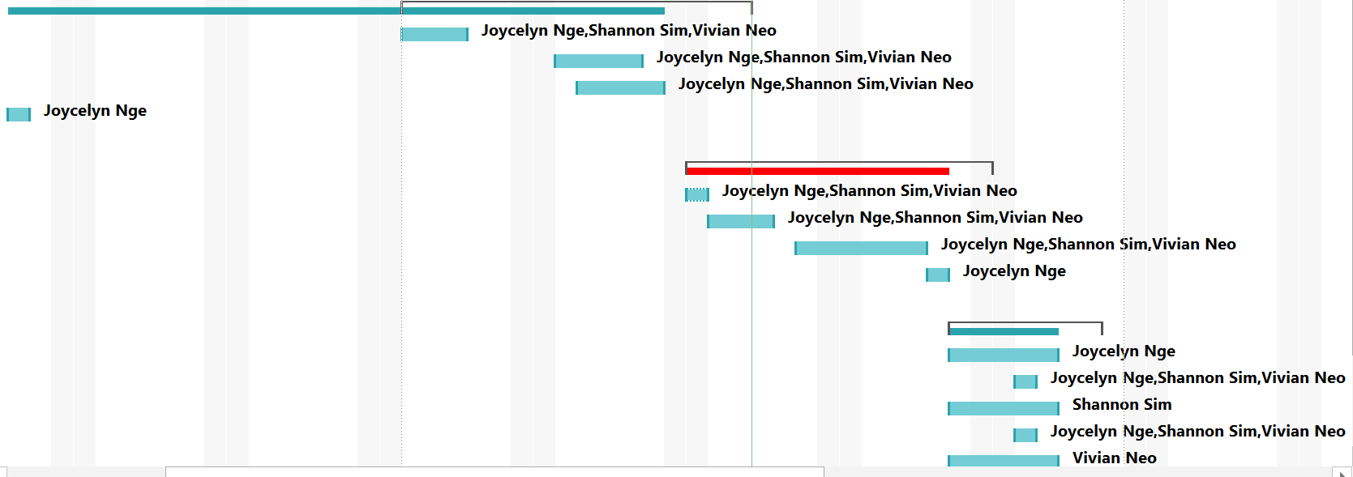

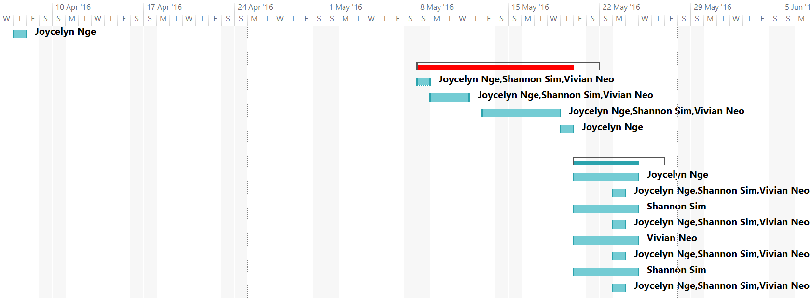

3.3 Budget Summary

The expenses budget consist of four main parts, each of the parts are being used for different purposes. The parts are:

* Manpower expenses

This budget will be used to pay the employees who are helping out for the project.

* Software expenses

This budget will be used to buy softwares required in creating this project

* Hardware expenses

This budget will be used to purchase hardware that will be needed for this project

|  |  |
| --- | --- |
| **Manpower** | **Cost** |
| Software Engineer | $1900 ~ $2700 |
| Webpage Designer | $2300 ~ $3400 |
| Marketing Executive | $2300 ~ $3000 |
| **Total:** | $6500 ~ $9100 |

|  |  |  |  |
| --- | --- | --- | --- |
| **Software** | **Brand** | **Quantity** | **Cost** |
| Microsoft SQL Server | SQL Server Standard Edition | 1 | $4500 |
| Firewall and Anti-Virus | Norman Best Security Suite PRO | 10 | $99 |
| **Total:** | | | $4599 |

|  |  |  |  |
| --- | --- | --- | --- |
| **Hardware** | **Brand** | **Quantity** | **Cost** |
| Laptop | ASUS X551MAV Notebook | 10 | $3500 |
| All-In-One Printer | Fuji Xerox Docuprint M265Z | 1 | $349 |
| Database Server | HuaWei E9000 Blade Server Chassis | 1 | $2700 |
| Internet Service Provider | SingNet eVolve Fibre Broadband | 1 | $60 |
| **Total:** | | | $ |

4 Risk Management Plan

## 4.1 Risk Assessment

|  |  |  |  |
| --- | --- | --- | --- |
| **Type of Risk** | **Severity of Impact** | **Likelihood of Occurrence** | **Risk Exposure** |
| Time Constraint | Medium (2) | High (3) | 6 |
| Lack of information | Medium (2) | High (3) | 6 |

There are many possible risks that can be identified for this project. Some of them are quite visible and could be identified easily. As stated in the project plan that we were only given 6 weeks to complete the project, one risk factor that should be brought to attention is time constraint. Time constraint gives us a certain risk of being unable to submit a working system on time.

Another issue that may not necessarily be a risk would be the lack of information. Currently, we only know that our main goal is to develop an online hotel management system for Mr. and Mrs. Wang. However, with not much information provided about the hotel and its customers, we might display wrong or unwanted information in our system. This may result in the loss of customers and a bad system production. Though the possibility of this risk is low, it is always better to be on the safe side.

## 4.2 Risk Mitigation

To solve the time constraint issues, we can plan out a schedule using Microsoft Project. The schedule would indicate when we are supposed to do a particular work and who is assigned to do it as well as the time available for that particular work. This schedule would be extremely reliable to help the team deal with the time constraint issue. Although the schedule might not fully help resolve the issue if the team does not follow the schedule. To prevent this, the team must be discipline enough to follow the schedule and not neglect it so that the project can be completed on time.

In addition, we would also try to request for additional relevant information from Mr. and Mrs. Wang in order to further enhance our system.