NLP:

What is Natural Language Processing (NLP)? 🗣️
NLP is a field of Artificial Intelligence and Computer Science that deals with giving computers the ability to understand human language (speech or text) as it is spoken and written.
- Goal: To process and understand natural human language in order to perform useful tasks, such as making appointments, social media monitoring, and generating responses. [03:10]
- The Problem: Only about 21% of available data is structured. The majority of data generated today (tweets, messages, emails) is highly unstructured text, which requires NLP techniques to extract meaningful, actionable insights. [02:06]

II. Applications and Components of NLP

Applications
NLP is essential across many industries, powering tools like: [03:29]
- Voice Assistants: Siri, Google Assistant, Cortana.
- Machine Translation: Google Translate (translating text in real-time).
- Chatbots: Customer service chat services.
- Sentiment Analysis: Determining the emotional tone (positive, negative, neutral) of a text.
- Spell Checking and Keyword Search.
- Ad Matching: Recommending ads based on search and browsing history.

Two Main Components
NLP is broadly divided into two processes: [05:04]
- Natural Language Understanding (NLU):
  - Mapping the input natural language into a useful representation.
  - This is generally considered the harder part of NLP due to the inherent ambiguity of human language. [05:55]
- Natural Language Generation (NLG):
  - The process of producing meaningful phrases and sentences in natural language from an internal representation.
  - Involves Text Planning (retrieving relevant content), Sentence Planning (choosing words and setting tone), and Text Realization (mapping to sentence structure).

III. The Difficulties and Ambiguities in NLU 🧠
A machine faces three main types of ambiguity when trying to understand human language: [06:14]
Ambiguity Type | Definition | Example
1. Lexical (Semantic) | A single word has two or more possible meanings. | "She is looking for a match." (A partner or a device to light fire?) [06:44]
2. Syntactical (Structural) | A single sentence structure allows for two or more possible interpretations. | "The chicken is ready to eat." (Is the chicken eating, or are we ready to eat the chicken?) [07:24]
3. Referential | Ambiguity arises when using pronouns, making it unclear which entity the pronoun refers to. | "The boy told his father the theft. He was very upset." (Was the boy, the father, or the thief upset?) [08:10]
Export to Sheets

IV. The NLP Processing Pipeline (Steps and NLTK)
The Natural Language Toolkit (NLTK) is the leading Python library for working with human language data, providing tools and resources for the following steps: [08:48]

1. Tokenization
The process of breaking up a text string into tokens (small, meaningful units). [09:57]
- Word Tokenization: Separating a sentence into individual words and punctuation.
- Sentence Tokenization: Dividing a text document into sentences.
- N-grams: Tokens of consecutive written words:
  - Bigrams: Two consecutive words. [17:10]
  - Trigrams: Three consecutive words.

2. Normalization (Stemming & Lemmatization)
The process of reducing different forms of a word to a common base form.
Method | Goal | Mechanism | Output
Stemming | Normalizes words by cutting off the end/beginning of the word. | Uses basic algorithms to chop off suffixes (e.g., -ing, -s). | The output might not be a proper word (e.g., 'giving' → 'giv'). This approach can be aggressive. [19:06]
Lemmatization | Normalizes words by taking into account the morphological analysis and context. | Requires a detailed dictionary (like WordNet) to map the word back to its lemma. | The output is always a proper word (e.g., 'gone' → 'go'). This is generally more accurate. [22:07]
Export to Sheets

3. Stop Words Removal
- Stop Words are common words (like 'I', 'the', 'is', 'for') that are useful in sentence formation but do not provide help in the actual processing or meaning extraction of the text. [24:17]
- These words are typically removed to reduce noise and computation time.

4. Part-of-Speech (POS) Tagging
- The process of tagging each word in a sentence with its grammatical type: noun, verb, adjective, adverb, proper noun, etc. [26:12]
- POS tagging is crucial because the same word can have different parts of speech based on the context (e.g., "Google" as a noun vs. "Google" as a verb).

5. Named Entity Recognition (NER)
The process of detecting and classifying named entities in text into predefined categories. [28:59]
- Categories include: Organization (Google), Person (Sundar Pichai), Location (Minnesota), Quantities, and Monetary Values. [30:14]
- NER adds a deeper layer of semantic understanding on top of POS tagging.

6. Syntax and Chunking
- Syntax: The set of rules governing the structure of a sentence. This is often represented using a Syntax Tree, which shows the hierarchical structure (e.g., Sentence Noun Phrase Article + Noun). [32:09]
- Chunking (Shallow Parsing): The process of grouping related tokens into bigger pieces, often called chunks or noun phrases (NP). [33:48]
  - Example: Grouping (the + pink + panther) into a single Noun Phrase helps the machine understand that these words represent a single entity. [34:30]

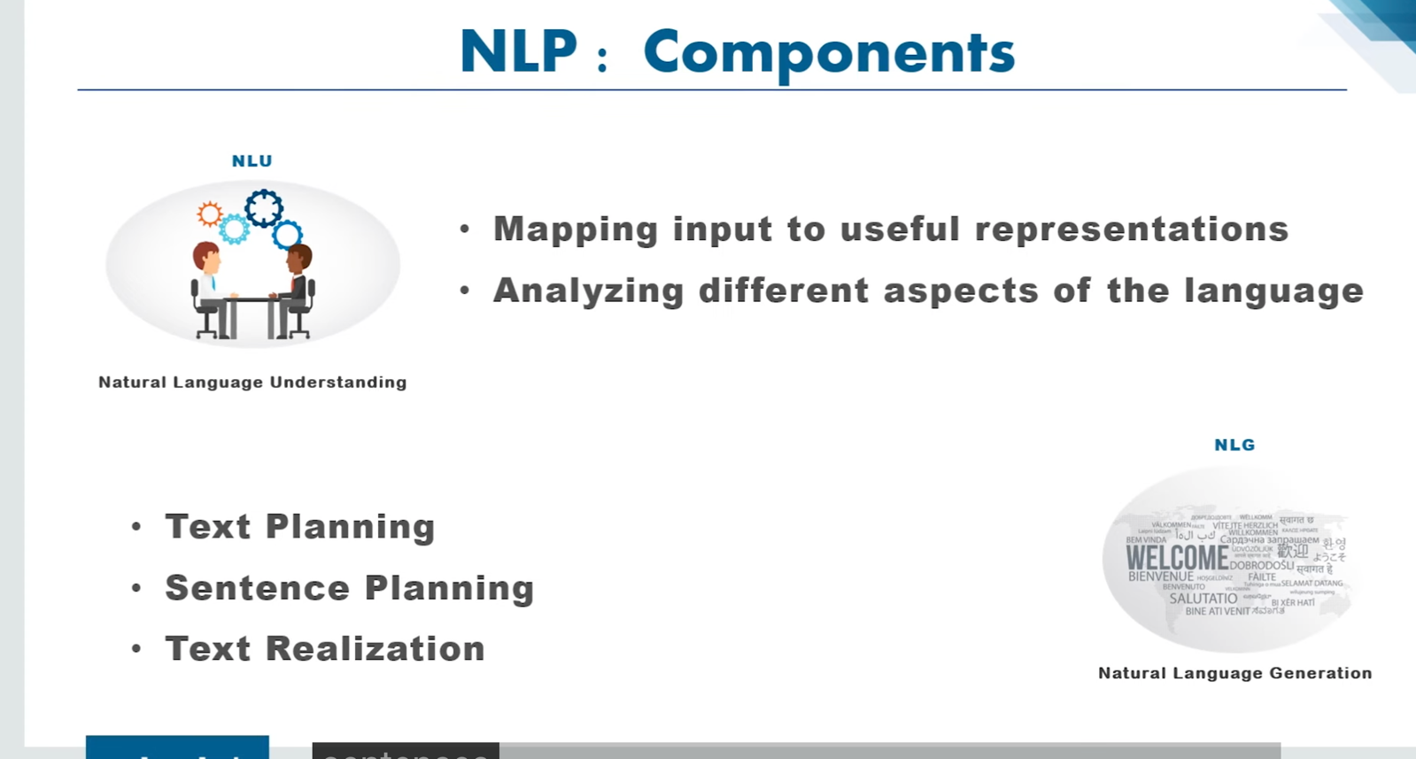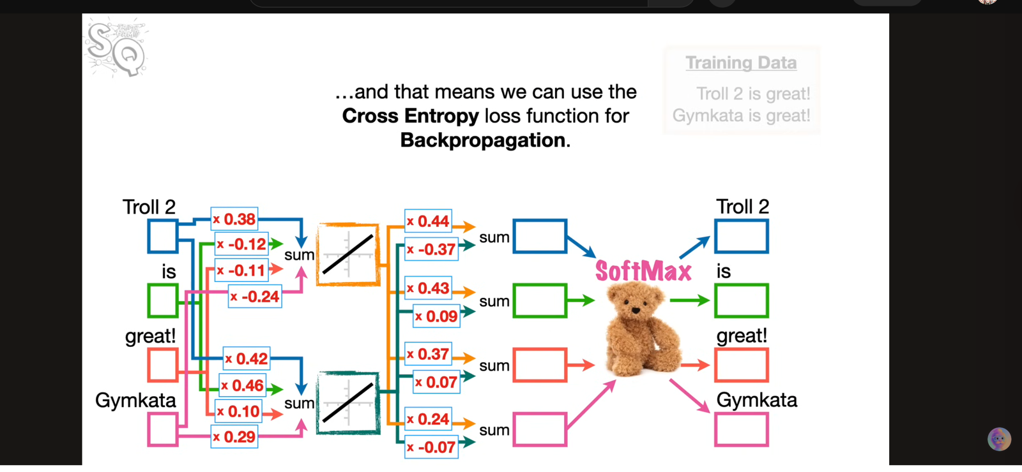

. Bag of Words (BoW) Overview 💼
The core idea of BoW is to represent a text document (such as a sentence or paragraph) as a vector that shows the frequency or presence of words within the document, without considering the order or grammar of the words.
- Goal: To convert unstructured text data into a numerical format (vectors) that can be understood and processed by machine learning algorithms (e.g., for Sentiment Analysis). [00:36]
- Methodology: A vocabulary of all unique words in the entire dataset is created. Each document is then represented as a vector where each element corresponds to a word in the vocabulary, and its value is the count of that word in the document.

II. Text Pre-Processing Steps ⚙️
Before applying the BoW conversion, the text data must be cleaned and normalized:
- Lowercasing: All words are converted to lowercase to ensure that variations like "He" and "he" are treated as the same word. [01:09]
- Stemming/Lemmatization: Used to reduce words to their root form (e.g., "running" to "run"). This was skipped in the simple example but is standard practice. [01:55]
- Stop Word Removal: Words that are common but do not contribute much to the meaning or sentiment (e.g., "is," "she," "a") are removed. This helps the model focus on the major data like adjectives and nouns (e.g., "good," "boy," "girl"). [02:11]

III. Vectorization: Converting Text to Numbers

A. Creating the Vocabulary (Histogram)
- After pre-processing (e.g., removing stop words), all remaining unique words from the entire dataset (e.g., all sentences) are collected.
- The frequency of each unique word across the entire dataset is calculated, forming the overall vocabulary or "histogram." [03:33]
- This collection of unique words defines the features () of the final vector representation. [04:49]

B. Bag of Words Representation
Two main types of BoW are discussed:
Type | Vector Value | Description
Normal Bag of Words | Frequency Count | The value in the vector is the count of how many times that vocabulary word appears in the current document (sentence). (e.g., If "boy" appears 2 times, the value is 2). [06:18]
Binary Bag of Words | Binary (1 or 0) | The value is simply 1 if the word is present in the document, and 0 if it is not present, regardless of how many times it appears. [05:10]
Export to Sheets
The resulting vectors () become the independent features used to train the machine learning model, with the model's desired output (e.g., positive/negative sentiment) serving as the dependent feature. [06:41]

IV. Disadvantage of Bag of Words ⚠️
The major limitation of the Bag of Words model lies in how it assigns weight to important words: [07:22]
- Equal Weight/Lack of Semantic Importance: BoW gives a similar representation (either the same count or just a '1' in binary BoW) to all words.
- The Problem: The model cannot differentiate which words are more important for determining the sentiment or topic.
  - For example, in a sentiment analysis task, the word "good" is far more critical than a noun like "boy." However, in a simple BoW vector, they may both be represented by a '1', giving them equal weight. [07:42]
This limitation leads to the use of more advanced techniques:
- TF-IDF (Term Frequency-Inverse Document Frequency): This technique, discussed as the next step, attempts to solve the weighting problem by giving higher values to words that are frequent in a document but rare across the entire document collection. [08:33]
- Word2Vec: Mentioned as the "best way" to solve NLP problems with large datasets, as it uses deep learning to create dense, semantically meaningful word embeddings. [09:05]

Natural Language Processing|Bag Of Words Intuition
Krish Naik · 225K views

I. The Need for Word Embeddings 🔢
- Problem with Simple Number Assignment: Simple methods like assigning a random number to each word (or using one-hot encoding, as implied by the initial random number example [02:06]) fail to capture the relationship between words.
  - For example, if "great" is given 4.2 and "awesome" is given -32.1, the machine learning model has no clue they are synonyms and must learn to process them separately. [02:47]
- Goal of Word Embedding: To assign similar words that are used in similar contexts with similar numerical vectors. [03:12]
  - This makes training easier because learning how to process one word helps the model process its synonyms.
  - An embedding assigns more than one number to a word (a vector, typically 100 or more dimensions in practice) to account for different contexts (e.g., positive vs. sarcastic negative use of "great"). [03:25]

II. How a Neural Network Creates Embeddings 🧠
A simple neural network is trained to perform a prediction task, and the weights in its hidden layer are extracted as the word embeddings.

1. Neural Network Architecture
The network uses a "shallow" two-layer design: [04:17]
- Input Layer: One input node for every unique word in the vocabulary (one-hot encoded input). [05:02]
- Hidden Layer: Contains activation functions, where the number of nodes determines the dimension of the embedding vector. (e.g., 2 nodes for a 2D embedding). [05:28]
- Output Layer: One output node for every unique word in the vocabulary, followed by a Softmax function for classification and a Cross-Entropy loss function for backpropagation. [07:27]

2. The Role of Weights
- The connections from the Input Layer to the Hidden Layer are the key. The weights on these connections are initialized randomly.
- The process of backpropagation adjusts these weights to minimize the loss.
- The final, optimized weights on the Input Hidden connections become the Word Embeddings. [09:32]
- Result: Words that appear in similar contexts (e.g., "Troll 2" and "Jim Kata" when predicting the word "is") will have their weights adjusted to be numerically closer to each other in the embedding space. [09:16]

III. Word2Vec Strategies 🌐
Word2Vec is a popular framework for creating word embeddings, utilizing two main strategies to define the context of a word: [11:43]
- Continuous Bag of Words (CBOW):
  - Task: Use the surrounding words (context) to predict the middle word.
  - Example: Use the words "Troll 2" and "great" to predict the word "is" that occurs between them. [11:57]
- Skip-Gram:
  - Task: Use the middle word to predict the surrounding words (context).
  - Example: Use the word "is" to predict the surrounding words, "Troll 2" and "great." [12:18]

Negative Sampling (Efficiency)
In practice, training on massive corpuses (like all of Wikipedia, which can lead to over 600 million weights to optimize) is computationally slow. Negative Sampling is a technique used by Word2Vec to speed up training: [12:50]
- Instead of updating the weights for all possible output words (millions of them) at every step, the model only optimizes weights for:
  - The correct context word(s) (the positive sample).
  - A small, randomly selected subset of words that are incorrect (the negative samples, typically 2 to 20 words). [14:39]
- This drastically reduces the number of weights updated in each optimization step, making the process much more efficient. [15:12]

