I. The Problem RNNs Solve: Sequential Data 🔄
Standard Neural Networks (NNs) are designed for fixed-size inputs (e.g., a image). RNNs are necessary when the input data is a sequence where the length can vary, and the order matters.
- Variable-Length Inputs: Examples include stock prices, where one company might have 5 days of data and another might have 50. An RNN can process both, while a standard NN cannot. [02:37]
- Sequential Dependence: In sequential data (like time series), the prediction for "tomorrow" depends on the values from "yesterday" and "today." RNNs use a mechanism to carry information from one step to the next. [05:01]

II. The Core RNN Architecture
The defining feature of a Recurrent Neural Network is the feedback loop.
- The Feedback Loop: A connection from the output of the hidden layer back to its own input (the summation step). This loop allows the network to incorporate the information it processed in the previous step when processing the current input. [04:28]
- Unrolling the RNN: To understand how the network processes sequences, the feedback loop is conceptually "unrolled."
  - Unrolling creates a separate copy of the network for each time step (input value). [07:51]
  - The feedback loop is replaced by a connection that passes the activation from hidden layer at time to the hidden layer at time . [08:04]
- Parameter Sharing (Efficiency): Regardless of how many times the RNN is unrolled (i.e., how long the sequence is), the weights () and biases () are the same across every time step. This is crucial because it means: [10:33]
  - The total number of parameters to train does not increase with the length of the sequence.
  - The model learns the same feature extraction logic for all parts of the sequence.

III. The Vanishing/Exploding Gradient Problem 💥
While parameter sharing is efficient, the unrolled structure (a very long sequence of identical layers) is highly susceptible to unstable gradients during Backpropagation Through Time (BPTT)—the term for training an RNN.
This instability stems from the Chain Rule, where the recurring weight ( in the diagram) is repeatedly multiplied across many time steps.
Problem | Mechanism | Implication for Training
Exploding Gradient | Occurs when the recurring weight () is greater than 1. When is raised to a high power (e.g., ), the gradient becomes huge. [12:30] | Leads to large, unstable steps in Gradient Descent, causing the optimization process to bounce around wildly and fail to converge on the optimal weights. [14:16]
Vanishing Gradient | Occurs when the recurring weight () is less than 1. When is raised to a high power (e.g., ), the gradient approaches zero. [14:35] | The small gradient causes baby steps in Gradient Descent. Information from early time steps is effectively lost, and the network stops learning long-term dependencies. [15:20]
Export to Sheets

IV. Interview Perspective & Next Steps 💡
Interview Question | Key Concepts to Emphasize
"When do you use an RNN?" | When dealing with sequential data or any problem where the output depends on a history of inputs. Examples: Time Series Forecasting (stock prices, weather), Natural Language Processing (NLP) (predicting the next word in a sentence), and Speech Recognition.
"What does 'unrolling' an RNN mean?" | It's a conceptual tool that unwinds the feedback loop into a deep feedforward network, with a copy of the network for each time step. It illustrates how information flows and is essential for understanding the Backpropagation Through Time (BPTT) training algorithm.
"How do modern architectures address the RNN's limitations?" | The vanishing/exploding gradient problems are the main reason vanilla RNNs are rarely used for long sequences. The primary solution is the Long Short-Term Memory (LSTM) network, which uses "gates" to explicitly control what information is remembered or forgotten across time steps. Transformers have since largely superseded RNNs and LSTMs in many NLP tasks.
http://googleusercontent.com/youtube_content/13

Back propagation:

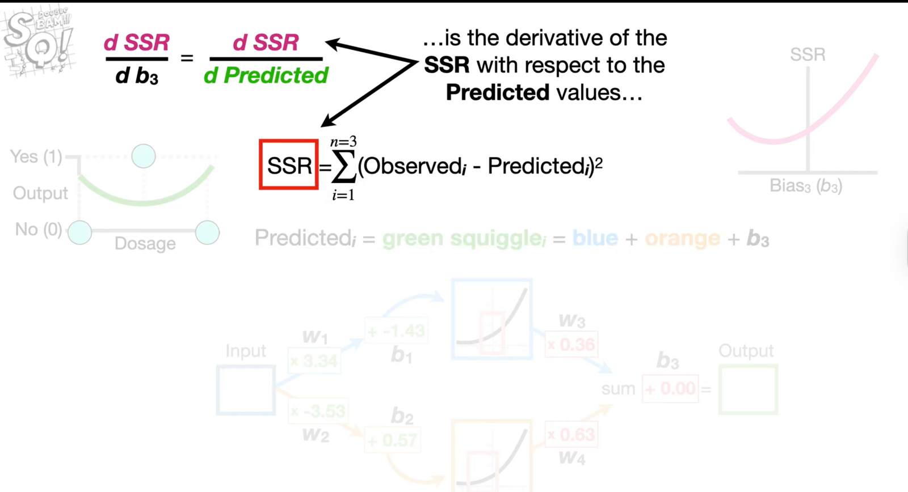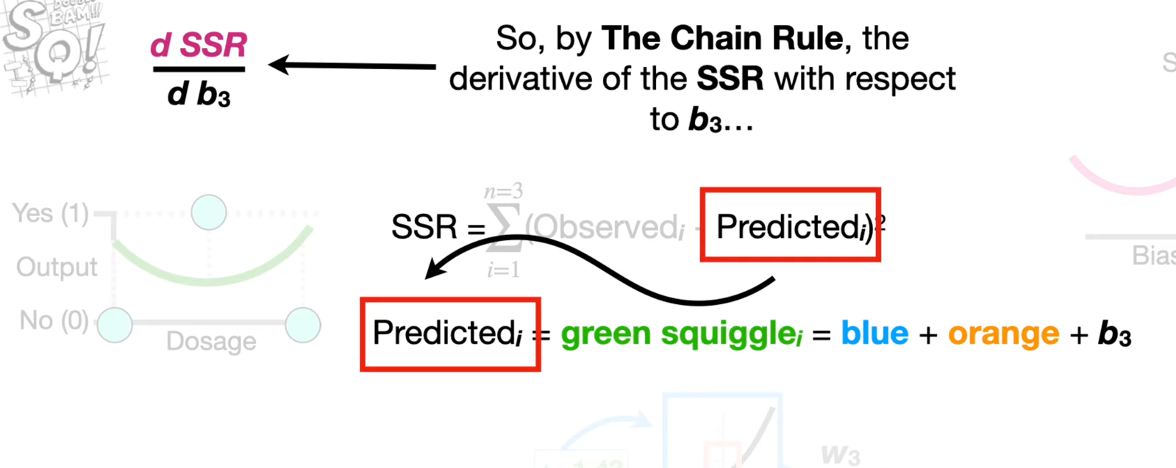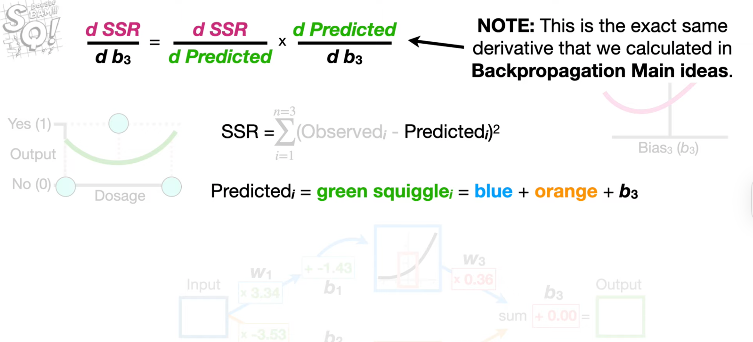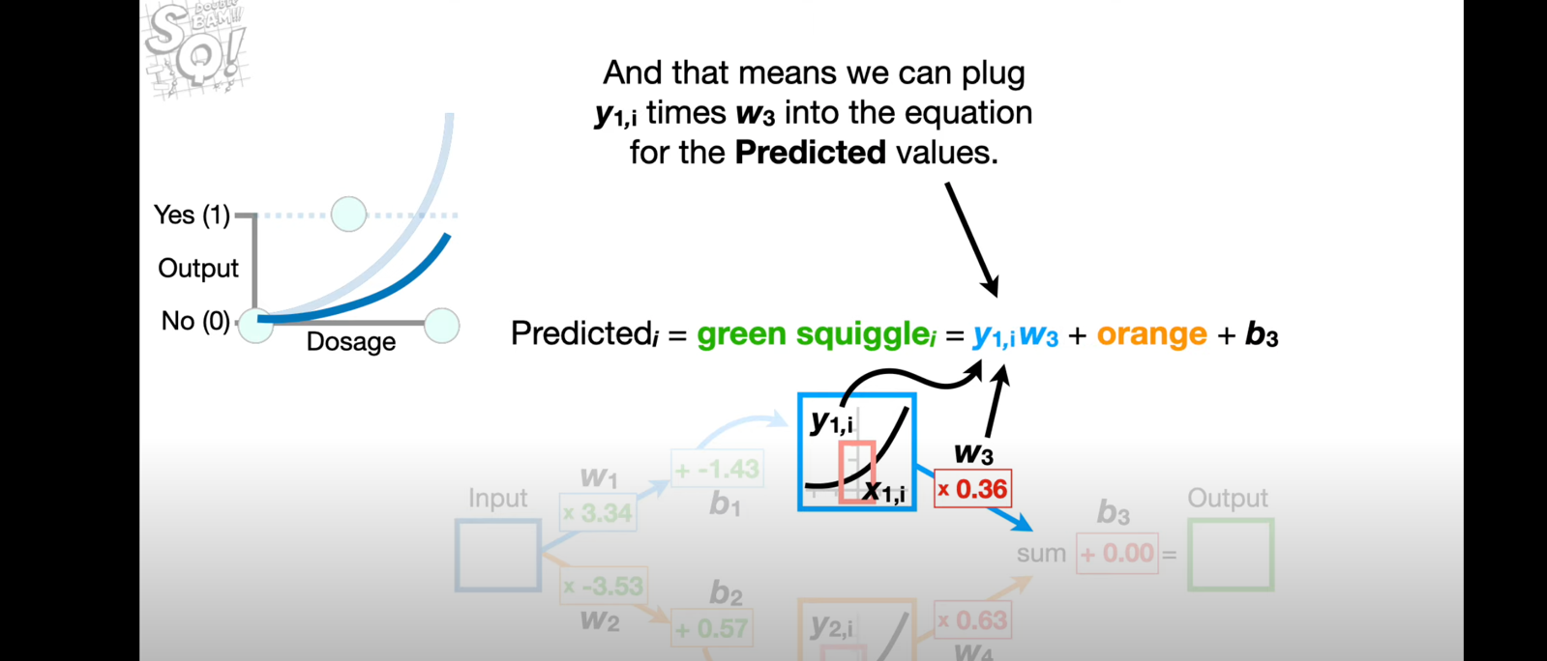

RNN :

