Yiqiao Jin

TA: Diyu Zhou

CS35L

03 March 2019

5G - the Future and the Challenges

5G, which stands for “5th Generation,” is the latest version of cellular mobile communication. 5G targets high data rate, reduced [latency](https://en.wikipedia.org/wiki/Latency_(engineering)" \o "Latency (engineering)), and massive device connectivity.

The major technical breakthrough of 5G is its high data rate compared with currently used 4G. It supports data transmission of up to 10 Gbps, surpassing the current cable internet, and is 100 times faster than 4G LTE [1]. Theoretically, the maximum speed that can reached by 5G is 20 Gbps. In this sense, 5G networks will not only serve cellphones, but also provide network connections to homes and offices, competing with wired internet providers like cable.

5G achieves higher data rates by using higher frequency radio waves in or near the millimeter wave band around 28 and 39 GHz. Previous cellular networks used frequencies in the microwave band between 700 MHz and 3 GHz. A second lower frequency range in the microwave band, below 6 GHz, will be used by some 5G providers, but this will not have the high speeds of the new frequencies. Because of the more plentiful bandwidth at millimeter wave frequencies[2]. 5G networks will use wider frequency channels to communicate with the wireless device, up to 400 MHz compared with 20 MHz in 4G LTE.

Another main advantage of 5G is lower network latency. 5G will support faster response time below 1 millisecond, compared with 30 - 70 ms for 4G. The noticeable reduction signifies decrease in loading time and improved responsiveness.

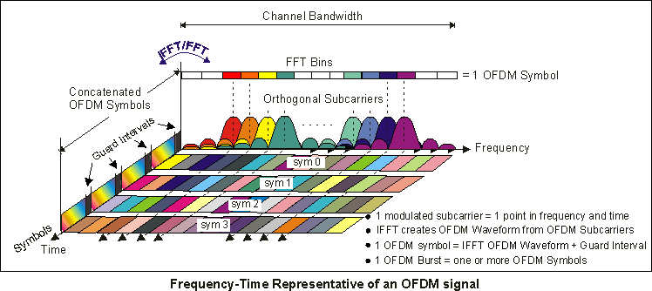

5G adopts OFDM, which stands for orthogonal frequency division multiplexing modulation. Multiple carrier waves are transmitted in the frequency channel, so multiple bits of information are being transferred in parallel simultaneously.

Similar to its predecessors, 5G networks are digital cellular networks, in which the service area covered by providers is divided into small geographical areas called cells. All the 5G wireless devices in a cell communicate by radio waves with a local antenna array and low power automated transceiver in the cell, over frequency channels assigned by the transceiver from a common pool of frequencies. They are reused in geographically separated cells [4]. The local antennas are connected with the telephone network and the Internet by a high bandwidth optical fiber. Like existing cellphones, when a user crosses from one cell to another, his mobile device is automatically switched to the antenna in the new cell.

Millimeter waves are absorbed by gases in the atmosphere and have shorter range than microwaves. Therefore, the cells are limited to smaller size. 5G cells will have size of a city block, as opposed to the cells in previous cellular networks, which could be many miles across. The waves also have trouble passing through building walls, requiring multiple antennas to cover a cell.

Works Cited:

[1] Hoffman, Chris (7 January 2019). "*What is 5G, and how fast will it be?*". ACM TechNews. 23 January 2019.

[2] "*Predicting real-world performance of 5G NR mobile networks and devices*". Qualcomm. 07 March 2018.

[3] Nordrum, Amy; Clark, Kristen (27 January 2017). "*Everything you need to know about 5G*". IEEE Spectrum magazine. Institute of Electrical and Electronic Engineers. 18 January 2019.

[4] Loughran, Jack. "*5G: the benefits and difficulties of creating a new wireless standard*". Engineering & Technology.