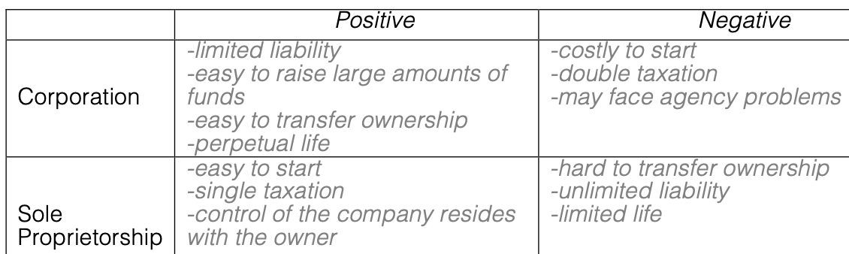

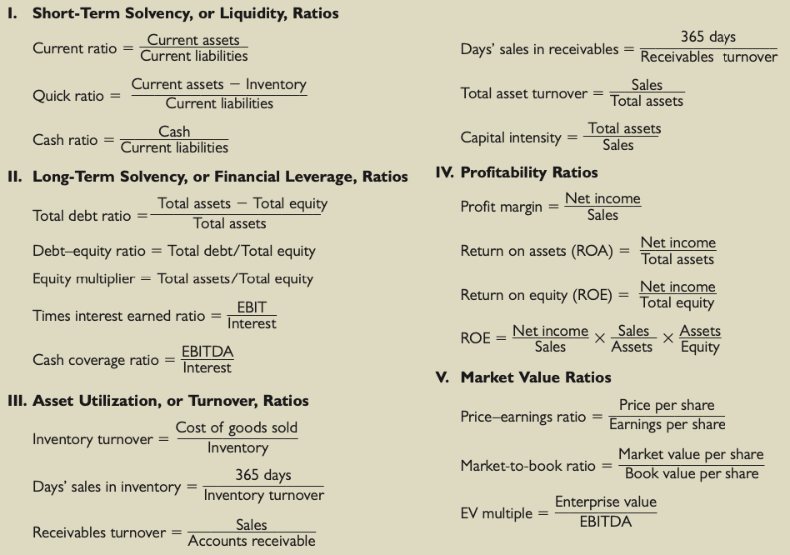Agency Problem: The agent may not fully represent the principal and act on a conflict of interest.

**NWC**:Positive NWC means the company can cover its short term liabilities with liquid assets

Current ratio measures a company's ability to pay current liabilities with its current assets

EBIT=Revenue(Sales)-COGS-Operating Expenses= NI+Interest+Taxes, reflects company’s profitability

Stock Buybacks: Aims:1. reduce the number of outstanding shares on the market, increasing the shareholder value 2.improve financial ratios: increase EPS, ROA, ROE as there is less assets and outstanding equity; invest in company itself when there are no better investment options.

When: P/E ratio is below industry standard

Does not have lucrative investment opportunities

cash ratio above industry standards

Days' Sales in inventory

Reason for going up: Demand for the company's product goes down; Industry in which the firm operates is going through a structural change

Economy is slowing down / Recession

Sustainable Growth: Rate = Retention Ratio * ROE or ROA*b / (1 - ROA * b)

Internal Growth rate=Retention ratio*ROA

Increase ROE or decrease COGS can increase SGR

EFN=Sales/Assets * ∂Sales - Spontaneous Liabilities/Sales * ∂Sales - PM*Projected Sales * (1-d)

low D/E: less likely suffer from long term solvency issues, need not allocate most resources for cost of borrowing. May missing potential to grow at higher rate

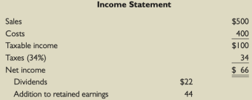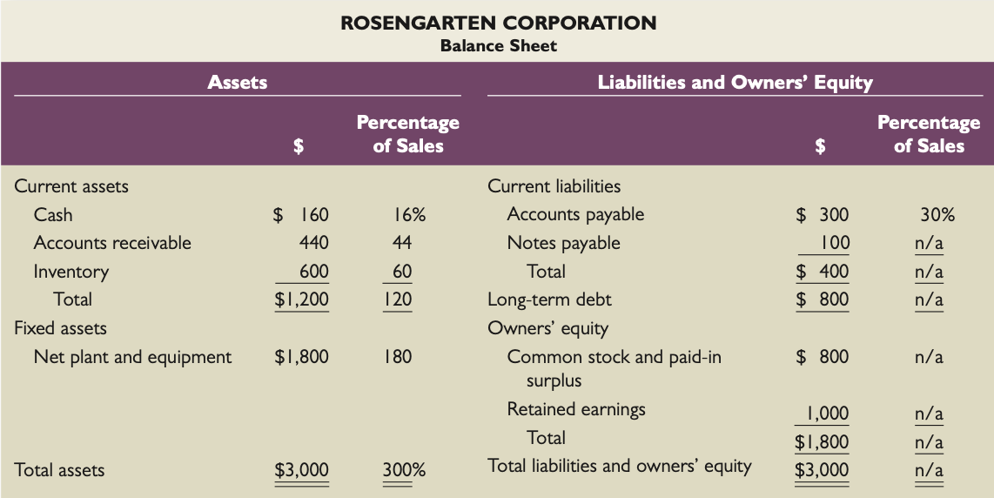

DuPont: ROE

Profit margin: Operating Efficiency; sell more products/raise product price/reduce COGS

TAT: Asset use efficiency

Equity Multiplier: Financial Leverage, increase leads to higher debt and interest payment. Preferable when interest rate is low

ROA: how effectively the company can make use of its assets to get maximum profit. low ROA indicates that the company is not able to make maximum use of its assets for getting more profits. low ROA high PM indicates low Assets turnover

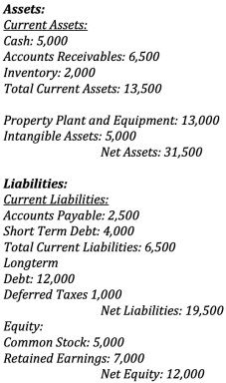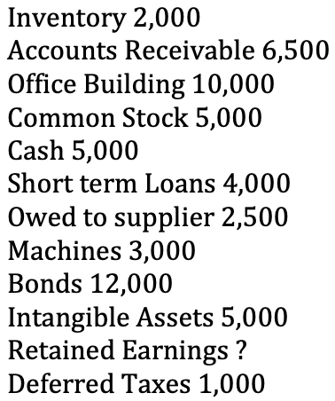

Pros and Cons of Going Public

Pros: Obtain money that does not have to be repaid; Increased visibility; Market valuation

Cons: Going public is costly; Management loses some of its freedom to act without board approval; Open to scrutiny; Public reporting; Company may be taken over

Goodwill: the excess purchase price of another company based on its proprietary or intellectual property, brand recognition, patents

Goodwill increases its value, as qualities such as the company's customer base, its brands, products, location, workforce, and reputation demonstrate the company's proven track record of generating income.

Stock price:reflects a company's financial health; reflects investor perception of its ability to earn and grow its profits in the future

high stock price: management would likely remain/increases in compensation; receive more favorable press from analysts; prevention of takeover

Positive EBIT Negative NI:company may experience depreciation; accrual expense: company records an expense for purchasing an asset, but does not have to pay for it until the next period. Expenses are recorded at the time they are incurred, not when they're paid

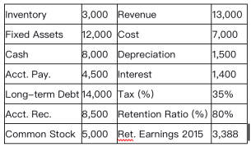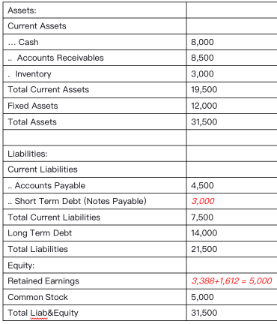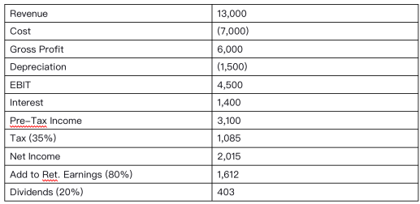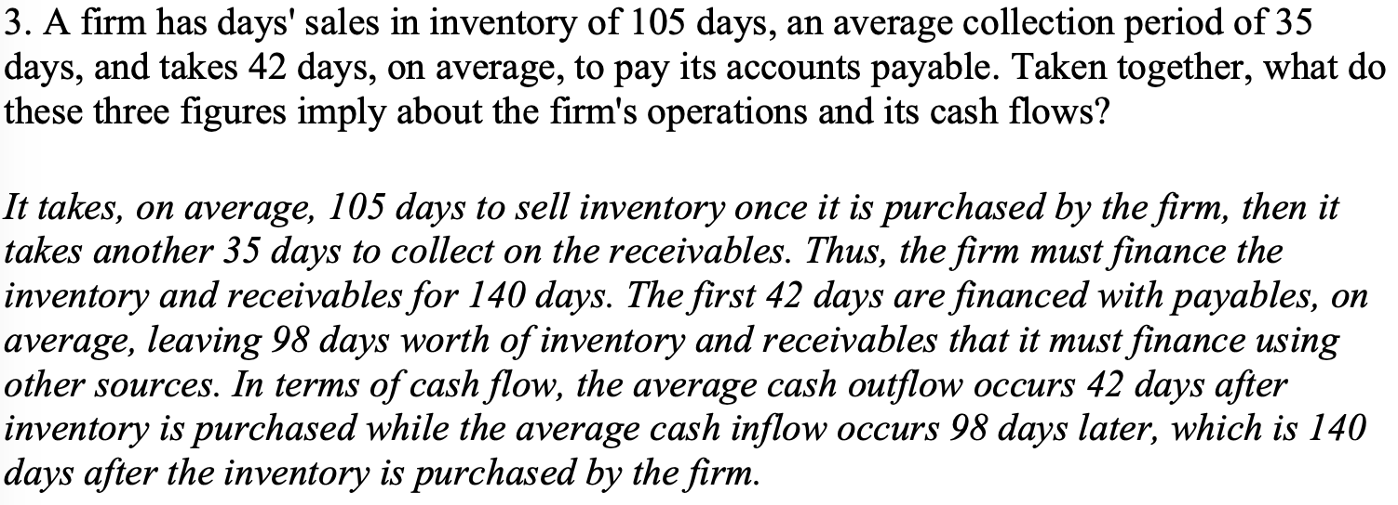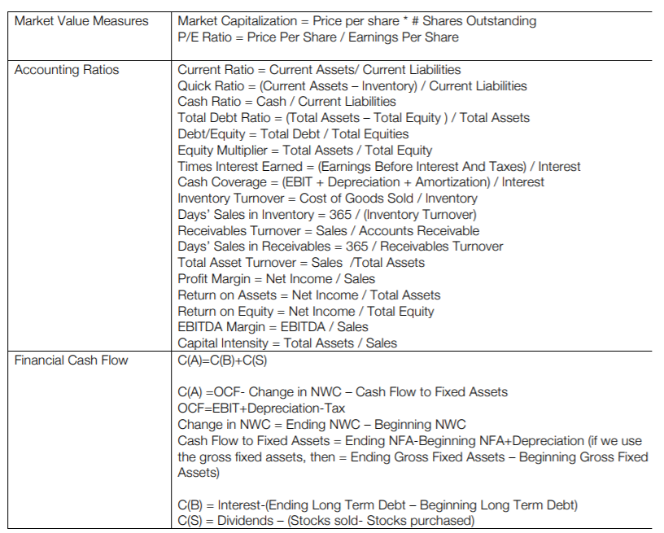

Value Company: Mature company whose growth level stablized and ceased to grow ;higher rates than peers

Growth company: companies that have demonstrated better-than-average gains in earnings in recent years and expected to continue delivering high profit growth