Yiqiao Jin

UID: 305107551

Section 1C

3.2 Answer: (b)

3.6

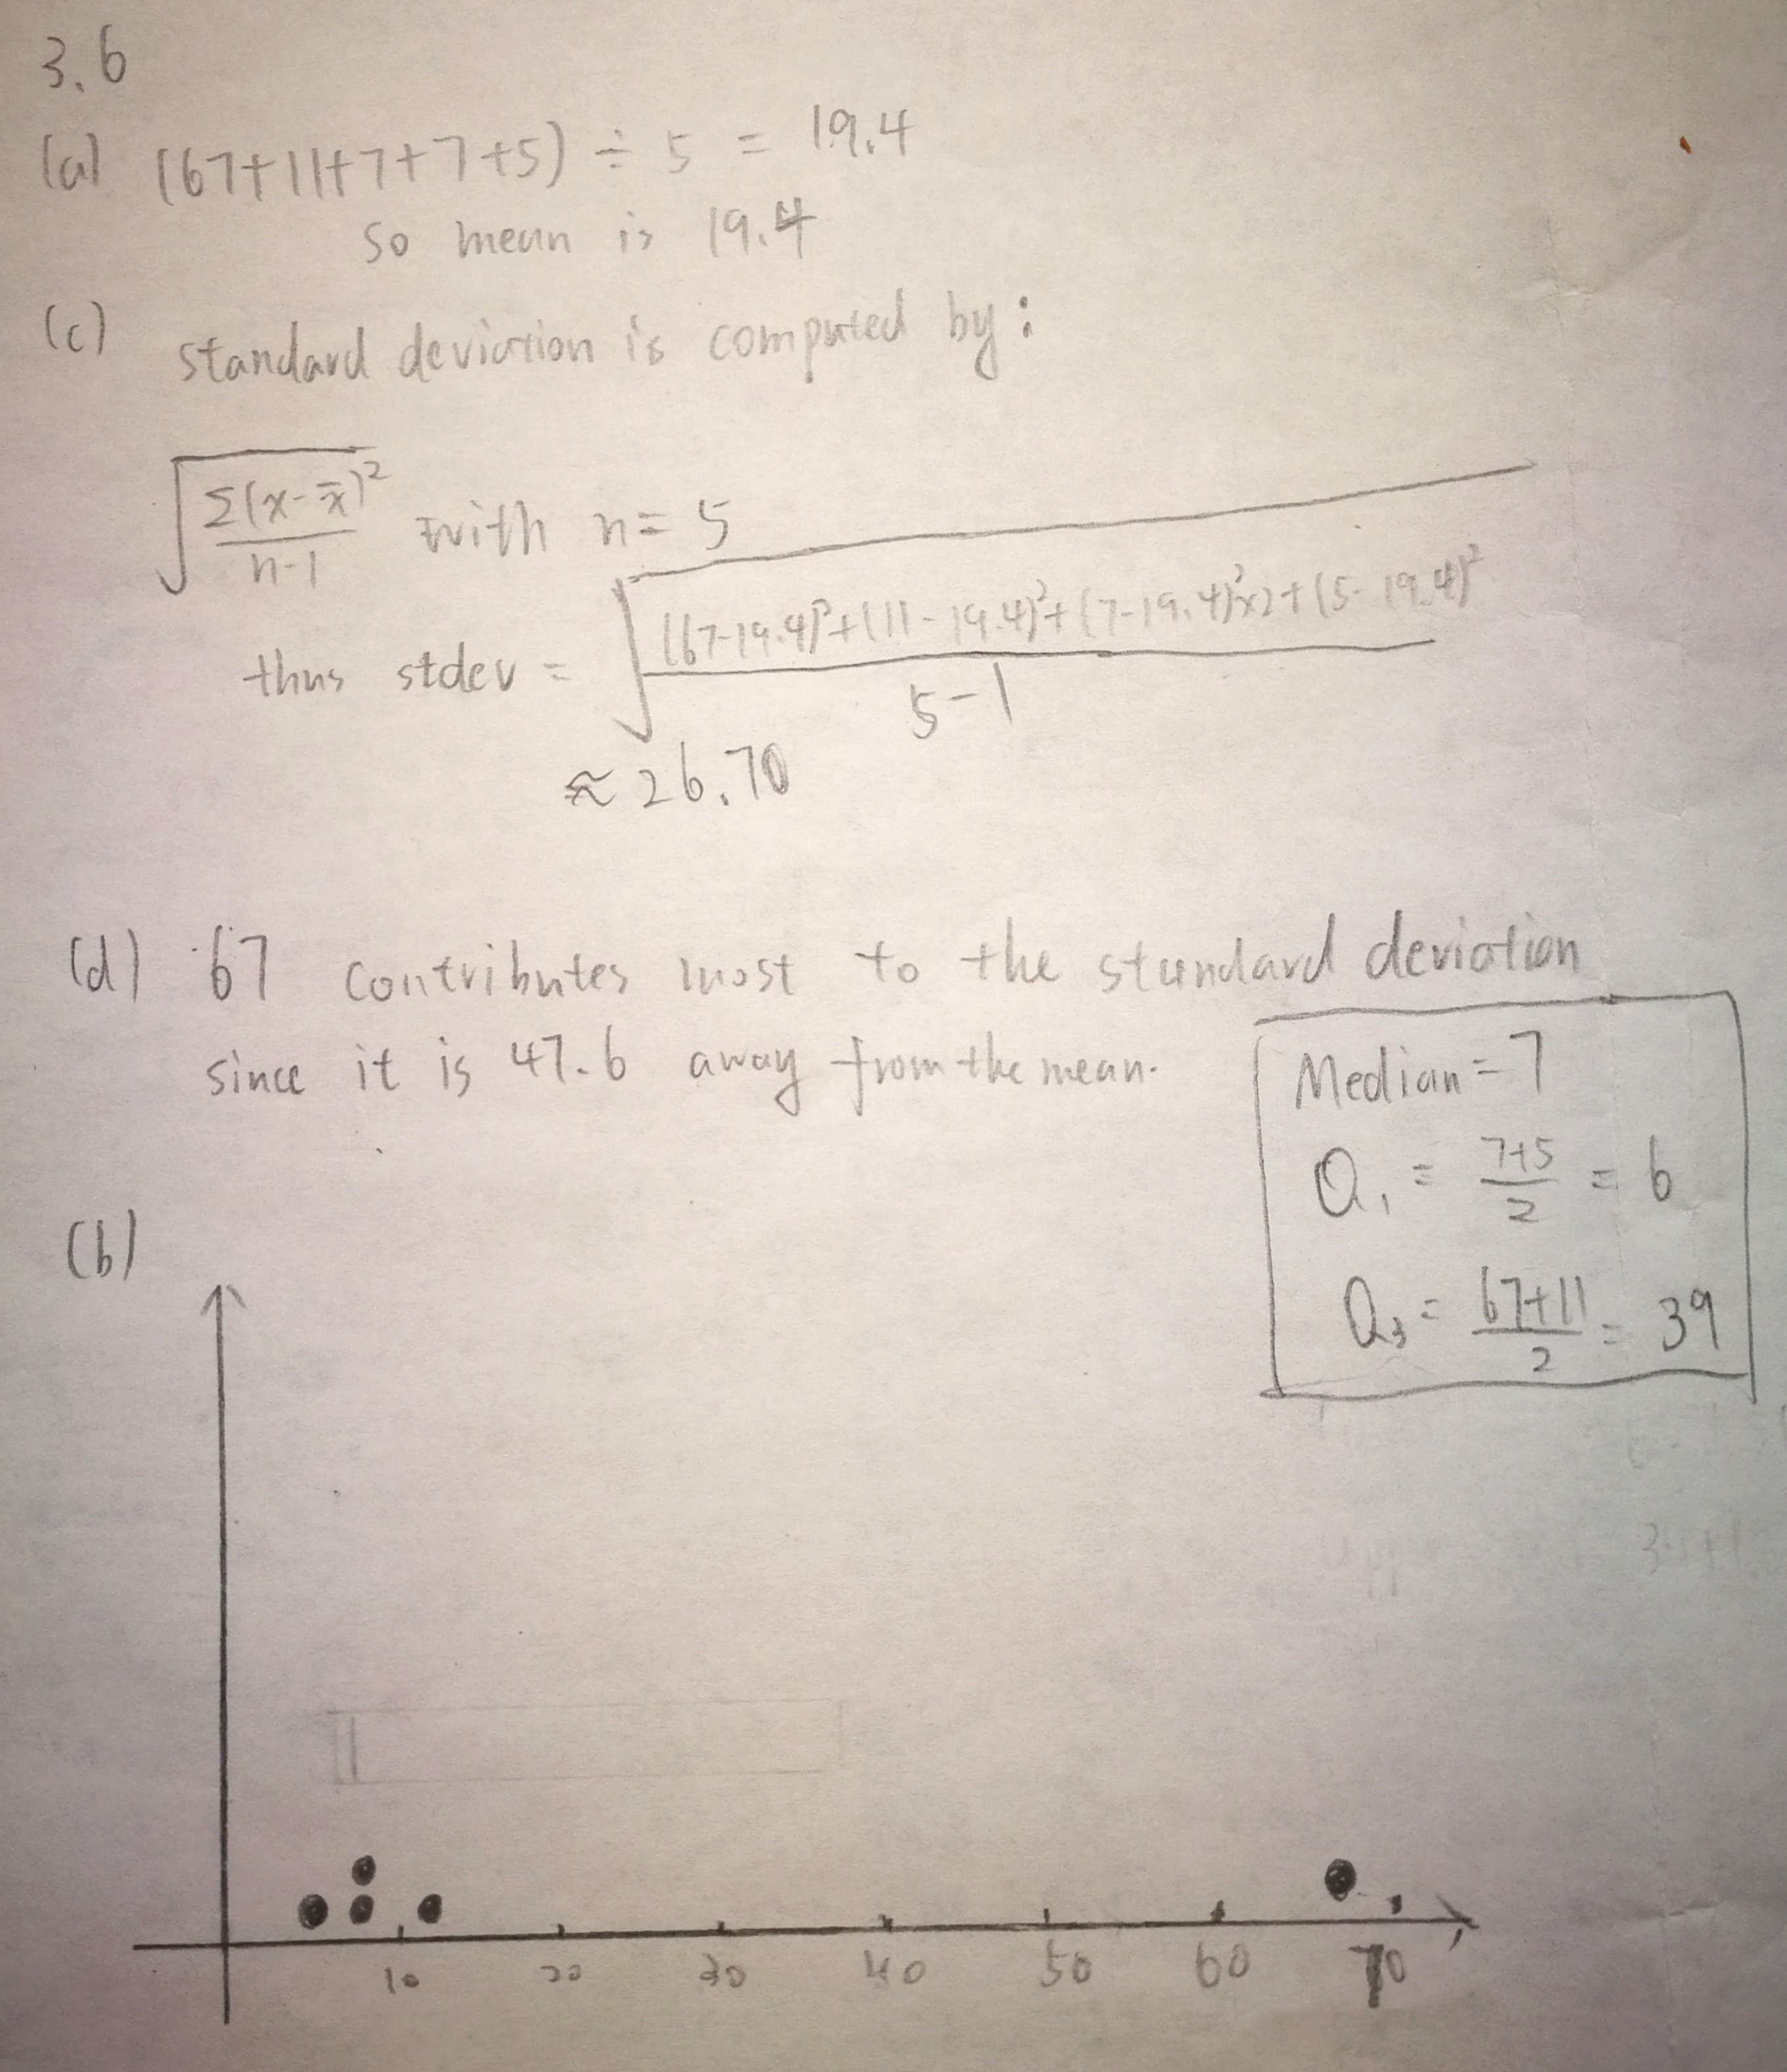

3.12

The means are higher for those in pre-algebra

9.00<10.833. Thus in pre-algebra, the mean is higher for the mothers

c.

Mothers of students in pre-algebra has the smallest standard deviation.

3.16

A has the larger standard deviation since A has a more even distribution, whereas B is normally distributed.

3.18

a.The range is 49.7cm to 54.7cm

52.2-2.5=49.7 52.2+2.5=54.7

b. No. (54-52.5)/2.5 < 1, which means it is within 1 stdev.

3.30

A.

(1600-2400)/400 = -2

Since the range is within 2 standard deviations, we expect 95% to be between 1600 and 3200

B.

(2000-2400)/400 = -1

Since the range is within 1 standard deviations, we expect 68.3%

C.

No. Because (400-2400)/400= -5, so 400 is 5 standard deviation from the mean. There is a possibility of less than 0.3% that this data is normal.

3.32

A. 64-3 = 61 inches

B.(70-64)/3 = 2. So z-score is +2.

3.34

They are equally usual. We notice that the distribution is bell-shaped, and the two values 272±9 have the same distance from the mean, which signifies that the absolute value of their z-scores are the same.

3.38

A. 500+(-1.5)\*100 = 350

B. 500+(1.8)\*100 = 680

3.42

Median = (218+217)/2 = 217.5

This means the intermediate value of box office dollars of the ten movies is 217.5 million

B.

Q3=268 Q1=198

So interquartile range for the movies is 268-198=70

3.50

If I am an owner, I will use mean because for a positively skewed distribution, mean is higher than median.

If I am a player, I will use median because it reduces the effect of extreme values above the mean, and it better reflects the middle value of players’ salaries.

Since the distribution is not normal but instead positively skewed, there is a large discrepancy.

3.52

A. Mean and standard deviation, since prices in town A is approximately normally distributed.

B.

Median and IQR, since prices in town B has a non-normal distribution, which is right-skewed. B has larger spread and standard deviation, so it is not well-represented by mean and stdev.

C.

I will use median since it better excludes the effects of outliers and better represents the middle values of prices between the two.

D.

The mean and median of town A is closer since it has a normal distribution

E.

For town B, its mean is greater than its median because it has outliers to the right.

3.58

Men has greater variation since IQR of men is larger.

3.60

X-M

Y-C

Z-P