Yiqiao Jin

UID: 305107551

Section 1C

6.4

1. Continuous
2. Discrete

6.10

|  |  |  |  |
| --- | --- | --- | --- |
| Number of Heads | 0 | 1 | 2 |
|  | 0.25 | 0.5 | 0.25 |

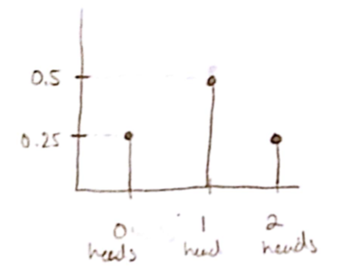  
6.12

P(between 2 and 4) = 0.2*(4-2) = 0.4

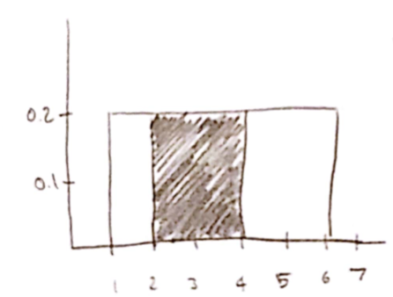

6.16

A.

Z-score = (72.5-65)/2.5=+3

Answer: Choice v. 0%

B.

Z-score = (70-65)/2.5=+2 (for 70)

Z-score = (60-65)/2.5=-2 (for 60)

Answer: Choice ii. 95% of women’s heights are between 60 and 70

C.

Z-score = (67.5-65)/2.5=+1 (for 67.5)

Answer: Choice iv. 34%

D.

Z-score = (62.5-65)/2.5=-1 (for 62.5)

Answer: Choice iii. 68%

E.

Z-score = (57.5-65)/2.5=-3 (for 57.5)

Answer: Choice v. 0%

F.

Z-score = (70-65)/2.5=+2 (for 70)

Answer: choice iii. 47.5%

6.24

a-c: all of these yield 0.999

D. The largest is z=-30

E. Below z=8

6.30

A.

The z-scores for x=7000 is -2/7 and 10/7 for x=10,000

So the probability is 0.9236-0.3897=0.5339

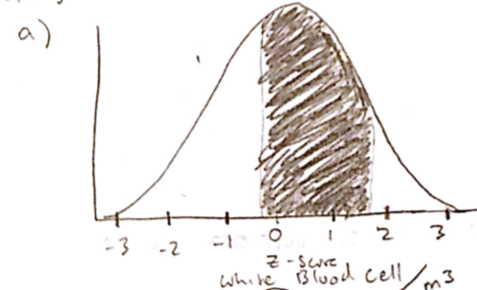

B.

Z-scores are -10/7 and +18/7 for the boundary conditions

So probability is 0.9949-0.0764=0.9185

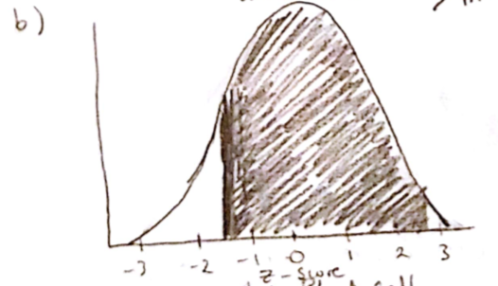

C.

Probability is 1-0.9236=0.0764

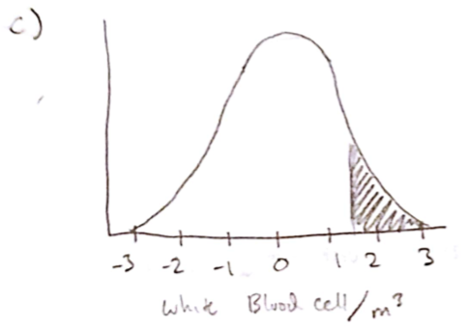

6.40

A.

This is asking for probability because we are given the actual data for measurement

Z-score=(68-65)/2.5=+1.2

B.

This is asking for inverse because we are given the measurement and we need to calculate the data

6.44

A.

Z-score should be between +0.52 and +0.53

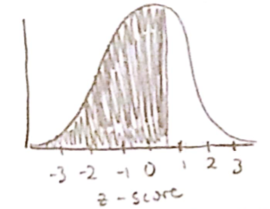

B.

Z-score should be about 1.65

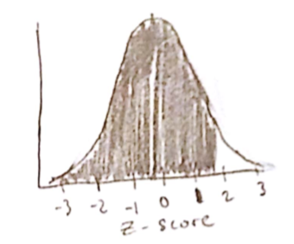

6.58

This is a binomial experiment because there are exactly 2 possible outcomes. Each trial is independent of each other. There is a fixed amount of trials (3 trials). The possibility of each outcome is always the same in each trial.

6.62

It does not satisfy the condition that possibility of each outcome(or possibility of ‘success’) is the same for all people, since people married for the first time and for the second time have different chance of getting divorce.

6.64

A.

b(20, 0.1, 6)

B.

b(20, 0.5, 6)

6.80 (parts a-d)

A.

n*p=100*0.9=90

90 people are expected to pass

B.

Standard dev = √(100*0.9*0.1) = 3

C.

As low as 84 and as high as 96

D.

It should not be a high number, since it is between 84 and 96, or within 2 stdev.