Yiqiao Jin

UID: 305107551

Section 1C

Q1

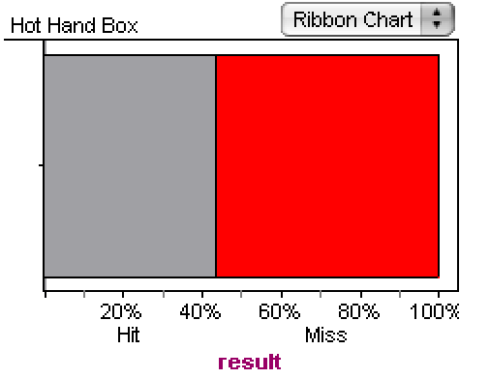

43.6% of Kobe’s attempts are successful.

Q2

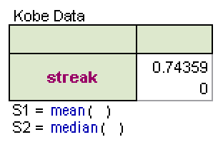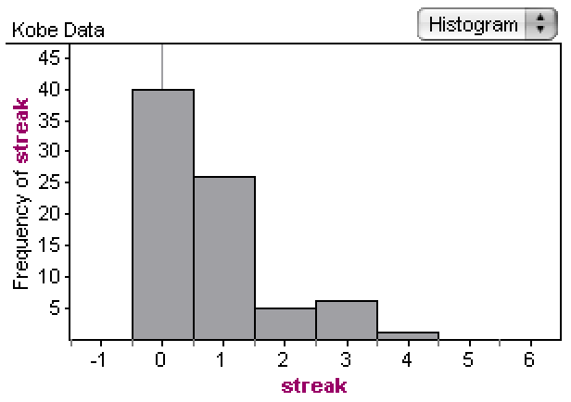

The typical streak length is 0, which is the median and the mode. The distribution is right-skewed and unimodal. The IQR is 1. The mean is 0.7436, which is not representative of the data compared with the median due to skewness of the graph.

Q3

We should draw out slips with replacement so that the total number of slips remains constant, thus the probability of hit or miss remains independent of the number of slips.

Q4

The collection now contains 44 hits.

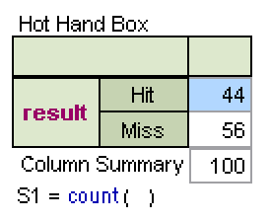

Q5

Each time we click on the tab, the computer performs one trial and we get one streak simulation. The computer samples with replacement.

Q6.

The distribution is right-skewed and unimodal, with a median and a mode of 0. It has a range of 6 with a minimum value of 0 and maximum 6. The IQR is 1.

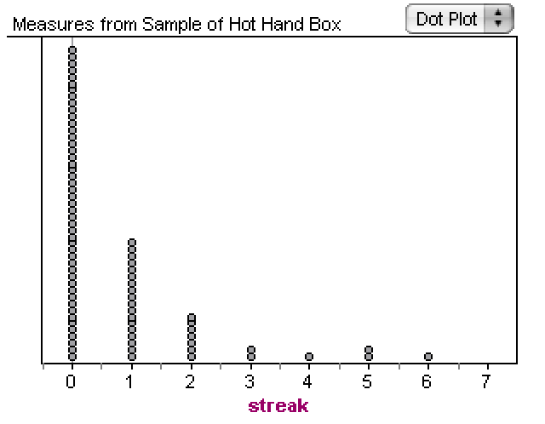

Q7

Both the simulation and the actual data have the same right-skewed and unimodal distribution. There are a few outliers in the simulation, which results in a larger range of 6 and a maximum number of 6 streaks.

Q8

In my opinion, the simulation provides evidence that Bryan has hot hands since the graph of simulation has the same right-skewed and unimodal distribution as Kobe’s data. The only difference lies in the outliers and the range in the simulation.

Summary

The lab covers simulation of randomness and aspects to be considered when we summarize the distribution, including IQR, skewness, unimodal/bimodal, and range. It also covers means, median and mode. I have seen these concepts in the textbook, lectures and homework.