Yiqiao Jin

UID: 305107551

Section 1C

1.It seems that treatment and outcome are dependent because as shown in the graph below, the group treated with Streptomycin had a lower death in comparison to the control group (the group that wasn’t treated). Death rate of people with treatment is 7.3% for people with treatment, but 26.9% for people without treatment.

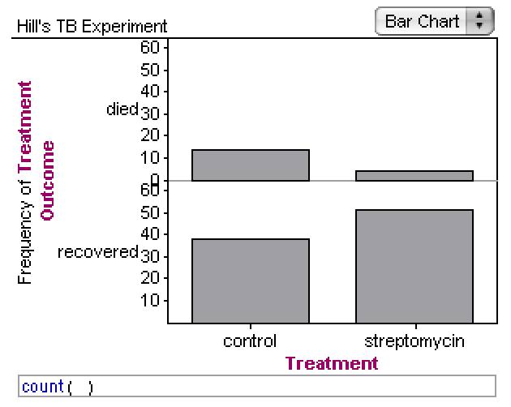

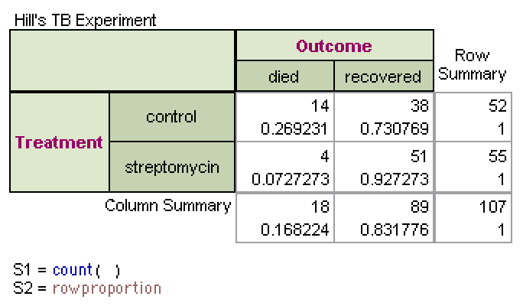

2.

16.8% of patients were expected to die.

16.8%\*55 = 9 people are expected to die in the Streptomycin group if treatment and outcome were independent

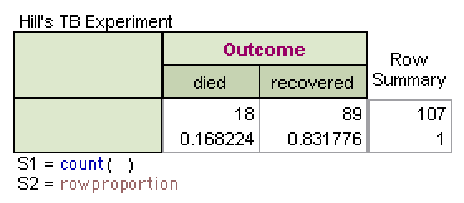

3.

Based on the 100 simulation, the number of people that died with Streptomycin treatment if it was independent and ineffective was higher than the original Hill’s TB Experiment. Thus, it is more appropriate to determine that Streptomycin is an effective treatment because in Hill’s TB experiment, the number of people that died with streptomycin treatment was 4 which is much lower than the mean value of the graph(which is 9).

Thus, the simulation signifies that Streptomycin was significant in treating patients and unlikely that Streptomycin and outcome is independent.

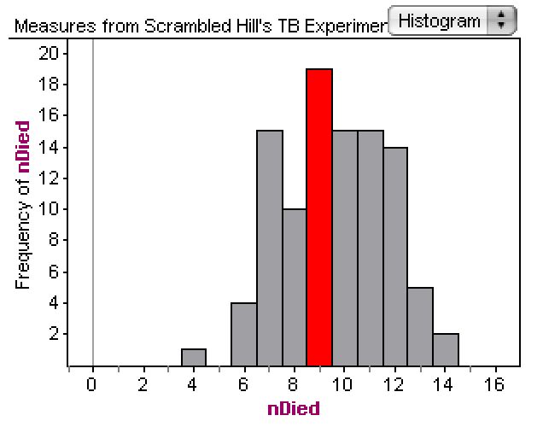

4.

Hill’s study is a controlled experiment because Hill randomly divides people into two groups. Also the assignment of patients to each group is done by Hill himself. Thus, we can conclude that Streptomycin was effective and we can conclude the cause is the antibiotic since this was a controlled experiment and that the percentage of people who died in the group without Streptomycin was significantly higher than the percentage of people who died in the group treated with Streptomycin, meaning the antibiotic is effective.

Summary

Concepts covered in the lab include controlled experiment and observational study, the independent or dependent relations between treatments and outcomes. I have seen these concepts in the textbook, lectures and homework.