Yiqiao Jin

UID: 305107551

Section 1C

1.

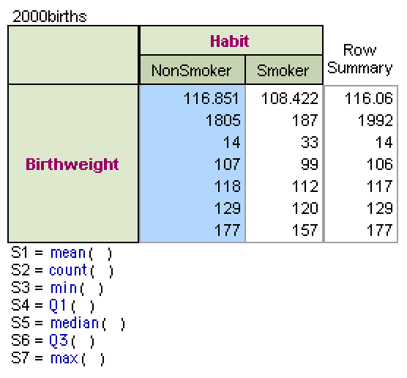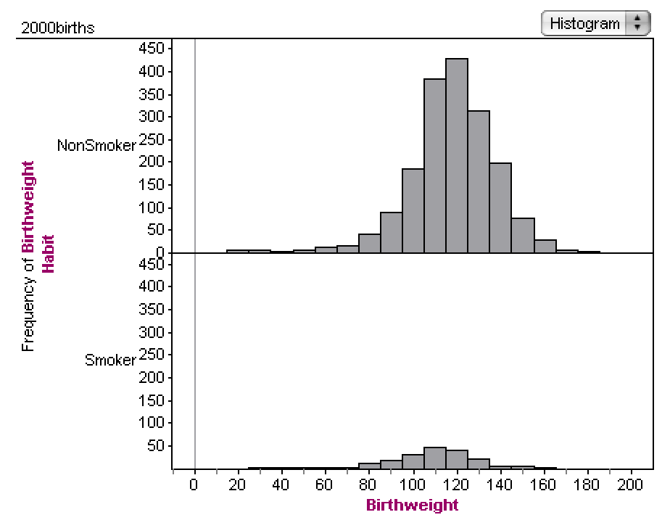

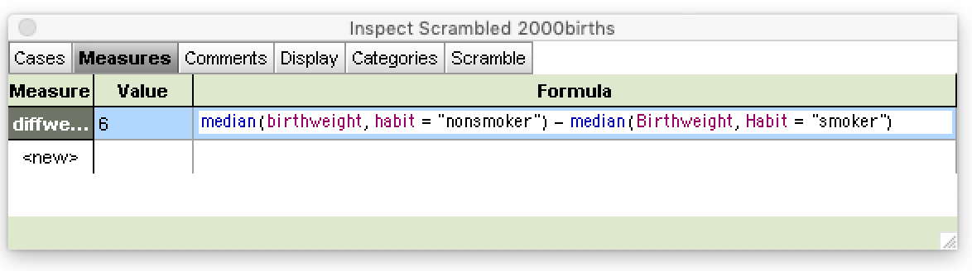

Based on the Histogram, the median for babies birth weight for smoking mothers is lower in comparison to that of babies born from non smoking mothers. The median of birth weight is 118 ounces for non smoker mothers, which is higher than the median of 112 ounces for smoking mothers. I would conclude that smoking habit of mothers will decrease baby’s weight by typically 6 ounces.

2.

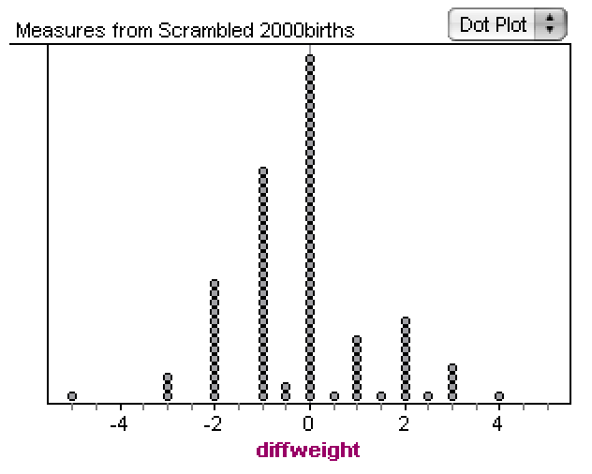

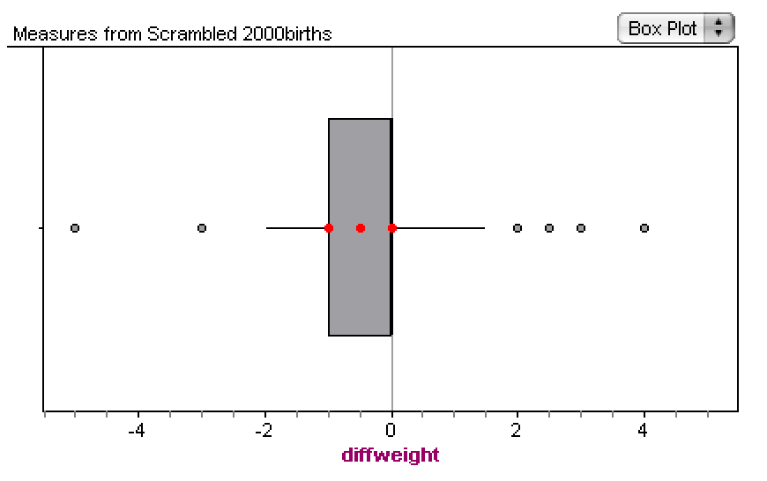

Based on the simulations, I consider 0 to be the typical difference between the two groups.

According to the box plot, an unusually large difference will be greater than 2 or less than -2 as they are about 1.5 IQR away from Q1 and Q3 respectively.

3.

Never. Based on my 100 simulations, the greatest difference is 4. There is never a difference more extreme than 6 or -6. The center is around 0, which means that there is generally no difference between the weights of babies born from smoking mothers vs non smoking mothers.

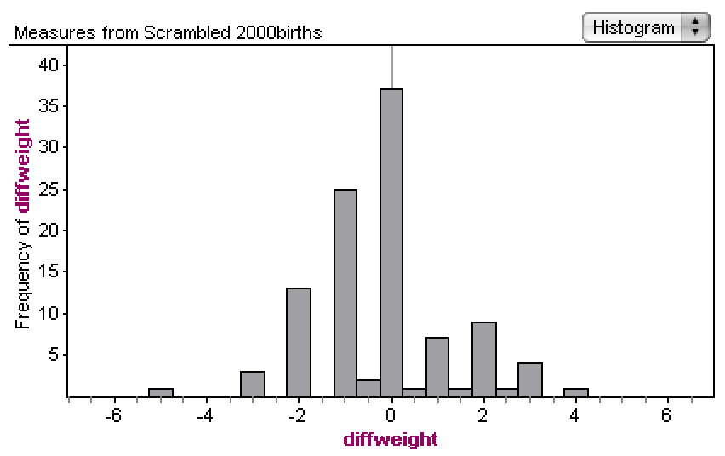

4.

The correct explanation is that smoking mothers have babies with lower birth weight and that the chance model only reveals the distribution of weights for babies born from smoking vs non smoking mothers if the difference between birth weights was 0. Because the chance model doesn’t have a difference in birth weight of -6 or more extreme, it’s very unlikely that chance model is valid and that there is no difference between the birth weight of babies born from smoking vs non smoking mothers.

5.

The original data is an observational study because the experiment gathers data from a lab instead of randomly assigning individuals into each group. Thus, even if we were to see a real difference in weight between babies born from smokers vs non smokers, we​cannot​​conclude smoking causes low birth weight. We cannot conclude causation.

Summary

Concepts covered in the lab include controlled experiment and observational study, means, median, the independent or dependent relations between treatments and outcomes. I have seen these concepts in the textbook, lectures and homework.