**Experiment 2: Measurement of *g***

Kubilay Agi

UID: 304784519

Lab Date: 15 August 2018

Lab Section 8 – Monday/Wednesday 11:30am

TA: Jordan Runco

Partner: Shannon Largman, Tian Dai

**(2.) Derivation**

We start with the equation for velocity . We will refer to the distance between the two photogates as and we will call the distance between the bottom photogate and the impact sensor . The corresponding times for the ball to reach each point will be referred to as and . We get the following equations for each average velocity:

We want average values for *T1* and *T2*. For *T1* we can just divide by two, but for *T2* we need to account for *T1* amount of time passing before it. So we have:

Acceleration is given by the equation . We substitute , , and into this equation.

**(3.) Plots**

**Figure 1:** This plot contains data from dropping a ball between photogates and onto an impact sensor. Each data point represents the gravitational acceleration acting on the ball depending on which height the ball was dropped from. The value of the slope is (0.5699 ± 0.1904) *s-2*, and the value of the intercept is (10.10 ± 0.08277) *m/s2*. The distance measured for each trial was the distance between the bottom photogate and the impact sensor.

Given that accepted acceleration due to gravity has a value of 9.80 *m/s2*, I expected our values of gravity to be near that value, regardless of the distance between the bottom photogate and the impact sensor. My expected results would have produced a horizontal trendline. Instead, the actual trendline indicates that the value of gravity depends on the value of the distance. Our data suggests that the value of the gravitational acceleration decreases as the distance traveled by the falling object increases.

To see how well the trendline fits the data, we run a regression data analysis. R square values indicate how well the linear regression fits the data. An R2 value close to 1 indicates very strong representation of the data. Alternatively, regression that produce R2 values closer to 0 do not fit the data well at all. The regression produced an R2 value of 0.749. Because our R2 value is 0.749, we cannot rule out the linear model for this data set. However, given more data points with higher values for *D*, we would be able to see whether the data continues to decrease, or whether it converges to a specific value.

**Figure 2:** This is a plot of the same data points as Figure 1, but it uses the power model instead of a linear model. The equation for the trendline indicates that the data converges at a value of 9.648 *m/s2*.

The linear model implied that the value of the acceleration due to gravity continues to decrease as the distance between the bottom photogate and the impact sensor increases. The power model indicates that the acceleration from gravity converges to 9.648 *m/s2*, which is more reasonable. Visually, the power model seems to fit the data better than the linear model. To confirm that it actually does fit better, we check the R square value for the power model. The power model produced an R2 value of 0.885, which is significantly higher than the linear model’s value of 0.749.

**Figure 3:** This plot shows the data from trials 2-5 when using the comb with the photogate. Each data series in the plot represents an instance of the comb being dropped in front of a photogate sensor. Each data point represents the time where a solid section of the comb blocked the photogate sensor. The distance along the comb identifies which individual section blocked the photogate sensor.

**(4.) Data Tables**

|  |  |  |  |
| --- | --- | --- | --- |
| Trials | Photogate Separation *d* (m) | Photogate to Sensor Separation *D* (m) | Acceleration due to gravity (m/s2) |
| 1 | 0.089 | 0.152 | 10.111 ± 0.16 |
| 2 | 0.089 | 0.230 | 9.8982 ± 0.083 |
| 3 | 0.089 | 0.373 | 9.8453 ± 0.12 |
| 4 | 0.089 | 0.522 | 9.7747 ± 0.094 |
| 5 | 0.089 | 0.676 | 9.7668 ± 0.092 |

**Figure 4:** This is the data collected for the ball drop at various separations between the bottom photogate and the impact sensor. The uncertainty for the photogate separation *d* is 0.01 *m*, and the uncertainty for the distance between the bottom photogate and the impact sensor is 0.02 *m*. As the distance from the photogates to the impact sensor increased, the value of gravity decreased.

To calculate the statistical error for *g*, we use equation ii.13 from the lab manual, where is the standard deviation, and *N* is the number of data points that we used. For this experiment, *N* is 10.

To calculate the systematic error, we need to find the upper and lower limits of the data points. This means that we need to find the values when we add the uncertainties and subtract the uncertainties.

We substitute these values for *d* and *D* in equation 2.1 to find *gmin* and *gmax*. To find systematic uncertainty, we have the following equation:

The total uncertainty shown in Figure 4 is the sum of the systematic and statistic uncertainties.

|  |  |  |  |
| --- | --- | --- | --- |
| Trials | Acceleration due to gravity (*m/s2*) | Statistical Uncertainty (*m/s2*) | Systematic Uncertainty (*m/s2*) |
| 1 | 10.111 | 0.116 | 0.0433 |
| 2 | 9.8982 | 0.0553 | 0.0272 |
| 3 | 9.8453 | 0.0554 | 0.0608 |
| 4 | 9.7747 | 0.0252 | 0.0697 |
| 5 | 9.7668 | 0.0215 | 0.0702 |

**Figure 5:** This is a table containing the values of the statistical and systematic uncertainty for each value of acceleration due to gravity. These values are for the data collected with the ball drop method.

For the first two trials, the statistical uncertainty was higher and for the last three trials the systematic uncertainty is higher. However, the values are close to each other in both cases, so it is not evident that one uncertainty dominated the other in these trials.

|  |  |
| --- | --- |
| Trial | Acceleration due to gravity (*m/s2*) |
| 1 | 9.793 ± 0.014 |
| 2 | 9.786 ± 0.68 |
| 3 | 9.784 ± 0.024 |
| 4 | 9.782 ± 0.18 |
| 5 | 9.726 ± 0.020 |

**Figure 6: Photogate comb trials with rods.** This plot shows the acceleration due to gravity for each trial done using the photogate comb method. The value of the acceleration was produced by taking the second derivative of each trendline from Figure 3. The systematic uncertainties were found through a quadratic regression analysis tool. The statistical uncertainties were determined with equation ii.13 from the lab manual.

The statistical uncertainty dominated the systematic uncertainty in this case.

**(5.) Conclusion**

For this experiment, there were two separate methods to determine the value of acceleration due to gravity. The first method was dropping a ball between two photogates and onto an impact sensor. The value of gravitational acceleration was calculated by plugging the distance and time values recorded by the photogate and impact sensor into equation 2.1.

The ball drop produced a result that indicated that the value of gravity is dependent on the distance that the ball fell. This was unexpected because acceleration from gravity should be constant everywhere on the earth’s surface, with only small fluctuations. Two different trendlines were used to fit the data. The linear model fit the data fairly well. It produced an R square value of 0.749. However, this trendline suggests that gravity continues to decrease as the distance increases. In fact, this model implies that the acceleration due to gravity is negative when distance between the photogate and impact sensor is greater than 17.72 *m*. We know that this is not true.

I also tried fitting the data with a power model. This produced a stronger fit for the data, producing an R square value of 0.885. The equation for this trendline is y = 9.6478x-0.022. The coefficient of the x-value is the value that the trendline converges to. A gravitational acceleration value of 9.6478 *m/s2* is close to the constant of gravity 9.80 *m/s2*. Convergence to a value around the accepted constant of gravitational acceleration is more reasonable than a trend that suggests that gravity becomes negative beyond a certain distance. Perhaps if we had done more than 5 trials with greater distances, we would be able to more clearly see the trend that emerges in the data. Other than the R square values, there is no definitive indication as to which model fits our data best. We know that the value of gravitational acceleration should not depend on the distance that the ball drops, but our data suggests that it does.

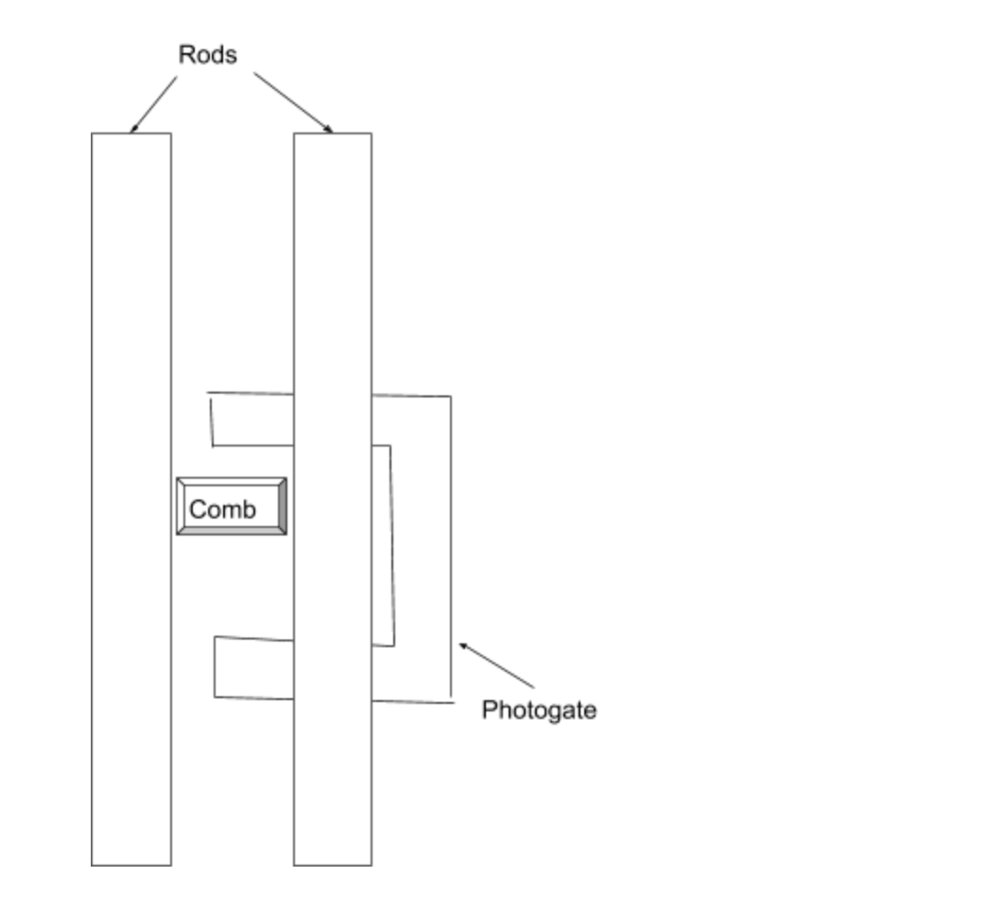

**Figure 7:** **Bird’s eye view of the apparatus with stabilizing rods.** This illustration depicts what the apparatus looks like from above. For each trial, the comb was suspended above the photogate sensors between the two stabilizing rods and then released. As the comb dropped, the rods prevent the comb from rotating to the left or the right.

The second method was dropping a photogate comb through a photogate and measuring the time intervals where the photogate was blocked by the comb. The sensor is blocked to unblocked repeatedly as the comb passes through the photogate. There are 35 open sections in the comb and 36 closed sections. Each of the 35 open sections is paired with the neighboring closed section. The sum of their lengths is the increment of distance traveled by the comb between consecutive recorded times that the photogate sensor was blocked. For these trials, we used rods as stabilizers to the comb to prevent rotation. The acceleration was derived by differentiating the equations of the trendlines produced for each data series in Figure 3.

The true value of gravity in room 1-238 is *g* = (9.7955 ± 0.0003) *m/s2*. The comb produced values almost identical to the actual value of gravity, and also produced values that were very consistent with each other. The actual value of gravity falls within the uncertainty window for the value of gravitational acceleration for each trial. This result is stronger than the results from the ball drop. The only error in the comb method of recording data arose from the comb rotating slightly along its pitch, yaw, and roll axes as it fell through the photogates. However, our guiding rods seemed to produce more consistent results than trials without the rods (illustrated in section 6).

The main challenge in improving the comb method for this experiment is eliminating rotation of the comb without adding fraction. One possible solution is to use a lubricated track that allows the comb to slide straight down. Another solution could be to use the rods that we did but add lubricant to them so that any contact between the comb and the rods does not generate significant friction.

The main source of error with the ball drop method was dropping it through the guiding hole consistently. When releasing the ball, it is possible that some extra downward force was applied to push the ball through. An apparatus for dropping the ball instead of using our hands would decrease the error in the experiment because the initial condition of the ball would be constant for every test. It is also possible that the inconsistencies arose from the ball striking different places on the force sensor. We were informed that some places on the force sensor do not read the value of the impact properly. It might be the case that the ball struck the lower-sensitivity positions on the sensor in some of our trials.

**(6.) Extra Credit**

|  |  |
| --- | --- |
| Trial | Acceleration due to gravity (m/s2) |
| 1 | 9.334 ± 0.396 |
| 2 | 9.762 ± 0.0165 |
| 3 | 9.804 ± 0.0392 |
| 4 | 9.640 ± 0.116 |
| 5 | 9.777 ± 0.0893 |

**Figure 8:** **Photogate comb trials without rods**. This table shows the data points for trials using the photogate comb without rods as a guiding mechanism. The values of gravitational acceleration were generated with a quadratic regression data analysis tool.

The standard deviation of the trials without the rods is 0.195 *m/s2* and the standard deviation for the trials with the rods is 0.0271 *m/s2*. There is less variance in the results produced from the trials with the guiding rods. Although the rods may have introduced a friction force into the experiment, they kept the photogate comb in the correct orientation throughout each trial.

We also attempted to use a string attached to the comb as a mechanism for releasing the string, but we were not able to collect data for this because the string would cause the comb to spin rapidly and block the photogate with its edges.

The methods that perform the best with the photogate comb manage to keep the comb still throughout the entire trial. The comb tends to rotate, tilt, and spin as it drops. This may be because of wind resistance, weight distribution of the comb, or the release method. In any case, these orientation changes lead to inconsistency in the data because the comb does not necessarily move in the same way in every trial. The rotations also make it difficult to record data in the first place because the comb strays away from the sensors and yields incomplete data.

**Presentation Mini-Report**

**Figure 9:** **Photogate Comb method of calculating acceleration due to gravity.** The data points on this plot are from the first trial and indicate the times at which the photogate’s sensors were blocked by the sections of the comb. The distance traveled along the comb was incremented for each data point as each section passes in front of the sensor. The value that the distance was incremented by for each data point was determined by first measuring the entire length of the comb, and then dividing the length by the number of sections that the comb had. We measured the comb to be (0.296 ± 0.001) *m*, and there were 35 sections. Therefore, the distance increment is 0.008457 *m*. Our equation has the form y = *a*x2 + *b*x + *c*, and the values of the coefficients are *a* = (4.8964 ± 0.00152 *m/s2*), *b* = (-24.282 ± 0.00811 *m/s*), *c =* (30.082 ± 0.0108 *m*). To find the value of acceleration from this plot, we take the second derivative of the trendline equation. The second derivative of a quadratic equation is a constant, which is what we expect for gravitational acceleration.

Figure 9 plots the first trial of using the photogate comb to record data in order to determine the value of acceleration due to gravity in room 1-238. For this trial, we placed two rods on either side of the comb to prevent any rotations; the apparatus is better illustrated in Figure 7. Each data point represents the time at which a specific closed section of the comb blocked the photogate sensor as the comb was falling. The comb consists of several open and closed sections along its surface. The photogate sensor is blocked if it is pointed at a closed section of the comb, and it is unblocked if it points at an open section. The trendline relating all of the points in the data series is a quadratic, so it has the form y = *a*x2 + *b*x + *c*. The coefficients and their uncertainties for the equation were found using a quadratic regression tool. The values for *a, b,* and *c* are *a* = (4.8964 ± 0.00152 *m/s2*), *b* = (-24.282 ± 0.00811 *m/s*), *c =* (30.082 ± 0.0108 *m*). This was our best trial and produced a constant gravitational acceleration value of (9.7928 ± 0.003) *m/s2*. This value was generated by taking the second derivative of our trendline equation. The actual value of acceleration from gravity in room 1-238 is *g* = (9.7955 ± 0.0003) *m/s2*. The reason that our value of *g* is slightly lower than the true value can be attributed to error and lower precision in measurements of distance for section from the start of the comb. However, the actual value of gravity in room 1-238 falls within the error window of our result, meaning that our result with the comb was near perfect for this experiment.

Caption Word Count: 192

Paragraph Word Count: 294