**Experiment 5: Harmonic Oscillator Part 1: Spring Oscillator**

Kubilay Agi

UID: 304784519

Lab Date: 27 August 2018

Lab Section 8 – Monday/Wednesday 11:30am

TA: Jordan Runco

Partner: Shannon Largman

**(2) Full Lab Report**

**Abstract**

**Analysis of a Spring’s Damped and Undamped Oscillations**

K. Y. Agi1

In this experiment, we investigate the frequencies and periods of damped and undamped oscillations. We want to see if the resonance frequency is the same in the damped and undamped trial. We suspended a spring with a mass on the end from a force sensor and recorded the tension it applied to the sensor as it oscillated up and down. The mass had magnets attached to itself along the sides, and the magnets were used to generate a damping force when the mass oscillated within an aluminum tube. We plotted the voltage readings against time to visualize the changes to the voltage amplitude in both trials. The amplitude in the undamped trial saw minimal change. The changes amplitude in the damped oscillation trial were clearly visible and indicated that the energy in our system underwent exponential decay. The ratio between one extremum’s amplitude and the previous, adjacent one’s amplitude was constant for each peak in our damped trial. The predicted frequency for our trials was (0.696 ± 0.002) Hz. The oscillation frequencies of the undamped and damped trials were (0.696 ± 0.002) Hz and (0.695 ± 0.015) Hz respectively. For the damped oscillation trial, the damping time was found to be (4.22 ± 0.09) s, and the quality factor is (9.23 ± 0.20).

1Department of Engineering and Applied Sciences, University of California, Los Angeles

**Introduction**

Simple harmonic motion is a state in which an object oscillates without any outside force acting on it. The frequency of oscillation of this object is known as the resonance frequency. Of course, in an ideal environment, an object in simple harmonic motion should oscillate with the same amplitude and frequency forever, without change in any of these values.

In a scenario where there is a force acting against the oscillating object’s movement, this is called damped oscillation. In our experiment, we produced a damping effect on a mass’ oscillations through the magnetic interactions between the mass’ magnets and the surrounding aluminum tube. To find the resonance frequency, we look at the damping time of the oscillation. The damping time is the time that it takes for the amplitude of oscillation decrease by a factor of 1/*e*. We also find the quality factor, which describes the effect of damping on an oscillator.

We observe both of these cases in our experiment to find the resonance frequency in each case, and to compare the results from each trial. We do this by suspending a mass from a spring attached to a force sensor. The plots of the force sensor’s voltage readings provide us with insight into the relationships between the resonance frequency from the undamped trial and the damped trial.

**Methods**

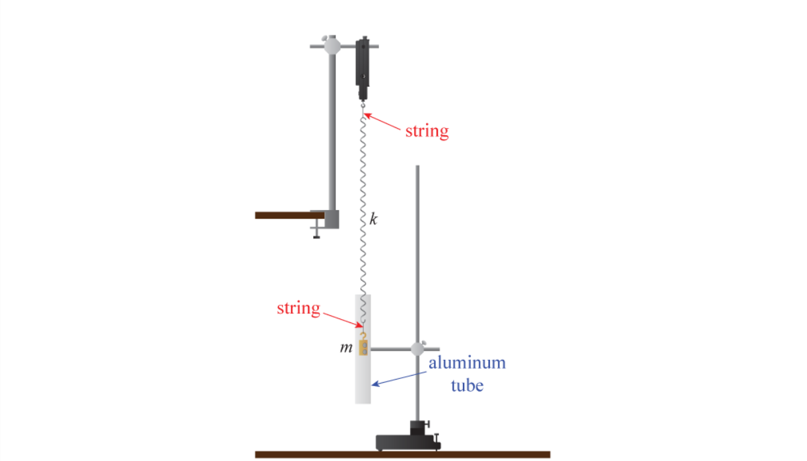

**Figure X**1**:** This image illustrates how our apparatus is set up for this experiment. The aluminum tube is not present in the first part when we measure the distance between the bottom of the spring and the floor.

The first step in this experiment is to calculate the string constant. We attach five masses of different mass to one end of our spring. The other end is attached to the force sensor. On both sides of the spring, the masses and force sensor are attached to the spring via a string. The string is used to reduce rotational motion during the experiment. The force sensor is oriented downward to be parallel with the hanging spring. For each mass that we hung on the spring, we measured the distance of the bottom of the string from the ground. We measured from the bottom of the spring because each mass had a different length. The data would be inconsistent, and it would not provide us with an accurate spring constant.

After calculating the spring constant, we begin our oscillation trials. We start with undamped oscillation. Since the mass with magnets attached to it is used in the damped oscillation trial, we use the same one for the undamped oscillation trial. We keep the same set up as we had when we were measuring distance between the bottom of the spring and the floor. The mass should not hit the floor when it is oscillating. The data acquisition system (DAQ) is set up to record timestamps and the voltage signal produced from the force sensor in units of Volts. To record values in volts from the sensor, we choose to read it as a User Defined Sensor instead of a Force Sensor. We pull the mass down and release it and press ‘Record’ on the DAQ interface. We record one minute of data, although only about 25 seconds worth of data was used in the analysis.

Next, we record the data for the damped oscillation trial. The setup for this trial is the same as the previous part, except that the mass needs to oscillate inside of a aluminum tube. We place the tube around the mass and spring, and we line it up so that the middle of the tube, both horizontally and vertically. We do this to make sure that the mass does not scrape against the insides of the tube, and also to keep the mass inside of the tube throughout the trial. If the mass were to come out of the tube in either direction during the mass’ oscillation, the movement would be damped less. This would lead to inconsistent data because the mass would only be outside of the tube on a couple of cycles, but not for all of them. The damping factor would be higher in the cycles that the mass was completely surrounded by the tube, and lower in the cycles where the mass was not. Again, we record the timestamps and the voltage produced by the force sensor when reading it as a User Defined Sensor.

**Analysis**

** Derive some equations for f, Q, tau **

The hanging mass had a mass of (173.9 ± 0.3) g. The scale only measures up to 110 g, so we counterbalanced the scale with a mass of (99.3 ± 0.2) g. Our uncertainty measurement for each mass was 0.2 g. The hanging mass we used for our experiment has a higher uncertainty because we need to account for the uncertainty of the mass used to counterbalance the scale.

**Figure X, Title:** This plot shows how the distance from the spring to the floor varies depending on how much mass is attached to the spring. Hooke’s Law tells us that this relationship should be linear. We see from the plot that this is true. The slope of the trendline is equivalent to the spring coefficient, and they have a value of (-3.328 ± 0.009) N/m. However, because we are measuring the distance between the string and the floor instead of the length of the spring itself, our value becomes negative. Therefore, our true spring constant has a value of (3.328 ± 0.009) N/m.

The data points in our graph should be almost perfectly linear. However, it’s possible that the oscillations of the spring made it difficult to place exactly where the equilibrium point for the spring. The second through fifth point on the graph are completely linear, but the value

*Calculations for Frequency with Uncertainty in Undamped Trial*

To calculate the experimental oscillation frequency, we look at the number of extrema that occur within a certain time span. We do not necessarily need to look at extrema; as long as we pick the same point in each oscillation cycle the result will be the same. It is just easier to look at the extrema because they are easily identifiable in the data points. Consider the case where we look at two adjacent maxima in the graph. There is one oscillation cycle that happens between these two points. In the case where we have three consecutive maxima, we have two cycles. A pattern emerges from this: for every *n* maxima, there are *n* – 1 cycles that happen inbetween them. Frequency is measured in units of Hertz, so we are looking for the number of cycles per second that happen. We can take the time values of the leftmost and rightmost extrema point. We also find the time difference between these two to get the time range that we are considering. From our data, we will look at *n* = 9 extrema. We use the following method:

Our equation of uncertainty for the experimental frequency is determined through the propagation of uncertainties. Here, is the standard deviation of each time difference between adjacent maxima, and *n* is the number of cycles that we look at (it is the same as it is in the calculation for frequency above)

Now we need to find the equation for the predicted oscillation frequency. The mass we used for this experiment has mass *m* = (0.1739 ± 0.0003) kg, and our spring constant *k* = (3.328 ± 0.009) N/m.

From this equation, we find that our frequency *f0* = 0.696 Hz. We also need to find the equation for the uncertainty.

|  |  |
| --- | --- |
| Predicted Frequency (Hz) | Experimental Frequency (Hz) |
| 0.696 ± 0.002 | 0.691 ± 0.005 |

**Figure X, Title:** This table shows predicted oscillation frequency of the system versus the actual observed frequency in our experiment. An analysis of the results is present below Figure X***.

We also know that the period, *T*, is equivalent to 1/*f*. With this, we can find the predicted and experimental period of oscillation.

Propagation of uncertainties for 1/*f* tells us that the uncertainty has a value of:

|  |  |
| --- | --- |
| Predicted Period of Oscillation (s) | Experimental Period of Oscillation (s) |
| 1.436 ± 0.004 | 1.447 ± 0.01 |

**Figure X:** This table shows the period of oscillation that we expect in an ideal environment, and the period of oscillation that we observe in our undamped.

Our results for frequency and period are close to the predicted value, although slightly off. These small discrepancies can be attributed to environmental factors. One place where some of the mechanical energy could be lost is from friction between our oscillating mass and the air. Also, we kept our aluminum tube on the floor, nearby the oscillating mass during the undamped trial. It is possible that the magnets and the tube interacted during the experiment, causing unintended damping.

**Figure X, Undamped Oscillation Trial:** This plot shows the voltage readings from the force sensor at each instance of time. The relationship between them is sinusoidal, which is expected because the spring oscillates. The data points had an offset of (-0.258 ± 0.001) V, so this value was added to each voltage reading so that the data is centered around zero.

Although it is not entirely clear in Figure X***, there is a slight decrease in amplitude of the oscillations as time goes on. Between time *t* = 0.62 s and time *t* = 4.94 s, there is a 0.001 V difference in the amplitudes. As mentioned previously, this slight difference can be attributed to environmental factors

*Calculations for Frequency and Uncertainty in Undamped Trial*

We can use the same calculations that were used to calculate oscillation frequency and period for the undamped trial for the damped trial. With these equations, the experimental frequency is (0.690 ± 0.014) Hz. The period of oscillation is (1.449 ± 0.029) s. The uncertainty for the damped oscillations is nearly three times greater than the experimental oscillation frequency that was found for undamped oscillations. This is expected because there is noise becomes more significant as the signal strength decreases.

It is worth noting that these methods work better when they are applied to undamped oscillations. For damped oscillations, it is more appropriate to use equations that involve damping time or damping term with the quality factor. Later on, we produce a value for oscillation frequency using this method.

**Figure X, Damped Oscillation Trial:** This plot shows the voltage readings from the force sensor at each point in time during the damped oscillation trial. The damping was created by placing a mass with magnets attached to it inside of an aluminum tube. The damping is what caused the exponential decay in the data. The offset for this data set was (-0.256 ± 0.001) V, so this value was added to every value of voltage to center the data around zero.

There is more noise in the readings as the amplitude decreases. This is likely the reason why the data points begin to deviate from their trend as time goes on (and each new maximum is reached).

*Calculation of Damping Time and Quality Factor*

Oscillating masses can be modeled with the following equation:

This is a linear homogeneous differential equation, so it has a solution of the form , where *A* is some nonzero constant.

Because *R* is nonzero, and the *e* term will always be nonzero, we have:

We plug this value back into our solution for *x*(*t*):

Our second term does not contain any oscillating terms, so we can substitute in damping time into the second term. Damping time is defined as:

Substituting, we get the result:

We will run into issues here when trying to solve for damping time, because we do not know the value of *b*. Instead, we can look at the ratio of adjacent amplitude measurements *V*(*t*) and *V*(*t*+*T*). We are allowed to do this because our decay is exponential.

**Figure X, Title:** This plot shows the ratio of decay in adjacent maxima for eight pairs of maxima. There are nine maxima total that were used to generate this plot. We expect that the ratio between each extremum is constant because we have constant damping. The linear trendline that fits our data has a slope of (-0.0097 ± 0.004). This value is close to zero, so the downward trend could be because of environmental factors or because of the noise picked up by the sensor. The values range from 0.64 to 0.74, and the average is 0.71.

Solving for the damping time, we get:

From Figure X***, we know that the average value of the ratio between the extrema amplitudes was 0.71. We can substitute this value into our equation for damping time.

The uncertainty for the damping time is calculated setting up a ratio between the frequency of oscillation and the damping time

We find that the amount of time that it takes for the amplitude to decay by a factor of 1/*e* is (4.22 ± 0.09) s.

*Calculation for Quality Factor*

We are given the definition of the frequency of damped oscillation in two forms

We notice that the second term under the radical in both equations should be equivalent. We set these two values equal to each other and solve for the quality factor *Q.*

We also have a definition for *b* that we can substitute into the equation for *Q*.

To determine the uncertainty of *Q*, we use the following equation:

Our value for the quality factor is (9.23 ± 0.01). We can now plug this value back into our definition of damped oscillation frequency that is dependent on *Q*:

With uncertainty, our value for damped oscillation frequency is (0.695 ± 0.015) Hz. This value is slightly larger than the (0.690 ± 0.014) Hz that was calculated earlier for the damped oscillation trial using the method for undamped oscillations. However, both methods produce a value of uncertainty higher than the uncertainty for the undamped oscillation. Both methods reflect that there was extra noise in the undamped oscillation trial picked up by the equipment.

*Calculation of Fast Fourier Transformation Quality Factor.*

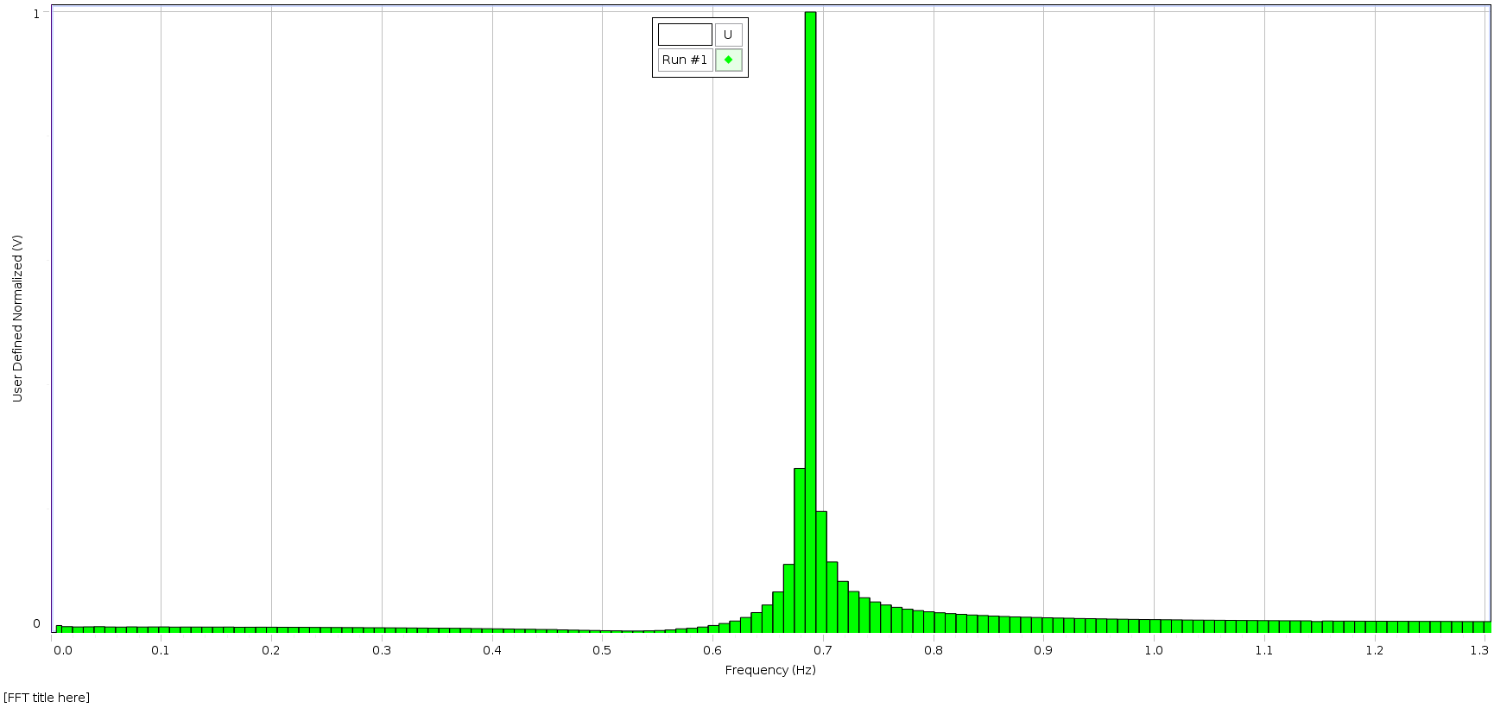

**Figure X, Title:** this is a fft (expand) for undamped oscillation

Agrees with its experimental frequency. Our calculated value was (0.691 ± 0.014) Hz and the plot also shows that the data is centered around 0.69

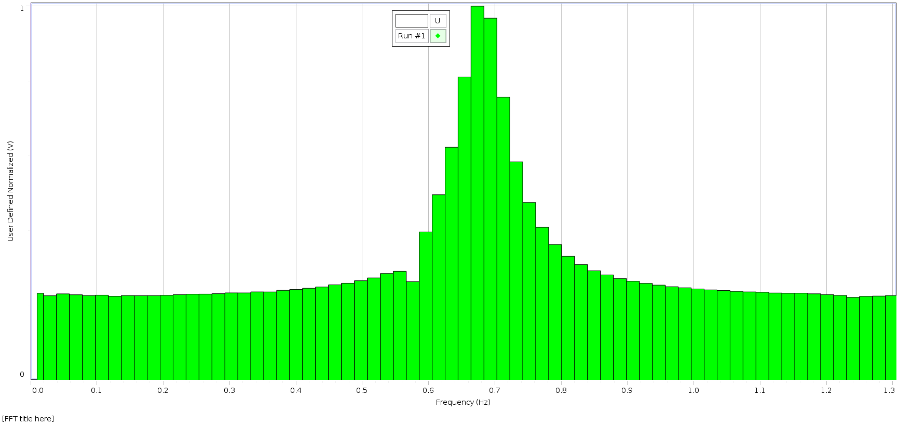

**Figure X, Title:** this is a fft (expand) for damped oscillation

This also agrees with the calculated value of experimental frequency, which was (0.691 ± 0.02) Hz. The plot is also centered around this point.

**Conclusion**

This purpose of this experiment is to investigate the resonance frequencies of undamped and damped oscillations. We attached a spring with a mass on one end to a force sensor. The mass has magnets surrounding it to produce a damping effect. We first needed to calculate the spring constant of the spring we were using. To do this, we hung various masses to the free end of the spring and measure the distance from the end of the spring to the floor. We plotted these points in Figure X*** and found a trendline. The slope of the trendline is the value of our spring constant: (3.328 ± 0.009) N/m. The slope that we found was actually negative. This is because we measured the distance from the end of the spring to the floor instead of measuring the length of the spring for convenience and accuracy. This way we did not need to hold up the meter ruler, and we were able to avoid the extra uncertainty holding it up would have caused.

In the second part of the experiment, began taking measurements from the oscillating mass trials. We pulled the mass down and released it and recorded the voltage readings produced by the force sensor as the mass oscillated up and down. In the first trial, we looked at undamped oscillation. We used a derived definition of oscillation frequency to produce a value to use as a reference point for our experimental results. Our predicted frequency is (0.696 ± 0.002) Hz. From our undamped trial, we observed a resonance frequency of (0.691 ± 0.005) Hz.

For the undamped trial, we set up our equipment so that the mass would oscillate within an aluminum tube. The interaction between the magnets on the mass and the surrounding metal tube produced the damping force. In this trial, our data produced an oscillation frequency of (0.695 ± 0.015) Hz. The damping time is the time it takes for a damped oscillation to decay by a factor of 1/*e*, and the quality factor describes the damping in an oscillating system. Through derivations of their equations, we also found that the damping time has a value of (4.22 ± 0.09) s and the quality factor is 9.23 ± 0.20.

The frequencies for our damped and undamped oscillation trials both fall within the error window of the predicted value. The uncertainty is higher in our frequency in the damped oscillation trial. This is because the ratio between the system noise and the signal strength is much higher. With our data for the damped and undamped trials, we verified that the resonance oscillation frequency is the same regardless if an object is in simple harmonic motion, or if its oscillation is damped.

** The quality factor of our fft graphs are …. We probably shouldn’t have normalized them because

There are a few possible sources of error in this experiment. While the mass is oscillating, the air resistance causes a slight damping, even in the undamped oscillation trial. This was the reason for the decrease in amplitudes over time in the undamped case. Another source of error may be that we did not pull the mass perfectly downwards. In both of the trials, the mass had horizontal motion in addition to its vertical motion. The spring also had a vibration that may have caused a difference in the experimental frequency results between the undamped and damped trial.

We can improve the experiment by having a mechanism that releases the mass for us to eliminate any extra horizontal motion that could affect the results of the experiment. Doing the experiment in a vacuum would allow us to produce simple harmonic motion in the undamped case. If we did this, the experimental frequency would be exactly the same as the predicted frequency. Additionally, a digital scale to measure masses would reduce the uncertainty in the measurement, which would propagate to our other calculated values and reduce their uncertainties as well.

**Bibliography**

1. Campbell, W. C. et al. Physics 4AL: Mechanics Lab Manual (ver. June 27, 2018). (Univ. California Los Angeles, Los Angeles, California).