PROJECT TWATTER

Software Engineering
Software Requirements Specification
(SRS) Document

Group 4
Ahror Abdulhamidov
San Jose State University
September 16th, 2020

Table of Contents

Title Page 0
Table of Contents 1
Preface 2
Glossary 3
1. Introduction 4
1.1 General description 4
1.2 Business context 4
1.3 Development process 4
2. Functional Requirements 5
2.1 User Requirements 5
2.2 System Requirements 6
3. Use Cases 7
4. User Interface Requirements 8
4.1 Use-case model 8
4.2 GUI design 9
5. Non-functional Requirements 11
5.1 Performance 11
5.2 Security 11
5.3 Maintainability 11
5.4 Portability 11
5.5 Standard complience 11

Preface
Version | Primary Author(s) | Description of Version | Date Completed
Draft 1 | Ahror Abdulhamidov | First draft including basic functional and non-functional requirements and description | 09/17/20

Glossary

App – Application
Twitter – popular blog posting website
SJSU – San Jose State University
Front-end – the practice of converting data to a graphical interface
Back-end – server side of an application and everything that communicates between the database and the browser
HTML – Hyper Text Markup Language
CSS – Cascade Style Sheet
PHP – Hypertext Preprocessor, general purpose scripting language, used primarily for web-development
Laravel – popular open source PHP based web-development framework

1. Introduction

1.1 General description
This software project “Twatter” is a short blog posting web application intended for public use. In general, it is a Twitter clone, a more simplistic and minimalistic version of it. It allows users to register / sign in to the system, post messages or short blogs online that can be viewed by others. In addition, users can follow other users, and therefore, have their posts on their personal feed. Users will also be able to like other people’s posts.

1.2 Business context
This project is under development of a single person team from San Jose State University and is sponsored by the University. This software is mostly intended for introducing the students with concepts of Software Engineering, however, it could be potentially upgraded and taken to the market. This software is intended for use by general public, and the profits could be potentially made from advertisement usage.

1.3 Development process
Currently, the development team is under training. The development of this application will begin on September 18th, 2020, or before. Initial prototype will be ready by the end of October. The prototype will reach its final phase with the first release of the application by the end November.

2. Functional Requirements

2.1 User requirements:
- User shall be able to register a new account in the system. He will be able to use his email to register, and add his name and profile picture to the profile. The user shall not be able to use the same email to create multiple accounts.
- User shall be able to reset his account password in case if he forgot it or just wants to change it.
- User shall be able to sign in with his registered account after which he will be able to use the application at its full potential.
- User shall be able to change his profile information at any time.
- User shall be able to find other people on Twatter.
- User shall be able to subscribe to other people on Twatter, and they can do the same for the user.
- User shall be able to view his followers (people who follow the user) and followings (people whom he follows).
- User shall be able to view his feed where it shows the posts from the user and his following people.
- User shall be able to post messages on his feed. The messages will be viewable for everyone on Twatter, and they shall appear on the user’s and his followers’ feed.
- Users will be able to like each other’s posts.

2.2 System requirements:
- The system (web application) must be able to display main page, authentication page, and profile page.
- The system must be able to display a user’s and his following users’ posts on his feed, sorted from the most recent to older tweets.
- The system must be able to display each posts message, author, time, date, and number of likes/dislikes.
- The system must be able to display a user’s followers and followings and allow him to follow another user.
- The system must be able to search through users by their names when requested by a user.
- The system must be able to store and keep track of the data: users, posts, etc.

3. Use Cases

Case 1:
User registers a new account using his personal email, sets a name / nickname. Then, he goes to his email to confirm the registration and goes back to Twatter. On Twatter, he sees his feed, which is empty, and then he goes to his own profile. He sets a profile pictures for himself. Then, he clicks on the search tab and searches for someone he knows. The system provides him with several results and he chooses the right one, views his feed, subscribes to him. Now he goes back to the main page and views the feed. This time, feed is not empty, he can see the posts of the person that he follows, which are sorted from newest to oldest.

Case 2:
User tries to log in, but the system says that he put wrong password or username, so he clicks “reset password” link. He provides his email, the system sends reset link to his email. The user clicks on that link, resets his password, and logs in back to Twatter as usual.

Case 3:
User logs in to Twatter, views his feed and likes some of the posts there. He then creates his own post and sends it for public to view. His followers see his post on their feed, and some of them click like on it. Later, the user is able to see the likes that he got.

4. User Interface Requirements

4.1 Use case model
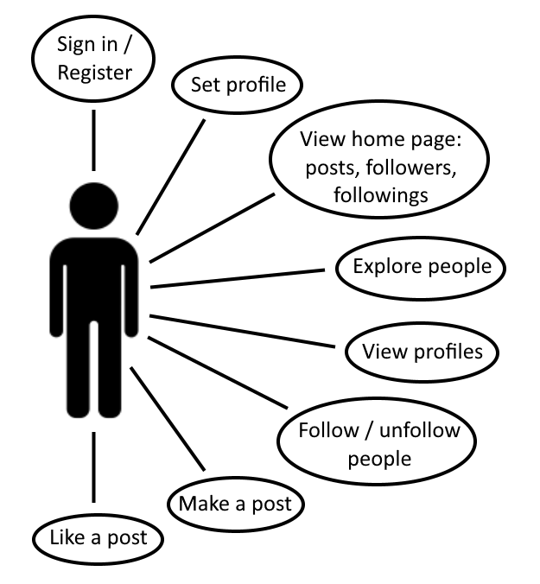

4.2 GUI design:
1) Authentication page:
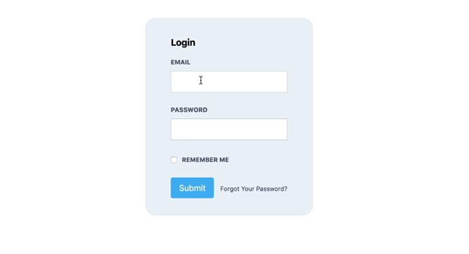
2) Home page (Twatter feed) 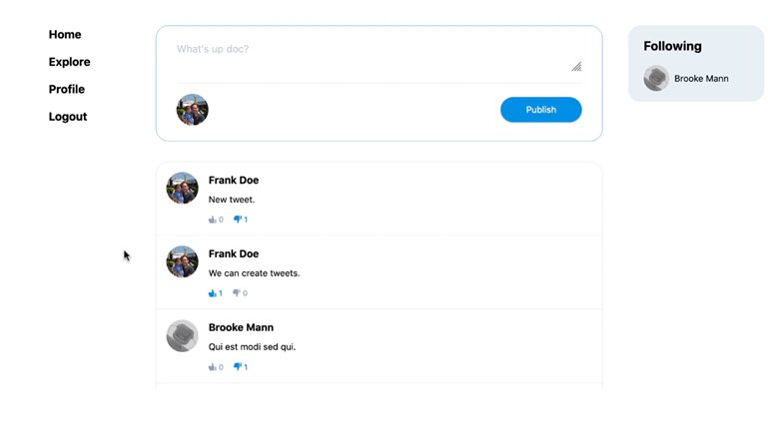

3) Profile page
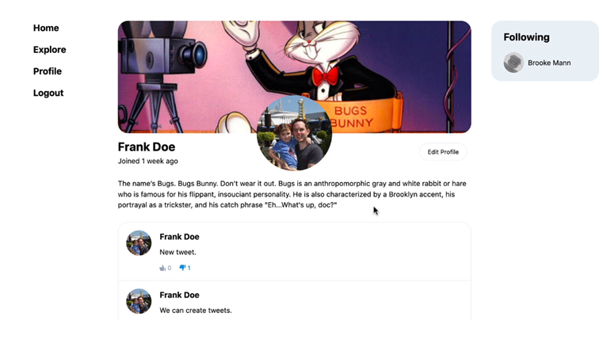
4) Explore page
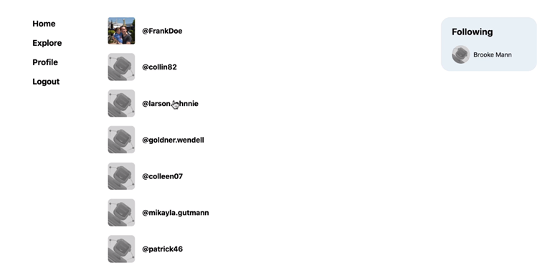

5. Non-functional Requirements
5.1 Performance
The web application server will run on a Dell Precision workstation laptop connected to a stable internet connection. The application will take about 500 MB on the server side initially and 2 GB later on, and the internet connection will need to be stable for it to work. Current server is able to take heavy workload. The application will also be able to scale to the size of the country as its size increases.
5.2 Security
Users will be able to log in and register using their real emails. The web application will follow standard web protocol security procedures which will covered by the Laraval framework and the developers of this application. The server will be under protection of its owner who is the developer of this application.
5.3 Maintainability
The development team will follow the best practices for clean, secure, and efficient code and maintain software’s modularity in order to make the application as secure and efficient as possible.
5.4 Portability
The application server side can be run on Windows / Linux / Mac OS computer, while for the users, it will be accessible through any smart device with modern browser and stable internet connection.
5.5 Standard compliance
Our application will follow the web standards of the World Wide Web Consortium (W3C). There will be no discrimination regarding who will be using our application, and their posts on the application will be protected under the Freedom of Speech.

