“Access Form” Final Year Project Guidelines

Software Requirements Specification

Version 1.0



Group Id: <F25PROJECT6110B>

Supervisor Name: <Mr. Abdullah Qamar>

Revision History

Date (dd/mm/yyyy) | Version | Description | Author
29/11/2025 | 1.0 | - Scope (of the project).  - Functional Requirements Non Functional requirements.  - Use Case Diagram.  - Usage Scenarios.  - Adopted Methodology.  - Work Plan (Use MS Project to create Schedule/Work Plan) | BC240219507

Table of Contents

- Scope (of the project).
- Functional Requirements & Non Functional requirements.

- Use Case Diagram.
- Usage Scenarios.

- Adopted Methodology.

- Work Plan (Use MS Project to create Schedule/Work Plan)

- Scope of Project:

The objective of this project is to design and develop Access Form, a web-based survey builder application that places web accessibility at its core. Unlike conventional tools such as Google Forms or SurveyMonkey, Access Form is specifically designed to ensure that surveys are inclusive, usable, and accessible to all individuals, including those with visual, hearing, motor, or cognitive impairments.

The project highlights strict compliance with the Web Content Accessibility Guidelines (WCAG 2.1). Students are expected to actively consult, interpret, and apply recognized accessibility standards and best practices throughout every stage of the design and development process.

A fully accessible web-based survey builder application, ensuring equal participation and usability for all users. Build a survey builder web application with accessibility-first design. Ensure all user interactions support keyboard navigation, screen readers, and high-contrast modes. Provide alternative input/output options (voice, SMS, captions, alt text). Deliver an analytics dashboard with accessible data visualization. Apply recommendations from official accessibility guides (e.g., WCAG, ARIA practices)

- Functional and non Functional Requirements:

Functional Requirements:

User Roles

Admin Panel: Manage users, monitor surveys, and oversee accessibility compliance.
Form Creator Panel: Build surveys, customize accessibility settings, and distribute forms.
Respondent Panel: Complete surveys via web, mobile, voice, or SMS.

Form Creation and Accessibility Features

Drag-and-drop survey builder for form creators.
Support for question types: multiple choice, text input, rating scales, file upload.

Accessibility enhancements:

- Keyboard-only navigation
- Screen reader compatibility (ARIA attributes).
- High-contrast and dyslexia-friendly themes.
- Alt text for images.
- Captioned or sign-language video support.

Response Collection and Adaptation

Web responses through any browser.
Voice-based responses (speech-to-text integration).
SMS-based participation for users without internet access.

Analytics and Reporting

Accessible dashboard for form creators
Screen reader–friendly graphs and tables.
Export in multiple formats (CSV, Excel, PDF).

Non Functional Requirements:

In software system engineering, a software requirement that describes not what the software will do, but how the software will do it, for example, software performance requirements, software external interface requirements, software design constraints, and software quality attributes.

Non-Functional Requirements are listed below.

Performance - Response Time, Throughput, Utilization, Static Volumetric
Usability: The system will be User Friendly.
Availability: The System will be available 24 hours.
Efficiency: The System will be efficient
Reliability: The System will be able to complete its on-going operations in spite of any error or problem within defined response time.

- Use Case Diagram(s):

- Usage Scenarios: -

Use case title | Register
Use case id | Uc-01
Description | In this use case form creator / user will register themselves using valid credentials to access the application.
Pre-conditions | Form creator / User will access to the registration functionality.  Application will be accessible and operational.  Form creator / User will have valid email and contact information.
Actions | Form creator / User will provide the required information in the registration form and submit it.  System will validate the provided data for completeness and accuracy.
Exceptions | N/a
Post conditions | Form creator / User will successfully receive the notification regarding the registration statue.
Alternative paths | N/a
Author | Bc240219507

Use case title | login
Use case id | Uc-02
Description | In this use case user will login using valid login id and password to access the application.
Pre-conditions | Admin / Form creator / User will have valid accounts within the system.  Database will be available.
Actions | Admin / Form creator / User will open the application.  They will enter their valid details through login form and submit it.  System will verify the information and provide access to the application.
Exceptions | N/a
Post conditions | Admin / Form creator / User will successfully login to application.
Alternative paths | N/a
Author | Bc240219507

Use Case Title | Manage Users / Manage Form Creators
Use Case Id | UC-03
Description | Admin can view, add, edit, or deactivate normal users. Admin oversees all form creator accounts.
Pre-Conditions | Admin must be logged in..
Actions | Admin opens "Manage Users".  Views list of users.  Selects user to edit/add/remove.  Approves, rejects, or updates creator accounts.  Saves changes.
Exceptions | N/A
Post Conditions | User records are updated in the database.
Alternative Paths | N/A
Author | Bc240219507

Use Case Title | Manage Surveys
Use Case Id | UC-04
Description | Admin can monitor, activate, deactivate, or delete surveys.
Pre-Conditions
  Admin logged in.
Actions | Opens “Manage Surveys”.  Views survey list.  Selects any survey.  Performs action: delete/disable/inspect
Exceptions | N/A
Post Conditions | Survey status updated.
Alternative Paths | N/A
Author | Bc240219507

Use Case Title | Manage System Settings
Use Case Id | UC-05
Description | Admin configures system-wide preferences.
Pre-Conditions | Admin logged in.
Actions | Admin opens settings.  Updates branding, accessibility defaults, SMS/voice API settings.  Saves.
Exceptions | N/A
Post Conditions | Modified system settings applied globally.
Alternative Paths | N/A
Author | Bc240219507

Use Case Title | Manage System Analytics
Use Case Id | UC-06
Description | Admin views system-wide statistics
Pre-Conditions | Admin logged in.
Actions | Admin opens analytics dashboard.  Views charts, user activity, survey counts.  Applies filters.
Exceptions | N/A
Post Conditions | System displays updated accessible analytics.
Alternative Paths | N/A
Author | Bc240219507

Use Case Title | Generate Reports
Use Case Id | UC-07
Description | Admin exports system-wide reports.
Pre-Conditions | Admin logged in.
Actions | Opens “Reports”.  Selects report type.  Chooses format (PDF/Excel/CSV).  System generates file.
Exceptions | N/A
Post Conditions | Report is downloaded/exported.
Alternative Paths | N/A
Author | Bc240219507

Use Case Title | Create Survey
Use Case Id | UC-08
Description | Creator designs a new survey.
Pre-Conditions | Creator logged in.
Actions | Opens builder.  Add questions using drag-drop.  Saves survey.
Exceptions | N/A
Post Conditions | Survey draft stored in system
Alternative Paths | N/A
Author | Bc240219507

Use Case Title | Apply Accessibility Settings
Use Case Id | UC-09
Description | Creator applies WCAG features.
Pre-Conditions | Survey created
Actions | Opens accessibility panel.  Enables ARIA labels, contrast modes, alt text, etc.
Exceptions | N/A
Post Conditions | Survey becomes accessibility-enhanced.
Alternative Paths | N/A
Author | Bc240219507

Use Case Title | Preview Survey / Publish Survey / Share Survey / View Responses
Use Case Id | UC-10
Description | Creator tests how the survey will appear. Makes survey live for respondents. Creator distributes the survey link. Creator checks submitted answers.
Pre-Conditions | Survey must exist.
Actions | Clicks “Preview”.  System shows live.  Clicks Publish.  System activates survey  Chooses share option.  Copies link or downloads QR.  Opens Responses tab.  Filters, views lists, details.
Exceptions | N/A
Post Conditions | Creator successfully perform all tasks.
Alternative Paths | N/A
Author | Bc240219507

Use Case Title | View Analytical Report
Use Case Id | UC-11
Description | Creator views accessible statistics
Pre-Conditions | Responses exist.
Actions | Opens Analytics Dashboard.  Views charts, tables.  Applies filters.
Exceptions | N/A
Post Conditions | Analytical insights displayed.
Alternative Paths | N/A
Author | Bc240219507

Use Case Title | View Survey / Switch Accessibility Modes
Use Case Id | UC-12
Description | User opens the accessible survey. User changes mode (high contrast, dyslexia font, large text).
Pre-Conditions | Survey must be published.
Actions | Clicks survey link  System loads survey.  User selects desired mode.
Exceptions | N/A
Post Conditions | UI updates to selected accessibility mode.
Alternative Paths | N/A
Author | Bc240219507

Use Case Title | Navigate with Keyboard / Use Screen Reader Compatibility
Use Case Id | UC-13
Description | User fills the survey using keyboard keys. System announces content using ARIA labels for blind users.
Pre-Conditions | Keyboard navigation enabled.
Actions | Uses TAB, arrows, Enter to answer.  User moves through fields and hears labels.
Exceptions | N/A
Post Conditions | User completes navigation using keyboard and Survey becomes fully readable through audio.
Alternative Paths | N/A
Author | Bc240219507

Use Case Title | Submit Responses / Answer via Speech / Answer via SMS / Submission Confirmation
Use Case Id | UC-14
Description | User submits answers through web. User speaks answers; system converts to text. User replies to survey via SMS. System confirms that responses were successfully submitted.
Pre-Conditions | User must be logged in.
Actions | Clicks submit, system validates, stores data.  User speaks system captures speech converts fills answer.  User sends SMS answer  System shows confirmation page or SMS reply.
Exceptions | N/A
Post Conditions | User send, view and receives confirmation message.
Alternative Paths | N/A
Author | Bc240219507

Use Case Title | Logout
Use Case Id | UC-15
Description | This use case describes admin / form creator / user will logout from an application and will terminate their current session.
Pre-Conditions | 1. Admin / Form creator / User will be logged into the application.  2. The application provides a functionality to logout.
Actions | Admin / Form creator / User will navigate to the account settings in the application and select the logout option.
Exceptions | N/A
Post Conditions | Admin / Form creator / User will successfully logout from the application.
Alternative Paths | N/A
Author | Bc240219507

5. Adopted Methodology:-

Methodology is a framework that is used to structure control and process of developing information system. VU process model is a combination of Water Fall model and Spiral model.

Water Fall Model:

This model is also known as linear sequential model because of starting with one stage then onto the next. This model is known as Water Fall model.
Water fall model is depicted in following diagram.

Requirement Definition
System and software design
Implementation and unit testing
Integration and system testing
Operation and maintenance

It recommends a systematic, sequential approach to software development that begins at system level and progresses through the analysis, design, coding, testing and maintenance. No phase is complete until the documentation for that phase has been complete.

Spiral Model:

Spiral model is Water Fall model with risk analysis. In that case each stage is preceded by identification of alternatives and risk analysis, and is then followed by evaluation and planning for next phase. Spiral model is depicted in following diagram.

Rapid Protoype

Specification

Design

Implementation

Verify

Risk Analysis

VU Process Model:

Having detailed knowledge of Water Fall model and Spiral model, and keeping in view nature of my project, I choose VU process model that is the combination of Water Fall model and Spiral model. It explains the simplified description of software processes in iteration to avoid maximum risk, Both spiral and water fall methods combine to develop a hybrid approach of system development that maximize the quality of the system and minimizes the risk and disadvantages to enhance the results of the system.

Requirements
Analysis
Design
Development
Testing
Acceptance

Reasons for choosing VU Process Model:

- VU Process model has benefits of probability from the signs based planning of Water Fall model as well as the benefit of feedbacks and creativity from Spiral model, so there are some following reasons.
- The VU process model is documentation- driven model. It therefore generates complete and comprehensive documentation and hence makes the maintenance much easier.
- VU process model works on phases so it is better to complete our project. It is sequential Model with backward repetition
- All activities are performed in sequence in vu process model.
- Another reason for choosing vu process model is we will do correction or maintenance at any stage whenever necessary.

6. Work Plan (Use MS Project to create Schedule/Work Plan):-

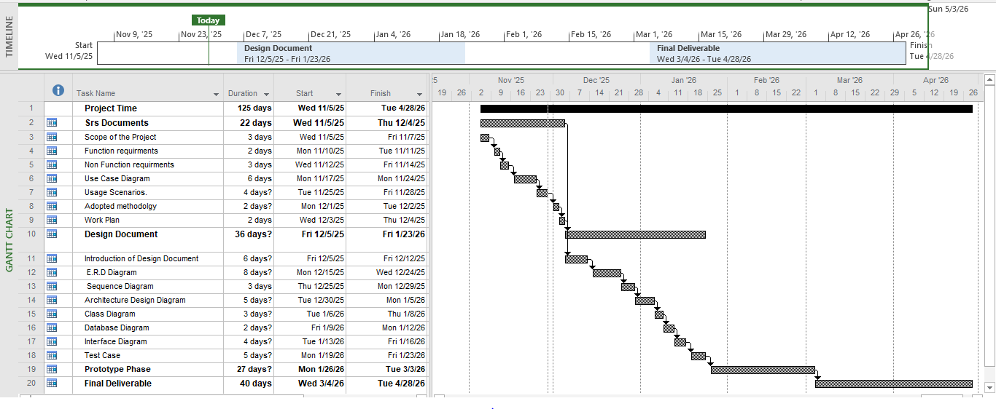

The END

