

Glarista-shopping at glance

Business Plan



May 5, 2018

TEchnology Entrrepreneurship



Contents

Executive Summary: 2

General Company Description: 2

Mission Statement: 2

Goals and Plan: 2

Product/Service Description: 3

Equipment Description: 3

Competitve Advantages 5

The Opportunity: 5

Market and Industry Analysis 5

Global Trends: 5

National Trends: 6

Local Trends: 7

PESTLE ANALYSIS: 7

Market Segmentation and Target Market: 9

Marketing Plan 9

Marketing Strategies: 9

o Product 9

o Price 9

o Place 9

Promotions 9

Sales Forecast: 10

SWOT Analysis: 10

Management Plan: 11

Organizational Structure: 11

The Team: 11

Financial Plan: 12

Conclusion: 12

Appendixes: 13

Marketing Material: 13

FB Page: 13

Banner: 13

Broucher: 14

Financial Statements: 15

Balance Sheet: 15

Income Statement: 15

# Executive Summary:

Glarista is an online shopping platform which intends to provide the flexibility of shopping comfortably while preserving the real charm of shopping. Online shopping has become pervasive given the technological resources we have it requires more refurbishment this is where Glarista comes in to play. We are planning to design 3D models of shops located in the congested markets of sukkur which can be accesed via VR glasses remotely while sitting comfortably at homes.

It is a startup business which consists of 5 owners. Being the computer science graduates we see a great potential in our technology taking into consideration the lack of awareness about technologies in Pakistani market which can add value in their business to great extent. Also the congested market areas in sukkur speaks volume for such a solution which reduces the overhead of wondering in schorching heat of sukkur and adds value in terms of comfort, speed and accessibility.

Currently we are targeting the shops in near by localities of shahi bazar in sukkur. In sukkur our major focuss is on those women who are not so comfortable with wondering in the narrow streets especially in hot summers further filteration has been applied on various factors such as per month income since we are targeting the middle class families, educational element since those using our app must be comfortable with technology.

Our business will start on January 1st 2019 with the start-up money of 1000000 .Our initial capital will be contributed from owners of the business and from our investors. Our early sales are 2300000. At initial stage of our business, we have lesser growth but after many marketing efforts and creating awareness among people our sales are increasing. Our marketing strategies will be implemented 4 months before the start of our business. If implemented as of the current projections inshallah we’ll come up with satisfying results.

# General Company Description:

## Mission Statement:

**“ Our mission is to modernize the current online shopping system using the tools of technology which surely adds value in terms of comfort, speed and accessibility for those who are resistant to crowded places and those who wants to enhance their online shopping experience.** “

## Goals and Plan:

**Goal1: Add new Products**

**Plan:** Every year we will be adding new domain in our virtual Mall such as Men’s shopping, Gold shopping.

**Goal 2:** To incorporate with the Branded Shops

**Plan**: Well will make a contract with the branded shops after 2 years like J,J, Ideas, Nishat Linen so that our customers which are living outside Sukkur can virtually shop from them.

**Goal 3:** To capture the market of Larkana “Resham Gali”.

**Plan** : As sukkur’s Shahi Bazar, Larkana also have a congested Market “Resham Gali” from which many women are willing to buy but thsese congested areas cause them problems. After 5 years our target will be the virtual conversion of Resham Gali into Mall.

**Goal 4**: Add new customers

**Plan** : After 8 years we will be including Dolmen and Hyperstar Mall of Karachi for virtual shopping so that the customers of interior Sindh can shop from these Malls by sitting at home.

**Goal 5**: Increase Sale by 30%

**Plan**: Including Malls of Karachi for virtual shopping will increase our sale upto 30% by our existing customers.

# Product/Service Description:

A visual experience of shopping of unbranded clothes especially of the congested Markets where it is difficult for the women to shop in such hot weather. There will be a virtual Mall of these nonproprietary shops at one place so that you can buy all required stuff in one place, wander in streets without putting effort at congested areas. You can wander around a store, look through items, and add things to a cart by staring at a product for long enough. You can select objects marked with floating blue dots, revealing the item’s description and price. And all your selected stuff will be delivered to you at your home by us without spending a penny on your travelling.

Our product includes:

1. A virtual Mall of nonproprietary shops of women’s clothing.
2. User friendly Environment for shopping.
3. Virtual Experience of streets, shops.
4. Varieties of unbranded clothing from our brand.
5. Delivery of your stuff at your home.

# Equipment Description:

The equipment’s that is mandatory for our product, most of us have one equipment that is common “Mobile” and rest of them are required to build our product. For example, VR glasses, Mobile app, platform for development. The languages we are going to use that are below.

**VR glasses:** It requires no technical knowledge, it is reliable and It cost up to Rs.650 from #AliBaba_shopping.

VR BOX 2.0 VR 3D glasses with Bluetooth Gamepad

1. 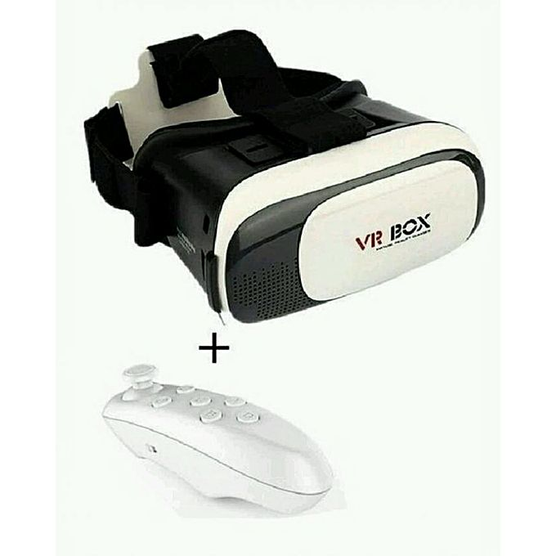

**Platform:** Visual studio

**Android version:** Marshmallow, nougat and upward.

**IOS version:** IOS 11 or above

**Language:** C#

**MobileApp:**

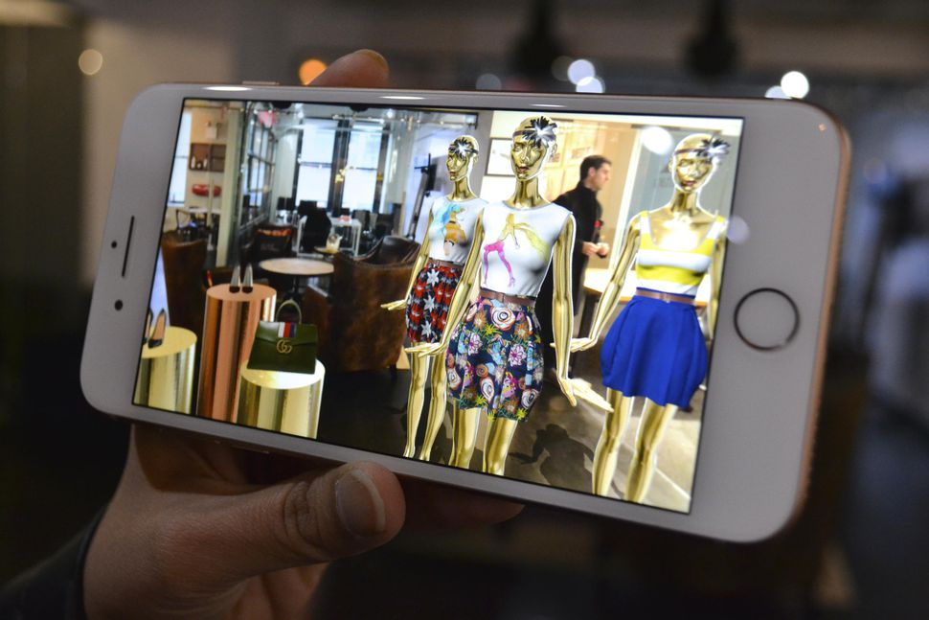

## Competitve Advantages

We are providing the virtually comfortable and user-friendly environment for women for whom it is difficult to go out in congested areas of Sukkur but want to shop these unbranded clothes of their own choice. Beside this that shopped stuff will be delivered at the doorstep of the customers but that stuff will be in hands of customers by virtually visiting Mall not just selecting item from a website.

# The Opportunity:

* No Virtual Shopping Centre in Sukkur
* Following three causes the main problem for women to shop
  1. Hot Weather of Sukkur.
  2. Congested Areas of Shahi Bazar.
  3. No time to go for shopping to market.

# Market and Industry Analysis

## Global Trends:

The idea is to develop a real-time immersive shopping experience, where customers can walk though virtual shops, examine virtual versions of real-life products and make purchases like they would in the real world. We want to create an immersive experience to enable consumers to enjoy online shopping just the way they would do in the real-life stores. And this development is started by London-based startup [**Trillenium**](http://www.trillenium.com/).

There is international company **MyMall**  which first launched VR shopping in 2008 in the UK on a Beta test. It achieved over 1 million visitors in the first 90 days and won the praise of many retailers and the media alike. According to MyMall Ecommerce sales will reach $4 trillion by 2030 of which 80% will come from VR.

[IKEA(a Swedish Company) has a VR store](http://www.ikea.com/au/en/catalogue-2017/VR_Experience.html) that you can stroll through to gather inspiration for your home interiors and shop for items. And last year, China’s [Alibaba launched Buy+](http://technology.inquirer.net/56131/alibaba-launches-full-vr-shopping-experience-buy), an immersive experience that allowed users to explore a virtual mall and pop into stores like Macy’s to buy a wide range of personal and home products. There is [Urban Ladder’s](https://www.urbanladder.com/)(indian company) giving their customers a new VirtUL experience.

The VR Shopping Mall officially opened in Korea during Korea Sail Fest, which lasts from 28th September to 31st October, 2017

Market researcher SuperData scaled back its virtual reality forecast for 2016, particularly after a disappointing launch of the PlayStation VR headsets. But it still believes that consumer VR software could grow from $407 million in revenue in 2016 to $14 billion by 2020.

The wall between VR and shopping will be broken. Actually, Alibaba was a path breaker that created a VR tour for its buyers, although this kind of shopping is still kinda in its infancy. Many predictors believe that the future of VR shopping is directly connected with a continuous growth of the VR industry itself. Without any doubt, for the future of buying clothing online, retailers could have a huge advantage.

#### The scope for Virtual Reality, goes beyond today’s technology which actually helped it to come a long way.  Although it has not yet broken into true mass appeal.

Lastly would like to conclude that

**“Virtual reality is something which is not in real but appears to be real.”**

Online shopping is on the rise—

it’s fast and ships directly to your doorstep, sometimes overnight. But with online shopping, you miss the experience of going into a store and picking up items. Enter virtual reality shopping, which tries to give you the convenience of online shopping and the experience of being in a store.

## National Trends:

Virtually Reality(VR) or Augmented reality(AR) is surely going to be the next replacement for the word future. However, it's startup implementations are very limited in Pakistan.

Given the technology advancement in terms of network speed, high-performance hand-held devices and most importantly to keep up with growing trend of technology to make business more commercially viable, VR has great potential to makes up its place in Pakistani markets.

specifically, it’s application in shopping speaks volume of its necessity. Because nowadays, everyone is busy in social and professional life, also the metropolitan cities, which are often too crowded and issue of personal security is of greater importance. This clearly requires something which certainly sounds more secure as well as comforting.

Currently, some of the high profile clothing brands have implemented the concept of Augmented Reality, which is somehow satisfactory. However, it has some limitations, since it lacks the originality of real shopping and often the products they are offering are limited on their related websites.

In this case, the concept of VR Shopping has great potential to be expanded since it let the customer to experience the real charm of shopping and that too with maximum comfort.

## Local Trends:

Surely, the Virtual Reality is going to take over most of the market in near future. However, the ques of its sustainability in sukkur is of greater concern. No doubt sukkur is growing day by day in terms of business and most of its business relies on the people situated in its nearby vicinity. Such as shikarpur, khairpur etc.

The people in those vicinities have surely some lacking when it comes to technology which is going to be a great challenge for the outreach of this product. However, it would be more convincing for them to be rather comfortable with technology than travelling longer distances with intervention of VR shopping one can visit the malls of sukkur while sitting comfortably at their homes.

### PESTLE ANALYSIS:

#### Political Forces

The concept of VR shopping comes under the umbrella of e-commerce.

There are several risk factor affecting the e-business, for example for the global leaders like

Amazon and e-bay growth in Asia pacific region can be made difficult by the red-tape, similarly in our case, platform like VR shopping can be easily implemented given the resources we have in technological sectors which can only operate under the the surveillance of Government agencies making it more cost sensitive in the light of taxation laws etc.

The political and regulatory challenges before the e-business have kept rising. The growth of e-commerce in EU has been challenged by political factors.

EU has kept targeting technology giants from US. In small technological startups like that of VR shopping can easily be challenged like controlling the networks speed which is very important in such businesses.

Political issues are not limited to just those discussed above what there are many more. Political stability in most region of the world leads to economics stability. Political chaos can result to destruction of business both online and physical.

overall political issues can have a significant impact on e-commerce and its growth.

#### Economic Forces

Pakistan is still largely a cash-based, informal economy. The economy of Pakistan is [42nd largest](https://en.wikipedia.org/wiki/List_of_countries_by_GDP_(nominal)) in terms of nominal [gross domestic product](https://en.wikipedia.org/wiki/Gross_domestic_product) and [Pakistan](https://en.wikipedia.org/wiki/Pakistan) has a population of over 207 million (the world's [5th-largest](https://en.wikipedia.org/wiki/List_of_countries_by_population)), giving it a nominal [GDP per capita](https://en.wikipedia.org/wiki/GDP_(nominal)_per_capita#Per_unit_GDP) of $1,629. People spend quality of money for their shopping and opt for ease of shopping. Despite inflation rate of 3.80 percent recorded in February 2018, shopping is continued on peaks on occasions like Eid and festivals. So spending money on purchase of VR technology for virtual shopping which saves money of travelling to different cities is no more a problem to people.

#### Social and Cultural

Science fiction is often a leading indicator of innovation. In the Digital Era, the line between science fiction and reality is blurring. If it can be imagined, it can be built. The rapid innovation in the Digital Era has had significant **social** and **cultural** impacts.

In this case, the lifestyle affects by the VR shopping that maintain our humanity within the boundary of specific religion , for those who don’t allow their families to go for shopping in different cities or problems of travelling and having they can adapt new style of life using VR shopping within at their homes.

Indeed, Culture of Pakistan most of us follow the western or eastern culture and put through and use the things are used by actors and celebrity within the Pakistan and across all over the world. VR shopping potentially crossing geographical platform for adapting their way of living in Pakistan with not lot of efforts required.

#### Technological Forces

The technology is changing day by day with the new innovation and idea in whole world including Pakistan as technology changes with the interest of people with the trend that is currently prevailing in the country. According to The World Bank, the number of people using internet in Pakistan has increased from 6.8% to 18% during 2007 to 2015. Presently, Pakistan is ranked 19th out of 210 countries in terms of internet users with 30 million internet surfers. People invest force preferably to buy [Online home shopping in Pakistan from](http://www.storemass.com/) daraz.pk, kamyu.pk and other sites. Virtual reality immerses consumers in sensory and personalized experiences, empowering them to interact with products and services online. With mobile devices capable of delivering rich VR experiences, shoppers can tour a store or try on a new fashion anywhere, at any time.

#### Environmental Forces

Pakistan’s weather is getting very extreme day by day especially of interior areas where in summer temperature reaches to almost 50°**C.** The highest temperature ever recorded in Pakistan is 53.5 °C (128.3 °F) which was recorded in Sindh on 26 May 2010. And with the narrow and jam-packed streets in small cities and town it becomes quite hazardous to go for shopping in such extreme and hot weather. Shopping from home but virtually at store makes it easy to cope with such weather which will also save fuel burning and contribute in fight with global warming.

## Market Segmentation and Target Market:

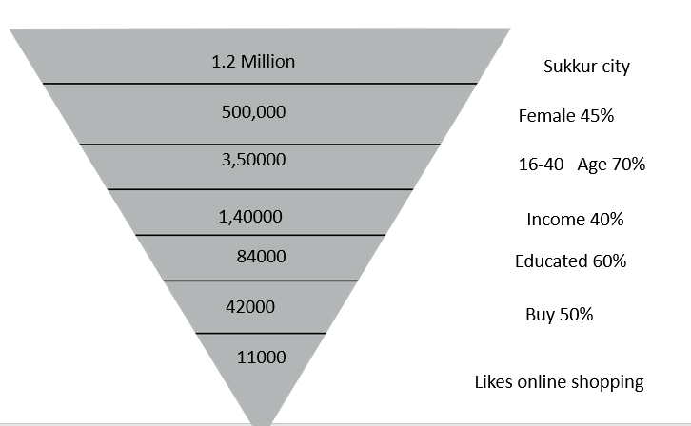

# Marketing Plan

## Marketing Strategies:

* + Product: since we are service selling business our major source of revenue is based on the overall sales of registered stores on our app where a total of 10% is charged on each sale from both the customer and store owner. Going by the nature of Our business marketing strategies will mostly involve attracting audiences by offering certain in demand products also providing sales discount up to certain threshold.
  + Price: since we are new in market also going by the market dynamics in Sukkur people are not so comfortable with technology use so we’ll go with price penetration strategy. Which will give us time to understand the market behavior and act accordingly.
  + Place: since our customer dealing is based on mobile app so we don’t require formalities of physical set up

Promotions: Our business provides the digital solution of the existing problems whch gives us added advantage of advertising our product in an effective way .We are going to promote our product through social network, live events, billboard, banner and brochures etc.

## Sales Forecast:

The following numbers generated by calculating the 10% commission on monthly sa;es from both of the parties. It is estimated on varies factors. Such as, sales in festive seasons, sales due to weather fluctuations etc.

|  |  |  |  |  |  |  |  |  |  |  |  |
| --- | --- | --- | --- | --- | --- | --- | --- | --- | --- | --- | --- |
| Jan | Fab | Mar | Apr | May | June | July | August | Sep | Oct | Nov | Dec |
| 180000 | 150000 | 170000 | 220000 | 218000 | 200000 | 240000 | 160000 | 160000 | 200000 | 320000 | 310000 |

## SWOT Analysis:

* + **Strengths:**
    - * a more comfortable and realistic approach in online shopping.
      * Increased bargaining power of customers since they can access local shops comfortably without walking here and there
  + **Weakness:**
    - Peoples discomfort in adjusting to new technologies
    - Increased cost due to advanced technology with respect to already available online platforms
  + **Opportunities:**
    - Modernizing the current shopping system in which we are lagging far behind due to lack of awareness.
  + **Threats:**
    - Peoples diversion to existing online platforms.

# Management Plan:

## Organizational Structure:

## The Team:

* **General Manager: (Vishal Bhattia)**

Coordinates the daily day to day activities manage funds, assign responsibilities and managing

Over all resources.

IT manager:(Ahsaan)

Manages the technological discreptencies, maintain the overall technological set up in order to run our application platform smoothly.

3D modeling Expert: (Yet to hire)

Helps and prepare the 3D models of shops in Shahi Bazaar.

Network Coordinator (Yet to hire)

Manages the overall network traffic on the websites and on our app.

Finance Manager: (Anoosha Bai)

Manages the overall financial activities of the business.

# Financial Plan:

To start-up our business we need a total of 10,00,000 investments, out of which we will have 500000 as a bank loan, 250000 on account from friends and relatives, 40%(400,000) from venture capitalist and the remaining investments will be done by team members Vishal,Ahsaan,Aftab,Anoosha,Saira.

As expected of first year we will have a net income of 727000 from which investor will have 40%

We are planning to launch it by January 01 of 2019 so we’ll be requiring our financials by july of 2018 since we have to plan for marketing campaign and its execution which requires a very heavy sum.

# Conclusion:

Glarsita is the first mover in the marker of virtual shopping.. Our idea is unique as it is giving the virtually comfortable and user-friendly environment to the women for whom it is difficult to shop in congested areas during the hot weather of Sukkur or for the women to whom time is money and don’t have time to go for shopping of unbranded clothes.

There are a lot of things that make us unique and paves a path for our success one of the most notify able from them is that a women will not need anymore to render in congested areas of Sukkur.

* For the very first time we are introducing Virtual Shopping Mall in the Sukkur.
* Technology innovation and techniques makes us most updated in the market in this region
* At the there is a good profit and interest margin in this business.

The profitability of our business is also good with the initial sales of 2300000. Conclusively, we can say that modern methodologies in shopping and progressive outlook of financials is a positive sign of our business to create trust in investors for our business.

# Appendixes:

## Marketing Material:

### FB Page:

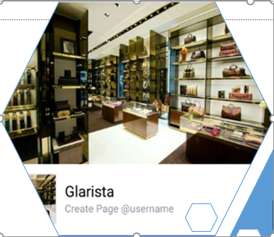

### Banner:

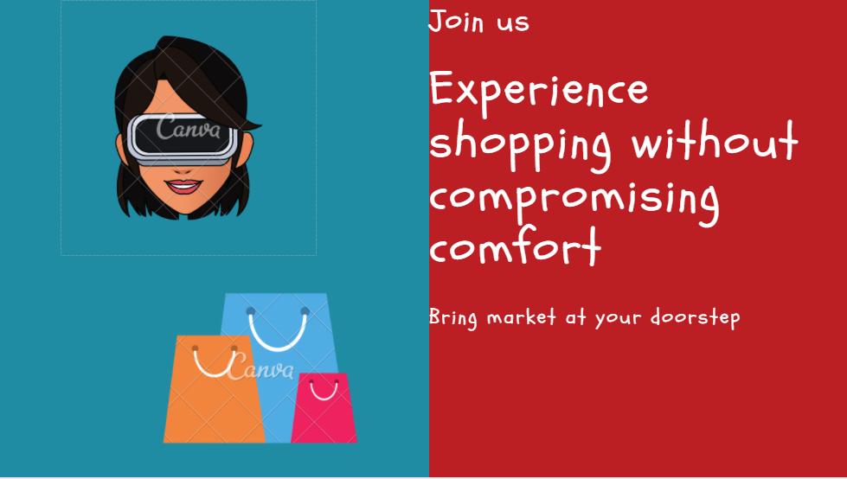

### Broucher:

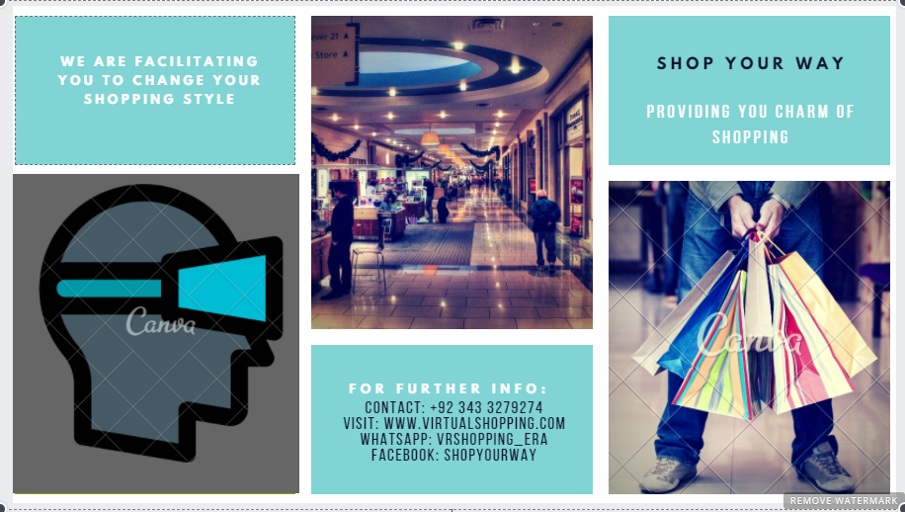

## Financial Statements:

### Balance Sheet:

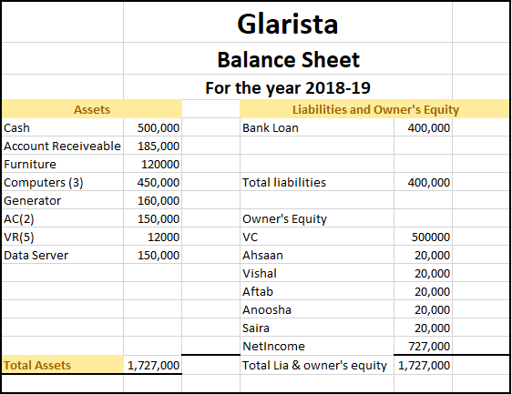

### Income Statement:

