FORMA APP/DASHBOARD NEW – PROVIDE QUOTE FOR COST

- OVERTIME RATE FOR CLIENT AND STAFF (TIES INTO COST CALULATION AND DATA HARVEST)
- TOTAL TIME OF DELAY (TIES INTO DATA HARVEST)
- ADD REIGON INTO STAFF AND CLIENT DETAILS (TIES INTO DATA HARVEST)
- QUANTITIY METRICS ADDED INTO DAILY REPORTING ( SHOWS ON DAILY REPORT AND DATA HARVEST )
- COMPANY ADMIN CAN ALLOCATE SELECTABLE PERMSIONS ON ADMIN WHEN CREATING
- USERS CAN ADD AND SAVE OTHER USERS FOR THEIR DAILY REPORT.
- CREATE SEPARATE PDF FOR COST CALCULATION LOOKS LIKE BELOW

- 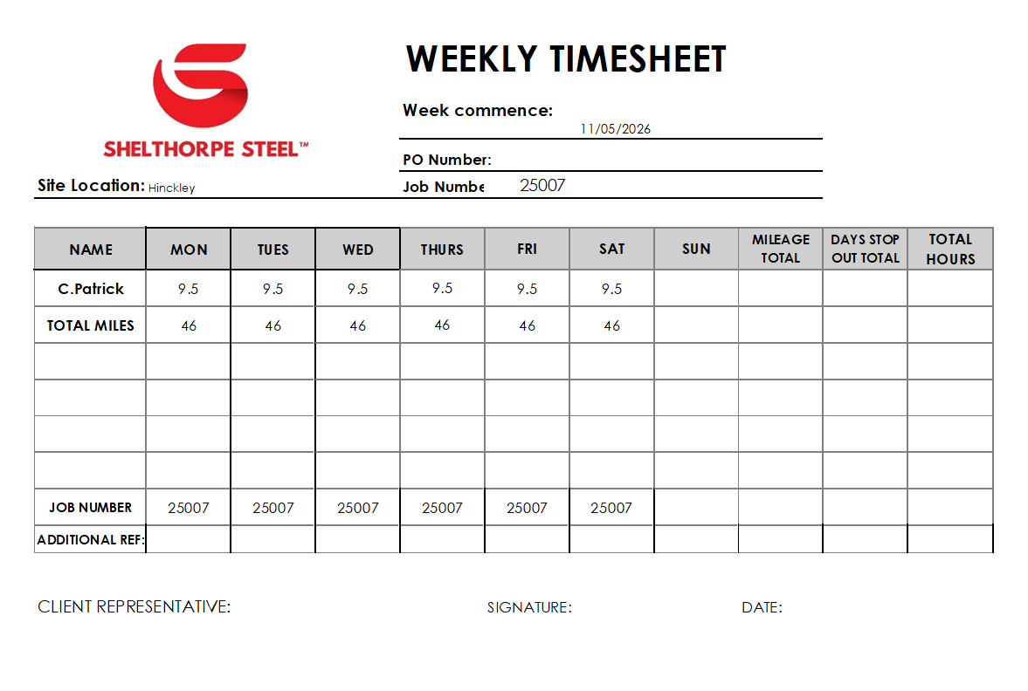

DATA HARVEST

“FILTER BY CLIENT” WILL BE THE COMPANY OWNER ADMINS THAT PURCHASE THE APPLICATION. WE CAN THEN FILTER SEPERATLEY BY THEIR INPUTTED CLIENTS.

IN LABOUR – ADD TOTAL TRAVEL TIME AND MILEAGE BOOKED, TOTAL EXPENSES, TOTAL DELAY TIME

COST – ADD DELAY/STANDING TIME X TOTAL HOURS X HOURLY RATE OF STAFF. SHOW NEXT TO IT CHARGEABLE HOURS = TOTAL DELAY TIME X CLIENT HOURLY RATE COST

IN PRODUCTIVITY- SHOW THE ADDITIONAL JOB NUMBER FROM APP - UNDER TITLE OF VARIATIONS
-ADD TOTAL TRAVEL TIME -
-ADD WORK COMPLETED COLUMN ON PRODUCTIVITY PAGE. SHOW WORK DESCRIPTION FROM APPLICATION

-AI Work Completed Data Extraction Brief
Objective
When a Daily Report is submitted, the AI should automatically analyse the Work Completed section and convert the free-text into structured data.
The AI should recognise construction activities, classify them correctly, identify quantities where possible and store the information as structured data.
No additional user input should be required.

Work Categories & Example Activities
Groundworks
- Site clearance
- Topsoil strip
- Bulk excavation
- Reduced level dig
- Trench excavation
- Foundation excavation
- Pile caps
- Ground beams
- Concrete blinding
- Drainage installation
- Manholes
- Catch pits
- Attenuation tanks
- Service ducts
- Cable ducts
- Kerbs
- Road formation
- Hardstanding
- Stone placement
- Backfilling
- Compaction

Concrete Works
- Reinforcement fixed
- Mesh installation
- Formwork erected
- Shuttering
- Concrete poured
- Concrete pumped
- Screeding
- Power floating
- Concrete repairs
- Expansion joints
- Saw cutting
- Precast installation

Structural Steel
- Columns erected
- Beams installed
- Rafters installed
- Bracing installed
- Floor beams
- Roof steel
- Wind bracing
- Temporary steel
- Connection plates
- Base plates
- Steel modifications
- Steel removal
- Portal frame erection
- Trimmers installed
- Primary Steel
- Columns
- Beams
- Rafters
- Bracing
- Portal frames
- Secondary Steel
- Secondary beams
- Support steel
- Trimmers
- PFCs
- Miscellaneous steel
- Connections
- Bolting
- HSFG bolts
- Splices
- Connection plates
- Cleats
- Welding & Modifications
- Site welding
- Steel modifications
- Repairs
- Drilling
- Cutting
- Staircases
- Stair flights
- Landings
- Stringers
- Treads
- Handrails & Balustrades
- Handrails
- Balustrades
- Guardrails
- Safety rails
- Flooring & Platforms
- Open mesh flooring
- Checker plate
- GRP flooring
- Catwalks
- Access platforms
- Cladding Support
- Side rails
- Roof purlins
- Wind posts
- Cladding rails
- Support brackets
- Plant Support Steel
- Plant decks
- Equipment supports
- Pipe supports
- HVAC supports
- Temporary Works
- Temporary steel
- Temporary bracing
- Propping
- Temporary supports
- Lifting Operations
- Offloading
- Crane lifts
- Steel positioning
- Slinger duties
- QA & Inspection
- Bolt inspections
- Weld inspections
- Surveys
- Snagging
- Client inspections

Metal Decking & Flooring
- Metal decking
- Open mesh flooring
- GRP flooring
- Checker plate
- Floor panels
- Stair treads
- Access flooring

Timber
- Timber frame
- Stud walls
- Roof trusses
- Joists
- Timber flooring
- Timber cladding
- Decking

Masonry
- Brickwork
- Blockwork
- Stonework
- Retaining walls
- Garden walls
- Lintels
- Cavity walls

Roofing
- Roof sheets
- Standing seam roof
- Composite panels
- Membrane installation
- Flashings
- Ridge caps
- Gutters
- Downpipes
- Rooflights

Cladding & Facades
- Cladding panels
- Curtain walling
- Aluminium system

Internal Works
- Drylining
- Partition walls
- MF ceilings
- Suspended ceilings
- Plasterboarding
- Plastering
- Skimming
- Raised floors
- Floor finishes

Joinery
- Doors
- Frames
- Architraves
- Skirting
- Kitchens
- Wardrobes
- Bespoke joinery

Mechanical
- Pipework
- Heating
- Chilled water
- HVAC
- Ventilation
- AHU installation
- Plant room
- Pumps
- Valves
- Lagging

Electrical
- Cable trays
- Basket
- Conduit
- Cabling
- Lighting
- Power circuits
- DB installation
- Containment
- Fire alarms
- Testing

Plumbing
- Hot water
- Cold water
- Soil pipe
- Waste pipe
- Sanitaryware
- Underground drainage
- Rainwater systems

Fire Protection
- Sprinklers
- Dry risers
- Fire alarms
- Fire stopping
- Fire doors
- Passive fire protection

Welding & Fabrication
- MMA welding
- MIG welding
- TIG welding
- Site fabrication
- Burning
- Grinding
- Gouging
- Steel alterations

Bolting & Fixings
- HSFG bolts
- Bolt tightening
- Torque checks
- Resin anchors
- Mechanical anchors
- Hilti fixings
- Chemical anchors

Plant & Lifting
- Crane lifts
- Tandem lift
- Telehandler
- Excavator
- MEWP
- Scissor lift
- Boom lift
- Forklift
- Slinger duties
- Lift supervision

Survey & QA
- Setting out
- Grid checks
- As-built survey
- Dimensional survey
- QA inspection
- Weld inspection
- Bolt inspection
- Client inspection
- Snagging
- Sign-off

Temporary Works
- Scaffold
- Edge protection
- Hoarding
- Temporary bracing
- Temporary supports
- Crash deck
- Propping

External Works
- Roads
- Car parks
- Footpaths
- Paving
- Landscaping
- Fencing
- Gates
- Street furniture
- Line marking

Logistics
- Steel offloaded
- Materials delivered
- Materials distributed
- Waste removed
- Skip exchange
- Site housekeeping
- Storage organised

Site Management
- Toolbox talks
- Client meetings
- Progress meetings
- Site inspections
- Inductions
- RAMS briefing
- Coordination meetings
- Permit reviews

Testing & Commissioning
- Pressure testing
- Electrical testing
- Functional testing
- HVAC commissioning
- Fire alarm testing
- Water testing
- Client demonstration
- Handover

Other
- Standby
- Waiting time
- General labour
- Site maintenance
- Making safe
- Temporary works removal

AI Output
For every activity identified, automatically store:
- Project
- Client
- Job Number
- User
- Date
- Original Work Completed text
- Primary Work Category
- Specific Work Activity
- Location/Area (if detected)
- Quantity (if detected)
- Unit of Measure (m², m³, tonnes, metres, linear metres, each, kg, hours, etc.)
- Plant Used (if detected)
- Labour Involved (if detected)
- AI Confidence Score
Example
Daily Report:
"Installed 8 columns, 14 beams and 32 metres of handrail. Completed 48 Hilti resin anchors and carried out a client inspection."
AI Extracts:
- Structural Steel → Columns Installed (8 No.)
- Structural Steel → Beams Installed (14 No.)
- Handrails → Installed (32 lm)
- Fixings → Resin Anchors Installed (48 No.)
- Quality → Client Inspection Completed
This level of extraction will allow the app to build powerful productivity dashboards, measure output by trade, compare projects, benchmark clients, and generate valuable construction datasets automatically.

-ADD DELAY TIME
REMOVE ACTUALL HOURS

IN DELAY REASON THIS NEEDS TO BE AUTOMATED :
AI Delay Data Extraction Brief
Objective
When a Daily Report is submitted, the AI should automatically scan the report for any delay-related information and convert it into structured data.
The user should not need to complete any additional forms. The AI should classify delays automatically, with the option for the user to edit the result if required.

Delay Categories & Examples
1. Labour
Issues caused by workforce availability or productivity.
- Labour shortage
- Operative absent
- Supervisor unavailable
- Waiting for additional labour
- Lack of skilled labour
- Shift change
- Welfare breaks exceeding programme
- Late arrival
- Early finish
- Labour dispute

2. Materials
Delays caused by missing, damaged or incorrect materials.
- Materials not delivered
- Late delivery
- Incorrect materials
- Missing fixings
- Missing steel
- Damaged materials
- Material shortage
- Waiting for replacement
- Supplier delay

3. Drawings & Design
Delays due to engineering or design information.
- Waiting for drawings
- Drawing revision
- Design change
- Engineer clarification
- RFI outstanding
- Missing dimensions
- Setting out information
- Survey required
- Design approval pending

4. Client / Main Contractor
Delays caused by the client or principal contractor.
- Awaiting instruction
- Client decision pending
- Programme changed
- Work area unavailable
- Site not ready
- Late handover
- Main contractor delay
- Coordination issue
- Access not authorised

5. Plant & Equipment
Delays involving machinery or equipment.
- Crane unavailable
- Crane breakdown
- MEWP breakdown
- Telehandler unavailable
- Plant breakdown
- Generator failure
- Equipment unavailable
- Lifting accessories unavailable
- Fuel issue
- Maintenance required

6. Weather
Weather preventing or slowing work.
- Heavy rain
- High winds
- Extreme heat
- Snow
- Ice
- Lightning
- Flooding
- Poor visibility
- Storm conditions

7. Access
Site access restrictions preventing work.
- Restricted access
- Scaffold incomplete
- Lift unavailable
- Security delay
- Road closure
- Delivery access blocked
- Work area occupied
- Temporary works incomplete

8. Safety
Health and safety related stoppages.
- Permit not issued
- Unsafe conditions
- Safety stop
- Incident investigation
- Near miss investigation
- Exclusion zone
- PPE issue
- Toolbox talk
- Safety inspection

9. Quality
Delays due to quality issues or failed inspections.
- Failed inspection
- Rework required
- Snagging
- Client rejection
- QA documentation missing
- NCR issued
- Welding repair
- Dimensional issue

10. Engineering
Construction or fabrication issues.
- Steel didn't fit
- Holes misaligned
- Incorrect fabrication
- Incorrect levels
- Holding down bolts incorrect
- Base plate issue
- Site modification required
- Tolerance issue
- Temporary works required

11. Logistics
Transport and delivery related delays.
- Delivery late
- Vehicle breakdown
- Traffic delays
- Waiting for transport
- Offloading delay
- Customs delay
- Escort required
- Incorrect delivery

12. Other Trades
Waiting on other contractors.
- Concrete incomplete
- Scaffold contractor delay
- Electrical contractor delay
- Cladding incomplete
- Roofing incomplete
- Groundworks incomplete
- M&E conflict
- Trade interface issue

13. Commercial
Commercial approvals preventing progress.
- Variation approval
- Purchase order delay
- Budget hold
- Commercial approval
- Contract clarification
- Awaiting quotation approval

14. Administration
Administrative delays.
- Site induction
- RAMS approval
- Missing documentation
- Sign-in delay
- Site meeting
- Missing permits
- Missing lift plan
- Administration error

15. Environmental
Environmental restrictions affecting work.
- Noise restriction
- Dust control
- Waste removal
- Wildlife restriction
- Environmental permit
- Pollution control
- Environmental inspection

16. Utilities
Loss of site services.
- No power
- No water
- Internet outage
- Temporary power failure
- Compressed air unavailable
- Lighting failure

17. External Factors
Events outside the control of the project.
- Road closure
- Emergency services
- Protest
- Customs delay
- Public event
- Local authority restriction
- Utility provider outage

18. Other
Anything that doesn't fit another category.
- Waiting for instruction
- Site shutdown
- Unknown delay
- Miscellaneous issue
- Other

AI Output
For every delay identified, the AI should automatically store:
- Project
- Client
- Job Number
- User
- Date
- Original Daily Report text
- Delay Category
- Delay Reason
- AI Confidence Score
The system should be designed so that new categories, reasons and keywords can easily be added in the future without changing the core functionality. The AI should improve its suggestions over time by learning from approved user corrections while always allowing manual edits.

