

**American International University-Bangladesh (AIUB)**  
Department of Computer Science

Faculty of Science &Technology (FST)

Course title: **Computer Graphics (CSC4118)**

**Project Concluding Report**

Semester: **Summer 2020-2021**

Section: **I,** Group No: **I**

Course Instructor: **Dipta Justin Gomes**

Project Title: **Digitalization of a village**

Submitted By:

|  |  |  |
| --- | --- | --- |
| Serial | Student Name | Student ID |
| 01 | HASAN, MD. MEHEDI | 19-41168-2 |
| 02 | RAHMAN ASHIQUR | 19-41191-2 |
| 03 | NAYEM, MD. AHSAN | 19-41212-2 |
| 04 | ALAM, MD.AL MAKSUD | 19-41192-2 |
| 05 | MUKUL, MD. MAHMODOR RAHMAN | 19-40689-1 |

Submitted on: **Tuesday – 18August, 2021**

In the [visual arts](https://en.wikipedia.org/wiki/Visual_arts), a cityscape is an artistic representation, such as a [painting](https://en.wikipedia.org/wiki/Painting), [drawing](https://en.wikipedia.org/wiki/Drawing), [print](https://en.wikipedia.org/wiki/Publishing) or [photograph](https://en.wikipedia.org/wiki/Photograph), of the physical aspects of a [city](https://en.wikipedia.org/wiki/City) or [urban area](https://en.wikipedia.org/wiki/Urban_area). It is the urban equivalent of a [landscape](https://en.wikipedia.org/wiki/Landscape). In [urban design](https://en.wikipedia.org/wiki/Urban_design), the terms refer to the configuration of built forms and interstitial space of all city elements.

In computer graphics, scenery refers to the combined application of transformation, projection, animation of elements in computer screen using OpenGL.

Here, a view or scene show continuous improvement of a village by graphical drawing algorithms. This is a mini project in computer graphics which is simple, good looking and useful. We have mainly created some artifacts in this mini project, like a sun, clouds, there will be tree, buildings on roadside, river and moving boats on the river. Clouds will be passing in the sky and the above-explained things are attained in the day mode of the city. This is an overview of the project. This project is made with C++ language including glut with OpenGL graphic library.

**Description of the scenery:**

**Motive:** In computer graphics, we learn about color, graphics characteristics like animation, transformation, projection etc. We learned to draw objects in glut display, movement of whole objects, changing color of any object according to time function, translation of an object, scaling and rotation of an object and collision detection. We got all the knowledge from this course to make a real-life scenario. So, have drawn a scenery where all of our learning from the computer graphics course is implemented.

**Scenario:** This animation has been representing the continuous improvement of a village. In first step, a scenario of a village is presented, showing the boating, tree, mud house and the two divided parts of the village by river. In the second step it adds a dirt road and school to the village. In the next step, the dirt road of the village is paved and the two halves of the village are connected by a bridge. In the fourth stage a revolution was achieved in the village. Now the village has mosque, windmills, and many buildings. Instead of boats, ships are seen sailing on the river. In the next or last step, industrial factories are seen in the village which indicates the continuous improvement of the village. In each step, images of day as well as night have been presented.

**Technology Involved:**

1. **Translation:** Translation is implemented to move the boat, cloud.
2. **Scaling:** When the clouds and boats were moving, scaling is used so that we can see a real-time view.
3. **Lightning:** We used lighting in the sun, sky. While the day, we used a glowing sun where the sun is shining.
4. **Shading:** We used shading in the sky, boat. Where the boat was moving, shading was visible. We also used shading on the cloud.
5. **Projection:** We used project to view the scene in a plain 2D surface (Monitor).

**Functions Involved:**

We used both built in GLUT function as well as our own user developed functions. Here, we are describing about the used Functions:\

void sun() : This function defines the properties of Sun.

void Moon() : This function make the moon.

void sky() : This function builds the sky area.

void Nightsky() : This function defines the night mode of sky and also have a number of stars.

void Cloud1() : This function builds the cloud objects on sky.

void Cloud2() : This function builds the cloud objects on sky.

void Cloud3() : This function builds the cloud objects on sky.

void LeftSide() : This function build left side of ground.

void LeftSideN() : This function build left side of ground at night time.

void RightSide() : This function build right side of ground.

void RightSideN() : This function build left side of ground at night time.

void Sea() : This function defines the properties of river.

void SeaN() : This function defines the properties of river at night view.

void Windmill() : This function builds the windmill objects on right side .

void Left_House() : This function builds the left sides house.

void Right_House() : This function work as left_house() but in the right side.

void School() : This function build a school on right side of rivers.

void Straw() : This function build straw in left side .

void Tree() : This function makes the trees.

void Boat1() : This function build boat1 which is moving left to right.

void Boat2 () : This function build boat2 which is moving right to left.

void Boat3() : This function build boat3 which is not moving.

void DirtRoad() : In screen3 show a dirtroad which is made by this function.

void Road() : This function make Road with bridge;

void Factory1() : This function build behind first factory.

void Factory2() : This function build front factory.

void FactoryRoad() : This function add factory road to main road .

void Building1() : This function make most left side buildings.

void BuildingRoad1() : This function build road for left side buildings.

void Building2() : This function make middle buildings .

void BuldingRoad1() : This function build road for middle side building.

void Bulding3() : This function make right side buildings.

void BuldingRoad1() : This function build road for right side buildings.

void Ship() : This function make ship which is replace boat1.

void Mosque() : This function make a mosque in left side.

void Scene1() : This function show first view of scenario.

void Scene2() : This function show second view of scenario.

void Scene3() : This function show third view of scenario.

void Scene4() : This function show fourth view of scenario.

void Scene5() : This function fifth view of scenario.

void Night_Scene1() : This function show night mode of scenario one .

void Night_Scene1() : This function show night mode of scenario two.

void Night_Scene1() : This function show night mode of scenario three .

void Night_Scene1() : This function show night mode of scenario four.

void Night_Scene1() : This function show night mode of scenario five.

First scenario Day and Night view.

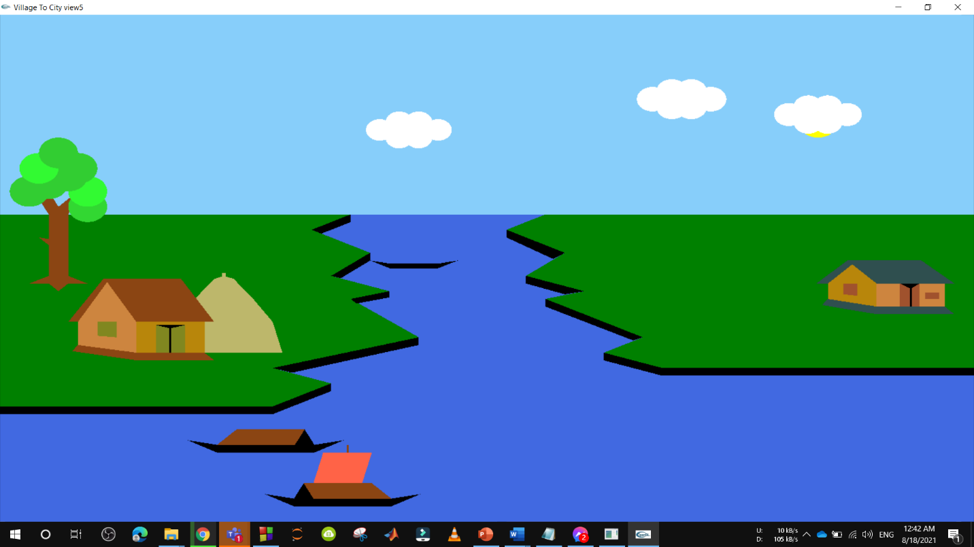

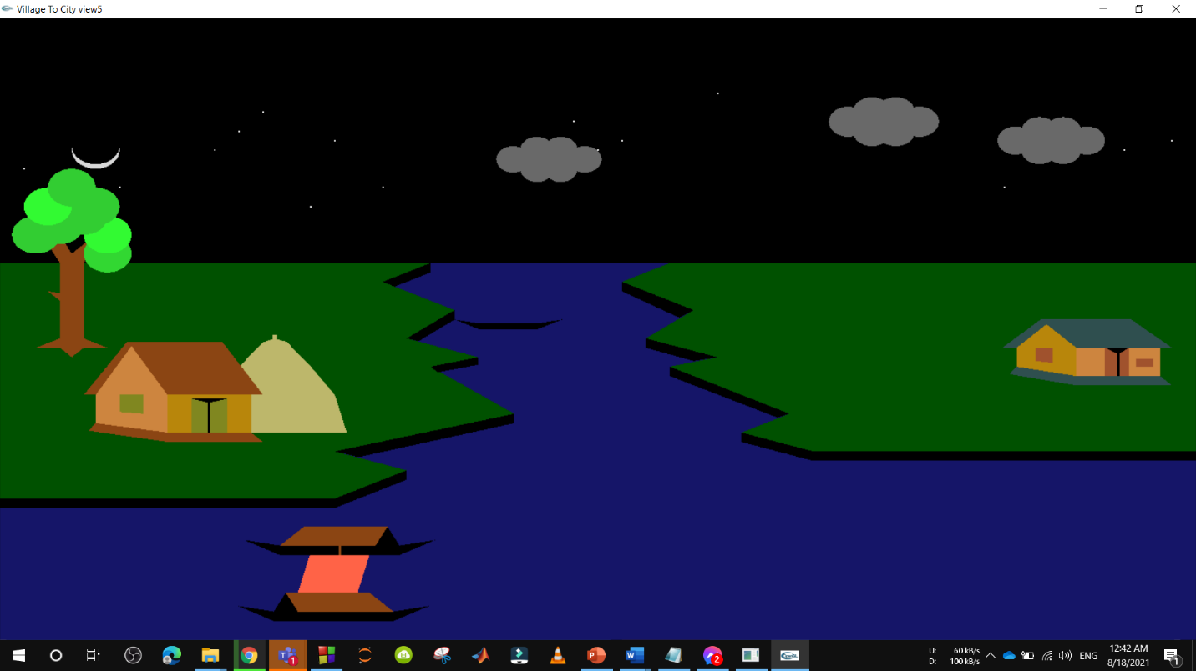

Second scenario Day and Night view.

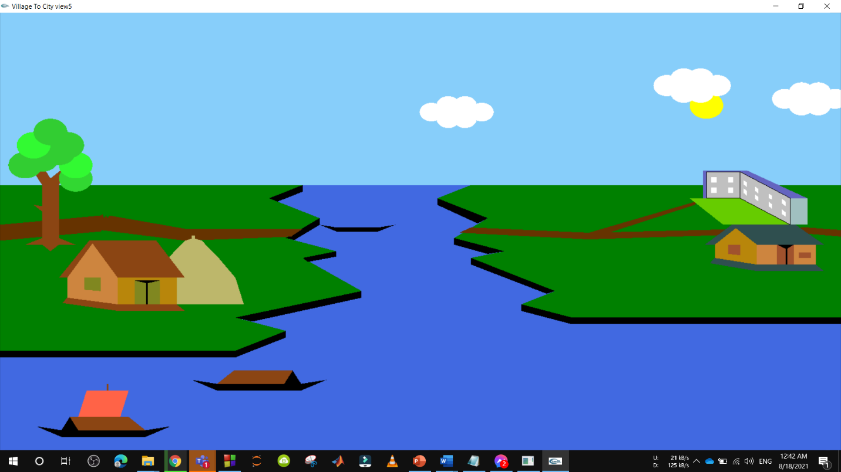

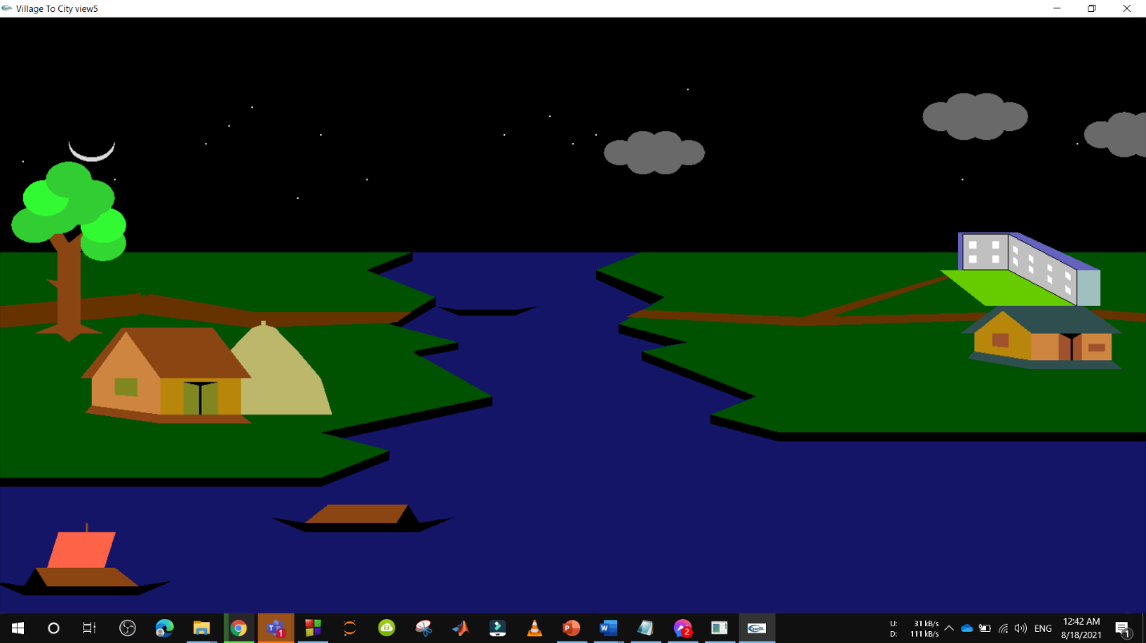

Third scenario Day and Night view.

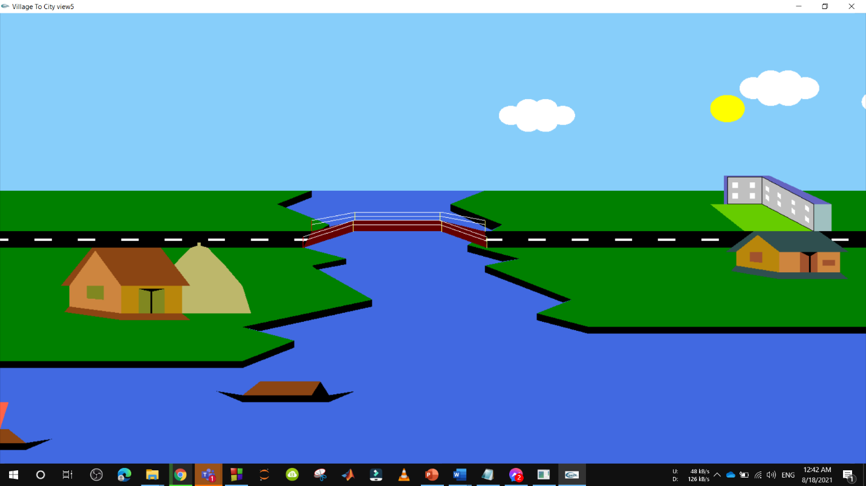

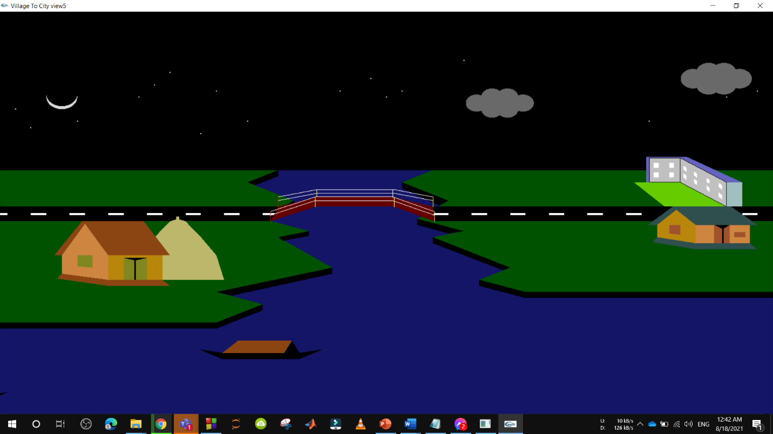

Fourth scenario Day and Night view.

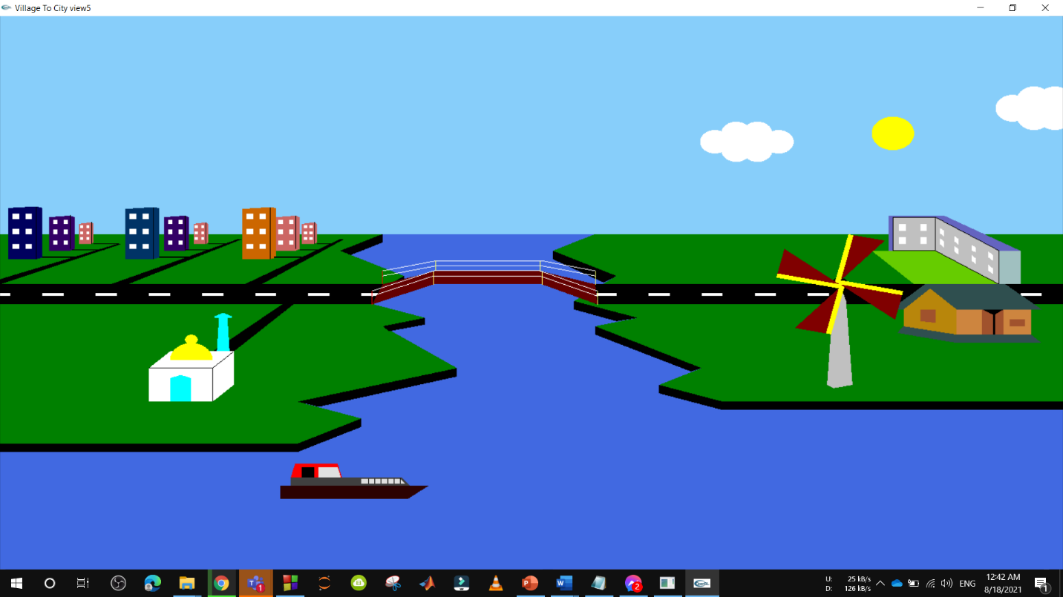

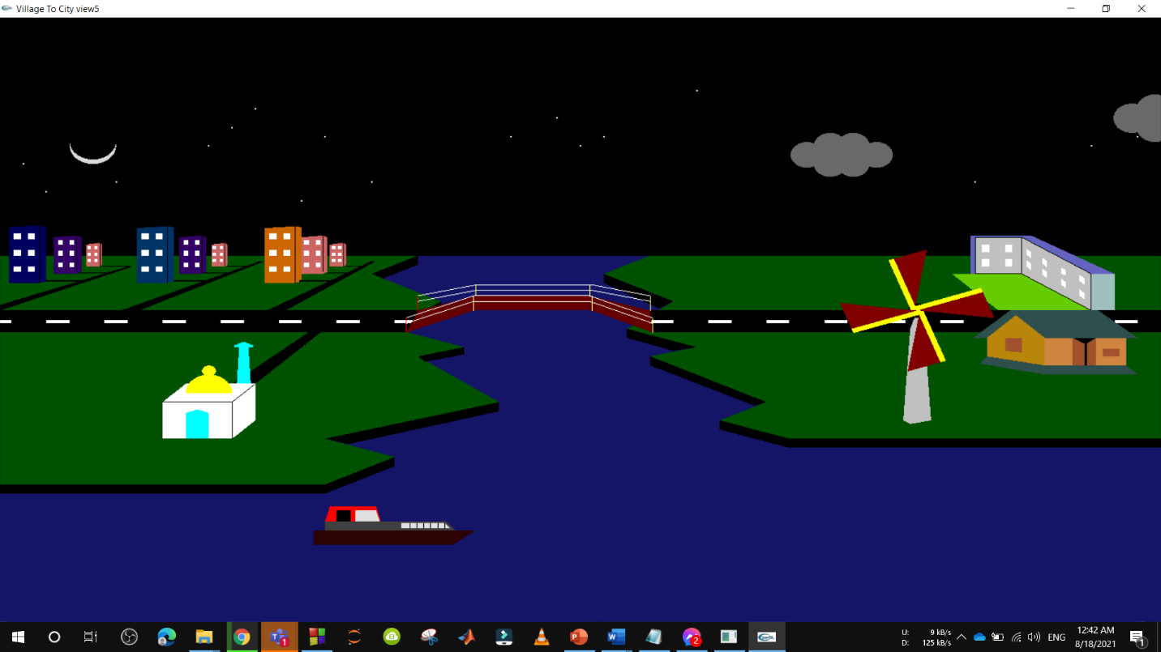

Fifth scenario Day and Night view.

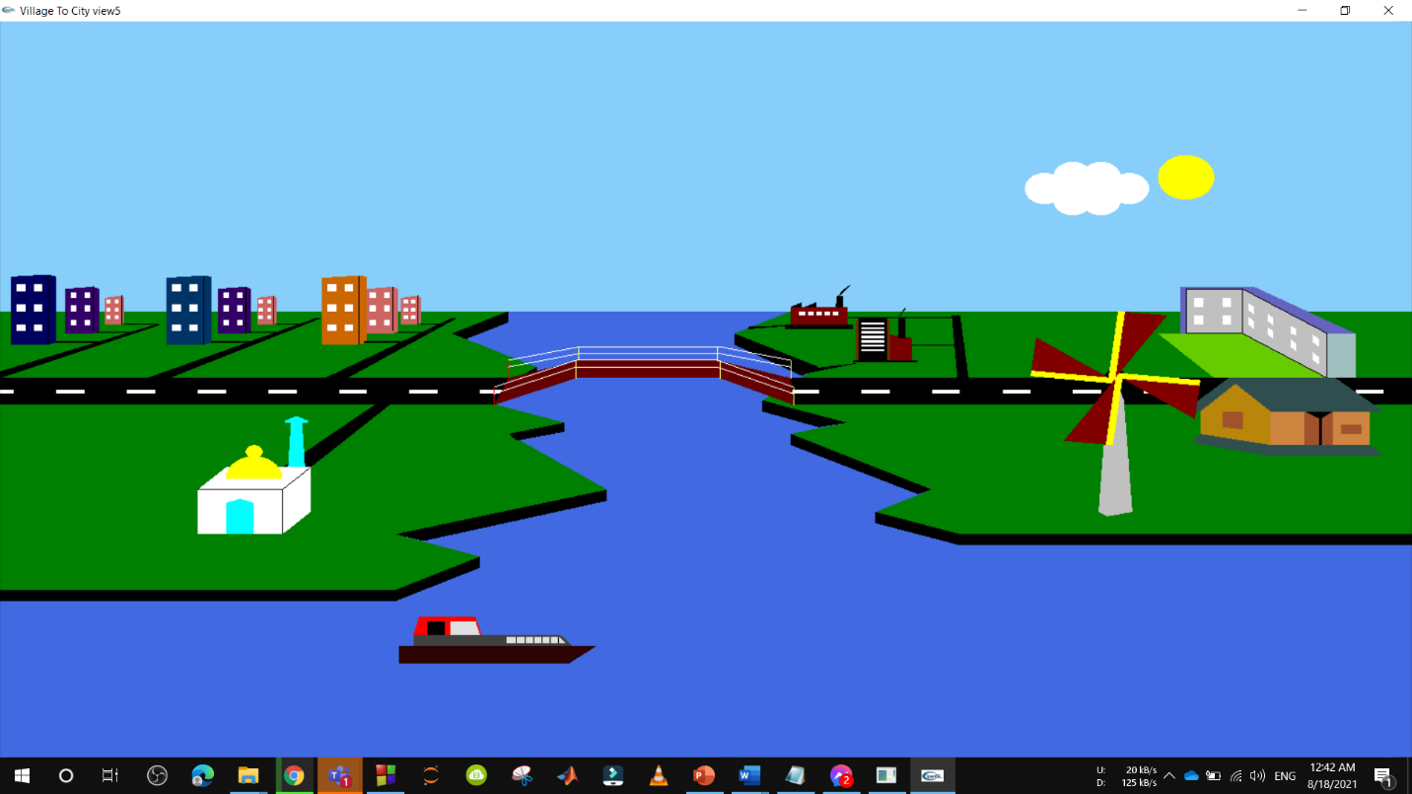

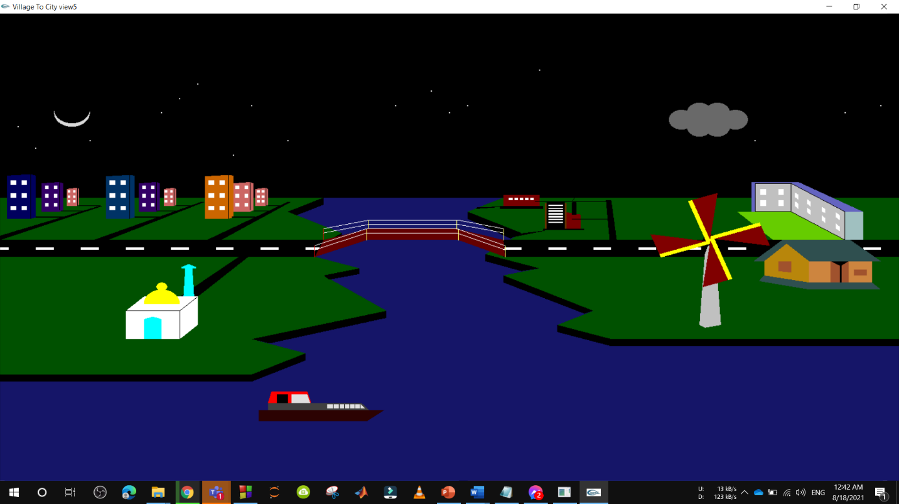

**Conclusion:**

Here this is a mini-project with a city scenery. In the future we will be able to add more features, objects and movements to this scene and also, we will go for develop this scene to animation video with roadside walking people. For the time being we tried to implement all the basics and agendas that we learned in the computer graphics program. We tried to implement some real-time effect in this scenery. We learned a lot from the course which we tried to show in this project and this small project is our great motivation to get into the deep of graphics contents and game development.

----------------------------------------------------- *The End* ----------------------------------------------------