

American International University-Bangladesh (AIUB)  
**Department of Computer Science and Engineering  
Faculty of Science &Technology (FST)  
Fall 20-21  
CSC 00191- Object Oriented Analysis And Design (OOAD)**

**Section: H**

**Project Title: Hospital Management System**

**Submitted by:**

|  |  |
| --- | --- |
| **Name** | **ID** |
| 1. **MD.MEHEDI HASAN** | **19-41168-2** |
| SADIKA AFRIN MEEN | **19-41178-2** |
| ASHIQUR RAHMAN | **19-41191-2** |
| MD. AHSAN NAYEM | **19-41212-2** |

**Submitted to:**

**MD. ANWARUL KABIR**

**Sr. Assistant Professor**

**Department of Computer**

**1.Project Title: Hospital Management System**

**2.Project overview:**

ANMCH is a hospital where patients are come for booking appointment with doctor. One patient will be able to appoint one or more doctor. At 1st, patient will **register** themself. Receptionists have to log in and book an appointment for a patient. One doctor handles the Prescription, Tests, Admit/discharge, Operations of one or many patients. All these doctoral handles will be recorded under treatment history. Nurses will update the treatment history of all patients. Patients can call for ambulance via receptionist. Technologists can do many tests of many patients at a day and after the confirmation of technologist, receptionist provide the test reports to the patient. When a doctor refers a patient to be admitted, then receptionist check for cabin availability and allot for the patient. After discharge of a patient, receptionist make the cabin unallocated from the patient. An automated bill calculator system will generate the bill based on a patient’s treatment history and verify patient’s payments. Patient can pay bill via cash or card.

**Feature and components:**

**Features:**

1. Book appointment: All valid patient will use this feature.
2. Call ambulance: All valid patient will use this feature .
3. Treatment history: Doctor, Patient, Nurses will use this feature .
4. Admit/Discharge: Doctor will use this feature and this feature will extend to treatment history.
5. Allocate/ Unallocated cabin: Receptionist will use this feature.
6. Bill Calculation: Billing system will use this
7. Pay Bill: Patient will use this.
8. Test: It will extend treatment history.
9. Prescription: It will extend treatment history.
10. Confirm: This will extend test report.
11. Verify: This will included to pay bill.
12. Cash/Card: this two will extend pay bill.

**Component:**

1. Test System: It will deliver all test reports.
2. Cash/Card(**ACCOUNCE SYSTEM**): this two will extend pay bill.
3. Reception System: It will help to do appointment and admit.

**Users:**

**Patient:** Will do registration

Will book appointment

Take report

Will call ambulance

Take Treatment

Make payment

**Doctor:** Will make treatment history

Admit or discharge patient

**Nurse:** Will update treatment history

**Receptionist:** Will log in

Will Confirm appointment

Will Delivered Test

Will confirm ambulance

Will allocate or unallocated cabin

**Technologist:** Will verify the test reports

**Billing System**: Will calculate the bill

Verify the payment of patient.

**Justification:**

* By the system, when the wants to have an appointment, they can simply dial the receptionist who will check the doctors schedule for the patient and set the appointment. So the patient can find the data about visiting hours and book a convenient time within a minute. Moreover, when it is an emergency case ,they can call ambulance.
* In addition, all the data of whole hospital management such as allocated cabin , pay bills, tests , treatment histories etc many more thing will be recorded in database of the system. So the system speeds up the process of patient registration and filling out all the necessary records.
* The doctors have the ability to check the disease history, test results, as well as add new data to the patient file. The job of the doctor that previously involved too much paperwork can be completely computerized. Doctors spend more time on patients’ treatment rather than documentation
* As the services and interactions are improved in all possible ways, everything is being planned with greater precision. It saves the time of all the system users and provides them with up-to-date information.
* Finally, the hospital authorities can control of all the interactions in their facility. The hospital system can generate the analysis of staff work, financial expenses, revenue, set the general priorities of the institution, outline future directions.

**Use Case Diagram of the Proposed Project**

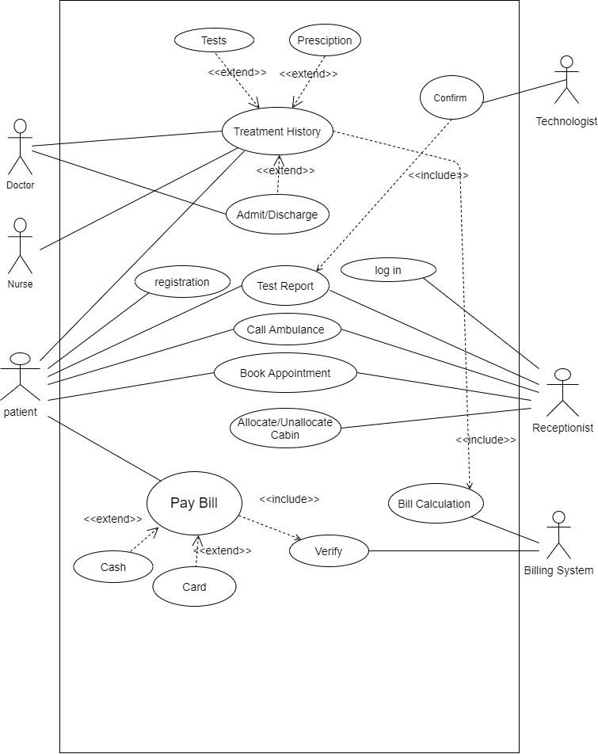

|  |
| --- |
| **Class Diagram of the Proposed Project** |

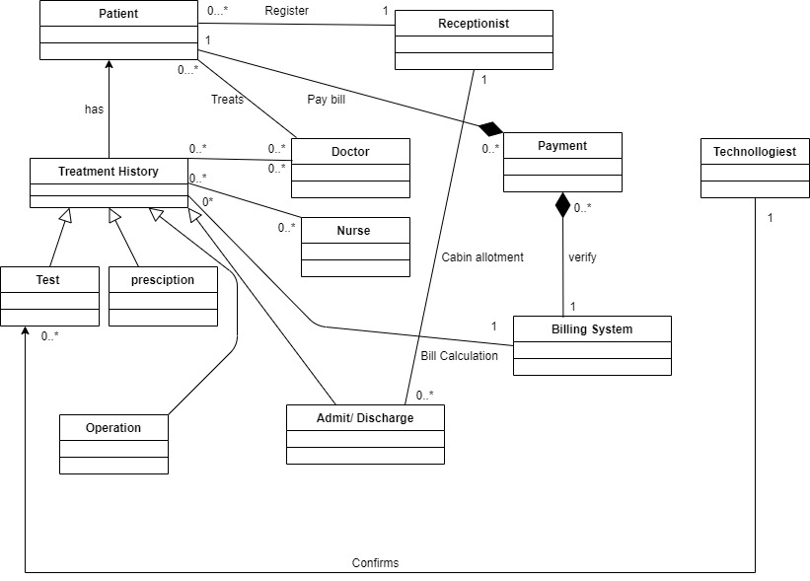

|  |
| --- |
| **Sequence Diagram 1 (Book appointment)** |

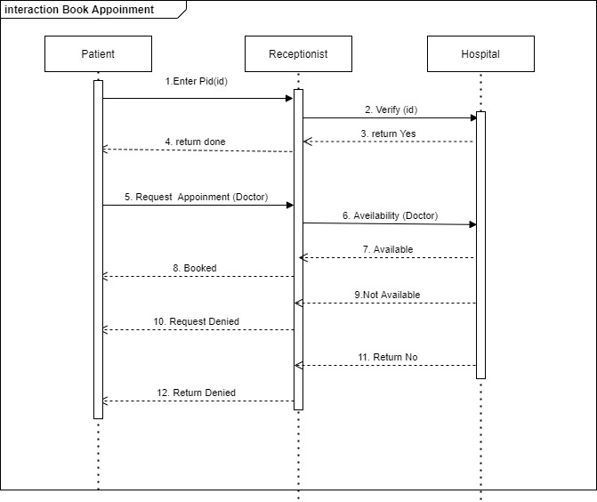

|  |
| --- |
| **Sequence Diagram 2 (Pay Bill)** |

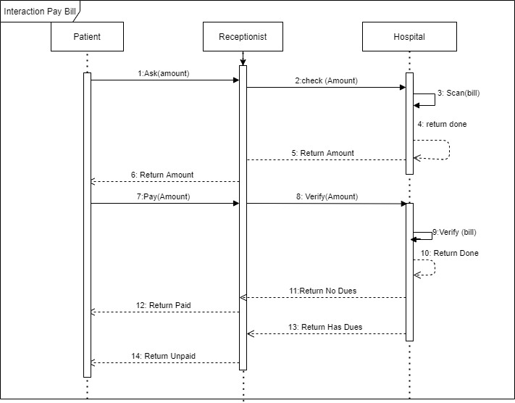

|  |
| --- |
| **Activity Diagram 1 (Book Appointment)** |

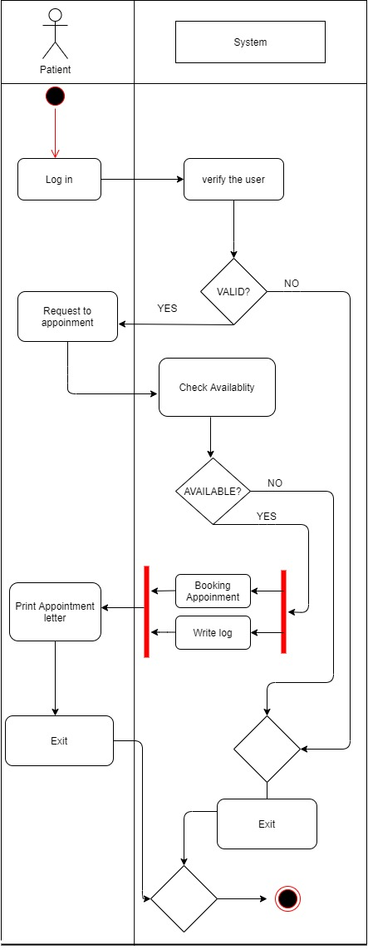

|  |
| --- |
| **Activity Diagram 2 (Pay Bill)** |

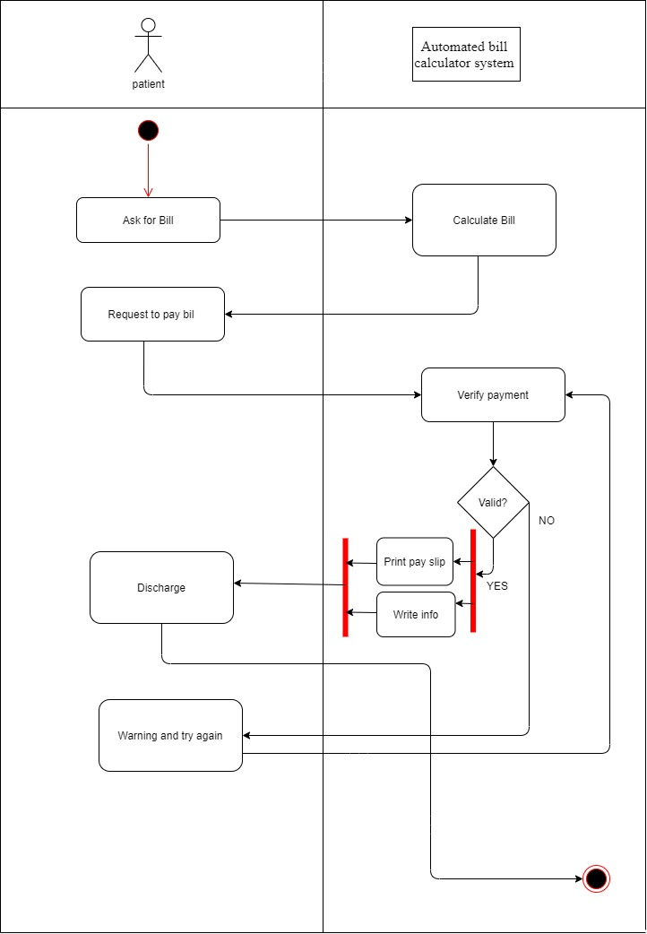

|  |
| --- |
| **Statechart Diagram 1 (Patient Object)** |

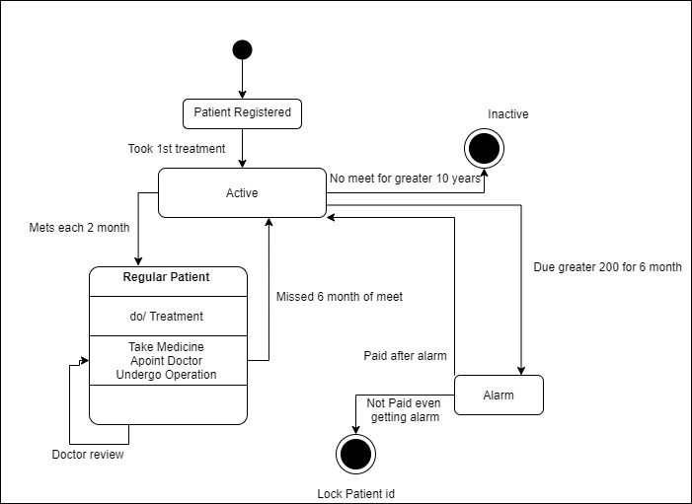

|  |
| --- |
| **Statechart Diagram 2 (Doctor Object)** |

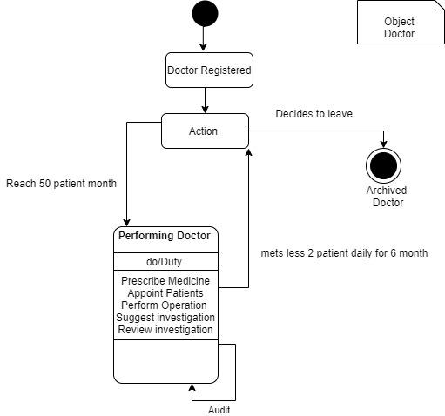

**Conclusion:**

The modern world is very creative. Individuals are using new technologies to manage the business. A very critical market sector is the hospital business. It needs to be well looked at. The hospital administration system has more benefits. The hospital company owner is going to a big disadvantage without any computer protection, and it would be a strong risk at any moment to get cyber attract. This is why high-quality control programs are being placed in place by health clinics, hospitals, emergency centers, recovery centers, and nursing homes. A complete quality control system ensures that the process of organizational and clinical decision-making is quick, precise, and efficient. With quick, single-view data focus usability, physicians, experts, and health care workers are supported. One of the key advantages here is machine automation. This allows patient interaction to be improved by hospital industry entrepreneurs. You can connect digitally, schedule appointments, and exchange information with medical specialists, hospital authorities, and patients. The Hospital administration program provides all the patient records needed. Doctors can access the results of the test, the history of the condition, and the recommended medicine without any hesitation in making an informed conclusion and checking the health of the patient. The lower dangers of missteps are motivated. When programs and initiatives change in all possible respects, it is more effectively designed. It saves all machine patient's hours and provides them with state-of-the-art information. So the hospital management system software plays an important role in the modern world medical sectors. Hospital management system is also important in our national medical field.