**American International University-Bangladesh (AIUB)**  
**Department of Computer Science  
Faculty of Science & Technology (FST)  
Spring 21_22**

**Section: C  
Group No: 07**

**AUTOMATED METRO RAIL TICKET MANAGEMENT SYSTEM**

A Software Development Project Management Project Proposal submitted

By

|  |  |
| --- | --- |
| **Student Name** | **Student ID** |
| Nayem, Md. Ahsan | 19-41212-2 |
| ESHEAK AHMED | 18-38088-2 |
| MD. NAIMUL HOSSAIN | 19-39513-1 |
| Mithun Chanda Shuvo | 19-39592-1 |

**1.0 Title: Automated Metro Rail Ticket Management System**

**2.0 Introduction**:

Metrorail is a new concept in Bangladesh that is going to be open to the public in a few years. Undoubtedly, Metrorail is going to be very popular in Bangladesh due to the congestion in the country and the mismanagement of the existing roads. Collecting Metrorail tickets can also be a challenge for such a large number of people.The following document contains information regarding a software development project for the Dhaka Metro Rail Ticket System. This project will develop an automated ticketing system for the purpose of selling tickets to customers. Customers can purchase their tickets with cash, mobile banking, or a credit card. In this way, each station will have adequate ticket booths at fixed distance intervals from which tickets can be collected. They may select their destination and purchase a ticket. Customers will view their train information, arrival time, ticket price, and other pertinent information regarding their journey while purchasing tickets.

**3.0 Justification:**

Metrorail is undoubtedly a blessing in a densely populated country like Bangladesh. A report in the **Dhaka Tribune on May 20, 2018**, stated that **"Dhaka's traffic congestion has been reduced to 5 million working hours, costing BDT 37,000 crores".** Metrorail can reduce at a significant rate. Therefore, I am hopeful that the automated ticket system will play an important role.

* Through this project passengers will be able to buy their tickets safely.
* Bangladesh Railway will be able to reduce manpower through this project.
* Since the project relies entirely online, all information on ticket sales and unsold seats will be stored in the system. Unscrupulous officials will not get any chance to black market.
* When buying tickets manually, we notice an overflowing rush that lasts for 1 day or longer during various festivals. This system can be used to overcome this situation. People will be able to save their precious time.
* Passengers will be able to buy tickets from anywhere as there is a mobile application, website, and booth facility. There is also a facility to buy tickets directly at the booth with cash.
* Passengers have special privileges to cancel their tickets within the stipulated time in case of unforeseen circumstances.

**4.0 Overview of the system:**

Automated Metrorail Ticket System Digital Bangladesh represents one step further. Dhaka is one of the most densely populated cities in the world. The Metrorail project here is as necessary as it is challenging to cope with the huge population. For this project, we are offering a system that can be used on mobile apps, websites, and booths. A passenger can create a new account using the Create Account option through any platform (mobile, web or booth). All account holders will be able to log in to the system using their ID and password. A user will be able to receive train schedules, seat information, departure breaks, departure details, and ancillary services. Will be able to update the user's information. Initially, we are thinking of 2 types of customers, user, and admin. The user will be able to use the above features and the admin will have the ability to update and change all this information as well.

Initially the following features are being considered:

**1. Train schedule and Ticket price**

**2. Booking Ticket**

**3. Payment**

**4. Ticket confirmation**

**5. Ticket cancellation**

**6. Search**

**7. About and Contacts**

**8. Admin Features:**

8.1 Admin can maintain the train schedule.

8.2 Admin can maintain the ticket price.

8.3 Admin can add another admin.

8.4 Admin can see the payment invoice.

8.5 Admin can see customer details.

8.6 Admin can confirm ticket cancellation.

**Use case Diagram:**

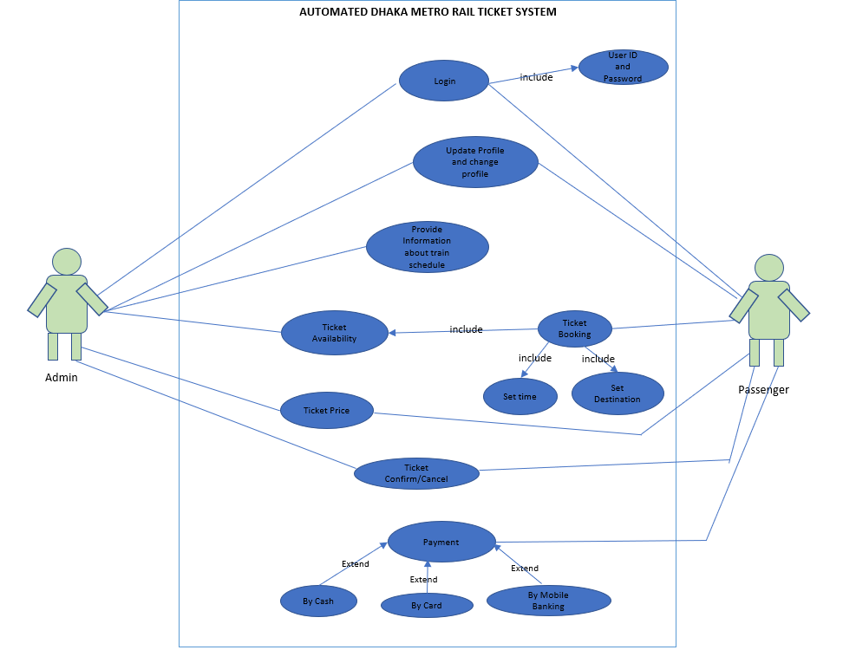

**5.0 Conclusion:**

As we all know, Metrorail will be a vital mode of transportation in Bangladesh nowadays. In our cities, public transportation is the only way for many people to commute from home to their workstations, and people must spend valuable time waiting in line to board a bus to get to work. Additionally, due to the narrow roads and rickshaws, traffic jams are inevitable, doubling the stress and wasting additional time. If we use this online system, we can easily save time, as the offline method requires us to wait an extended period of time in a ticket line to collect our ticket. The ticket black market is an open secret in this country. The system is expected to play a vital role in saving passengers time on rail travel, access to information, and valuable time. We believe that this system will play an effective role in ensuring the highest results with the great initiative of Metrorail.