
NOTEVERSE
ONLINE NOTES SHARING WEBSITE

Submitted By:
SALMAN SHABBIR
AHSAN RASOOL
ZAIN UL ABIDEEN
Submitted To:
Sir. Ashir
Dated:
05-01-2025
Department of Computer Science
University of Engineering and Technology, Lahore.

1. Introduction
NOTEVERSE is a simple notes-sharing website developed as a university project. The purpose of this project is to allow users to upload, share, browse, and search notes easily. This project covers basic web development, database concepts, design using Canva, and uploaded to GitHub.

2. Objectives
- To design a basic website using HTML and CSS.
- To understand database concepts using SQL.
- To create basic designs using Canva.
- To upload and manage a project using GitHub.
- To document the complete project work clearly.

3. Tools Used
HTML & CSS – For website structure and styling.
SQL – For database.
Canva – For logo, banner, and poster design.
GitHub – For project hosting and version control.
MS Word – For documentation.

4. Website Pages Explanation
Home Page: Displays website introduction and main features.
About Page: Explains the purpose of NOTEVERSE.
- Services / Features Page: Shows features like
- Upload notes
- Share notes
- Browse notes
- Search notes.
Contact Page: Contains a contact form for user communication.

5. Database Tables
Table 1: Users – Stores user information (student_id, student_name, book_id).
Table 2: Books – Stores book data (book_tilte, student_name).
Table 3: Student and Book – (student_name, book_title).
Table 4: (student_id, student_name, book_id)

6. SQL Queries
CREATE: Used to create tables in the database.
INSERT: Used to insert data into tables.
SELECT: Used to retrieve data from tables.
UPDATE: Used to modify existing records.
DELETE: Used to remove records from tables.
OUTPUT:
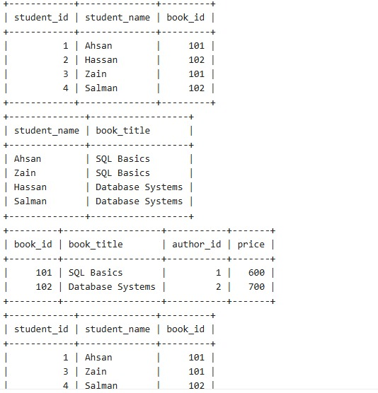

7. Canva Designs
Website Banner: Designed to represent NOTEVERSE branding.
Logo: A creative logo representing notes and knowledge.
Poster: A social media poster highlighting website features.

8. GitHub Link
The complete project is uploaded on GitHub including source code and README file.
GitHub Repository Link: (github.com/Ahsan-Rasool/AICT)

9. Conclusion
This project helped me understand the basics of web development, database design, graphic design, and project documentation. NOTEVERSE successfully fulfills all given requirements of the university task.

