

Name: Ahsan Bashir

Registration #: 21-NTU-CS-1294

Department: Computer Science

Section: BSSE-5th A

Submitted to: Dr. MA Qayum

**Lab-05 Web Engineering**

**Task 1:**

**Code:**

/** @type {import('tailwindcss').Config} */

module.exports = {

  content: ["./src/**/*.{html,js}"],

  theme: {

    extend: {},

  },

  plugins: [],

}

**Output:**

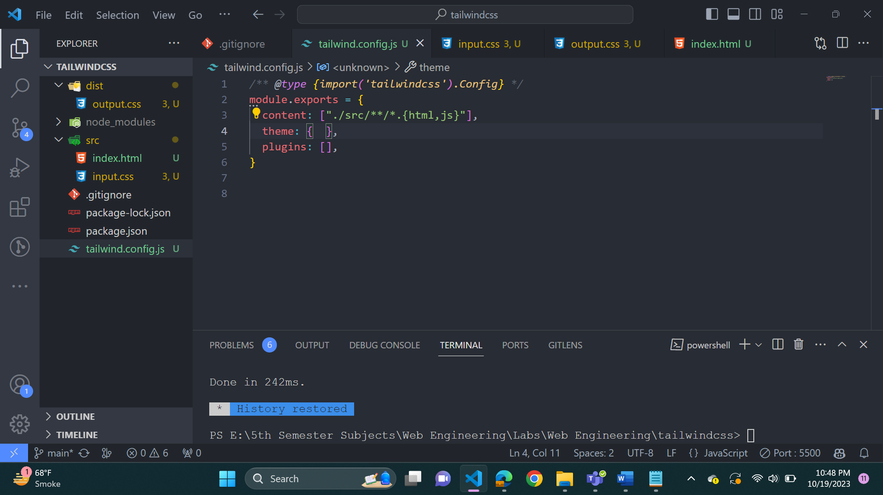

**Task 2:**

**Code:**

 npx tailwindcss -i ./src/input.css -o ./dist/output.css –watch

**Output:**

**Task 3:**

**Code:**

**Tailwind CSS IntelliSense**v0.10.1

**Output:**

**Task 4:**

**Code:**

<!DOCTYPE html>

<html lang="en">

<head>

    <meta charset="UTF-8">

    <meta name="viewport" content="width=device-width, initial-scale=1.0">

    <link rel="stylesheet" href="../dist/output.css">

    <title>21-NTU-CS-1294</title>

</head>

<body>

<h1 class="text-5xl font-sans underline text-green-800">

Hello world!

</h1></body>

</html>

**Output:**

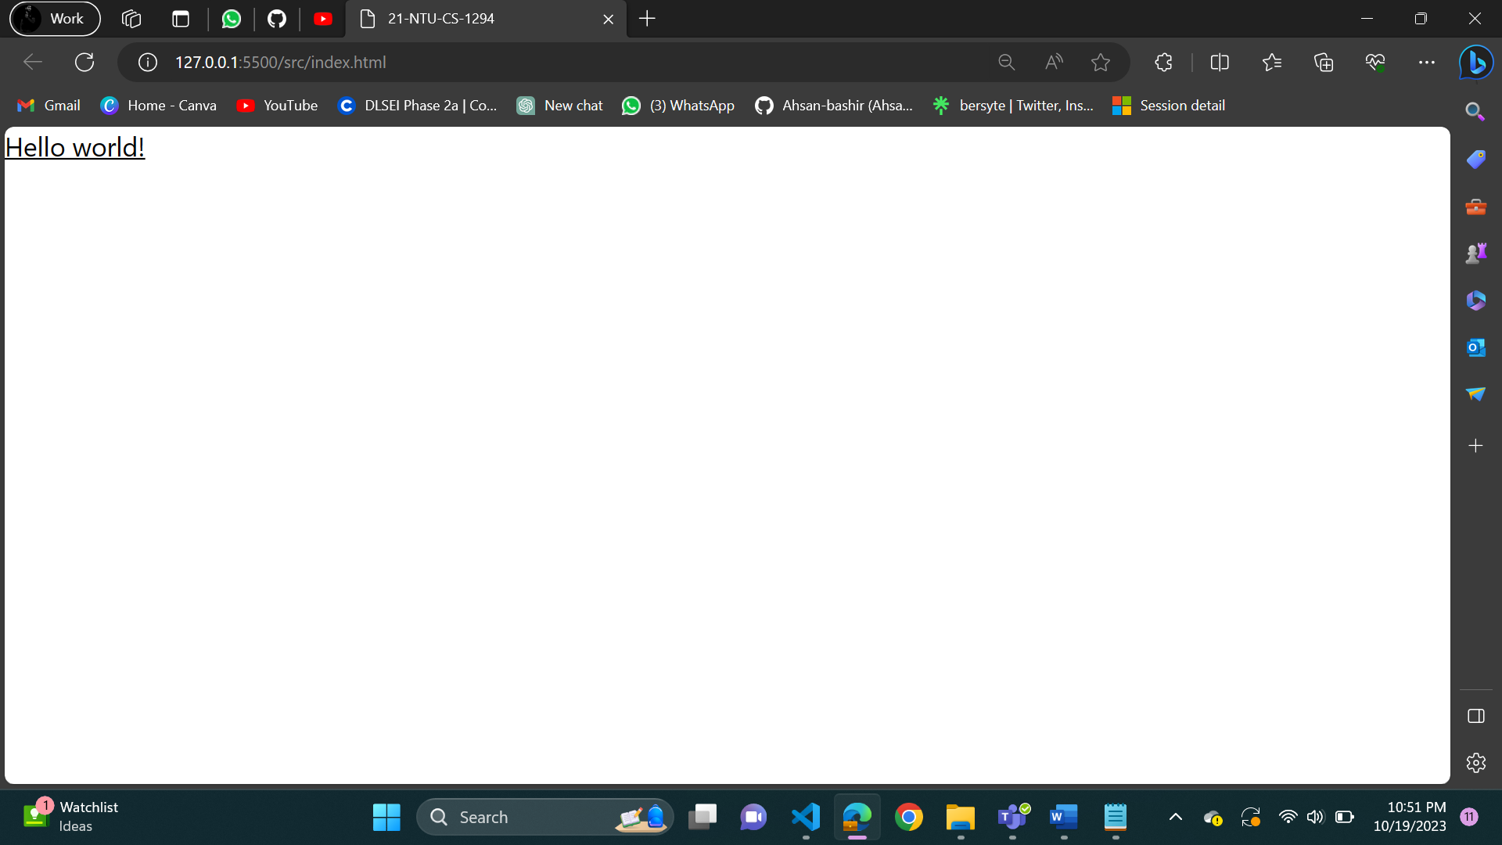

**Task 5:**

**Code:**

<!DOCTYPE html>

<html lang="en">

<head>

    <meta charset="UTF-8">

    <meta name="viewport" content="width=device-width, initial-scale=1.0">

    <link rel="stylesheet" href="../dist/output.css">

    <title>21-NTU-CS-1294</title>

</head>

<body>

<h1 class="text-5xl font-sans underline text-ahsan border-red-300 m-5 p-5">

Hello world!

</h1></body>

</html>

**Output:**

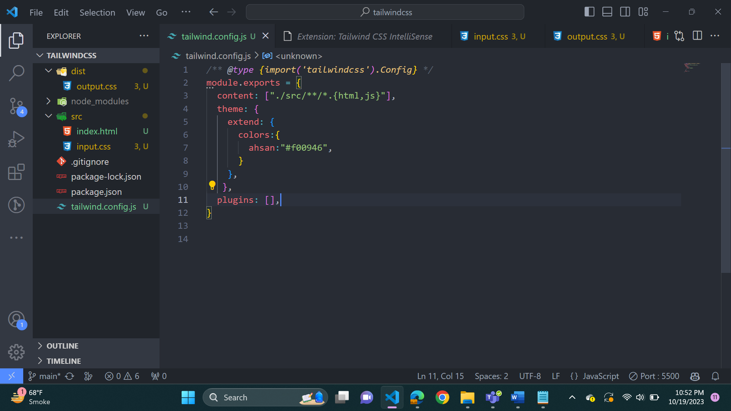

**Task 6:**

**Code:**

<!DOCTYPE html>

<html lang="en">

<head>

    <meta charset="UTF-8">

    <meta name="viewport" content="width=device-width, initial-scale=1.0">

    <link rel="stylesheet" href="../dist/output.css">

    <title>21-NTU-CS-1294</title>

</head>

<body>

<h1 class="text-5xl font-mono border-9 border-ahsan m-4 p-5">

Hello world!

</h1></body>

</html>

**Output:**

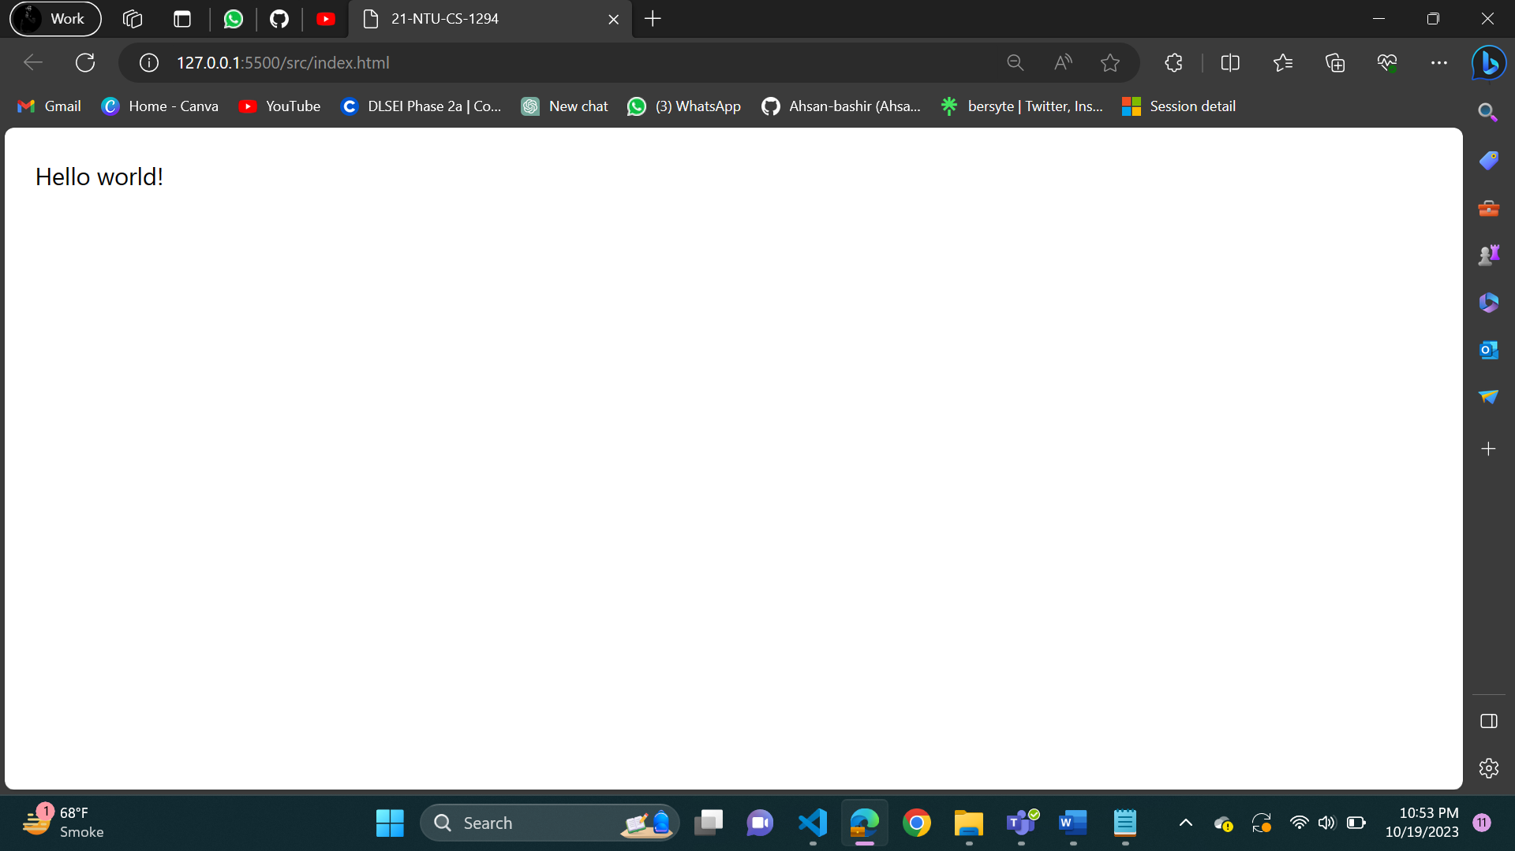

**Task 7:**

**Code:**

<!DOCTYPE html>

<html lang="en">

<head>

    <meta charset="UTF-8">

    <meta name="viewport" content="width=device-width, initial-scale=1.0">

    <link rel="stylesheet" href="../dist/output.css">

    <title>21-NTU-CS-1294</title>

</head>

<body>

<h1 class="lg:text-9xl md:text-5xl sm:text-2xl font-sans underline border-8 border-ahsan m-5 p-5">

Ahsan Bashir

</h1></body>

</html>

**Output:**



