Ahsan Ali

Ahsan.ali140221@gmail.com

Url Shortener

**Introduction :**

The following github repository contains code files for the frontend and backend of a web application named 'urlshortener'. The basic purpose of this url shortener is that a user types in a url with the proper url standards for instance (wwww.google.com) and gets a short url i.e a random number. The original url along with short url are stored in as a collection in mongodb. When the user requests again with the shorturl, database is queried which checks the corresponding original url with that short url and the user is redirected to the original url with the help of short url.

**Tools and Technologies :**

Microsoft Visual Studio Code

Angular

Angular Material

Node.js

Express

Mongo Db

**Working:**

The frontend or the client side com[rises of a UI which asks the user to enter the URL. The user clicks on the button SHORTEN to get the shortUrl.

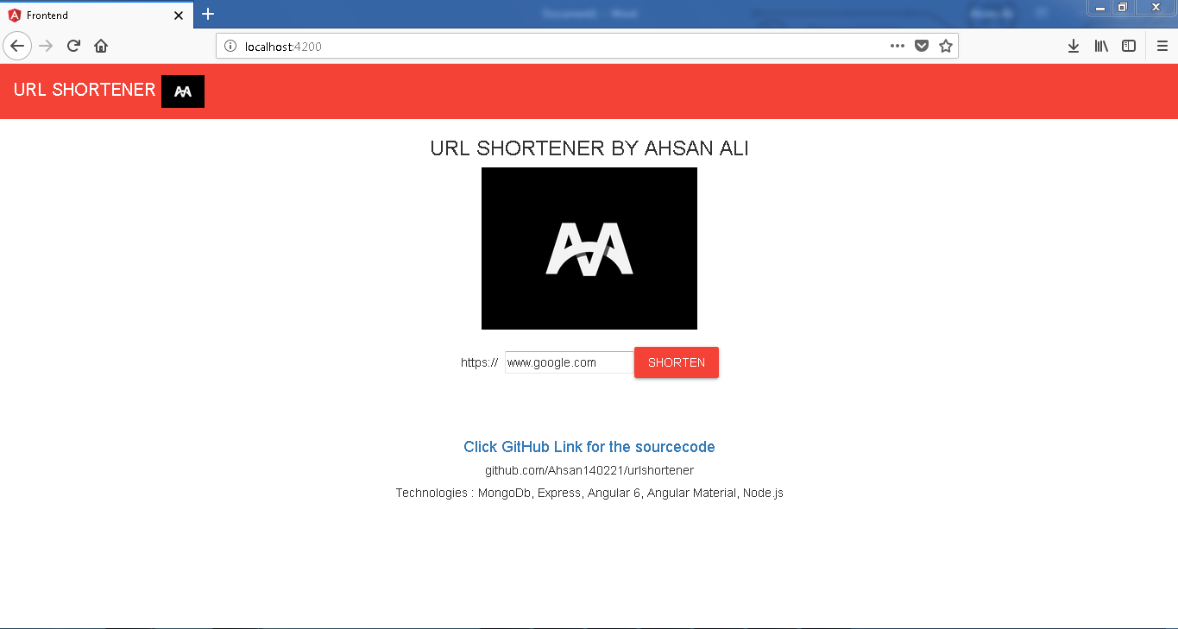

After the user clicks on SHORTEN button, the client connects with the (Node.js) server and stores original url and the shortUrl in MongoDb in the first get request. It is stored as a key value pair in database.  
 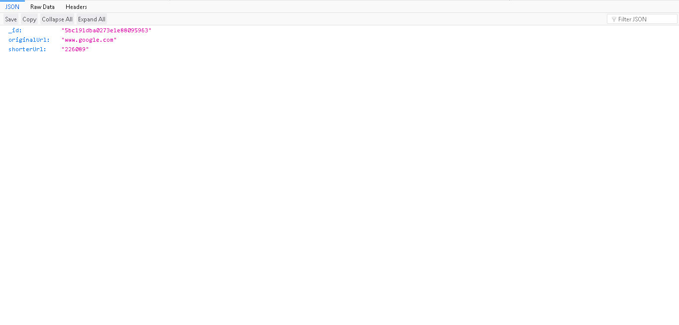

The shorterUrl is a random code generated at the server side which is stored at MongoDb along with the originalurl. The user when tries to perform another get request along with the shortUrl, it checks the entry of shorterUrl with originalUrl. If the entry is found, then the user is redirected to the originalUrl. Otherwise an error 301 is generated.



