# **: Learning GIT & GitHub for collaboration:**

Following are the instructions that must be followed during the process of collaborating with other developers:

1. Create an account on GitHub
2. Join Taraz Organization on GitHub to have access to previous repositories/ projects.
3. Create a repository of your assigned project in Taraz Technologies.
4. After creating your own repository fork the repository in your personal GitHub using the **fork** option on the top right side of screen.

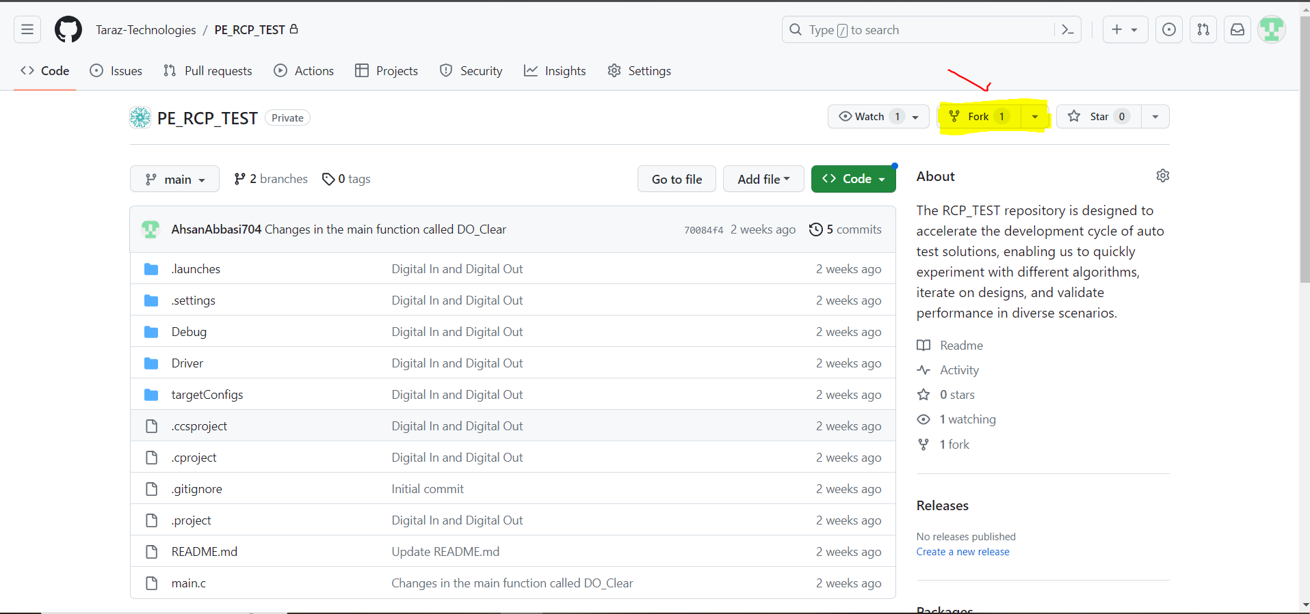

1. After this you have same repository in your personal GitHub account:

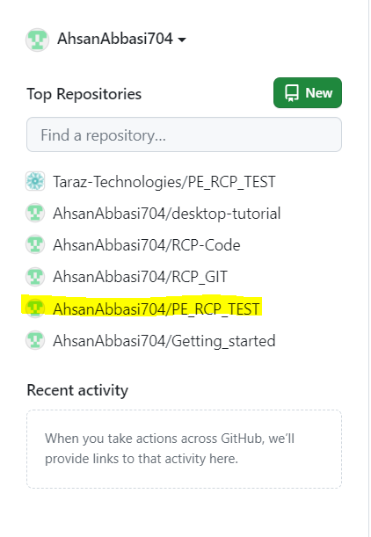

1. Now you should create a file of the module you are working on in the forked repository.
2. After creating the new file and making desired changes, you should stage file by using git add command on the git bash tool.

**The easiest way to add all files to your Git repository is to use the “**[**git add**](https://git-scm.com/docs/git-add)**” command followed by the “-a” or “ .” option for “all”.**

$ git add -a

$ git add .

$ git add filename // to add a specific file in the repository.

1. After staging the file now, you should commit the changes in the repository using git commit command:

**The easiest way to commit files to your Git repository is to use the “**[**git commit**](https://git-scm.com/docs/git-add)**” command.**

$ git commit -m “Commit Message.”

1. After committing the changes, you should push the changes in the repository using git push command:

**The easiest way to commit files to your Git repository is to use the “**[**git push**](https://git-scm.com/docs/git-add)**” command.**

$ git push -u