**Ahsan Ali**

**22K-4036**

**BAI-6A**

**Computer Networks Lab 1**

**Class Tasks**

1. **Address Class Identification**
2. **A**
3. **B**
4. **C**
5. **B**
6. **C**
7. **A**
8. **C**
9. **D**
10. **B**
11. **A**
12. **E**
13. **C**
14. **A**
15. **C**
16. **C**
17. **A**
18. **A**
19. **B**
20. **C**
21. **Circle network and host portions**

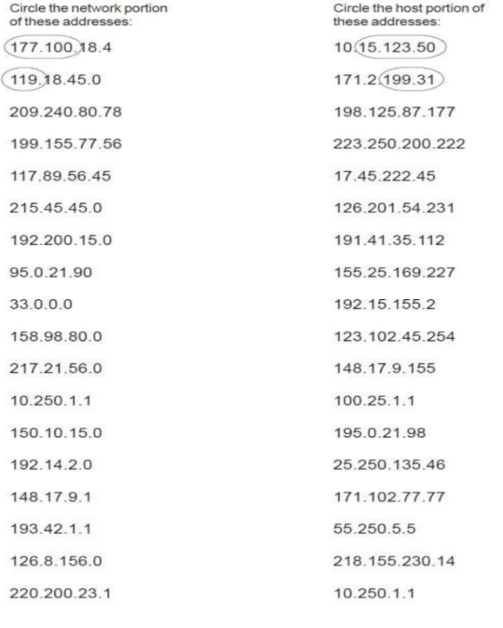

1. **Using IP address and subnet masks shown write out the network address:**
2. **188.10.0.0**
3. **10.10.48.0**
4. **192.149.24.0**
5. **150.203.0.0**
6. **10.0.0.0**
7. **186.13.23.0**
8. **223.69.0.0**
9. **200.120.135.0**
10. **Using IP address and subnet masks shown write out the host address:**
11. **0.0.18.2**
12. **0.0.0.80**
13. **0.0.0.11**
14. **0.0.230.19**
15. **0.10.10.10**
16. **0.0.0.11**
17. **0.0.23.20**
18. **0.0.0.215**
19. **Write correct default subnet mask for each of the following addresses:**
20. **255.255.0.0**
21. **255.0.0.0**
22. **255.255.0.0**
23. **255.255.255.0**
24. **255.0.0.0**
25. **255.0.0.0**
26. **255.255.255.0**
27. **255.255.255.0**
28. **255.0.0.0**
29. **255.255.0.0**

**Home Tasks**

1. **Command: ipconfig**

**IP Address: 192.168.100.36**

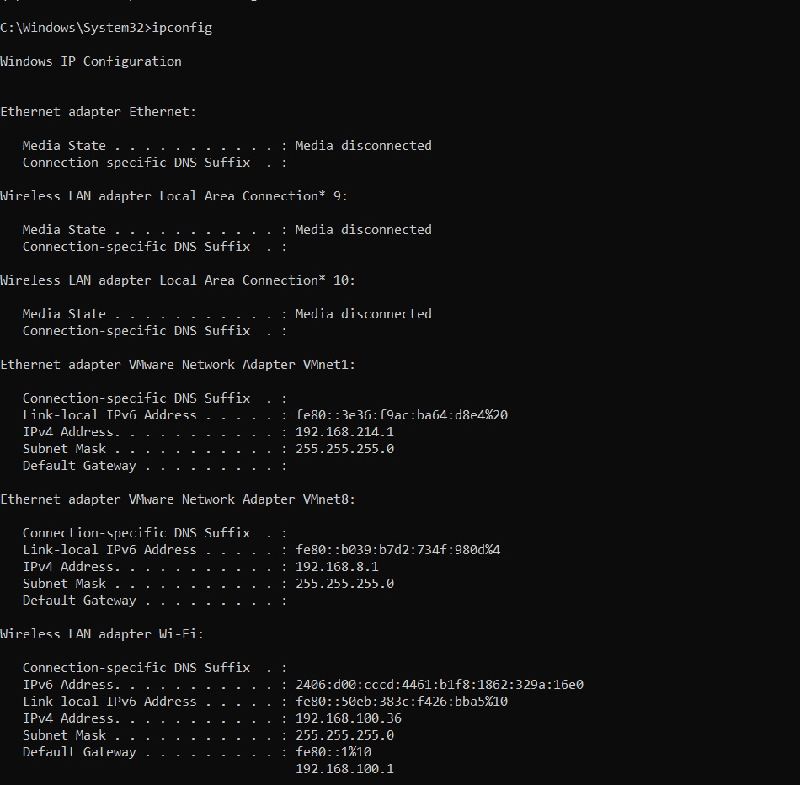

1. **Command: ipconfig/all**

**IP Address: 192.168.100.36**

**IPv4 Gateway: 192.168.100.1**

**DHCP is Enabled**

**MAC Address : E4-A8-DF-E8-C2-8C**

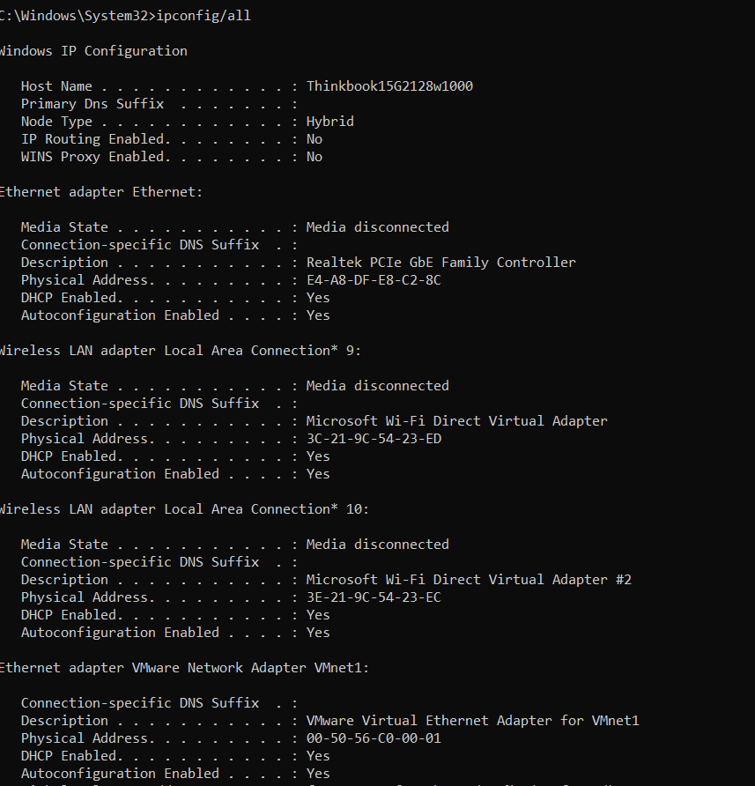

1. **Command: hostname**

**Host Name: Thinkbook15G2128w1000**

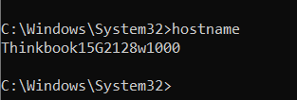

1. **Command : ping ip_address for checking by ip**

**ping desktop_name for checking by name**

**Reason: Destination host is unreachable because pc with ip : 192.168.100.37 is either powered off, not connected to the network or has a misconfigured IP Address.**

**The name Thinkbook resolves successfully and the pings are successful without any packet loss.**

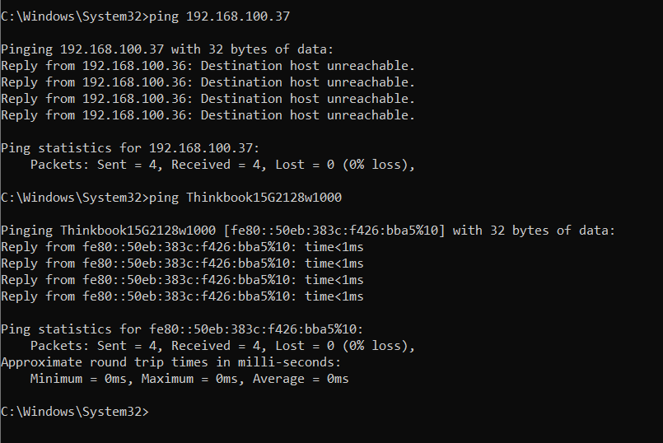

1. Command: netstat –an

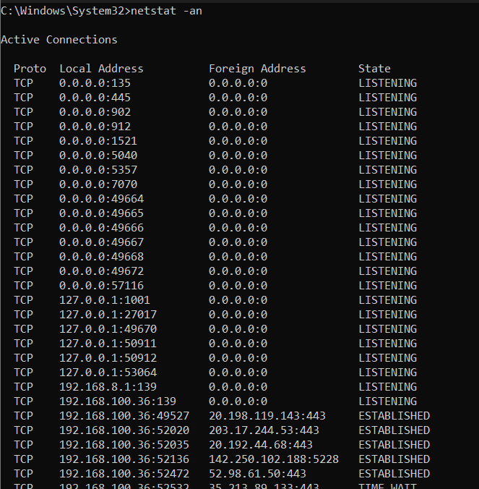

1. **Command: tracert** [**www.google.com**](http://www.google.com)

**IP Address : 142.250.185.36**

**Hops: 16**

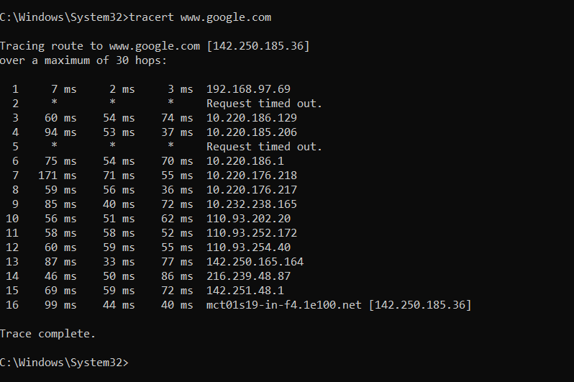

1. **Issue lies in name resolution.**

**The system cannot resolve the name ‘blue machine’ to its corresponding IP address because of misconfigured or unavailable DNS server.**

**The target computer may not configured for network discovery, making its hostname unavailable**

1. **Ethernet cables like Cat5e,Cat6 or Cat6E are typically used for wired connections in a normal home installation. These cables are designed for high speed data transfer and are suitable for connecting devices such as routers, switches, computers and smart TVs.**
2. **Yes, a straight-through cable can connect a router to a PC since they work on different layers of the network. For switches, modern ones support auto-MDIX, so straight-through cables will work, but older switches may need crossover cables.**
3. **Optome provides my home internet connection using fiber-optic cables connected to a TP-Link router. They offer packages ranging from 5 Mbps to 99 Mbps, and we have an 11 Mbps connection, which meets our needs.**

**The setup includes both wired and wireless connections. The router provides Wi-Fi for mobile devices and gaming consoles, while wired connections are available for devices that require stability or faster speeds. This simple yet efficient setup ensures smooth connectivity for all household activities.**