Ahsan Ali

CN Lab 6

22K4036

BAI-6A

Question 1:

Overview:

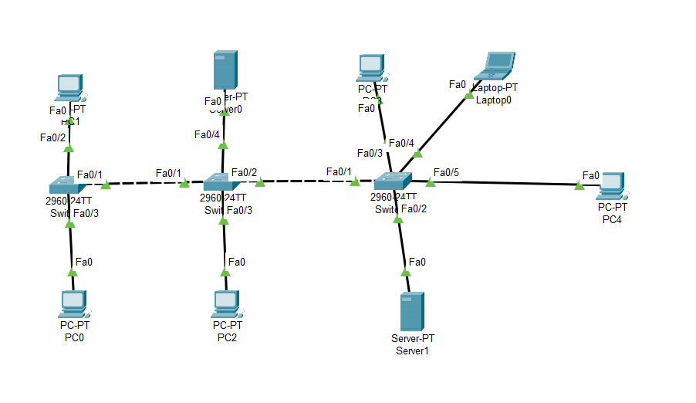

PC0 Configuration:

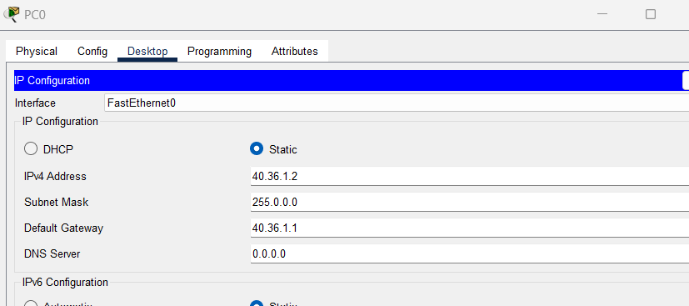

PC1 Configuration:

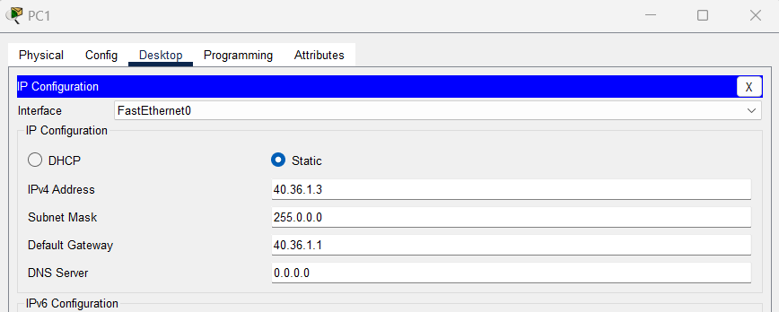

Mail Server Configuration:

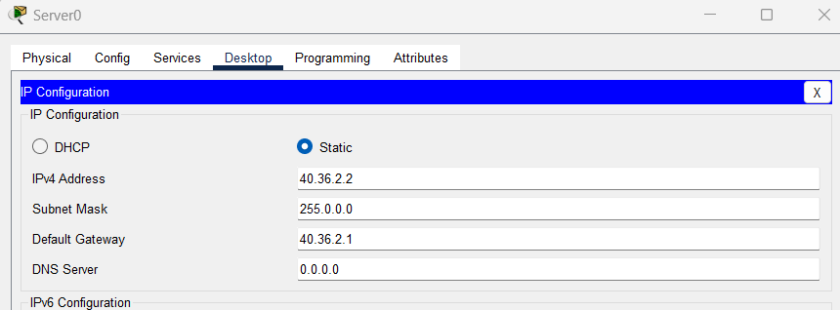

PC2 Configuration:

IP : 40.36.2.3

Laptop0 Configuration:

IP: 40.36.3.3

PC4 Configuration:

IP: 40.36.3.4

DNS + FTP Configuration:

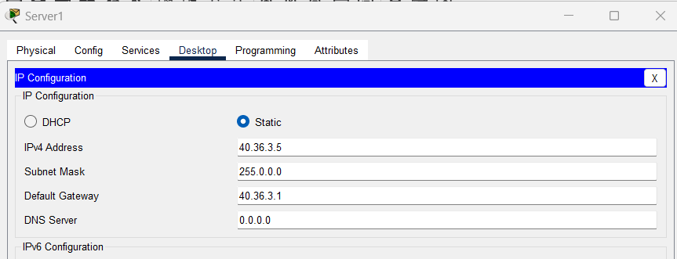

Switch 0 Command Line:

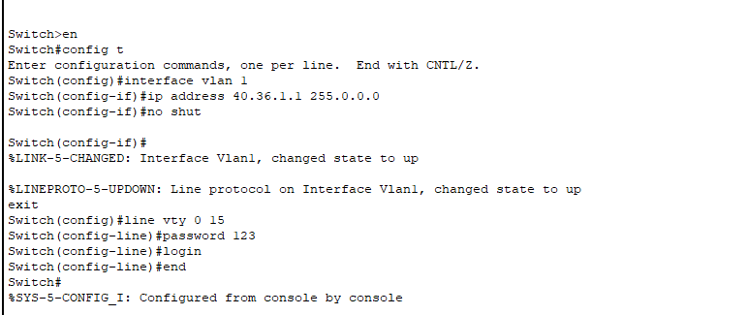

Switch 1 Command Line:

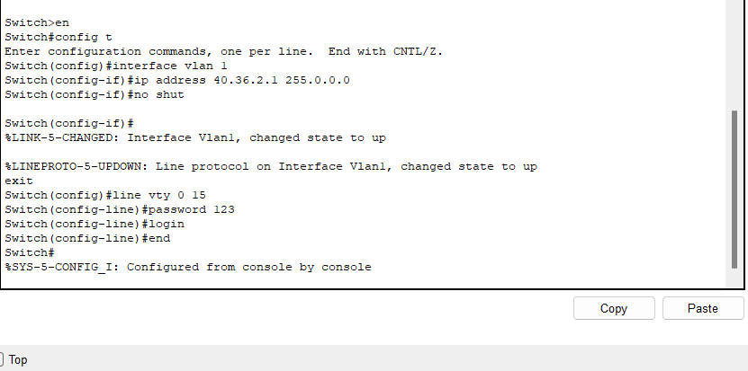

Switch 2 Command Line:

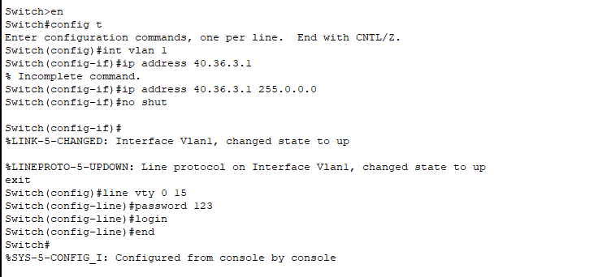

Both Servers pinged from PC0

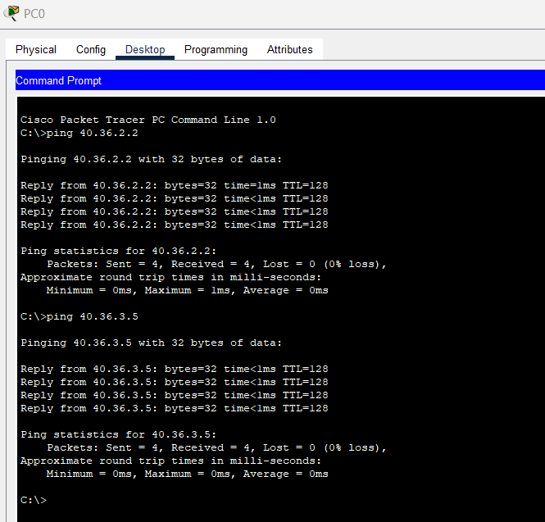

Pinging from laptop 0:

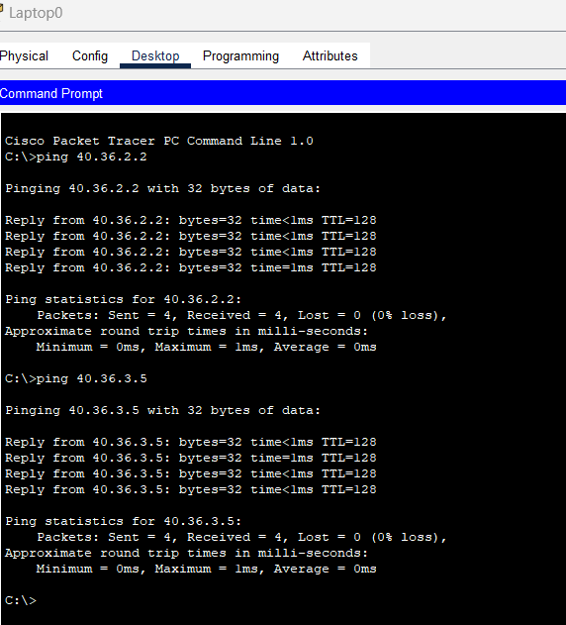

Telnet Access of switch 0 with PC1

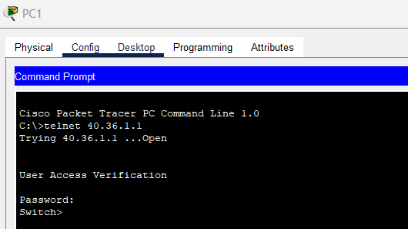

Telnet Access of switch 1 with PC2:

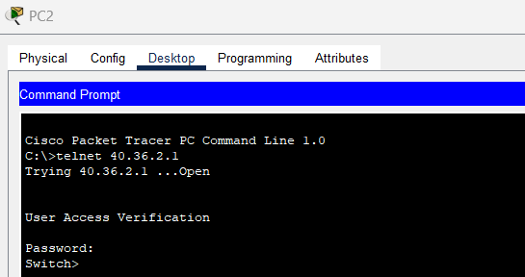

Telnet Access of switch 2 with PC3:

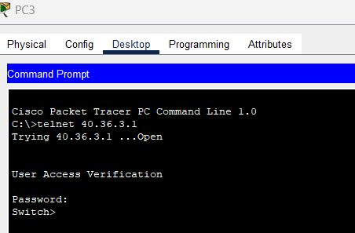

Enabling Password:

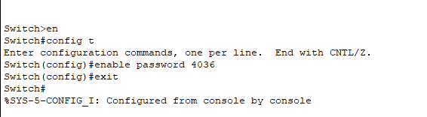

Changing IP from command prompt of PC2, Connection timed out because the switch’s IP changes, and the session is lost:

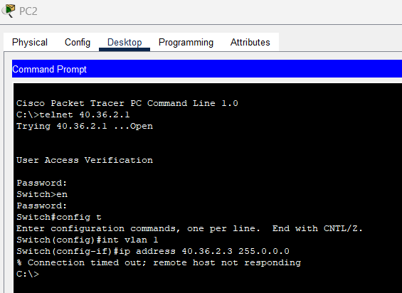

Changing IP back to original:

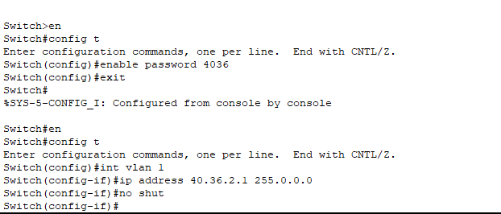

Keeping Same IP, So Connection is Not Lost:

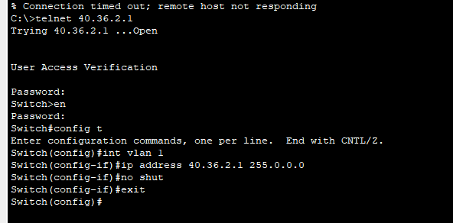

Question 2:

Overview:

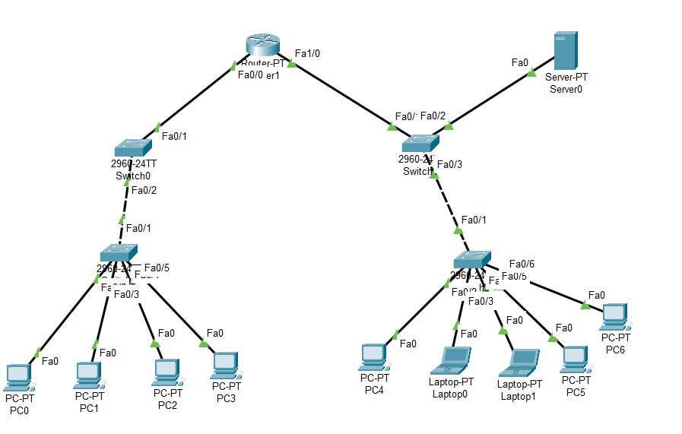

Router Configuration using CLI:

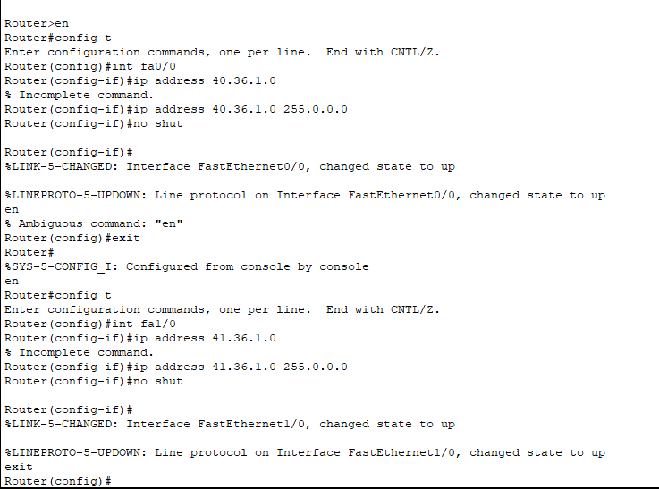

PC0 Configuration:

40.36.1.3

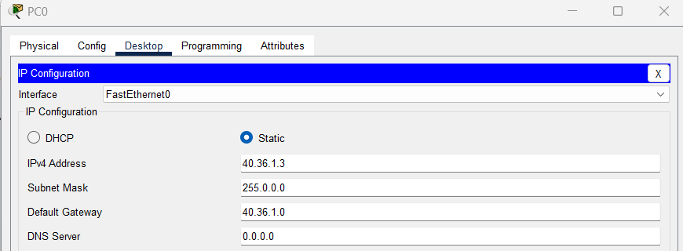

PC1 Configuration:

40.36.1.4

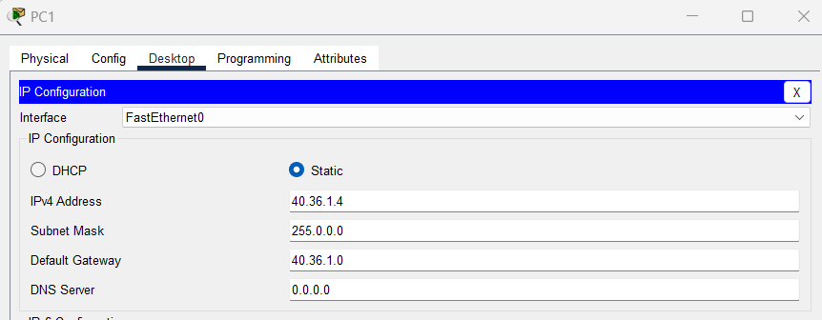

PC2 Configuration:

40.36.1.5

PC3 Configuration:

40.36.1.6

PC4 Configuration:

41.36.1.3

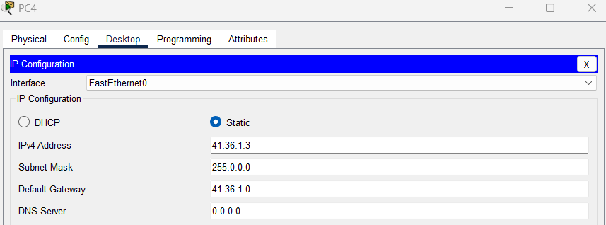

Laptop0 Configuration:

41.36.1.4

Similarly for Laptop1, PC5 or PC6

Main Server Configuration:

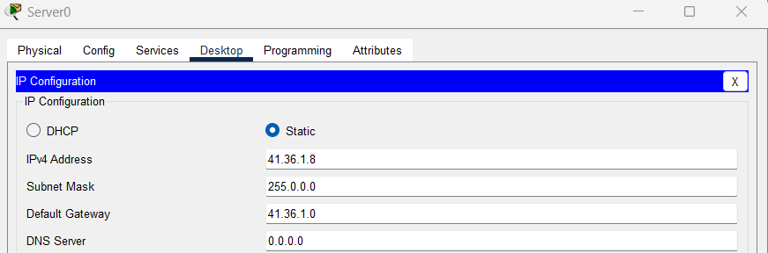

Switch 0:

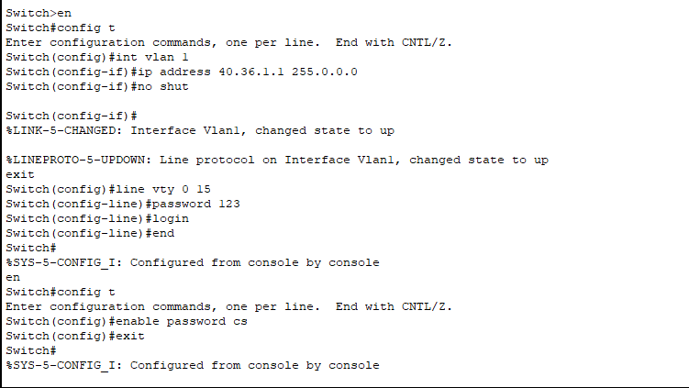

Switch 1:

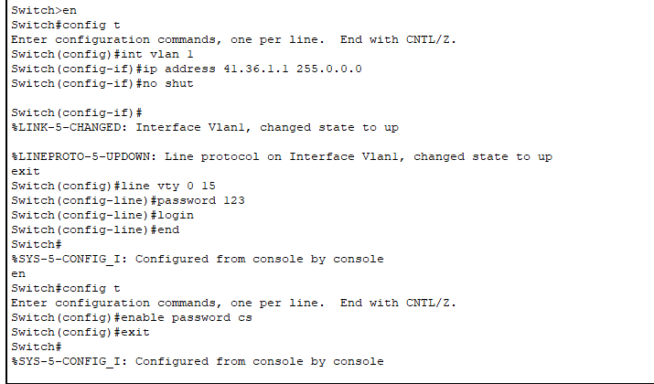

Switch 2:

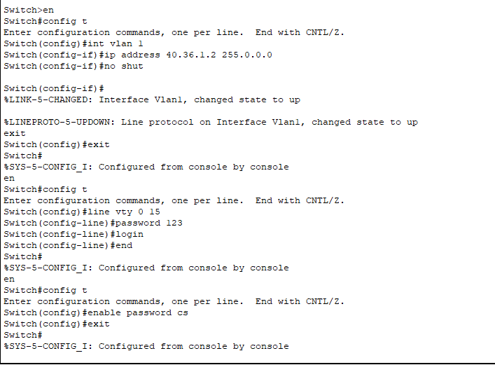

Switch 3:

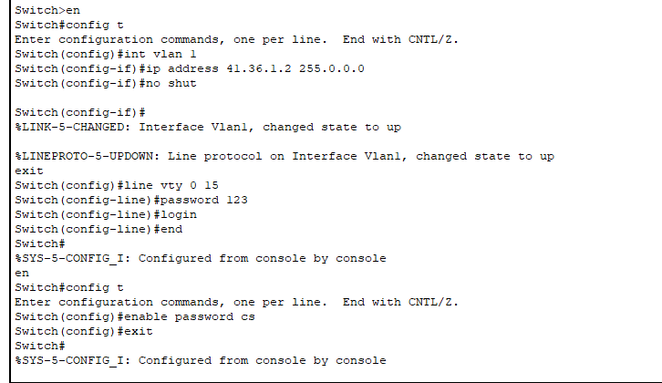

Switch 0 show run command:

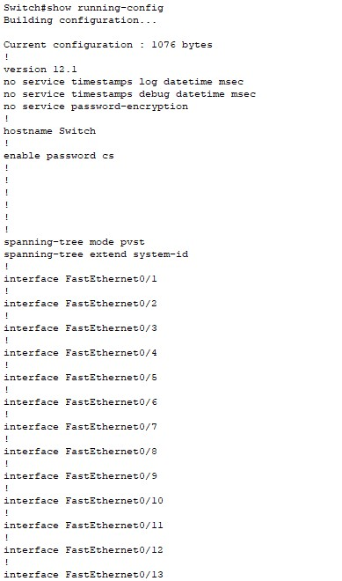

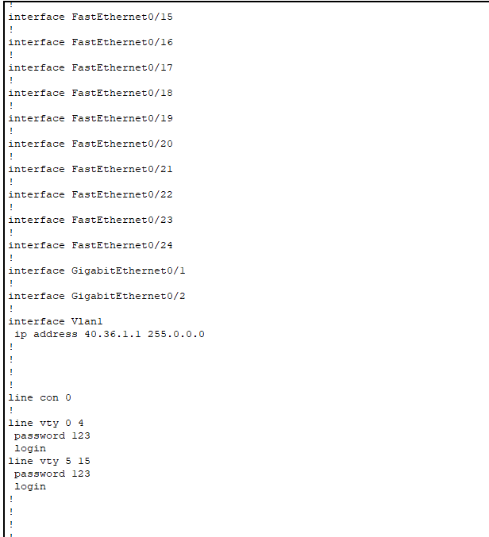

Switch 1 show run command:

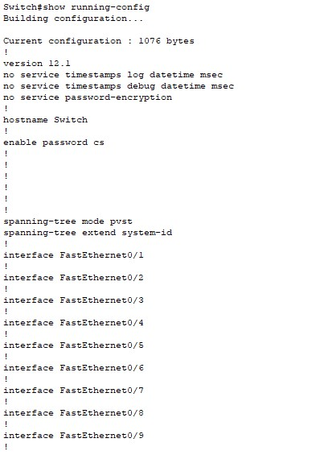

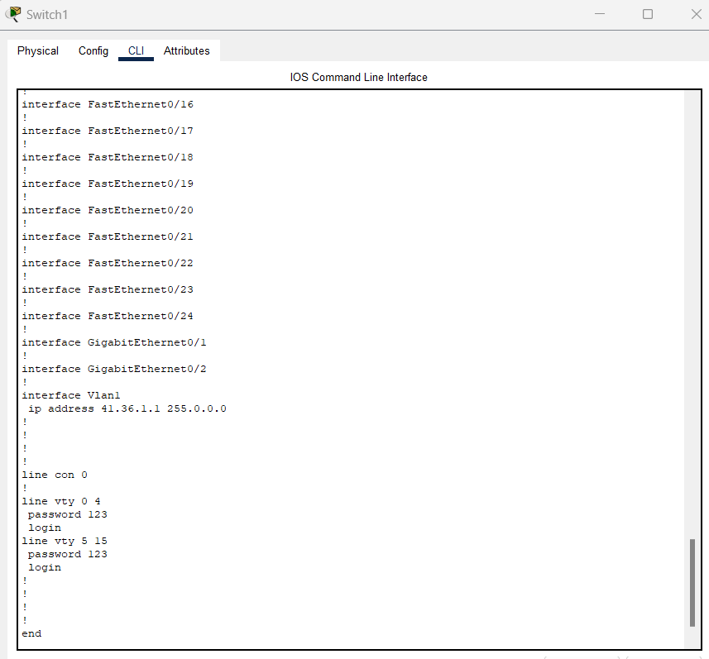

Setting Up ssh on Router:

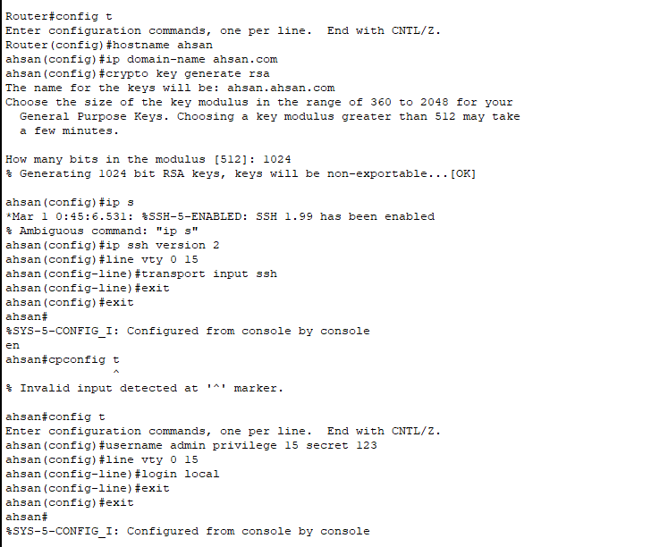

Ssh Verification:

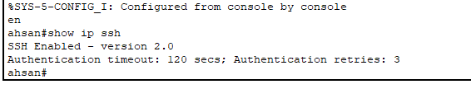

Ssh Verification from PC’s:

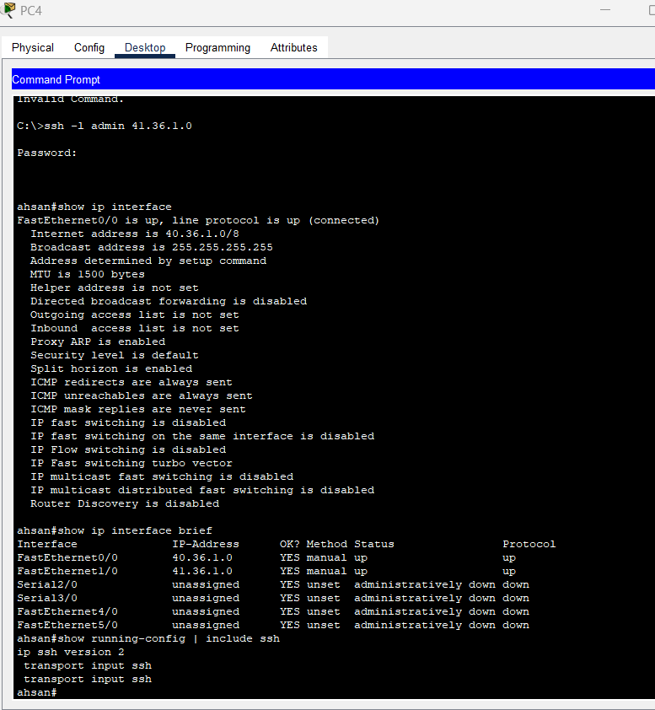

Setting Up Interface Fa0/0 from Laptop 0:

