**Ahsan Ali**

**BAI 6A**

**22K-4036**

**CN Lab 7**

**Running File:**

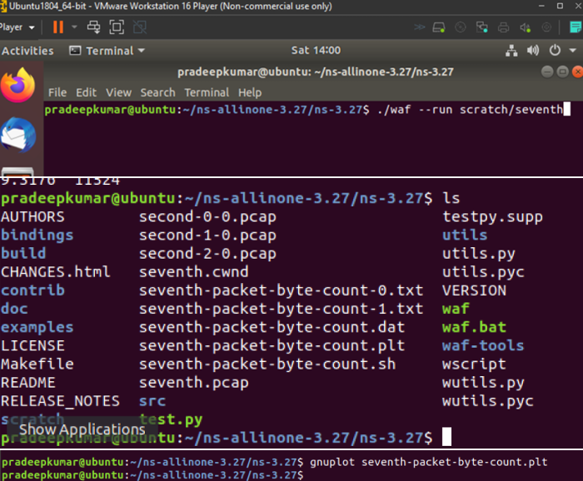

**TCP Congestion Control:**

**pointToPoint.SetDeviceAttribute ("DataRate", StringValue ("2Mbps"));**

**pointToPoint.SetChannelAttribute ("Delay", StringValue ("10ms"));**

**Ptr<RateErrorModel> em = CreateObject<RateErrorModel> ();**

**em->SetAttribute ("ErrorRate", DoubleValue (0.0001));**

**echoClient.SetAttribute ("MaxPackets", UintegerValue (50));**

**echoClient.SetAttribute ("Interval", TimeValue (Seconds (0.1)));**

**echoClient.SetAttribute ("PacketSize", UintegerValue (512));**

**Modified Arguments for second code:**

**pointToPoint.SetDeviceAttribute ("DataRate", StringValue ("1Mbps"));**

**pointToPoint.SetChannelAttribute ("Delay", StringValue ("20ms"));**

**csma.SetChannelAttribute ("DataRate", StringValue ("10Mbps"));**

**csma.SetChannelAttribute ("Delay", TimeValue (NanoSeconds (20000)));**

**echoClient.SetAttribute ("MaxPackets", UintegerValue (100));**

**echoClient.SetAttribute ("Interval", TimeValue (Seconds (0.05)));**

**echoClient.SetAttribute ("PacketSize", UintegerValue (2048));**

NS-3 Parameter Comparison: Before vs After Changes

1. Device DataRate

Before Changing: 5 Mbps

After Changing: 1 Mbps

Impact/Observation: Bandwidth significantly reduced → limits the data transmission rate and results in earlier congestion, slower cwnd (congestion window) growth, and more queuing delays.

2. Channel Delay

Before Changing: 2 ms

After Changing: 20 ms

Impact/Observation: Higher round-trip time (RTT) → delayed acknowledgments cause slower feedback to the sender, which slows cwnd growth and can lead to bursty traffic patterns and increased latency.

3. Error Rate

Before Changing: 0.00001

After Changing: 0.0001

Impact/Observation: Slightly higher error rate → more frequent packet losses, which may cause more conservative congestion control behavior (frequent reductions in cwnd).

4. Packet Size

Before Changing: 1040 bytes

After Changing: 2048 bytes

Impact/Observation: Larger packet sizes → fewer packets for the same volume of data, improving throughput efficiency. However, each packet loss results in more data lost and more impact on cwnd.

5. Application MaxPackets & Interval

Before Changing: 1 packet every 1.0 sec

After Changing: 100 packets at 0.05 sec intervals

Impact/Observation: Much more aggressive traffic generation → quickly saturates the link, causing congestion and making the simulation useful for studying loss recovery and fairness.

6. Congestion Window Growth

Before Changing: Smooth with moderate growth

After Changing: Slower, more erratic growth with frequent reductions

Impact/Observation: Lower link capacity + higher delay and error → leads to unstable cwnd behavior and slower ramp-up. Packet drops reset cwnd more often.

