**Ahsan Ali**

**22K-4036**

**CN LAB 8**

Q2. Overview:

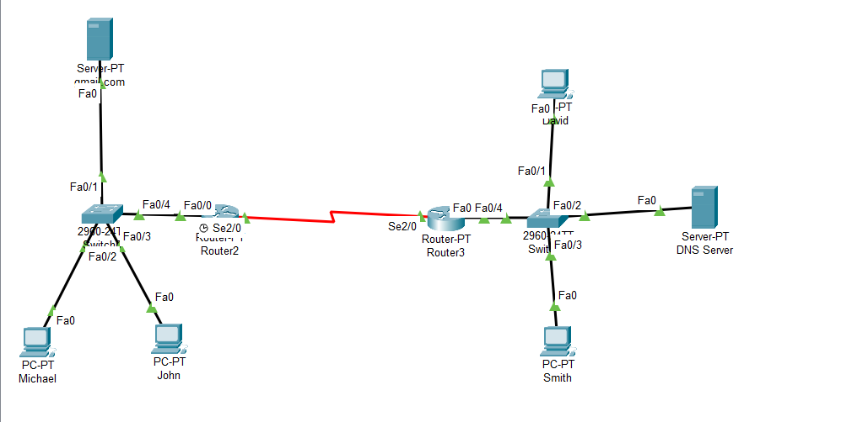

Assigning IPs to Routers  
  
Router2(Router0):

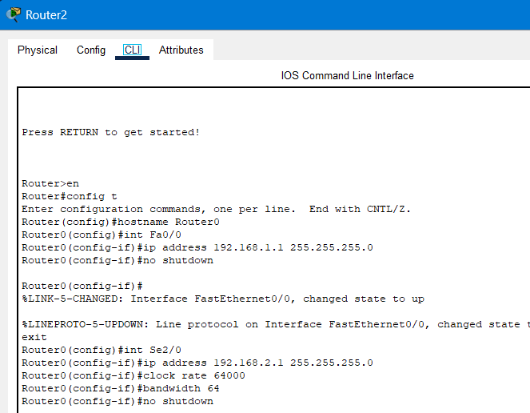

Router3(Router1):

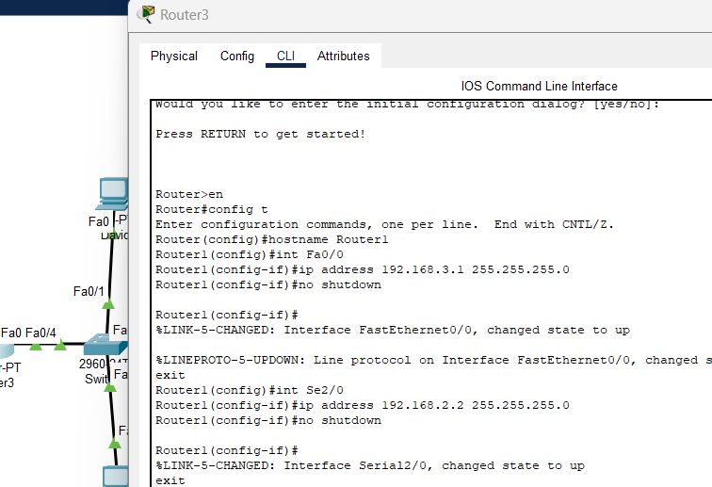

Static NAT on Router2(Router0):

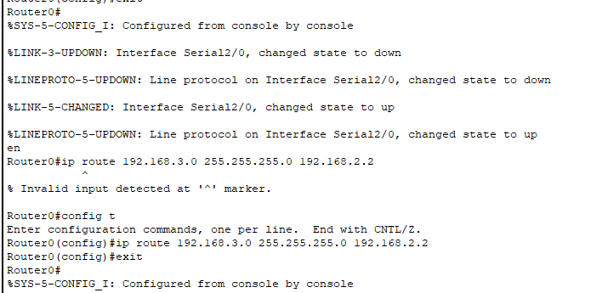

Dynamic NAT on Router3(Router1):

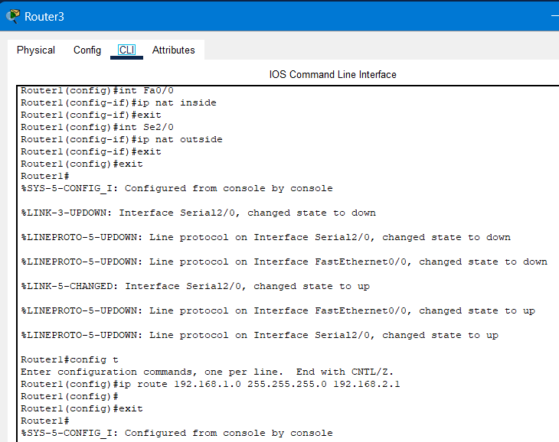

Mail Configuration:

Michael:

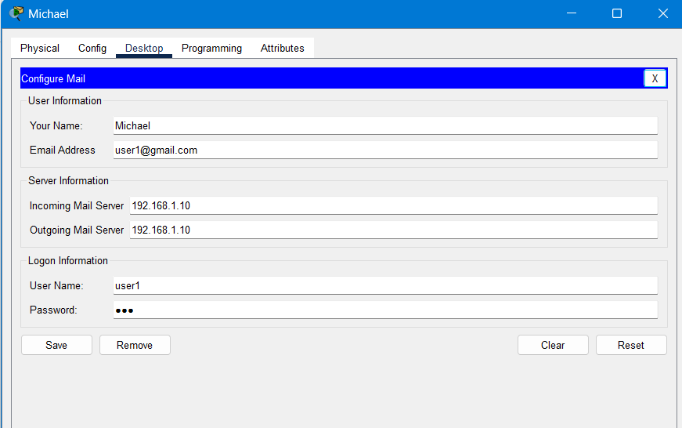

David:

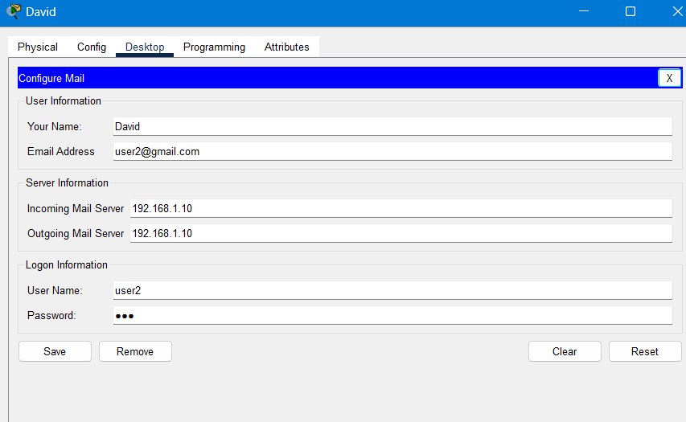

Mail from Michael to David:

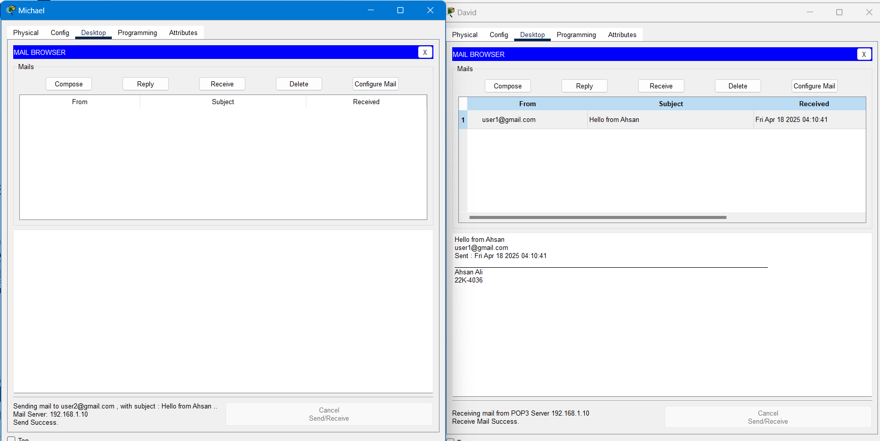

DNS From John:

