**Ahsan Ali**

**22K-4036**

**CN LAB 9**

**BAI-6A**

LOGIN

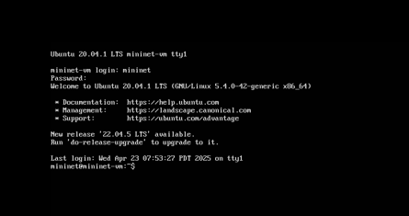

Username : mininet

Password: mininet

**Command: sudo mn**

**Description:**

**Sets up a basic network with a controller, one switch, and two hosts.  
Displays a notification that the command-line interface is active and shows the Mininet prompt.  
Configures the network with hosts h1 (IP 10.0.0.1) and h2 (IP 10.0.0.2), switch s1, and controller c0.**

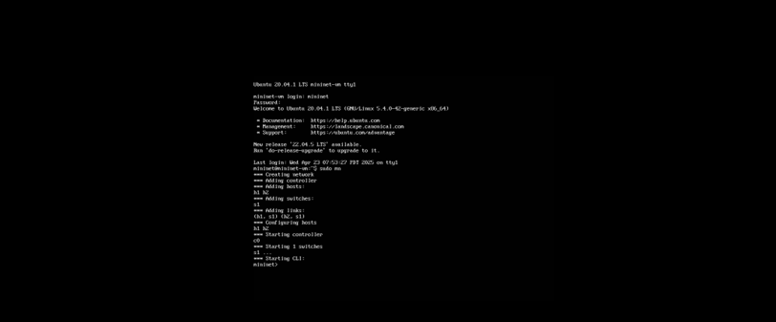

**Command: help**

**Description: Lists all possible commands that can be used in the Mininet CLI along with usage examples.  
Provides a detailed reference of commands, their parameters, and how to use them.  
Serves as a guide for interacting with mininet command-line interface.**

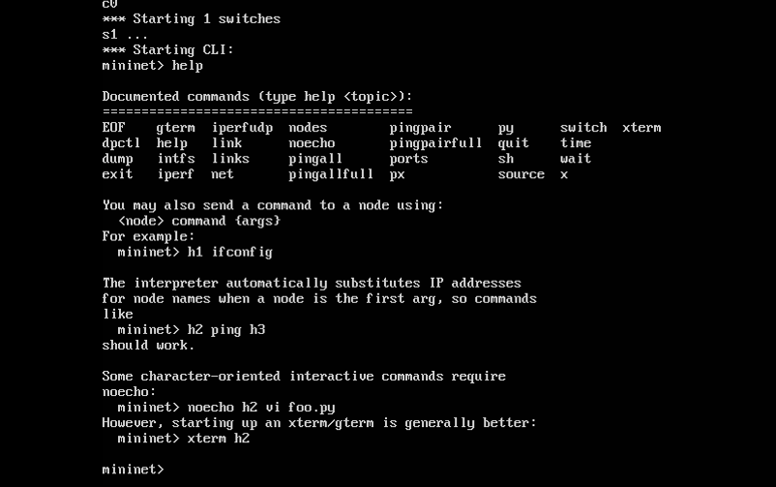

**Command: nodes**

**Description:**

**Displays all network devices in the current topology.  
Output includes the controller (c0), hosts (h1, h2), and switch (s1).  
Offers a quick summary of all network components.**

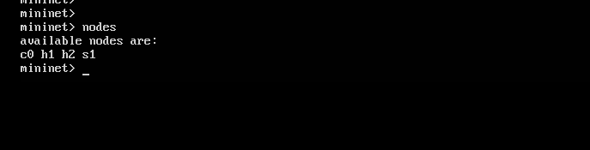

**Command: net**

**Description:**

**Shows the connections between devices in the network.  
Lists links between hosts and switches, including interface names (e.g., h1-eth0 connected to s1-eth1).  
Provides specifics about how devices are interconnected and their interface settings.**

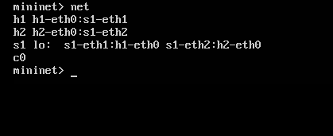

**Command: h1 ifconfig**

**Description:**

**Runs the Linux ifconfig command on host h1.  
Displays h1's network interfaces, such as h1-eth0 (IP 10.0.0.1) and the loopback (lo).  
Reveals detailed network configuration for host h1.**

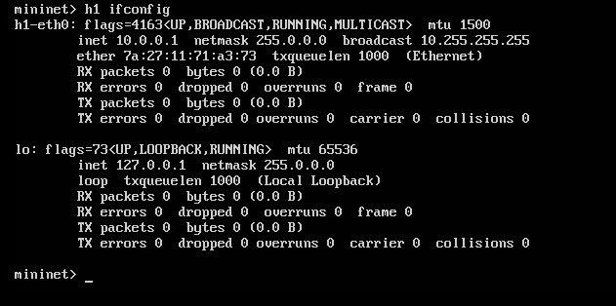

**Command: h1 ping 10.0.0.2**

**Description: Checks network connectivity between h1 (10.0.0.1) and h2 (10.0.0.2).  
Output includes ICMP packet transmission and reception details, along with round-trip time metrics.  
Can be interrupted with Ctrl+C to stop the ping test.**

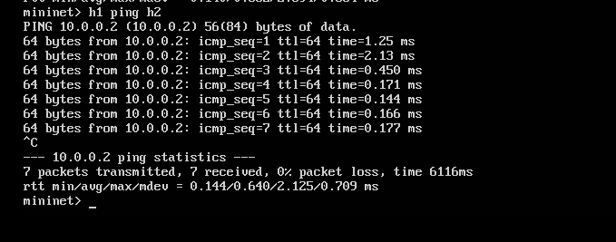

**Command : h1 ping h2**

**Description: Tests connectivity between host h1 and host h2 using ICMP echo requests.  
Displays packet transmission details, including success/failure, round-trip time (RTT), and packet loss statistics.  
Can be stopped manually with Ctrl+C.**

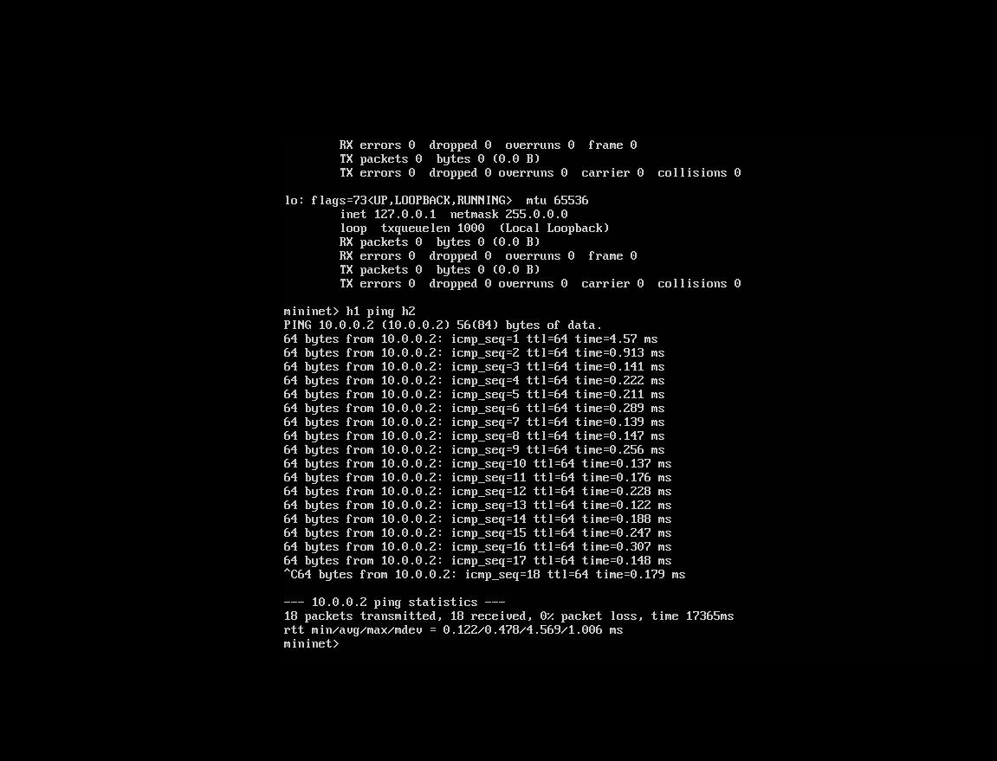

**Command: pingpair**

**Description: Checks basic reachability between all host pairs in the network (e.g., h1 ↔ h2 in a default setup).  
Performs a quick connectivity test to verify that all hosts can communicate with each other.  
Outputs success/failure results for each pair.**

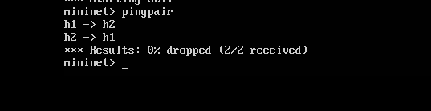

**Command: Links**

**Description:**

**Displays the status of all links between switches and hosts in the topology.  
Shows whether each link is up (active) or down (inactive).  
Useful for troubleshooting connectivity issues in the network.**

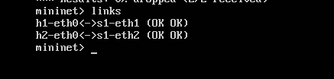

**Command: exit**

**Description: Closes the Mininet CLI and terminates the current session.  
Ends the network emulation and returns to the system shell.**

