**Library System**

# Command Line interaction with system

## Database.py

This file has functions to interact with data files

### Read_file(path,mode)

Used to read data from any .txt file

Path : path of the .txt file

Mode : mode in which you want to open

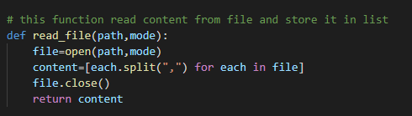

### Updater()

This function updates the data to database.txt. This function used everywhere there is a need of updating the data. If you want to change the database.txt then it is necessary to provide the path of new file to this function.

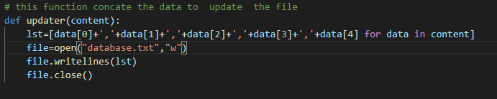

## Logfile.py

In this file there is two function checkout and returning respectively. These two function update the logfile.txt. if you have another logfile.txt and want to replace with it then it is necessary to provide the path to these function otherwise your logfile.txt will not update.

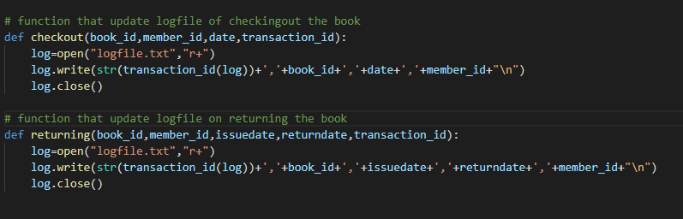

## Booksearch.py

If you want to search books by title using command line interference then run this file and type the exact name of the book title otherwise nothing will be appear

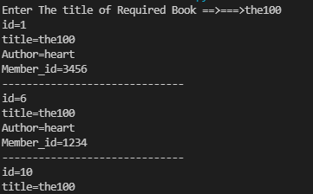

Remember the program is case sensitive.

## Bookcheckout.py

If you want to issue a book to member through command line the run this file.

Provide the four-digit member id and the valid book id

If the book id is not in the database.txt it may raise an error or any exception.

## Bookreturn.py

If you want to return a book from member through command line the run this file.

Provide the valid book id

If the book id is not in the database.txt it may raise an error or any exception.

# Graphical User Interference

## Menu.py

This is has the code for GUI.

Main Window

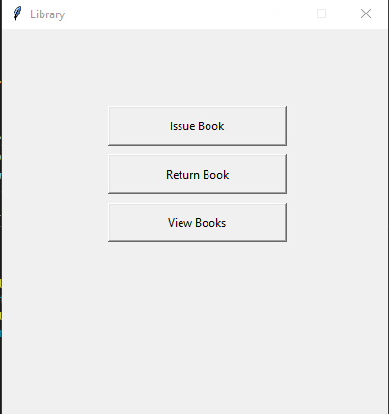

### Issue book

You can issue book using issue book button

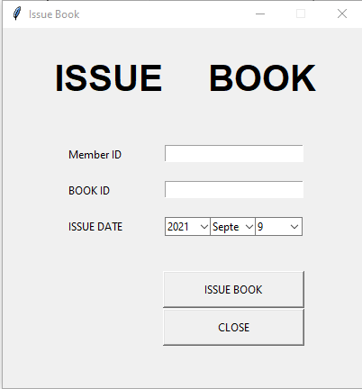

Provide the four-digit member id and the valid book id

By pressing the close button you will go to the main window

### Return Book

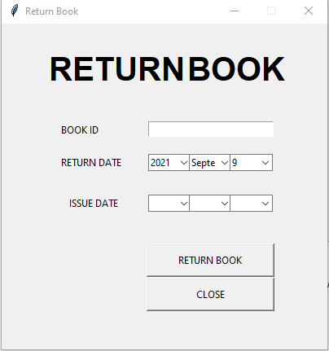

Provide the valid book id and enter the issue date by checking of the member card

By pressing the close button you will go to the main window

### Search Book

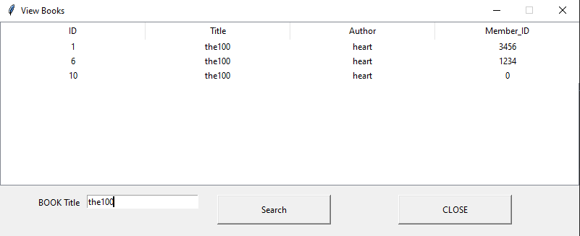

Provide the valid book title and get the record of the book

By pressing the close button you will go to the main window

# Booklist.py

This file has code that calculate the popularity of books on the behave of logfile.txt

