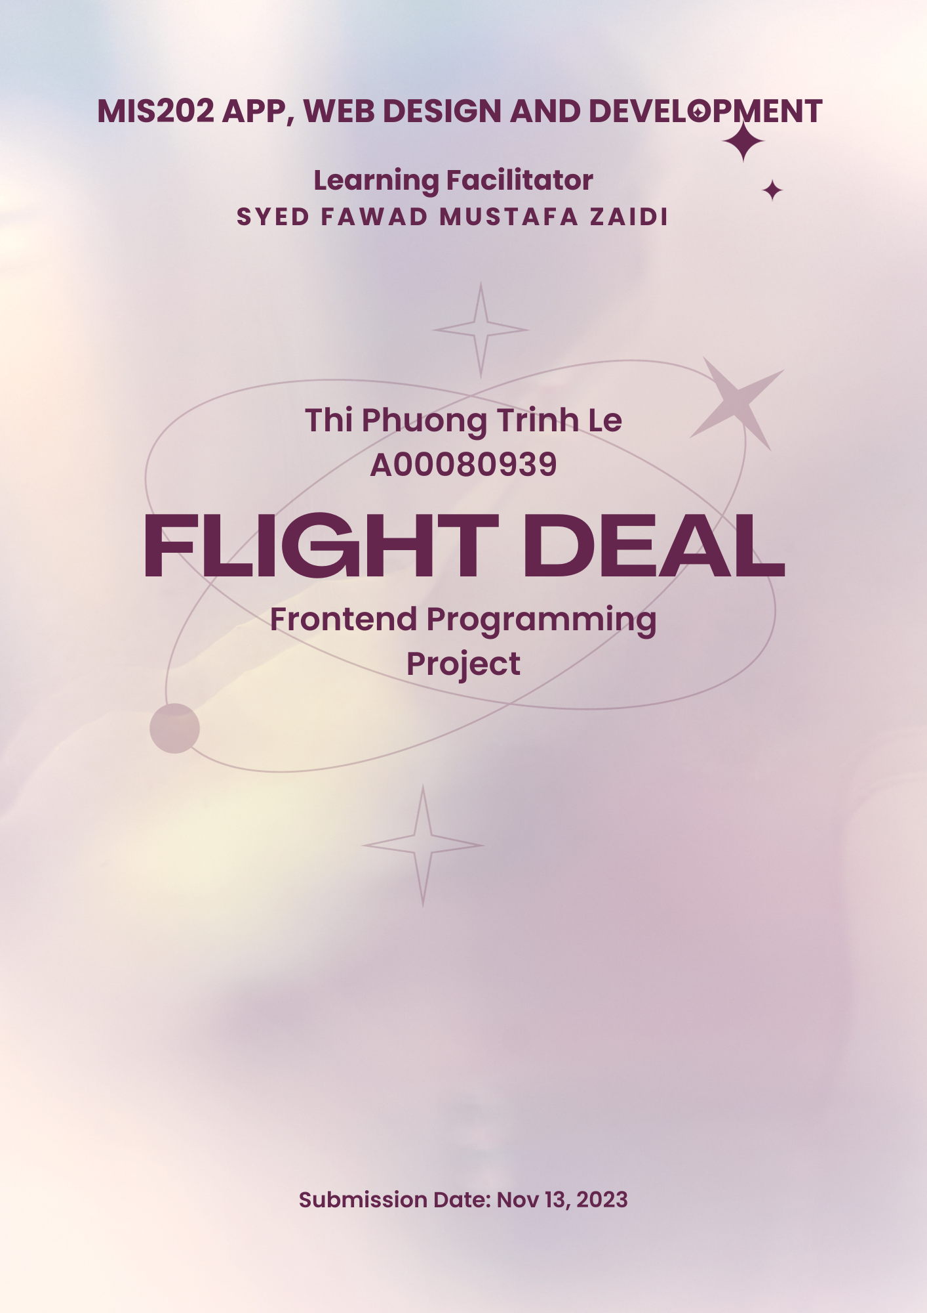

# Read My Document

## About the Project

Assessment 2 submission based on the designs which provided on Assessment 1. However, I have modified the UI such as button, layout.

## About my code

The html/CSS and JS have been developed, based on Bootstrap latest version: <https://getbootstrap.com/docs/5.2/getting-started/introduction/>

The submission included:

* 22 .html files (for student, advertiser, sale team, moderator, and admin roles)
* 2 .js files (.js files which used for Enquiry function)
* 1 .css files
* And other folders (audio, images, video)

The .js files which used for Enquiry function that the

In my code, I have created some notes which help to find the blocks, sections of code easier. View the screenshot below as an example:

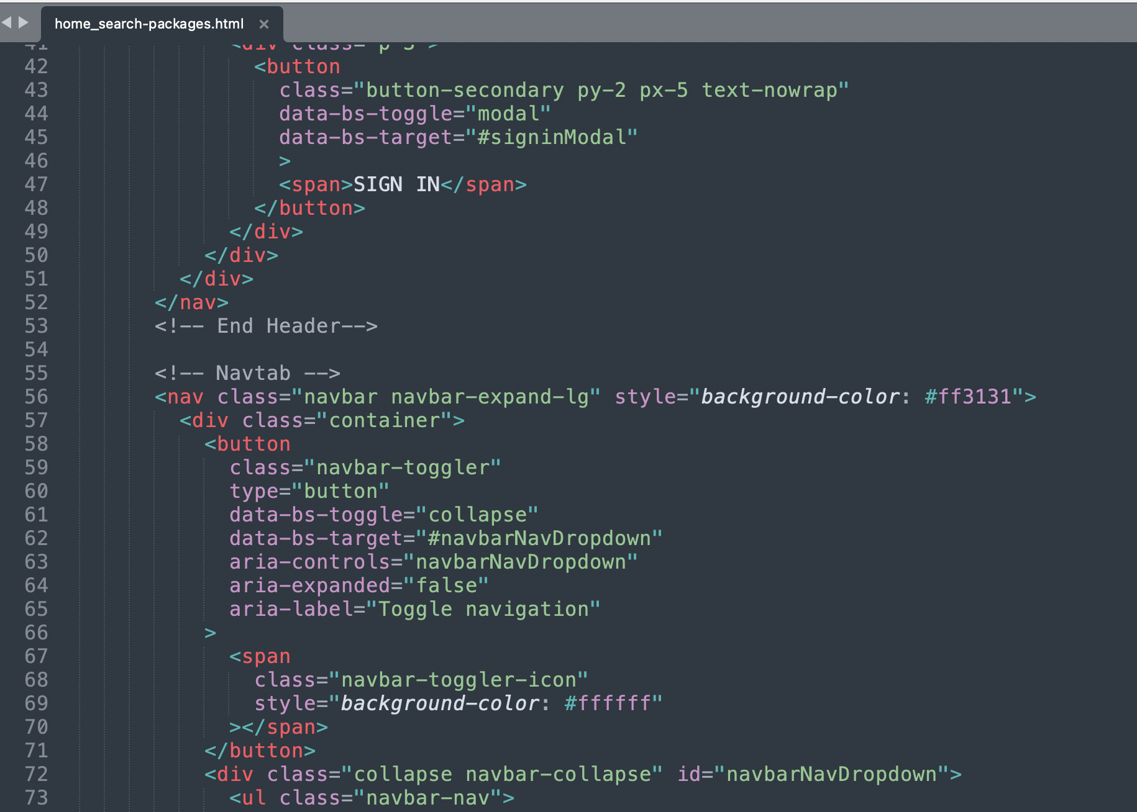

For Homepage (index.html), I have used <carousel> instead of <image>. In my opinion, the carousel which designed carefully and eyes catching can help to attract customer. However, for this assessment, I have not used graphic design skill for making any banner on Carousel section.

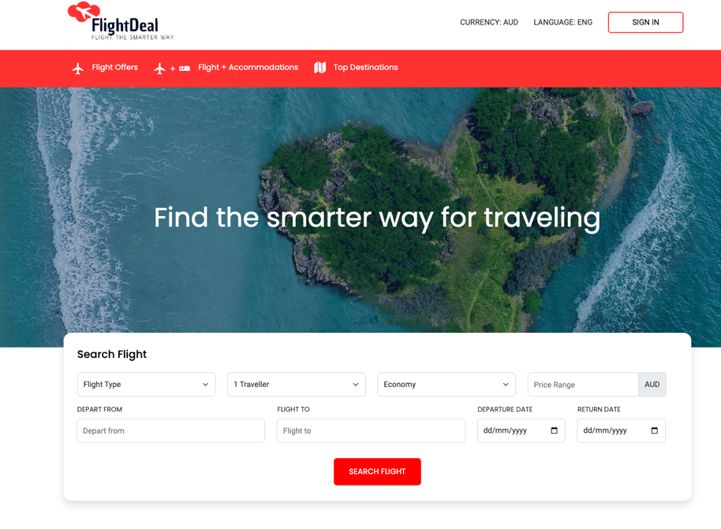

About resource used for this project,

* the pictures downloaded from pixabay.com
* icon, graphic used from Feather icon which provided by Bootstrap