10/16/2024

**SOFTWARE DESIGN AND ARCHITECTURE**

**NAME: AHSAN FARAZ**

**REGISTRATION: FA22-BSE-073**

**ASSIGNMENT: 1**

**SUBMITTED TO: SIR MUKHTIAR ZAMIN**

**Virtual Study Group Platform**

**1. Project Overview**

The **Virtual Study Group Platform** aims to revolutionize the way students collaborate on their studies by providing an online space for them to form study groups. In this digital environment, students can join or create study groups, participate in real-time communication through chat or video conferencing, share study materials, and manage group tasks effectively. The platform's primary objective is to eliminate geographical barriers to collaboration, ensuring that students can work together regardless of their physical location.

**2. Problem Statement**

In traditional educational settings, study groups often require in-person meetings, which can pose significant challenges due to conflicting schedules, geographical distances, and the need for flexibility in study arrangements. General communication tools like Zoom or Discord do not specifically cater to the needs of academic collaboration, leaving students without an effective means to manage their study sessions. This gap necessitates a dedicated platform that addresses these challenges by providing tailored features for academic collaboration.

**3. Solution**

The Virtual Study Group Platform provides a comprehensive solution to the issues faced by students seeking to collaborate effectively. Key features of the platform include:

**Group Creation and Management**: Users can easily create or join study groups based on their academic interests.

**Real-Time Communication**: The platform supports both text chat and video conferencing, enabling dynamic discussions and study sessions.

**Task Assignment and Tracking**: Group members can assign and track tasks, ensuring everyone stays on top of their responsibilities.

**Resource Sharing**: Students can upload and share study materials, facilitating access to important resources.

**Notification System**: Users receive reminders for upcoming study sessions and task deadlines, helping them stay organized.

**4. Key Features**

**User Registration and Authentication**: Secure sign-up and login mechanisms utilizing JWT (JSON Web Tokens) for authentication.

**Group Management**: Functionality for creating, joining, and managing study groups, with privacy settings to control group access.

**Chat and Video Conferencing**: Integrated real-time chat using Socket.io and video calls powered by WebRTC or third-party APIs.

**Task Management**: An interface for creating tasks, setting deadlines, and tracking progress within study groups.

**File Sharing**: Users can upload and share documents, notes, and other study materials with group members.

**Notification System**: Automatic alerts and reminders to keep users informed about group activities and deadlines.

**Responsive Design**: A mobile-friendly interface that ensures accessibility across various devices.

**5. Technology Stack**

The Virtual Study Group Platform utilizes the MERN (MongoDB, Express, React, Node.js) stack, offering a robust and modern architecture:

**Frontend**: React.js is used to build an interactive and dynamic user interface, enabling the creation of reusable components and efficient state management with Redux.

**Backend**: Node.js and Express serve as the backend framework, handling API requests and user authentication, while integrating real-time communication features using Socket.io.

**Database**: MongoDB is utilized to store user profiles, group information, messages, and task data, allowing for efficient data management.

**Real-Time Communication**: Socket.io facilitates real-time chat, while WebRTC or third-party services (like Agora) support video conferencing.

**Cloud Storage**: Integration with cloud services (such as AWS S3 or Google Cloud Storage) is used for storing shared files and documents.

**6. Design and Architecture**

The application employs a microservices architecture, ensuring modular development and scalability. Each component (user management, group management, chat service, task management) operates independently, allowing for streamlined updates and maintenance.

**Frontend-Backend Communication**: The frontend communicates with the backend via REST APIs to fetch and submit data, while Socket.io handles real-time messaging.

**Database Structure**: MongoDB is used to manage collections for users, groups, messages, and tasks, providing a flexible schema to accommodate varying data types.

**7. System Workflow**

**User Registration/Login:** Users register on the platform and log in to access their accounts. JWT tokens are issued for secure session handling.

**Group Creation and Join**: Users can create new study groups, set preferences, and invite others to join or browse existing groups.

**Communication**: Users engage in group chats or initiate video calls for real-time discussions.

**Task and Resource Management**: Users create and manage tasks, upload study materials, and track their progress collaboratively.

**8. Use Case Scenario**

Consider the following scenario involving a student named Alice:

**Sign-Up/Sign-In**: Alice signs up for the platform using her email and sets up her profile.

**Creating a Study Group**: Alice creates a group titled "Math Exam Prep," setting it as public to allow classmates to join.

**Inviting Friends**: Alice sends invitations to her classmates to join the study group.

**Group Chat and Task Management**: In the group chat, Alice and her classmates discuss topics to focus on, assign tasks, and track each member's progress.

**Sharing Resources**: Alice uploads her study notes, while other members share their own materials within the group.

**Video Study Session**: On the eve of the exam, Alice initiates a group video call for a final review of key concepts.

**Tracking Progress**: Alice monitors the group's task progress, ensuring that all assigned work is completed.

**9. Conclusion**

The Virtual Study Group Platform is an innovative solution designed to facilitate student collaboration in a digital age. By offering a dedicated space for study groups, along with features that promote real-time communication, task management, and resource sharing, the platform enhances the academic experience for students. With its robust technology stack and scalable architecture, this platform is positioned to support a growing user base and adapt to the evolving needs of students in an increasingly digital learning environment.

**USE CASE DIAGRAM**

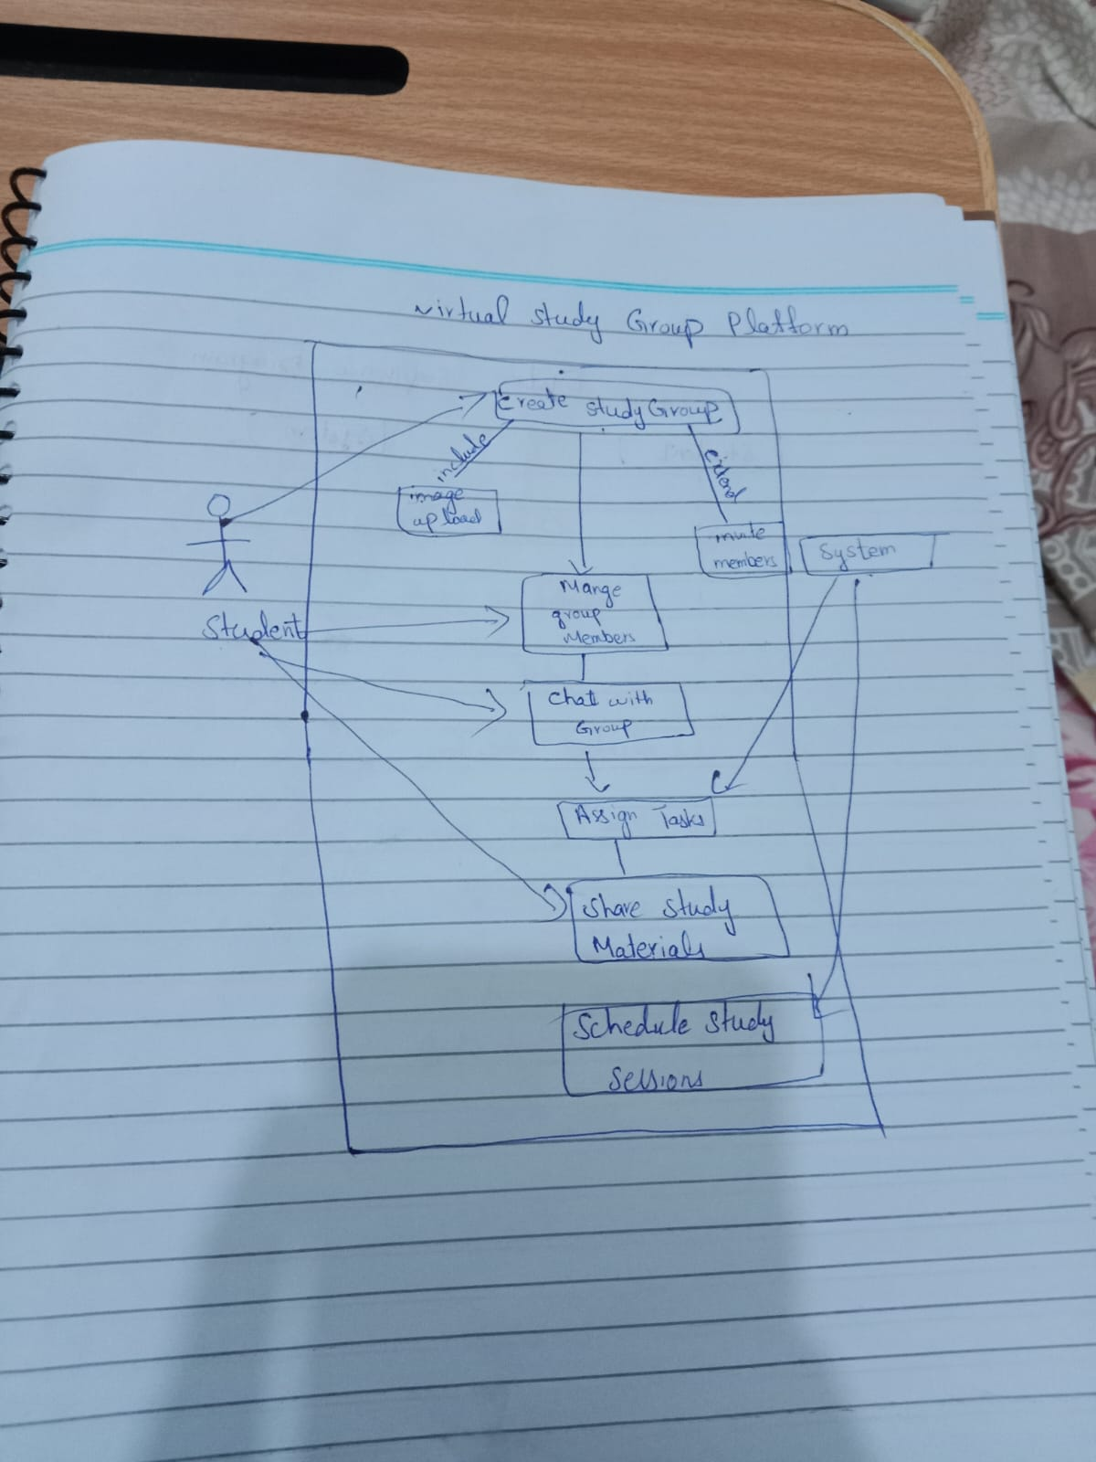

**FULLY DRESSED USE CASE DIAGRAM**

**Fully Dressed Use Case: Share Study Material**

**Use Case Name**:  
Share Study Material

**Primary Actor**:  
Student

**Scope**:  
Virtual Study Group Platform

**Level**:  
User-goal level

**Stakeholders and Interests**:

* **Student**: Wants to share study materials with group members to facilitate group study.
* **Other Group Members**: Benefit from accessing shared study materials for their study sessions.

**Preconditions**:

* The student is logged in.
* The student is a member of a study group.
* The student has appropriate permissions to share files in the group.

**Success Guarantee (Postconditions)**:

* The study material is successfully shared and made accessible to other group members.
* The material is stored in the group’s shared resources and visible to all members.

**Main Success Scenario**:

1. The student navigates to the study group’s page.
2. The student selects the “Share Study Material” option.
3. The system prompts the student to select a file or link to share.
4. The student selects a file or pastes a link and submits.
5. The system validates the file type or link.
6. The system shares the file or link with the group.
7. The system confirms the successful sharing of the material with the student.
8. The study material is now accessible to other group members.

**Extensions**:

* **3a**. *No File or Link Selected*:  
  If the student does not select a file or link, the system prompts the student to provide one.
* **5a**. *Invalid File Format or Link*:  
  If the selected file is in an invalid format or the link is broken, the system displays an error and requests a valid file or link.
* **6a**. *Sharing Failure*:  
  If the system fails to share the material due to a system error, it informs the student and logs the issue for debugging.

**Includes**:

* File or Link Selection

**Extends**:

* Notify Members (when new materials are shared)

**Sequence diagram**

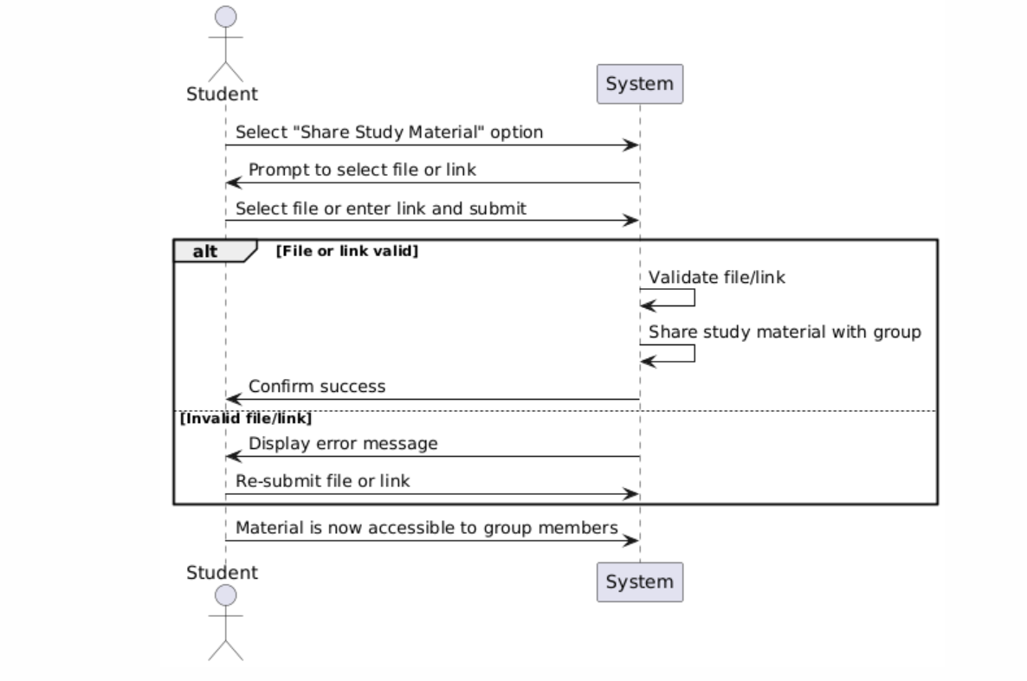

**Key Elements of the Diagram:**

1. **Actor**: The **Student** initiates the action by selecting the option to share study material.
2. **System Responses**: The system prompts the user for input, validates the file or link, and either confirms the success or shows an error.
3. **Conditional Logic**: The alt section handles the two scenarios:
   * If the file or link is valid, the system proceeds to share the material.
   * If invalid, the system prompts for a valid file or link.

**Communication diagram**

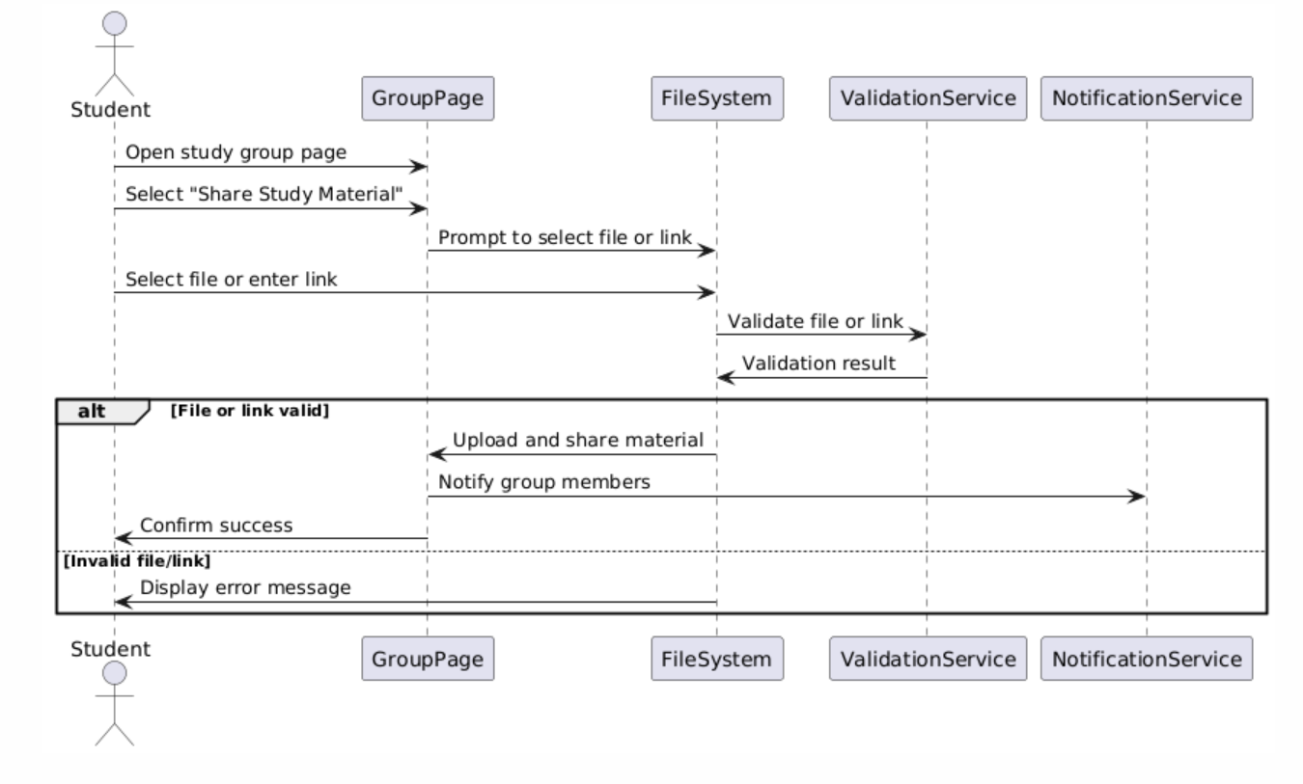

**Key Elements of the Diagram:**

1. **Actor**: The **Student** interacts with the **GroupPage** (the user interface for the study group).
2. **Components**:
   * **GroupPage**: The system component that the student interacts with to share materials.
   * **Filesystem**: Handles file selection or link input.
   * **Validation Service**: Validates the file format or link correctness.
   * **NotificationService**: Notifies group members of the new material.
3. **Conditional Logic**: The alt block represents the flow of actions if the file/link is valid or invalid.