Exercise 1:

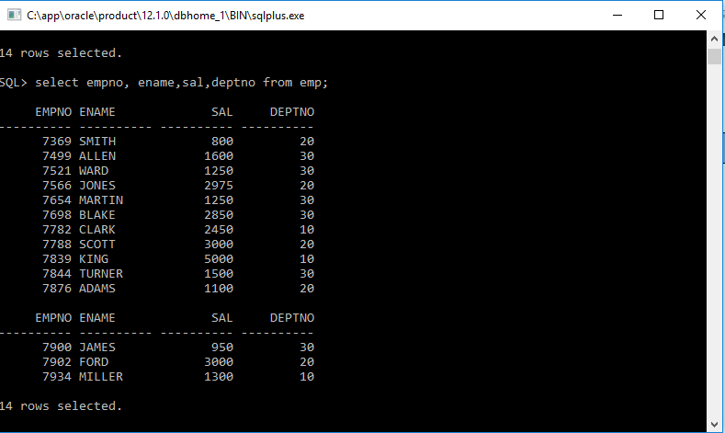 **Get empno,ename,sal,deptno from emp table.**

Exercise 2:

**Count total number of employees.**



Exercise 3:

**Get the highest and the lowest salary from emp table.**



Exercise 4:

**Calculate net salaries of employee (by adding salary and comm).**

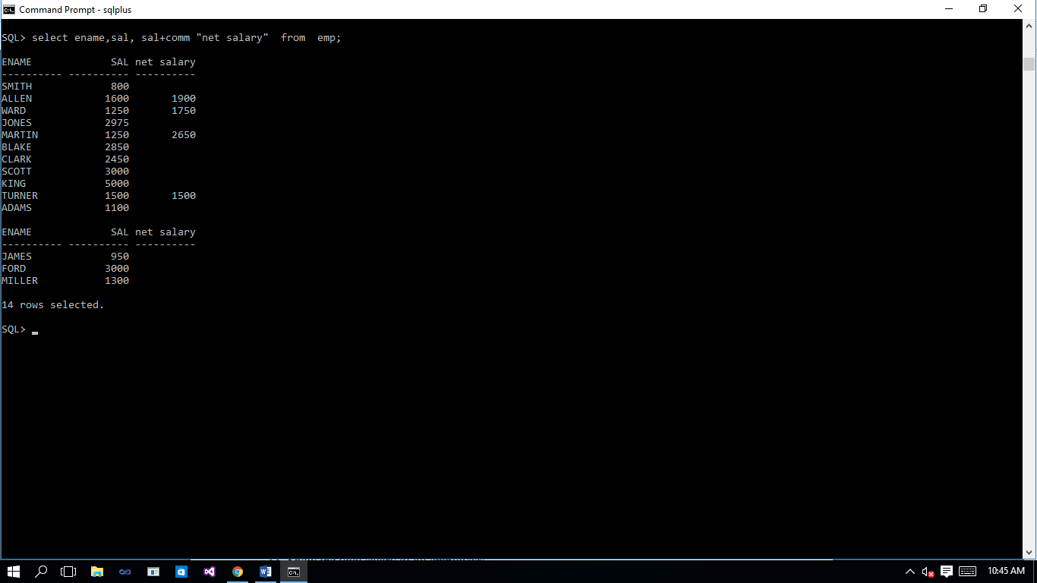

Exercise 5:

**Display all the deptno that employees belong to, but don’t allow repetition.** 

Exercise 6:

**Display data of all employees who work as Salesman.**

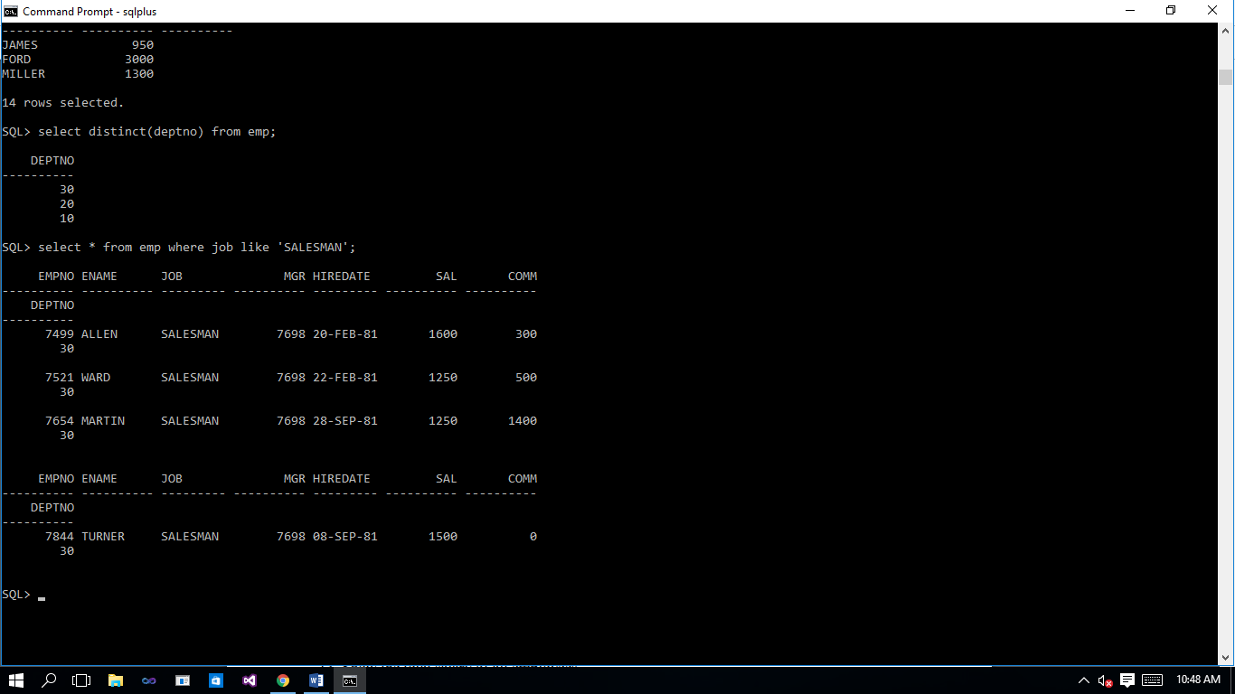

Exercise 7:

**Display names of employees who work in deptno 20.**

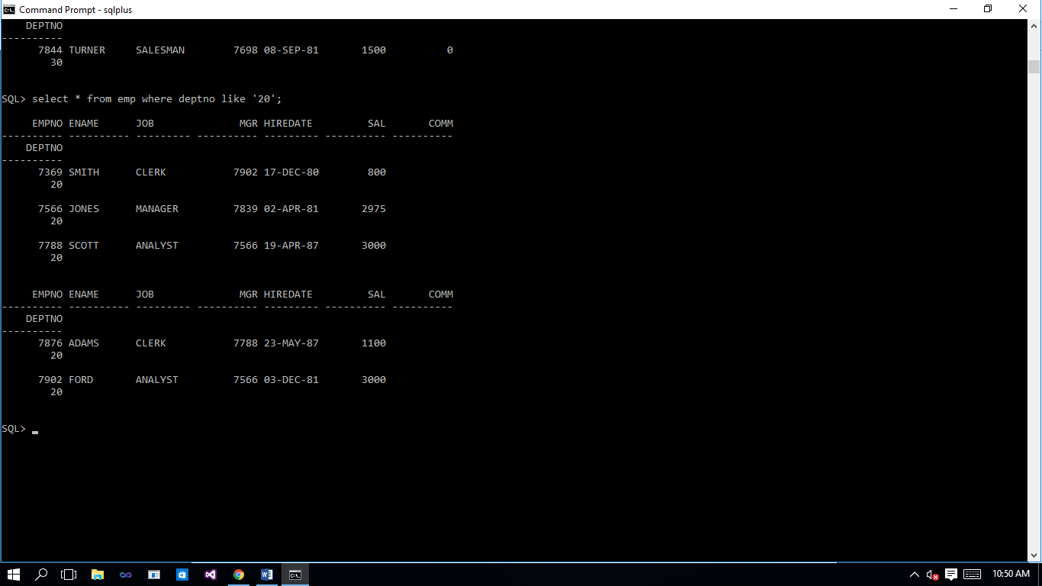

Exercise 8:

**Calculate one year salary of every employee from emp table.**

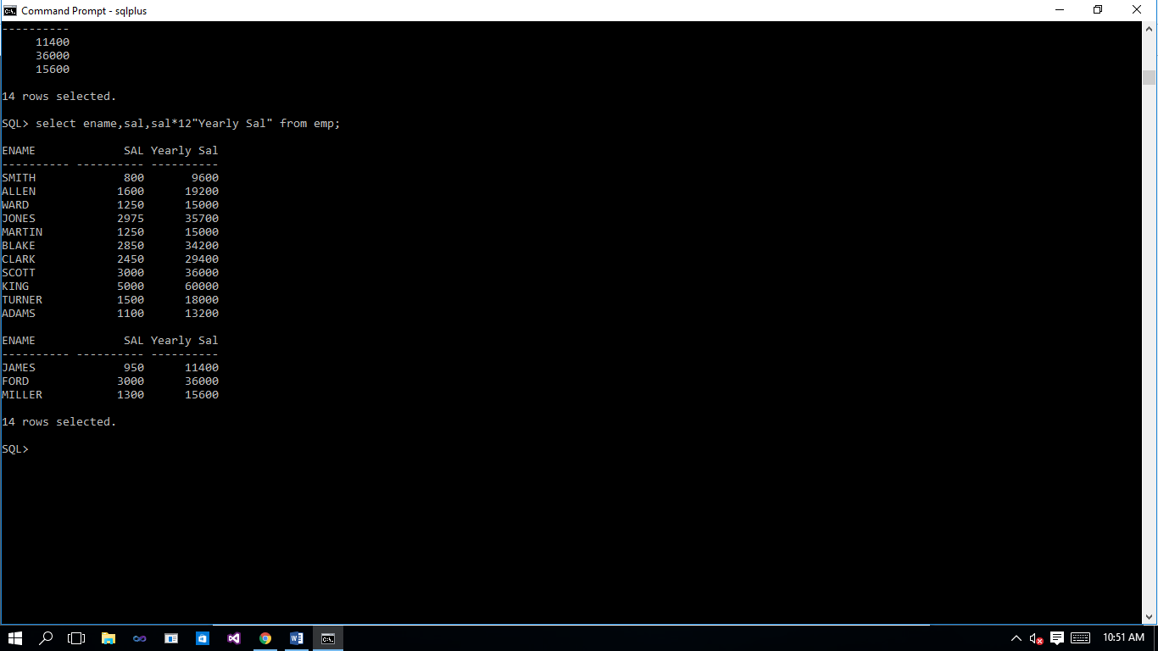

Exercise 9:

**Display the total count of departments from dept table.** 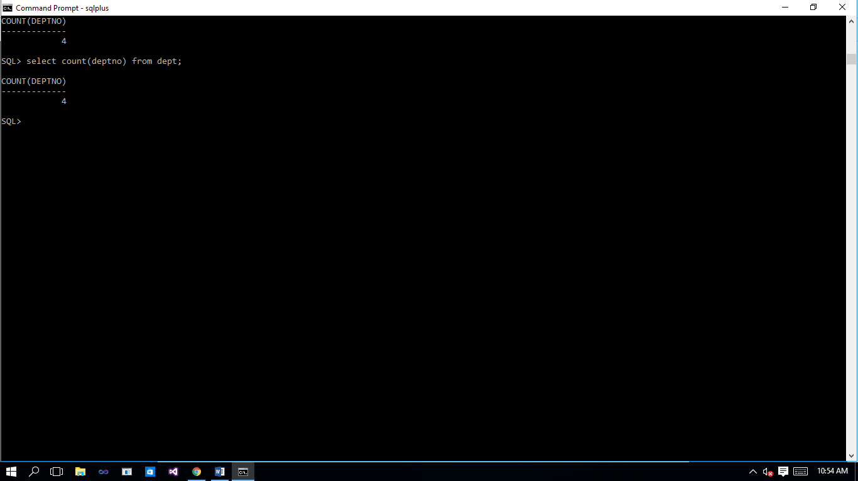

Exercise 10:

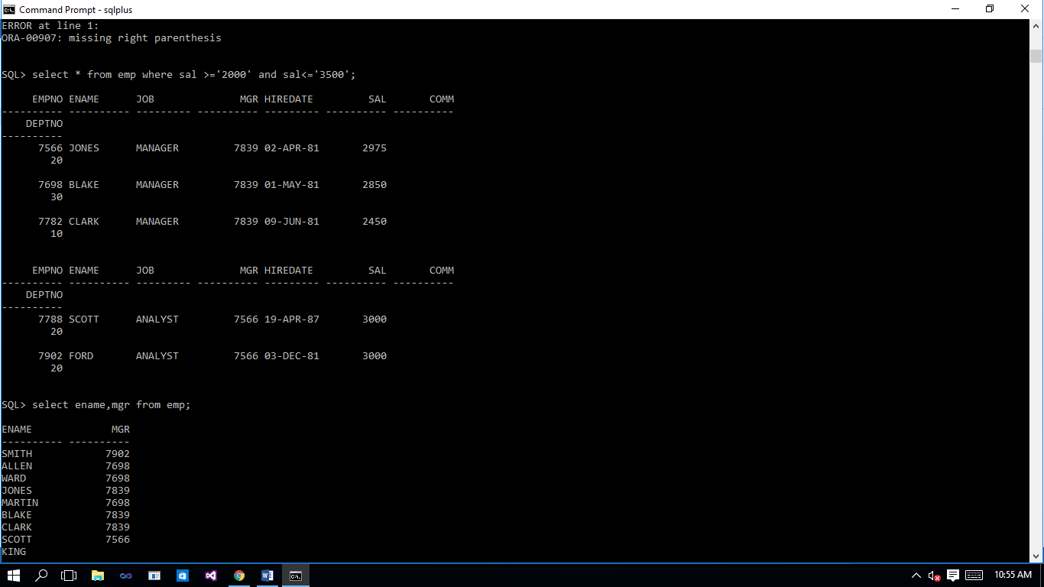**Display the employee name whose salary is more than 2000 but less than 3500.**

Exercise 11:

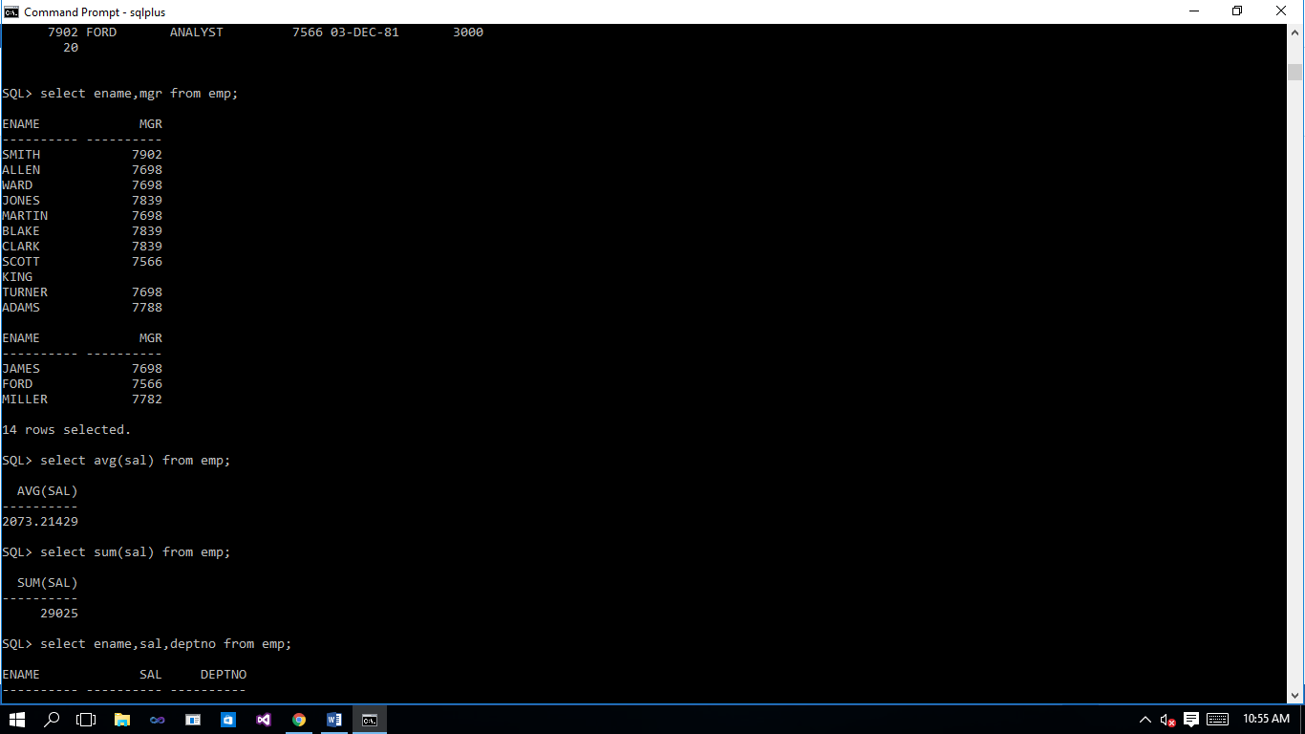**Display all employee names and their manager number from emp table.**

Exercise 12:

**Show the average salary of all employees.**

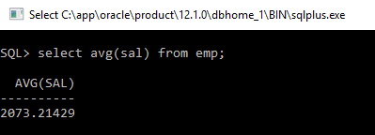

Exercise 13:

**Show the total salary of all employees.**

