Exercise 1:

**Display empno,sal of employees whose sal is less than 2000.**

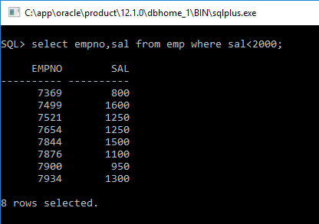

Exercise 2:

**List ename of all employees whose name starts with letter ‘A’.**

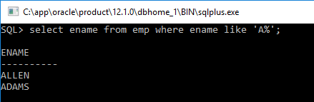

Exercise 3:

**Display ename,job,deptno of employees who are either SALESMAN or belongs to deptno = 10.**

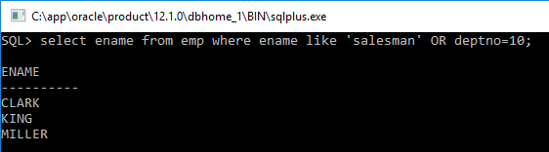

Exercise 4:

**Display ename,sal of employees whose salaries lies in the range of 1500 to 3000.**

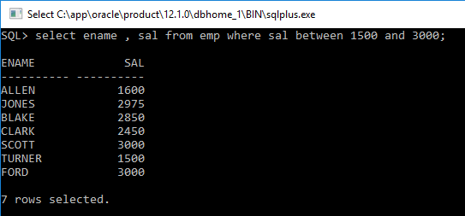

Exercise 5:

**Display ename,comm of employees whose commission is empty.**

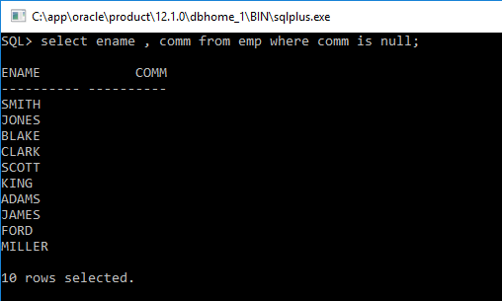

Exercise 6:

**Display names of all employees that end with alphabet ‘N’.**

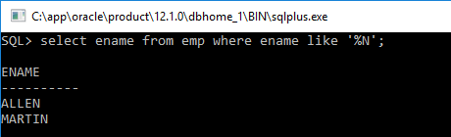

Exercise 7:

**Show ename,sal,job of those employees who are not ‘SALESMAN’.**

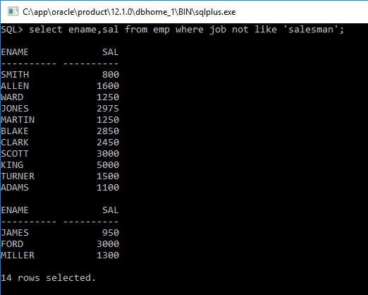

Exercise 8:

**Show empno,sal of those employees who do not have salaries of 1600, 1250, 3000.**

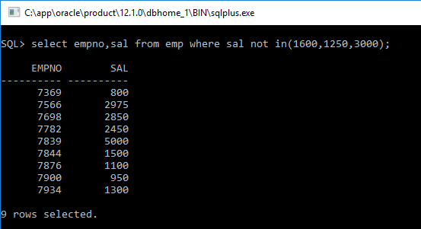

Exercise 9:

**Show names of those employees whose name starts with A and ends with N.**

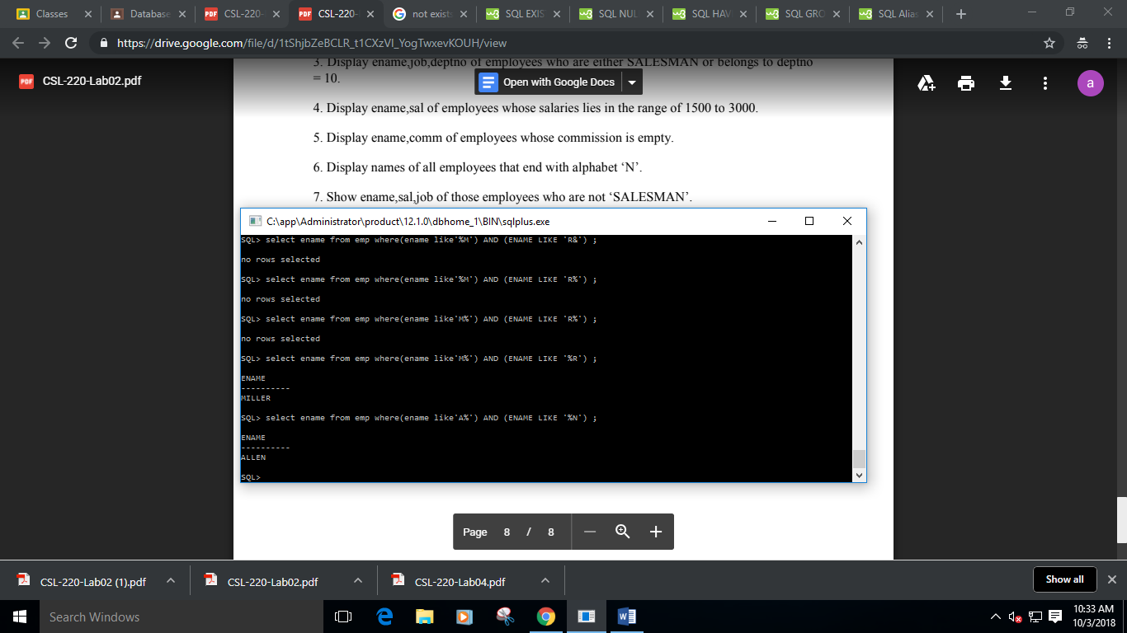

Exercise 10:

**Display the list of employee names that have letters ‘LA’ in their names.**

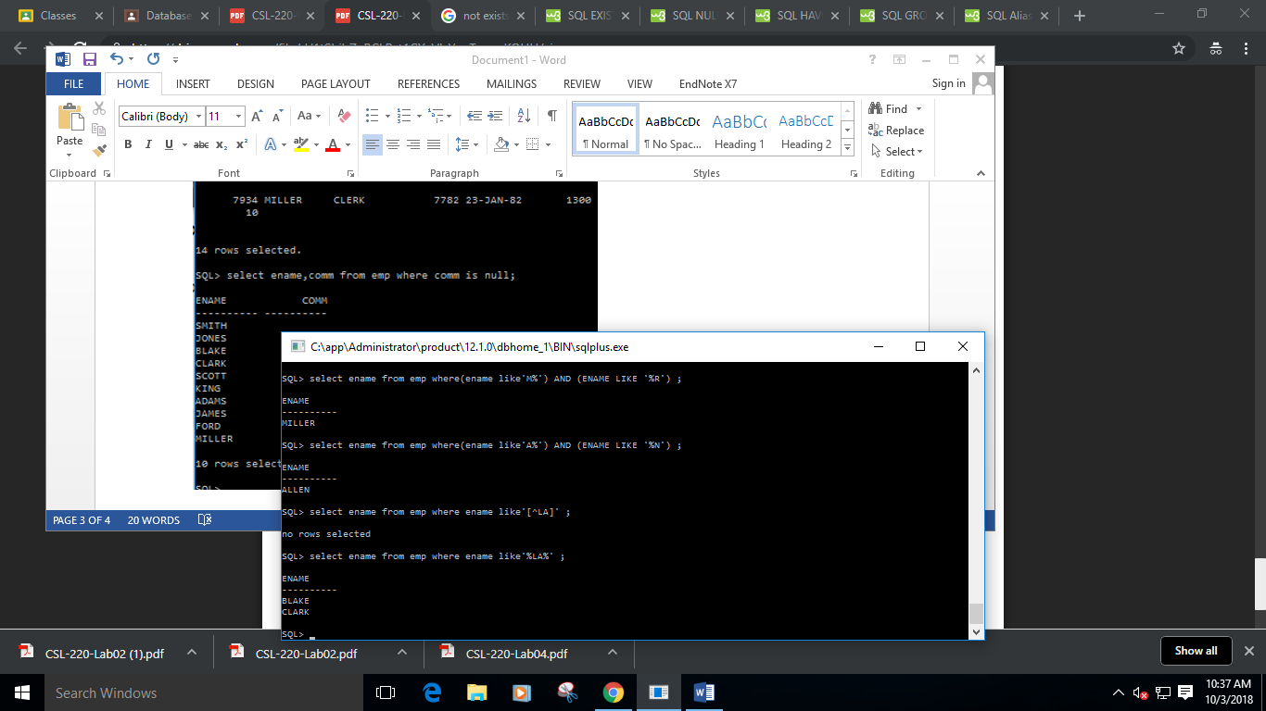

Exercise 11:

**Display the empno,sal of employees. In that, the highest paid employee should display first and lowest paid should display last.**

