Exercise 1:

1. Display ename, job, sal of all the employees whose job is “CLERK”. Keeping this in mind that CLERK may be in capital, small or combination of small capital characters in the table.

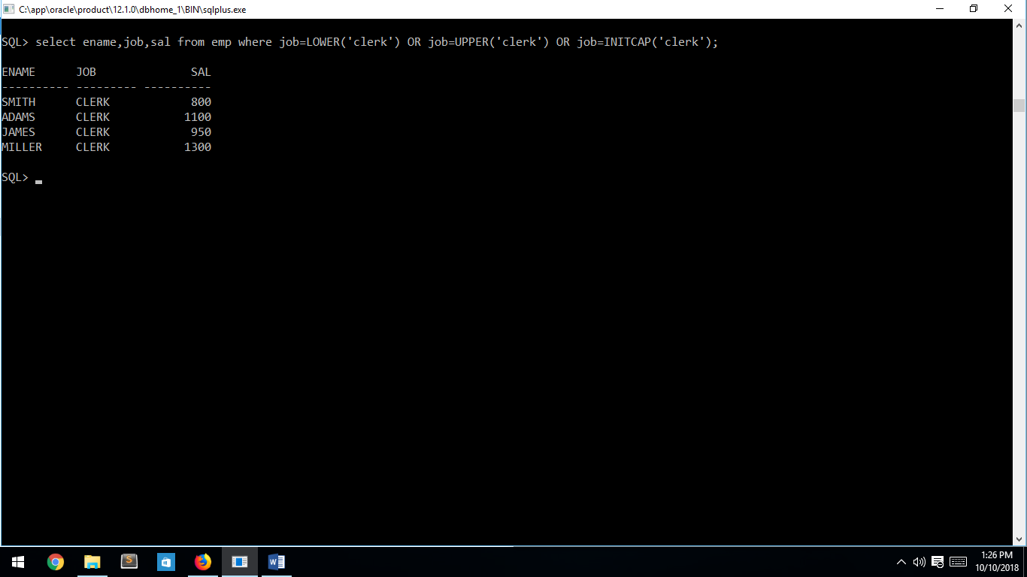

Exercise 2:

2. Generate new names of the employees by combining the first 3 characters of the ename and last 3 characters of the job.

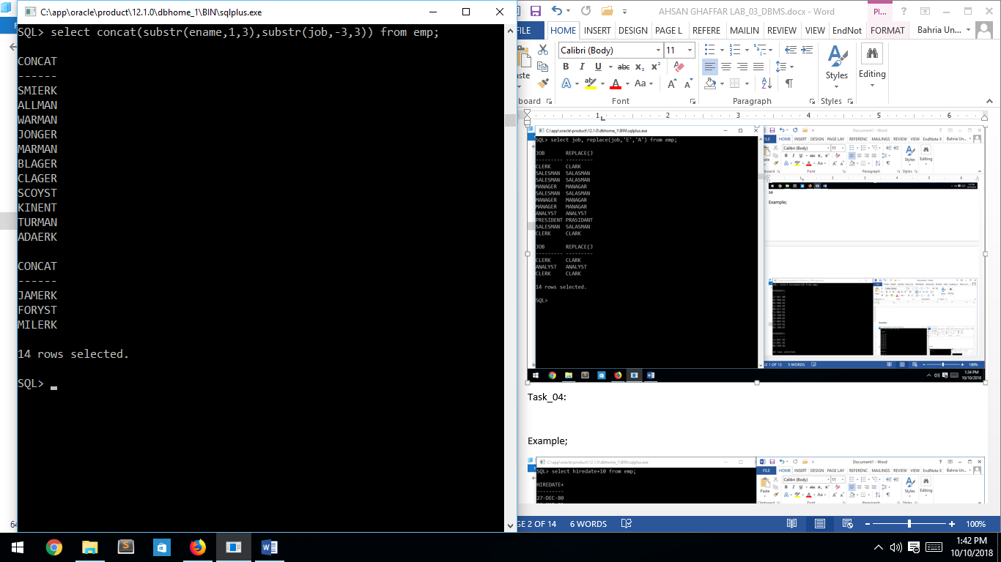

Exercise 3:

3. Generate new jobs of the employees by changing letter E with A in the existing jobs.

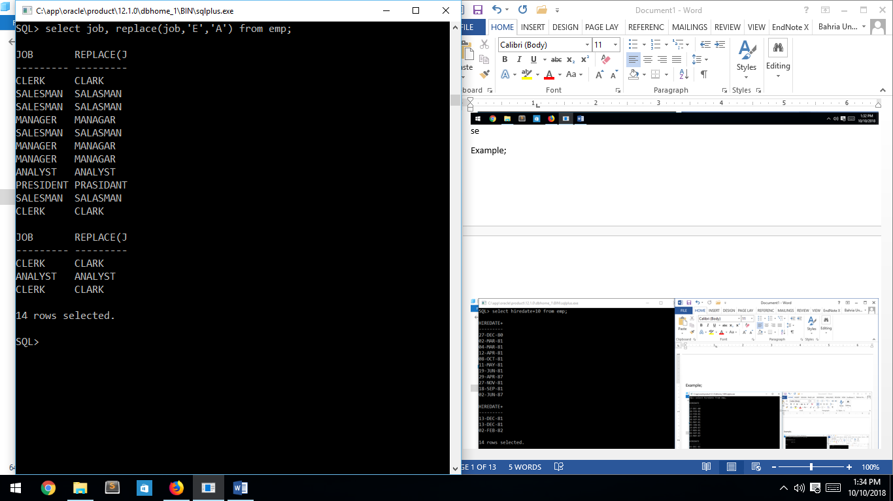

Exercise 4:

4. Display ename, total years in the department.

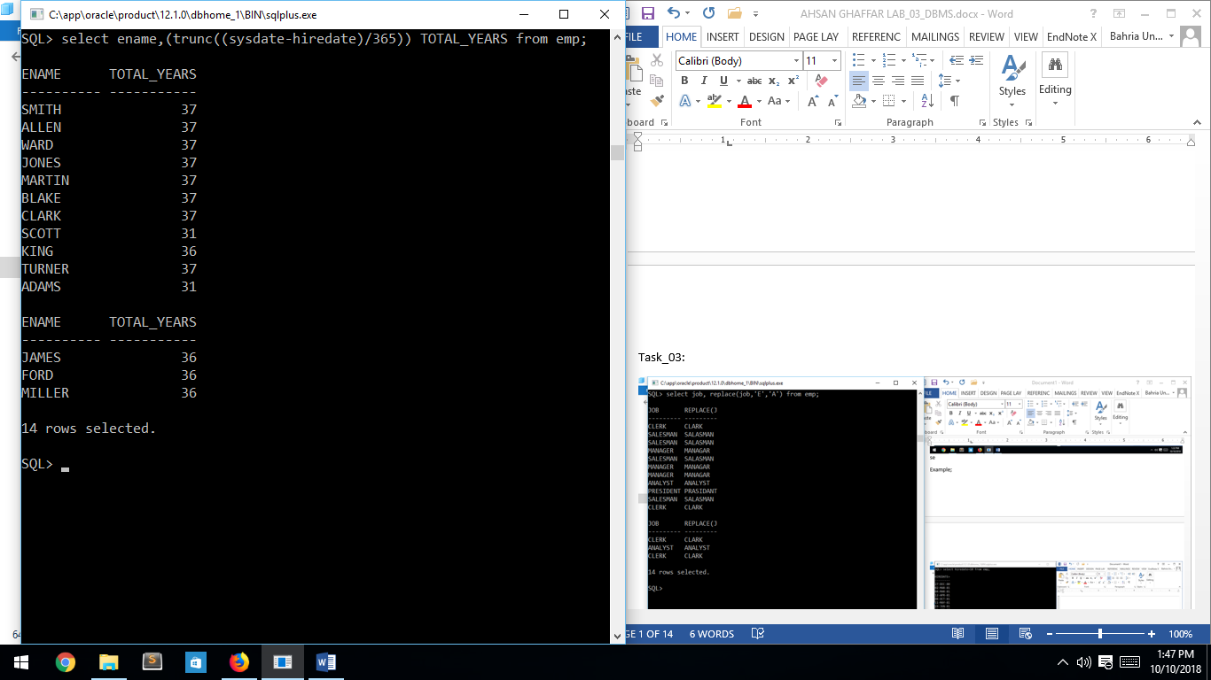

Exercise 5:

5. Display ename, hiredate of all the employees who were hired before February 20, 1981. Keeping this in mind that hiredates should be displayed in the format “MONTH DATE, YEAR”. Also date in the where clause should be in the format “MONTH DATE, YEAR”.

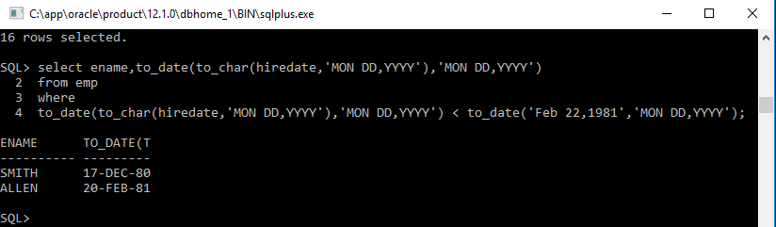

Exercise 6:

Display employee name,sal,comm and total salary (Comm + Sal) of all the employees. Keeping this in mind that comm of some of the employee might be null but total salary of the employees should not be null.

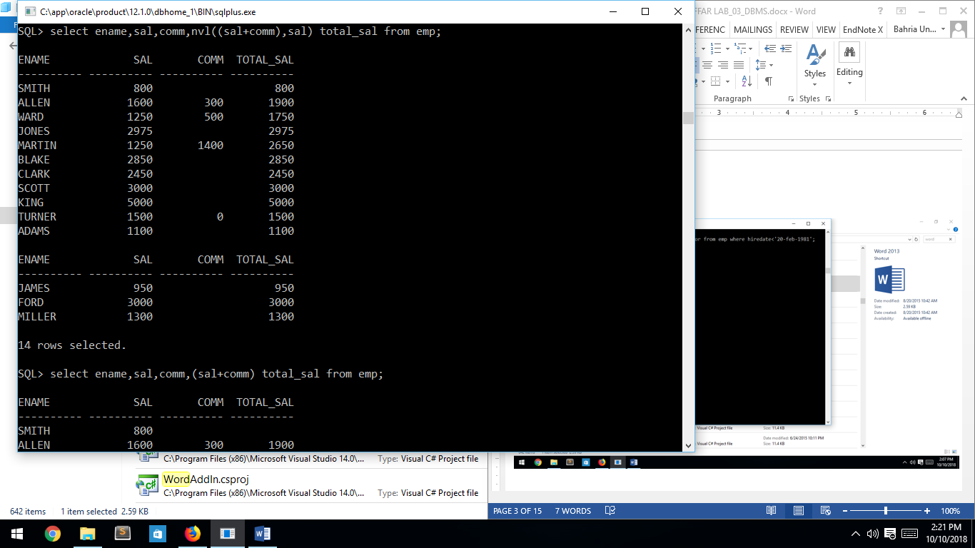

Exercise 7:

Display employee name,sal,comm and total salary (Comm + Sal) of all employees. Keeping this in mind that comm or sal of some of employee might be null but total salary of the employees shouldn’t be null.In case of comm is null, total salary should be original salary or if salary is null, total salary should be the original comm.

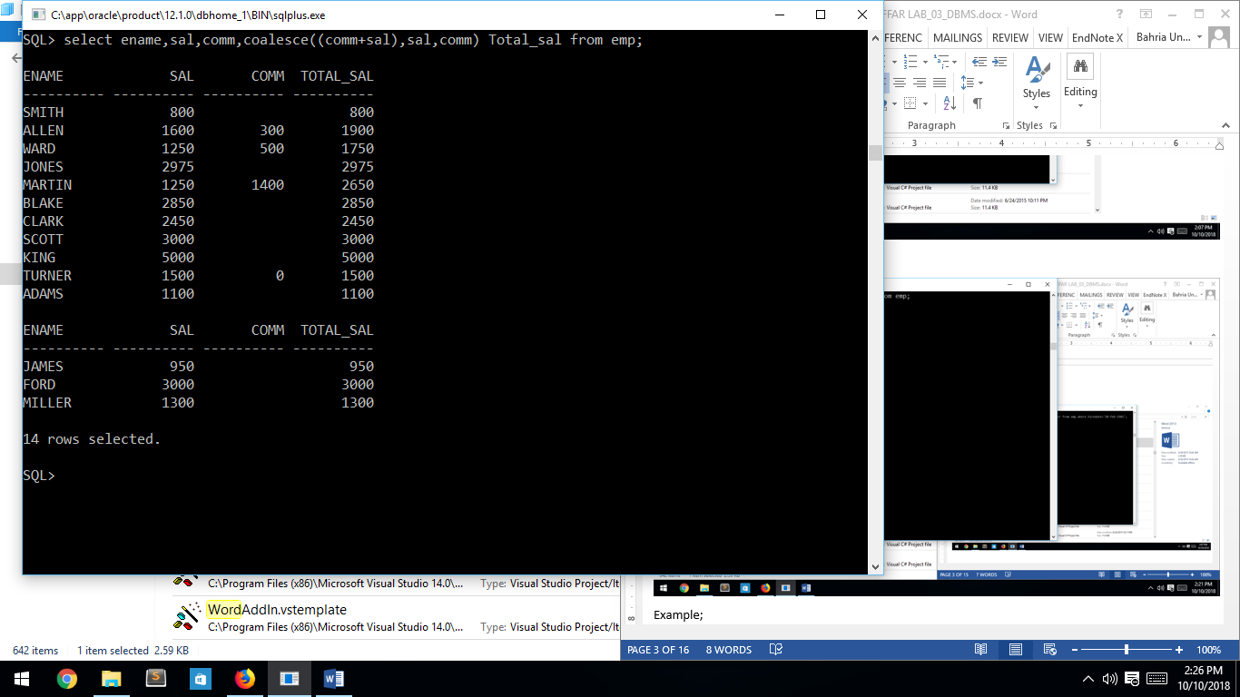

Exercise 8:

8. Display ename,sal,comm and bonus of all the employees. If job = CLERK then bonus = 20% of the salary, if job = SALESMAN then bonus = 30% of the salary, if job = MANAGER then bonus = 50% of the salary else bonus = 10% of the salary

