Exercise 1:

**Display the dname and average salary of those departments whose average salary is > than 2500.**

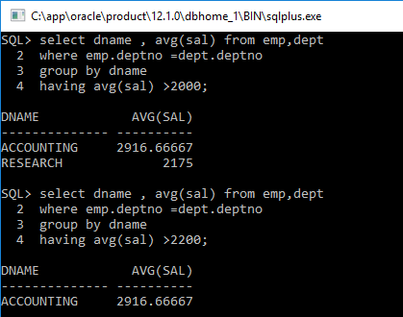

Exercise 2:

**Display the ename, sal, deptno and average salary of the department of those employees who earn more than the average salary of their own departments.**

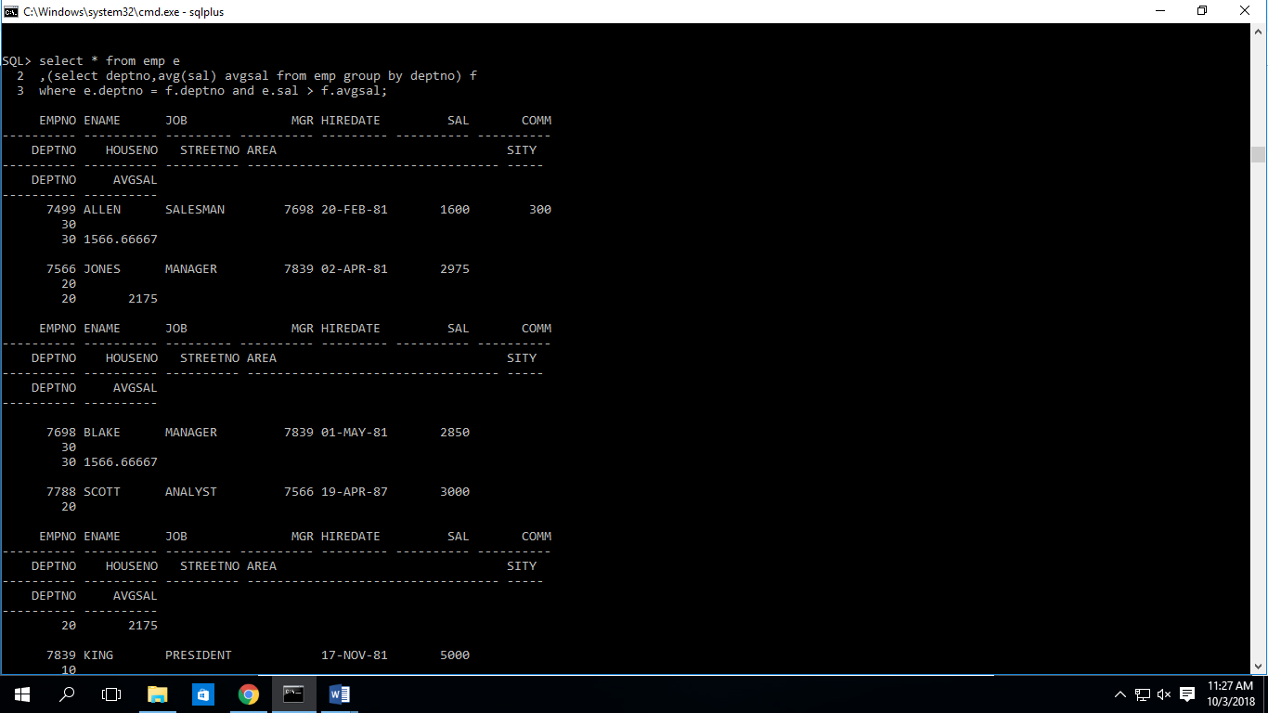

Exercise 3:

**Display the total number of employees who have no commission.**

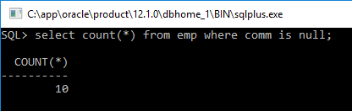

Exercise 4:

**Write a query to display the number of employees with the same job.**

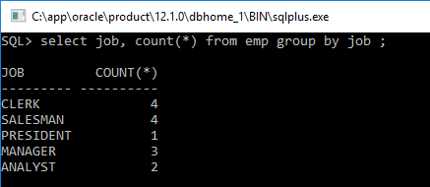

Exercise 5:

**Display the manager number and the salary of the lowest paid employee of that manager. Exclude anyone whose manager is not known. Exclude any groups where the minimum salary is 2000. Sort the output is descending order of the salary.**

