Exercise 1:

**1. Create a unique listing of all jobs that are in department 30. Include the location of department in the output.**

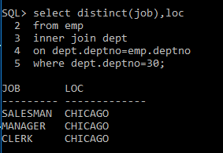

Exercise 2:

**2. Write a query to display the employee name, department name and loc of all employees who earn a commission.**

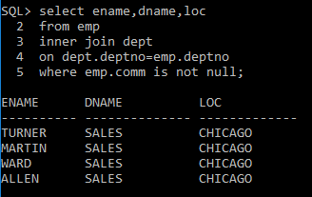

Exercise 3:

**3. Create a query that displays the name, job, department name, salary, and grade for all employees.**

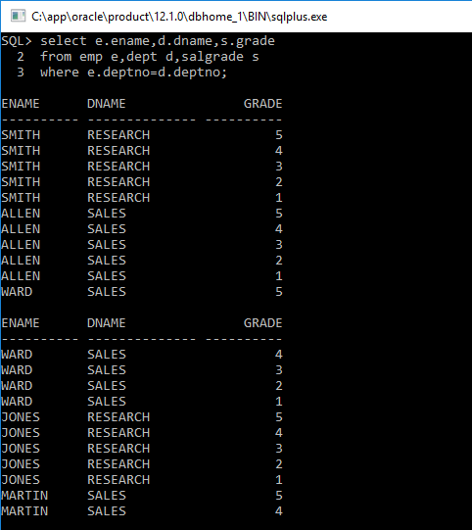

Exercise 4:

**4. Create a query to display the name and hire date of any employee hired after employee ADAMS.**

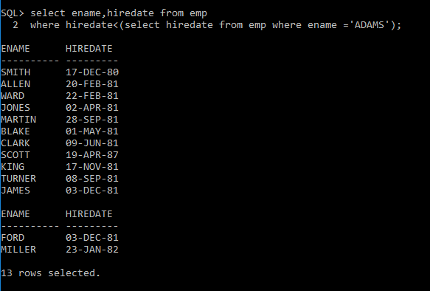

Exercise 5:

**5. Display the names and hire dates for all employees who were hired before their managers, along with their manager’s names and hire dates.**

