Exercise 1:

**Create a replica of EMP table with all the records in it.**

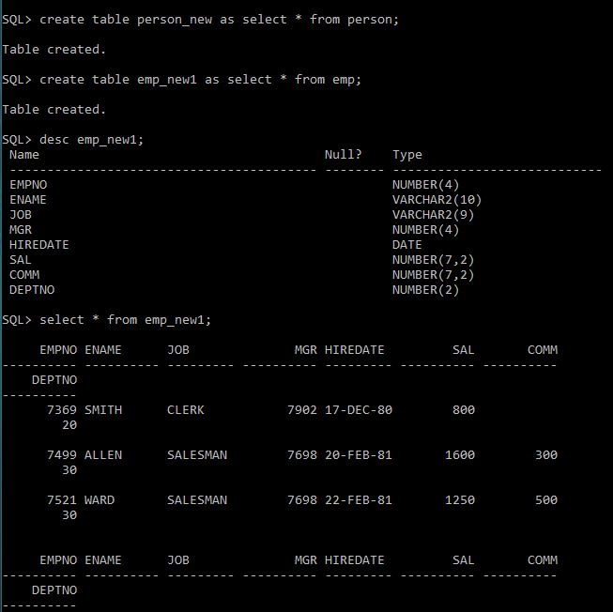

Exercise 2:

**Add a column ‘Address’ in it.**

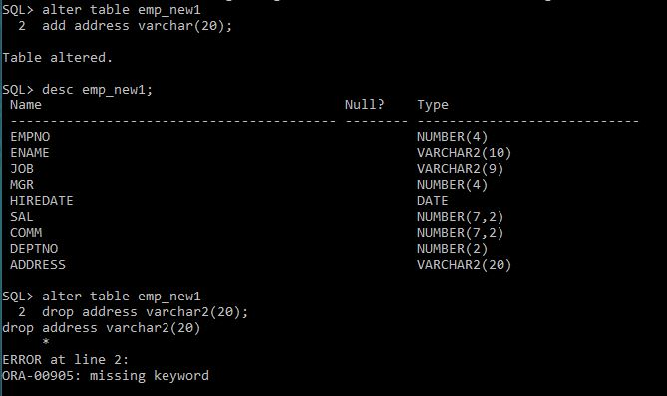

Exercise 3:

**Drop column ‘Address’ from it.**

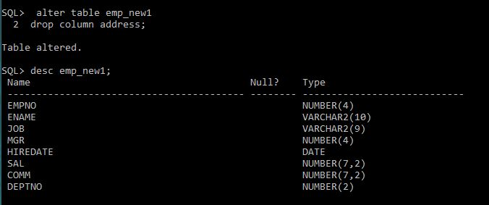

Exercise 4:

**Add columns ‘House No’ character ,’Street No’ numeric, ’Area’ character ,’City’ character in it with the respective data types.**

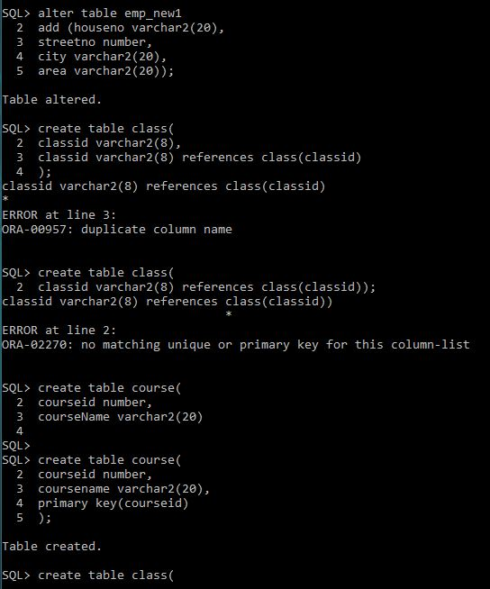

Exercise 5:

**Change the data type of ‘House No’ from character to numeric.**

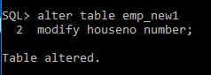

Exercise 6:

**Create the Data Definitions for each of the relations shown below, using SQL DDL.**

**Assume the following attributes and data types:**

**FACULTY:**

**FacultyID (integer, primary key)**

**FacultyName (25 characters)**

**COURSE:**

**CourseID (8 characters, primary key)**

**CourseName (15 characters)**

**CLASS:**

**ClassID (8 characters) CourseID (8 characters foreign key)**

**SectionNo (integer) Semester (10 characters)**

**STUDENT:**

**StudentID (integer, primary key)**

**StudentName (25 characters)**

**FacultyID (integer foreign key)**

**FACULTY:**

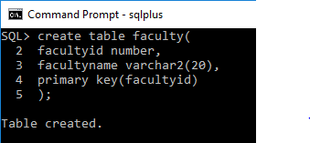

**COURSE:**

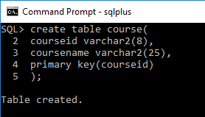

**CLASS:**

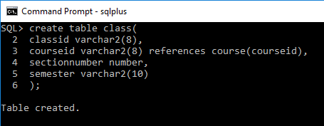

**STUDENT:**

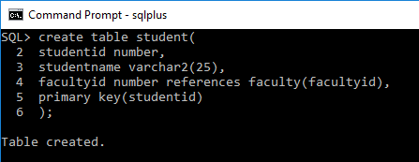

Exercise 7:

**How would you add an attribute, CLASS, to the STUDENT table?**

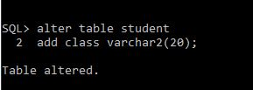

Exercise 8:

**How would you remove the FACULTY and STUDENT tables?**

