Exercise 1:

Create a table DEPARTMENT with the following attributes:

DEPTNO number, DNAME varchar2(10), LOC varchar2(10).

PRIMARY KEY constraint on DEPTNO.

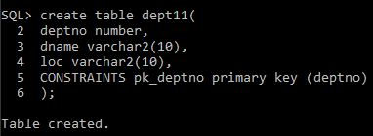

Exercise 2:

2. Create a table EMPLOYEE with the following attributes:

EMPNO number, ENAME varchar2(10),SAL number, DEPTNO number.

Apply FOREIGN KEY constraint on DEPTNO referencing the DEPARTMENT table created in question 1 and PRIMARY KEY constraint on EMPNO and DEPTNO.

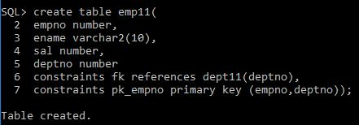

Exercise 3:

3. ALTER table EMPLOYEE created in question 2 and apply the constraint CHECK on ENAME attribute such that ENAME should always be inserted in capital letters.

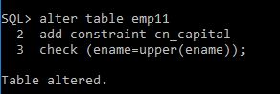

Exercise 4:

4. ALTER table DEPARTMENT created in question 1 and apply constraint on DNAME such that DNAME should not be entered empty.

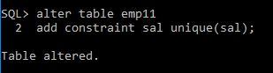

Exercise 5:

5. ALTER table EMPLOYEE created in question 2 and apply the constraint on SAL attribute such that no two salaries of the employees should be similar.

