Exercise 1:

**Create a new table EMPLOYEE replica of EMP table with no records in it.**

**Create a new table DEPART replica of DEPT table with all the records in it.**

**Create a primary foreign key relationship between EMPLOYEE and DEPART tables.**

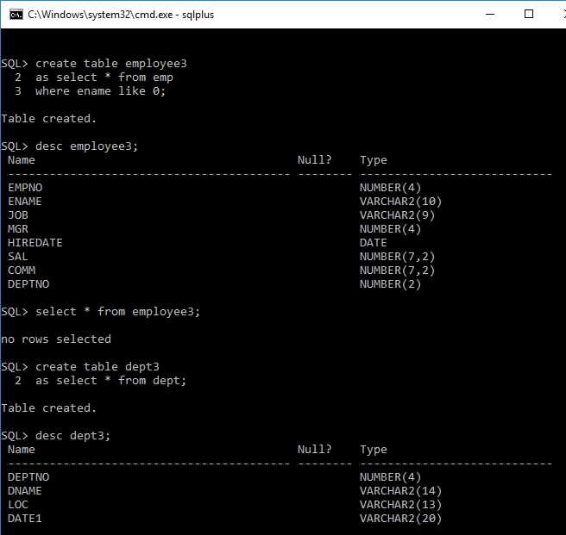

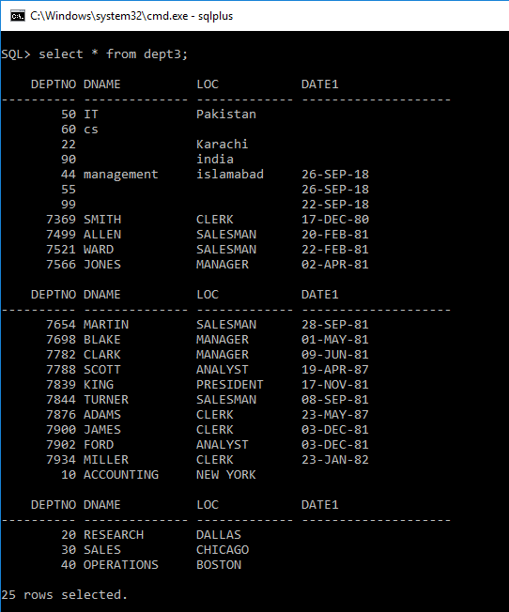

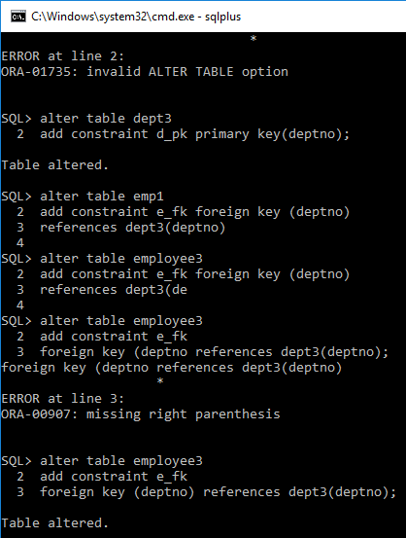



Exercise 2:

**Insert following records into EMPLOYEE using following values:**

**EMPNO = 101, ENAME = WASEEEM, SAL = 5000, JOB = CLERK and DEPTNO = 20.**

**EMPNO = 102, ENAME = SAJID, SAL = 15000, JOB = ANALYST and DEPTNO = 10.**

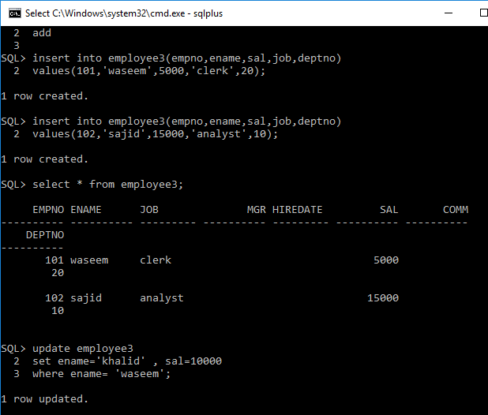

Exercise 3:

**Change the record inserted in question 2 from ENAME ‘WASEEM’ to ‘KHALID’ and SAL 5000 to 10000.**



Exercise 4:

**Remove all the records from EMPLOYEE table having job = ‘ANALYST’.**

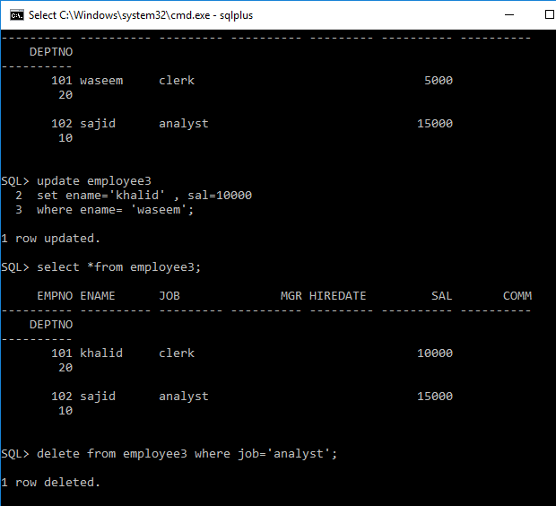

Exercise 5:

**Try to update the table DEPART and change the value of DEPTNO from 10 to 30. Find the error and give the reason for the error.**

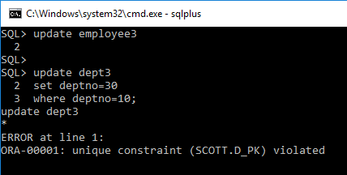

**Reason of Error:**

The **deptno** of **dept3** table is not updated because the **dept no** is set as a primary key, which takes only unique values but the number which we trying to update is already in the records that’s why it gives **unique constraint** error.

Exercise 6:

**Insert a new record into EMPLOYEE using following values:**

**EMPNO = 103, ENAME = SALEEM, SAL = 60000, JOB = ANALYST and DEPTNO = 60. Find the error and give the reason for the error.**

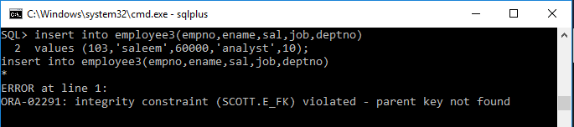

**Reason of Error:**

In **employee3** table the row is not inserted because the deptno(10) doesn’t exist in the parent table **dept3** that’s why it gives **integrity constraints** error.