**Exercises**

Exercise 1:

Write a PL/SQL program using CASE statement to assign COMM to employee 7369. COMM will be assigned with respect to the JOB of the employee 7369.

If JOB = CLERK then COMM = 5% of sal

If JOB = ANALYST then COMM = 10% of sal

If JOB = MANAGER then COMM = 15% of sal

The commission of the employee must be update in the EMP table.

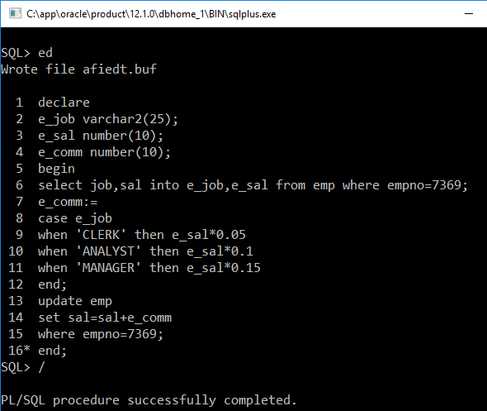

Exercise 2:

Write a PL/SQL program using Basic Loop to print multiplication table from 2 to 10. Each table must be printed from 1 to 10.

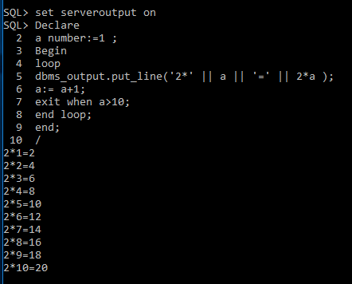

Exercise 3:

Write a PL/SQL program using While Loop to display all DEPTNO,DNAME and LOC from DEPT table. Assuming the difference between two deptno is 10.

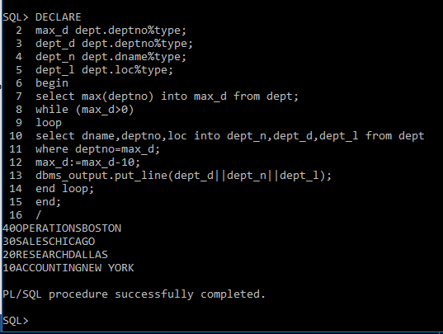

Exercise 4:

Write a PL/SQL program using FOR LOOP to insert 3 new DEPTNO in the dept table. New DEPTNO should have a difference of 10 between them and must be greater then the existing maximum DEPTNO in DEPT table.

