Exercise 1:

Write a PL/SQL program using cursor which displays all employees’ names, employees’

salaries, their managers’ name and managers’ salaries from emp table.

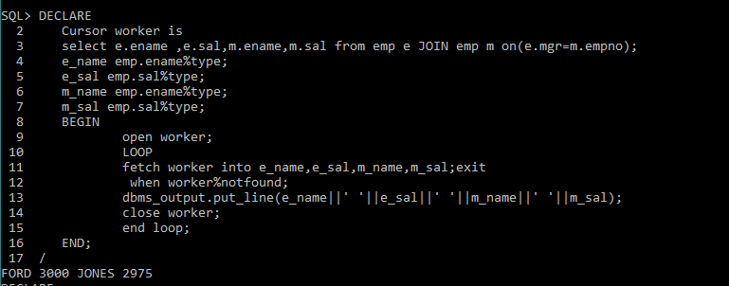

Exercise 2:

Write a PL/SQL program using cursor which displays all employees’ names, their salaries and

their jobs from emp table having salary greater than 4000 and are not CLERKS.

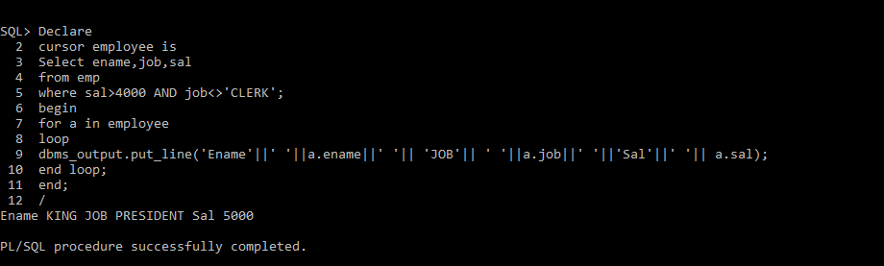

Exercise 3:

Write a PL/SQL program using cursor which displays all employees’ names, their departments’

names and their managers’names who don’t report to JONES. Cursor must use %FOUND

attribute to check the cursor.

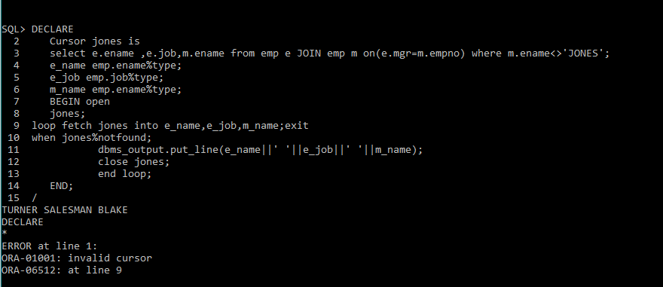

Exercise 4:

Write a PL/SQL program using cursor FOR LOOP which gives increments in salaries to all the

employees of emp table with respect to their jobs.

If job = ‘CLERK’ then increment must be 5% of the salary, If job = ‘SALESMAN’ then increment

must be 10% of the salary, If job = ‘ANALYST’ then increment must be 15% of the salary else

increment must be 20% of the salary.

