GenAI Project 1
Urdu Question Generation Using an RNN Encoder–Decoder with Attention
Course: Generative AI
Project Report
Group Members: 22P-9280 & 23F-0016
Submission note: The automatic evaluation below is based on the completed experiment. The human-evaluation table is explicitly marked as AI-assisted proxy ratings and must be replaced with genuine independent member ratings before claiming it as a human evaluation.

Abstract
This project develops an Urdu question-generation system that receives an Urdu sentence with an answer span marked by <ans> and </ans>, and generates a question whose answer should correspond to that marked span. The system follows the project constraints by using a from-scratch RNN sequence-to-sequence architecture rather than a pretrained model or Transformer. A custom 8,000-token SentencePiece tokenizer is trained on the training pairs. The neural model uses a two-layer bidirectional LSTM encoder, a two-layer LSTM decoder, and Luong general attention. The best checkpoint was obtained after 15 epochs. Evaluation was performed on the UQA validation set and the out-of-domain Wiki-UQA set using greedy and beam-search decoding. Results show low automatic scores, substantial repetition and semantic errors, and a clear performance drop on Wiki-UQA, indicating limited generalization of the small from-scratch model.

1. Problem Statement and Objectives
The task is a conditional text-generation problem. Given an Urdu sentence containing a marked answer span, the model must generate an Urdu question for which the marked span is the answer. The project therefore combines sequence encoding, attention-based conditioning, and autoregressive question generation.
The main objectives were:
- Prepare answerable UQA examples at sentence level while preserving the answer span.
- Train a custom SentencePiece subword tokenizer with an 8,000-token vocabulary.
- Implement and train a from-scratch RNN encoder–decoder with attention.
- Evaluate the best checkpoint with greedy and beam-search decoding.
- Compare in-domain UQA validation performance with out-of-domain Wiki-UQA performance.
- Provide automatic metrics, human-evaluation structure, qualitative analysis, and a small web front end.

2. Dataset and Preprocessing
The primary dataset is UQA, an Urdu question-answering corpus derived from SQuAD-style data. Only answerable examples were retained. For each answer, the character offset was used to locate the sentence containing the answer. The answer was then wrapped with <ans> and </ans>. Pairs whose source exceeded 60 whitespace tokens or whose target exceeded 25 whitespace tokens were removed. This sentence-level formulation keeps the input manageable for a from-scratch RNN.
Dataset | Raw rows | Answerable rows | Pairs after filter | Mean source / target length
UQA Train | 124,745 | 83,018 | 75,067 | 32.59 / 11.92
UQA Validation | 16,824 | — | 10,018 | 33.23 / 12.29
Wiki-UQA | 210 | 209 | 209 | 156.60 / 11.49

Wiki-UQA was evaluated as an out-of-domain set without applying the UQA source-length filter, so all 209 valid answerable pairs were retained. Its much longer average source length (156.60 whitespace tokens) compared with UQA validation (33.23) is an important distribution shift.

3. Tokenization
A SentencePiece unigram tokenizer was trained only on the UQA training sources and targets. The vocabulary size was 8,000, character coverage was 1.0, and <ans> and </ans> were registered as user-defined symbols. The special IDs were PAD=0, UNK=1, BOS=2, and EOS=3. Subword tokenization is useful for Urdu because words and morphological components can be decomposed into reusable pieces, reducing the need to store every surface form as a separate vocabulary item.

4. Model Architecture
The model is a from-scratch sequence-to-sequence architecture. The encoder is a two-layer bidirectional LSTM with 256-dimensional embeddings and 512 hidden units. Because the bidirectional encoder produces 1,024-dimensional hidden/cell representations, linear projection layers map them to the decoder's 512-dimensional state. The decoder is a two-layer LSTM. At each decoding step, Luong general attention scores the decoder state against encoder outputs; the resulting context vector is concatenated with the token embedding before entering the decoder LSTM. A final linear layer maps the decoder representation to the 8,000-token vocabulary.
Configuration | Value
Architecture | RNN Encoder–Decoder with Attention
Encoder | 2-layer Bidirectional LSTM
Decoder | 2-layer LSTM
Attention | Luong General Attention
Embedding size | 256
Hidden size | 512
Dropout | 0.3
Vocabulary | 8,000
Trainable parameters | ≈25.79 million
Optimizer | Adam
Learning rate | 1e-3
Learning-rate schedule | None specified
Batch size | 64
Epochs | 15
Teacher forcing ratio | 0.5
Best checkpoint | Epoch 15
Best logged validation loss | 4.8202

5. Training
Training used cross-entropy loss with padding ignored and Adam optimization. Teacher forcing was used with a ratio of 0.5. The checkpoint with the lowest validation loss was retained. Training loss decreased consistently from 6.1696 in Epoch 1 to 4.0591 in Epoch 15. Validation loss decreased from 6.0906 to 4.8202, with small fluctuations after the tenth epoch. The best validation loss was therefore reached at Epoch 15.
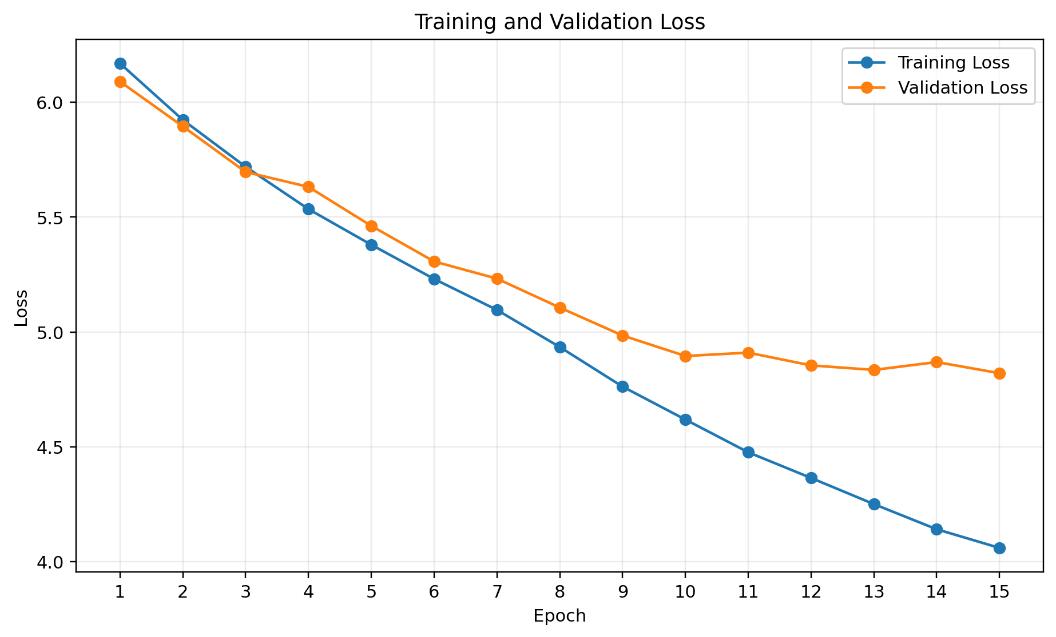
Figure 1. Training and validation loss over 15 epochs.
The loss curves show that the model learned the training task, but the relatively large gap between training and validation loss by the end of training suggests limited generalization. The model was trained once as required by the assignment rather than used as a comparison study.

6. Evaluation Methodology
The best checkpoint was evaluated on 10,018 UQA validation pairs and 209 valid Wiki-UQA pairs. Two decoding methods were used: greedy decoding and beam search with beam size 3. Automatic metrics follow the assignment definitions: corpus-level SacreBLEU BLEU-4 on detokenised output, average ROUGE-L F-measure, perplexity from teacher-forced reference likelihood, and the fraction of generated tokens decoded as <unk>.
Split | Decoding | BLEU-4 | ROUGE-L F1 | PPL | <unk> %
UQA valid | Greedy | 2.5842 | 0.0041 | 61.5156 | 0.5892
UQA valid | Beam (k=3) | 2.8041 | 0.0048 | 61.5156 | 0.8566
Wiki-UQA | Greedy | 1.6246 | 0.0000 | 115.9396 | 2.8795
Wiki-UQA | Beam (k=3) | 1.5119 | 0.0000 | 115.9396 | 3.4257

Beam search gives a small improvement over greedy decoding on UQA validation: BLEU-4 rises from 2.5842 to 2.8041 and ROUGE-L from 0.0041 to 0.0048. However, beam search increases the <unk> rate from 0.5892% to 0.8566%. On Wiki-UQA, beam search instead reduces BLEU-4 and increases the <unk> rate. Thus, a wider search does not automatically produce better questions when the underlying model is weak.

7. Required Figures
The following result files were generated in the project's results directory and should be inserted at the indicated positions in the final submission:
- Figure 1 — results/loss_curves.png: training and validation loss per epoch.
- Figure 2 — results/source_length_histogram.png and results/target_length_histogram.png: source and target length distributions.
- Figure 3 — results/attention_heatmap.png: Luong attention heatmap with source tokens on the x-axis and generated tokens on the y-axis.
- Figure 4 — frontend screenshot: insert the final screenshot of the working web interface here.
The attention heatmap was generated from one validation example using the model's actual decoder attention weights. The final heatmap uses an Urdu-capable font and Arabic text shaping for readable labels.

8. Qualitative Analysis
The available fixed 50-sample evaluation file shows a severe generation-quality problem: the sampled outputs contain frequent repetition, malformed question structures, unrelated entities, and unknown tokens. Consequently, there are not five genuinely good examples in the available sample. To avoid misrepresenting the results, the first subsection reports five relatively stronger examples rather than falsely calling them successful questions.

8.1 Five relatively stronger examples
ID | Reference | Greedy | Beam | Assessment
1 | نارمنڈی کس ملک میں واقع ہے؟ | 15 ویں صدی کے اوائل میں کس ملک کو ملک میں آباد کیا گیا تھا؟ | 15 ویں صدی کے اوائل میں کون سا ملک ملک ملک کو آباد کیا گیا تھا؟ | Wrong content; repetition
7 | کس صدی میں نارمنز نے پہلی بار اپنی علیحدہ شناخت حاصل کی؟ | کس وسطی میں یورپ میں کب شروع ہوا؟ | ⁇ کب تیار ہوا؟ | Wrong structure; UNK in beam
8 | کس صدی میں نارمنز نے پہلی بار اپنی علیحدہ شناخت حاصل کی؟ | کس صدی میں دوران میں وسطی میں نمودار ہوئی؟ | کس صدی کے دوران میں وسطی میں انقلاب میں نمودار ہوئی؟ | Wrong content; repetition
17 | کون سا دریا اصل میں ڈچی کی حد بندی کرتا تھا | کون سا دریا کے کے کے کے کے کے کے؟ | کون سا دریا کے کے کے کے کے؟ | Repetition
45 | نارمنز نے ڈیرراچیم پر کب حملہ کیا؟ | کس سال میں نے نے نے نے حملہ کیا؟ | کس سال نے قسطنطنیہ پر حملہ کیا؟ | Hallucinated entity / copied pattern

8.2 Five clear failure cases
ID | Reference | Greedy | Beam | Failure type
3 | نارمنز نارمنڈی میں کب تھے؟ | کس سال میں نے کے کے کے کے کے کو کب کیا؟ | ⁇ " کے مشرق ⁇ " کے ⁇ ⁇ " کے نام کیا تھا؟ | UNK + malformed output
4 | نورس کس ملک سے پیدا ہوئے تھے؟ | ملکہ کے کے کے کے سے کس سے سے؟ | وکٹوریہ نے کس کے کے کے کے کے؟ | Hallucinated entity / wrong question
13 | نارمنز کا مذہب کیا تھا؟ | کیتھولک کیتھولک نے کس مذہب میں کس مذہب میں؟ | کیتھولک چرچ نے کس میں کس مذہب کا مذہب کیا؟ | Repetition + wrong structure
24 | ہروی نے کب بازنطینی جنرل کی حیثیت سے خدمات انجام دیں؟ | ⁇ "ایک کے ⁇ ⁇ " کب" کب تھا؟ | ⁇ "مققہ ⁇ ⁇ " کب ⁇ "? | UNK + repetition
50 | ایما نے کس سے شادی کی؟ | وکٹوریہ کی شادی کے دوران شوپن نے کس کی شادی کی؟ | وکٹوریہ کے والد کی قیادت کس نے کی؟ | Hallucinated entities + semantic drift

9. Human Evaluation
The assignment requires both group members to independently rate the same fixed 50 validation examples for fluency, relevance, and answerability, followed by Cohen's kappa. The currently available completed file contains AI-assisted proxy ratings rather than genuine independent human ratings. The numbers below are included for transparency and debugging, but they should not be presented as actual member ratings. Replace them with real ratings before final submission if possible.
Criterion | Member 1 (% yes) | Member 2 (% yes) | Cohen's κ
Fluency | 64.0 | 64.0 | 0.9132
Relevance | 94.0 | 94.0 | 1.0000
Answerability | 8.0 | 74.0 | 0.0023

The large disagreement in answerability is consistent with the qualitative results: a generated question can look superficially like a question while failing to make the marked answer a valid answer. This criterion is therefore especially important for judging the model.

10. Discussion

10.1 Which question words does the model get right most often?
The sampled outputs most often attempt common question starters such as 'کس' and 'کون', and sometimes 'کب'. This indicates that the model has learned a weak surface-level association between the task and question-word generation. However, the surrounding syntax and semantic content are often incorrect, so recognizing a question word alone does not imply that the generated question is useful.

10.2 Where does beam search help, and where does it hurt?
Beam search provides a small in-domain improvement in BLEU-4 and ROUGE-L, suggesting that searching over several candidate continuations can find slightly better sequences than greedy decoding. However, the improvement is small and comes with a higher <unk> rate. On Wiki-UQA, beam search hurts BLEU-4 and raises the <unk> rate further. This suggests that search can amplify the model's learned preferences without fixing its underlying semantic or language-modeling weaknesses.

10.3 Why does performance drop on Wiki-UQA?
The out-of-domain Wiki-UQA results are substantially worse: PPL increases from 61.52 on UQA validation to 115.94 on Wiki-UQA, while ROUGE-L falls to zero for both decoding methods. Wiki-UQA also has a much longer mean source length (156.60 tokens versus 33.23 for UQA validation). These differences create a strong distribution shift that a small from-scratch RNN is not well equipped to handle. In addition, training data derived from translated QA material can contain translation-specific wording and patterns. A model trained mainly on those patterns may learn dataset-specific phrasing rather than robust Urdu question-generation behavior. The Wiki-UQA results therefore highlight the importance of diverse, naturally written Urdu training data and stronger language modeling.

11. Limitations and Future Improvements
- The model is relatively large for the available training setup but still has weak generation quality.
- Outputs show repetition, semantic drift, hallucinated entities, and occasional <unk> tokens.
- The long-source distribution of Wiki-UQA exposes the limitation of sentence-level training and short input constraints.
- A stronger decoding strategy alone is insufficient; improvements should target the model and data.
- Future work could include better regularization, scheduled teacher forcing, coverage-aware attention, repetition penalties, improved decoding constraints, and additional naturally written Urdu training data.
- The human-evaluation table must be replaced by genuine independent member ratings for full compliance with the assignment.

12. Front-End Demonstration
A minimal web front end is required by the project specification. It should accept an Urdu sentence with a marked answer span and display both greedy and beam-generated questions. The final submission should place a screenshot of the working interface below this heading and also include it in the README.
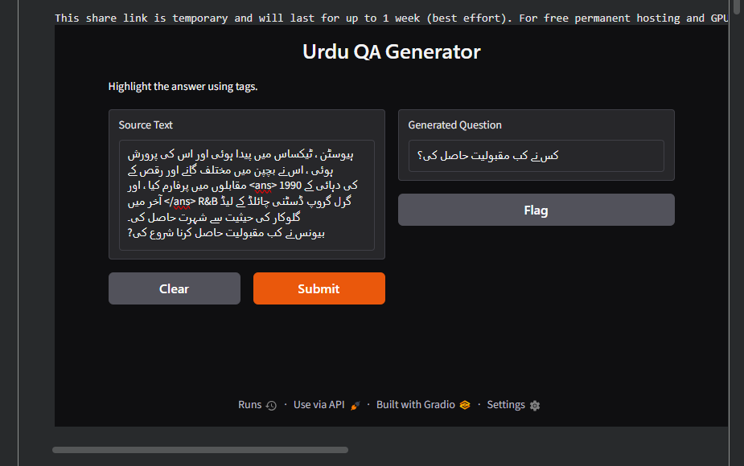

13. Reproducibility and Result Files
The experiment artifacts are organized under the project's results directory. The key files are:
- results/samples.tsv — 100 fixed validation examples with source, reference, greedy, and beam columns.
- results/human_evaluation_template.tsv — 50-example rating template.
- results/loss_curves.png — training/validation loss figure.
- results/source_length_histogram.png — source-length histogram.
- results/target_length_histogram.png — target-length histogram.
- results/attention_heatmap.png — attention visualization.
- best checkpoint — epoch 15, validation loss 4.8202.

14. Conclusion
The project successfully implements the required from-scratch RNN encoder–decoder with Luong attention, custom SentencePiece tokenization, greedy decoding, beam search, automatic evaluation, and result visualization. The training loss decreases steadily and the best checkpoint is reached at Epoch 15. Nevertheless, the low BLEU/ROUGE scores and qualitative failures show that the current model does not generate reliable Urdu questions. Beam search offers only a small in-domain gain and hurts performance on Wiki-UQA. The strong Wiki-UQA degradation, especially the PPL increase from 61.52 to 115.94, indicates poor out-of-domain generalization and the limitations of relying on a small translated training corpus. The most important next step is therefore improving data quality and semantic generation rather than simply increasing decoding search.

Appendix A — Training Loss by Epoch
Epoch | Training Loss | Validation Loss
1 | 6.1696 | 6.0906
2 | 5.9236 | 5.8954
3 | 5.7193 | 5.6968
4 | 5.5350 | 5.6319
5 | 5.3798 | 5.4619
6 | 5.2308 | 5.3068
7 | 5.0958 | 5.2323
8 | 4.9342 | 5.1061
9 | 4.7617 | 4.9844
10 | 4.6182 | 4.8952
11 | 4.4757 | 4.9098
12 | 4.3639 | 4.8543
13 | 4.2500 | 4.8346
14 | 4.1404 | 4.8688
15 | 4.0591 | 4.8202

Assignment alignment: The report follows the required result-table structure and addresses dataset statistics, model configuration, automatic metrics, human evaluation, figures, qualitative samples, and the three required discussion questions. The assignment specifically requires 5 good and 5 bad examples and genuine independent ratings by both members; the present report deliberately flags the two places where the available evidence does not support claiming full compliance.

